Additional file 2. Search strategies for all sources
MEDLINE (Ovid or PubMed)
(((("Review" [Publication Type]) OR "Systematic Review" [Publication Type]) OR (systematic review[Title/Abstract])) OR (review[Title])) AND (((((("Patient Participation"[Mesh]) OR ("Stakeholder Participation"[Mesh])) OR ("patient and public involvement"[Title/Abstract])) OR ("public involvement"[Title/Abstract])) OR ("patient engagement"[Title/Abstract])) OR ("patient partner"[Title/Abstract]))

Embase (ELSEVIER)
(('patient participation'/exp OR 'stakeholder engagement'/exp OR 'patient and public involvement':ab,ti OR 'public involvement':ab,ti OR 'patient engagement':ab,ti OR 'patient partner*':ab,ti) AND ([cochrane review]/lim OR [systematic review]/lim) OR (('patient participation'/exp OR 'stakeholder engagement'/exp OR 'patient and public involvement':ab,ti OR 'public involvement':ab,ti OR 'patient engagement':ab,ti OR 'patient partner*':ab,ti) AND [review]/lim)) AND ([danish]/lim OR [english]/lim OR [norwegian]/lim OR [swedish]/lim) AND ('article'/it OR 'article in press'/it OR 'review'/it) AND (2022:py OR 2023:py OR 2024:py)
Scopus (ELSEVIER)
( TITLE-ABS-KEY ( "patient participation" OR "stakeholder participation" OR "patient and public involvement" OR "public involvement" OR "patient engagement" OR "patient partner*" ) ) OR ( ( TITLE-ABS-KEY ( "patient participation" OR "stakeholder participation" OR "patient and public involvement" OR "public involvement" OR "patient engagement" OR "patient partner*" ) AND TITLE-ABS-KEY ( "systematic review" ) ) ) AND PUBYEAR > 2021 AND PUBYEAR < 2025 AND ( LIMIT-TO ( DOCTYPE , "re" ) ) AND ( LIMIT-TO ( LANGUAGE , "english" ) OR LIMIT-TO ( LANGUAGE , "swedish" ) OR LIMIT-TO ( LANGUAGE , "norwegian" ) OR LIMIT-TO ( LANGUAGE , "danish" ) )

CINAHL (EBSCOhost)
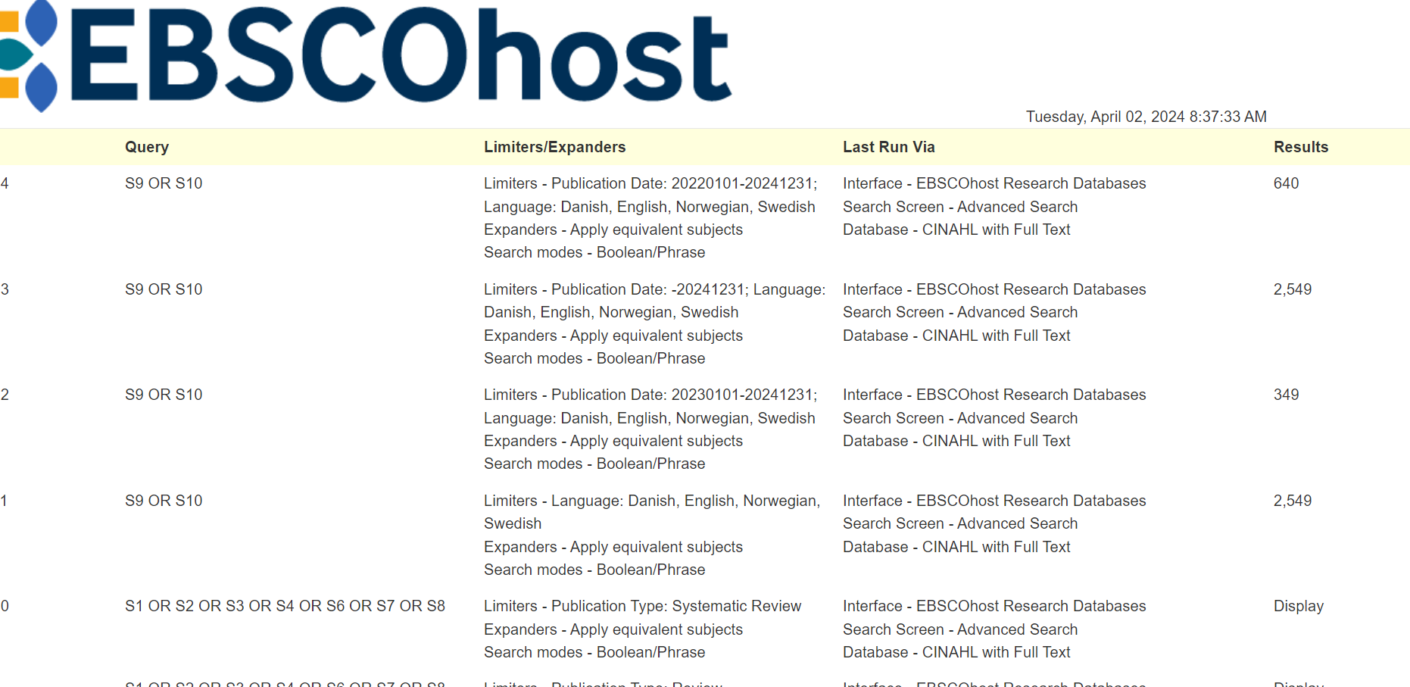

PsycInfo (EBSCOhost)
(MAINSUBJECT.EXACT("Client Participation") OR (ab("stakeholder participation") OR ti("stakeholder participation")) OR (ab("patient and public involvement") OR ti("patient and public involvement")) OR (ab("public involvement") OR ti("public involvement")) OR (ab("patient engagement") OR ti("patient engagement")) OR (ab("patient partner*") OR ti("patient partner*")) OR (ab("patient participation") OR ti("patient participation"))) AND (la.exact("ENG") AND stype.exact("Scholarly Journals" NOT ("Books" OR "Dissertations & Theses")) AND me.exact("Literature Review" OR "Systematic Review"))

Google Scholar search
("patient participation" OR "stakeholder participation" OR "patient and public involvement" OR "public involvement" OR "patient engagement" OR "patient partner*") AND ("systematic review" OR review)

