Supplementary Appendix

Supplementary Table 1 Search terms on PubMed
Supplementary Table 2 Quality of Evidence by GRADE approach
Supplementary Figure 1 Flowchart of Study selection
Supplementary Figure 2 Risk of bias graph: review authors' judgements about each risk of bias item presented as percentages across all included studies.
Supplementary Figure 3 Risk of bias summary: review authors' judgements about each risk of bias item for each included study
Supplementary Figure 4 Funnel plot of incidence of any cardiac adverse events in lung cancer patients treated with immune checkpoint inhibitors
Supplementary Figure 5 Forest plot of risk ratio of arrhythmia in lung cancer patients treated with immune checkpoint inhibitors vs control
Supplementary Figure 6 Forest plot of risk ratio of myocardial infarction in lung cancer patients treated with immune checkpoint inhibitors vs control
Supplementary Figure 7 Forest plot of risk ratio of atrial fibrillation in lung cancer patients treated with immune checkpoint inhibitors vs control
Supplementary Figure 8 Forest plot of incidence of any cardiac adverse events in lung cancer patients treated with immune checkpoint inhibitors

Supplementary Table 1: Search strategy
Database (Articles Retrieved) | Search Strategy
MEDLINE  (5,601 results) | (('lung cancer'[Title/Abstract]) OR ('NSCLC'[Title/Abstract]) OR ('SCLC'[Title/Abstract])) AND (('Atezolizumab' [Title/Abstract]) OR ('Avelumab' [Title/Abstract]) OR ('Nivolumab'[Title/Abstract]) OR ('BMS936559' [Title/Abstract]) OR ('BMS-936559' [Title/Abstract]) OR ('Durvalumab' [Title/Abstract]) OR ('Ipilimumab' [Title/Abstract]) OR ('Pembrolizumab'[Title/Abstract])OR ('Pidilizumab' [Title/Abstract]) OR ('Tremelimumab' [Title/Abstract]) OR ('Spartalizumab' [Title/Abstract]) OR ('Cemiplimab' [Title/Abstract])). (Cardiotoxicity OR "adverse cardiac effects" OR "adverse cardiac events" OR "cardiac toxicity" OR "myocardial toxicity" OR "Cardiotoxicity"[Mesh]) OR ("Immune Checkpoint Inhibitors/adverse effects"[Mesh] OR "Immune Checkpoint Inhibitors/toxicity"[Mesh] OR "Immune Checkpoint Inhibitors"[Mesh]) AND (nivolumab OR Opdivo OR Ipilimumab OR Yervoy OR atezolizumab OR avelumab OR durvalumab OR pembrolizumab OR Cemiplimab OR keytruda OR "anti-programmed cell death-1 monoclonal antibodies" OR "Anti-PD-1 monoclonal antibodies" OR "PD-1" OR "PD-L1" OR "CTLA-4") AND (“lung cancer” OR “lung neoplasm”)
(285 results) | ("lung neoplasms"[MeSH Terms] OR ("lung"[All Fields] AND "neoplasms"[All Fields]) OR "lung neoplasms"[All Fields] OR ("lung"[All Fields] AND "cancer"[All Fields]) OR "lung cancer"[All Fields] OR ("lung neoplasms"[MeSH Terms] OR ("lung"[All Fields] AND "neoplasms"[All Fields]) OR "lung neoplasms"[All Fields] OR ("lung"[All Fields] AND "neoplasm"[All Fields]) OR "lung neoplasm"[All Fields]) OR "sclc"[All Fields] OR ("carcinoma, non small cell lung"[MeSH Terms] OR ("carcinoma"[All Fields] AND "non small cell"[All Fields] AND "lung"[All Fields]) OR "non-small-cell lung carcinoma"[All Fields] OR "nsclc"[All Fields] OR "nsclc s"[All Fields] OR "nsclcs"[All Fields])) AND ("immune checkpoint inhibitors"[Pharmacological Action] OR "immune checkpoint inhibitors"[MeSH Terms] OR ("immune"[All Fields] AND "checkpoint"[All Fields] AND "inhibitors"[All Fields]) OR "immune checkpoint inhibitors"[All Fields] OR ("immune"[All Fields] AND "checkpoint"[All Fields] AND "inhibitor"[All Fields]) OR "immune checkpoint inhibitor"[All Fields] OR "ICI"[All Fields]) AND ("cardiotoxic"[All Fields] OR "cardiotoxicity"[MeSH Terms] OR "cardiotoxicity"[All Fields] OR "cardiotoxicities"[All Fields] OR "cardiotoxity"[All Fields] OR ("heart failure"[MeSH Terms] OR ("heart"[All Fields] AND "failure"[All Fields]) OR "heart failure"[All Fields]) OR ("myocardic"[All Fields] OR "myocarditis"[MeSH Terms] OR "myocarditis"[All Fields] OR "myocarditides"[All Fields]) OR ("arrhythmias, cardiac"[MeSH Terms] OR ("arrhythmias"[All Fields] AND "cardiac"[All Fields]) OR "cardiac arrhythmias"[All Fields] OR "arrythmia"[All Fields] OR "arrythmias"[All Fields]) OR ("myocardial infarction"[MeSH Terms] OR ("myocardial"[All Fields] AND "infarction"[All Fields]) OR "myocardial infarction"[All Fields]) OR (("cardiacs"[All Fields] OR "heart"[MeSH Terms] OR "heart"[All Fields] OR "cardiac"[All Fields]) AND ("adverse"[All Fields] OR "adversely"[All Fields] OR "adverses"[All Fields]) AND ("event"[All Fields] OR "event s"[All Fields] OR "events"[All Fields])))
Google Scholar  (9,790 results) | (Lung cancer OR lung neoplasm) AND (immune checkpoint inhibitors OR ICI) AND (cardiotoxicity)
OVID EMBASE  (381 results) | (Immune checkpoint inhibitor OR ICI) AND (cardiotoxicity OR cardiac adverse events OR cardiac failure OR myocardial infarction OR pericardial effusion OR cardiac arrhythmia OR cardiac tamponade OR ventricular fibrillation OR myocarditis OR atrial fibrillation) AND (small cell lung cancer OR non small cell lung cancer OR lung cancer)
Cochrane Library  (619 results) | ''Lung Cancer'' AND ''Immune Checkpoint Inhibitor''

Supplementary Table 2 Quality of Evidence by GRADE approach

Cardiac Adverse Events in Immune Checkpoint Inhibitor (ICI) Compared to Control for Lung Cancer
Outcomes | Anticipated absolute effects* (95% CI) |  | Relative effect  (95% CI) | № of participants  (studies) | Certainty of the evidence  (GRADE)
Outcomes | Risk with Control | Risk with Immune Checkpoint Inhibitor | Relative effect  (95% CI) | № of participants  (studies)
Single ICI vs Chemotherapy | 4 per 1,000 | 9 per 1,000  (5 to 17) | RR 2.15  (1.13 to 4.12) | 6929  (9 RCTs) | ⨁⨁◯◯  Lowª
Single ICI plus Chemotherapy vs Chemotherapy | 21 per 1,000 | 29 per 1,000  (22 to 39) | RR 1.38  (1.05 to 1.82) | 6870  (12 RCTs) | ⨁⨁⨁⨁  High
Single ICI vs Dual ICI | 15 per 1,000 | 7 per 1,000  (2 to 26) | RR 0.48  (0.13 to 1.80) | 1011  (4 RCTs) | ⨁⨁◯◯  Low^{a,b}
*The risk in the intervention group (and its 95% confidence interval) is based on the assumed risk in the comparison group and the relative effect of the intervention (and its 95% CI).
CI: confidence interval; RR: risk ratio
GRADE Working Group grades of evidence
High certainty: we are very confident that the true effect lies close to that of the estimate of the effect.
Moderate certainty: we are moderately confident in the effect estimate: the true effect is likely to be close to the estimate of the effect, but there is a possibility that it is substantially different.
Low certainty: our confidence in the effect estimate is limited: the true effect may be substantially different from the estimate of the effect.
Very low certainty: we have very little confidence in the effect estimate: the true effect is likely to be substantially different from the estimate of effect.
a. Imprecise as confidence interval included potential for important harm or benefit
b. some concern with performance bias and detection bias.

Supplementary Figure 1 Flowchart of Study selection

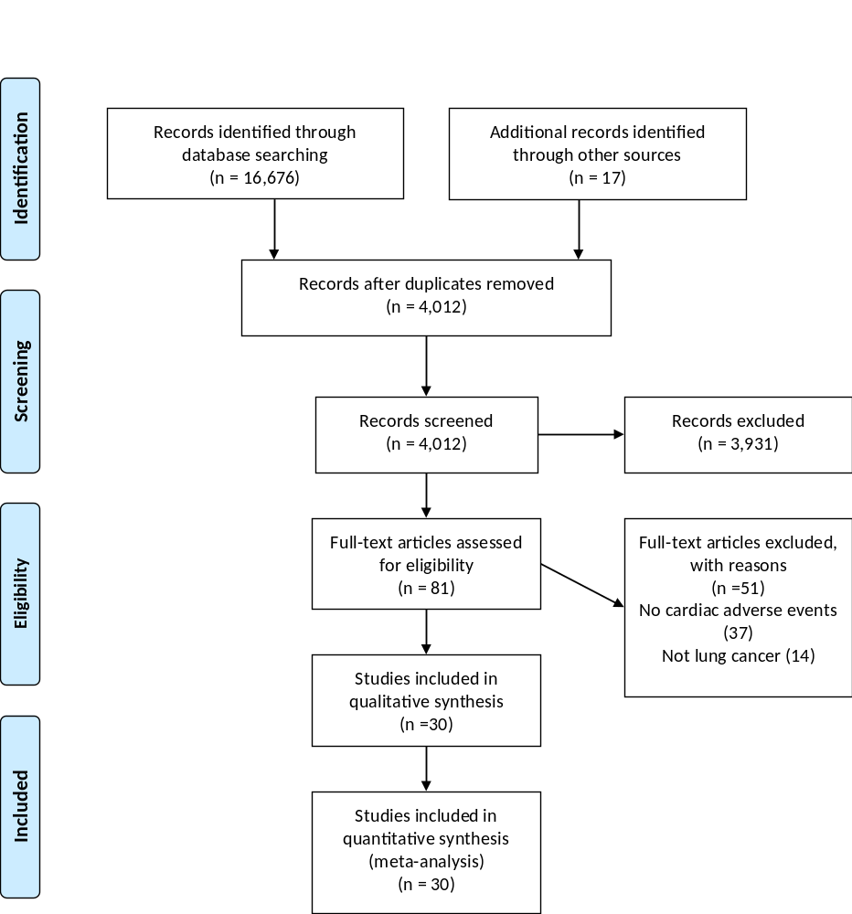

Supplementary Figure 2 Risk of bias graph: review authors' judgements about each risk of bias item presented as percentages across all included studies

Supplementary Figure 3 Risk of bias summary: review authors' judgements about each risk of bias item for each included study

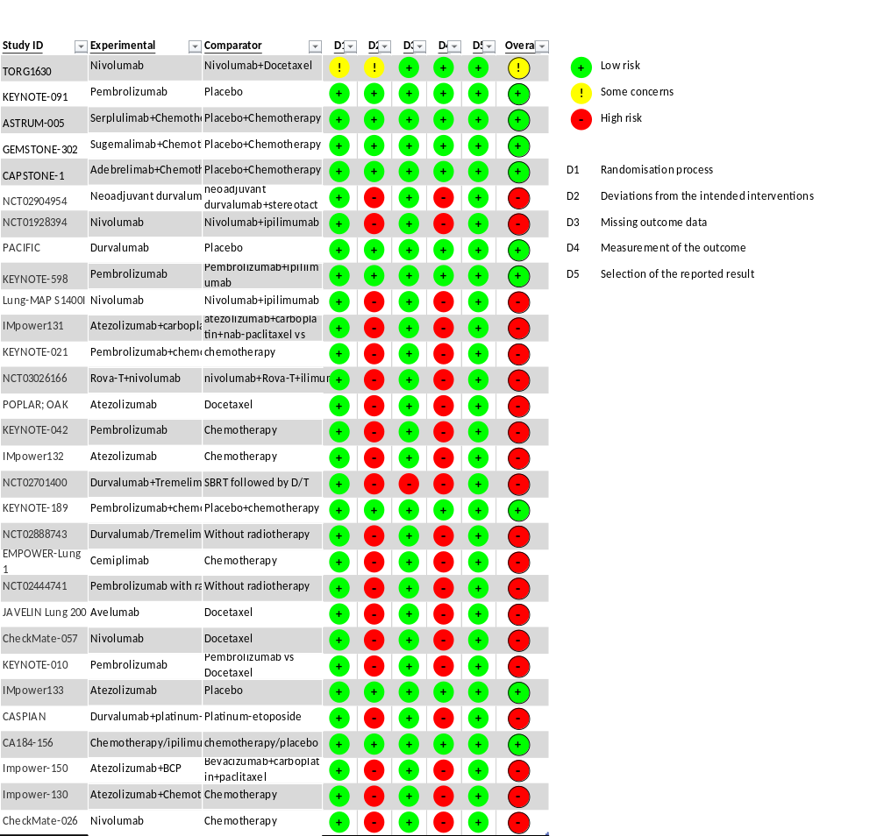
Supplementary Figure 4 Funnel plot of incidence of any cardiac adverse events in lung cancer patients treated with immune checkpoint inhibitors
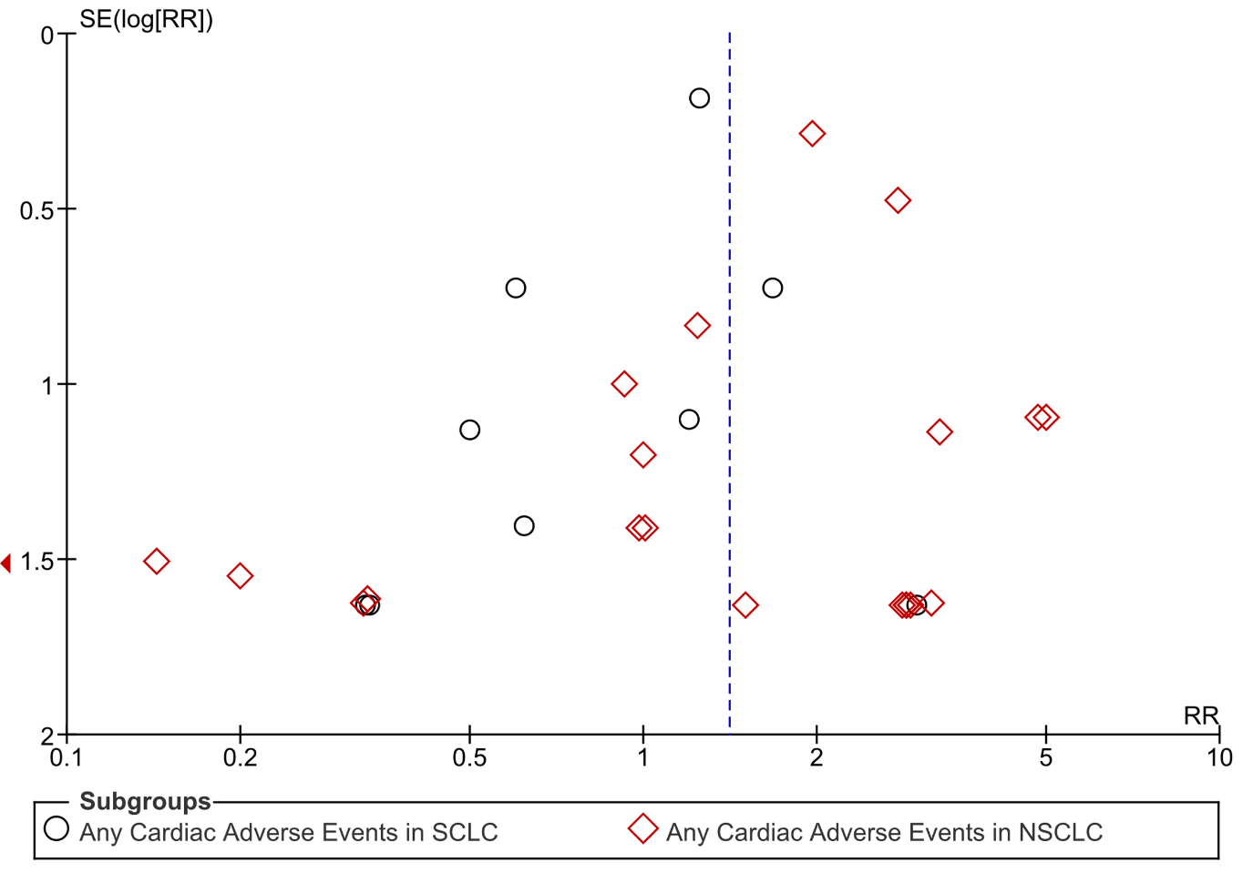

Supplementary Figure 5 Forest plot of risk ratio of arrhythmia in lung cancer patients treated with immune checkpoint inhibitors vs control

Supplementary Figure 6 Forest plot of risk ratio of myocardial infarction in lung cancer patients treated with immune checkpoint inhibitors vs control

Supplementary Figure 7 Forest plot of risk ratio of atrial fibrillation in lung cancer patients treated with immune checkpoint inhibitors vs control
Supplementary Figure 8 Forest plot of incidence of any cardiac adverse events in lung cancer patients treated with immune checkpoint inhibitors
