SUPPLEMENTAL MATERIAL
Table S1
International Classification of Diseases (Ninth and Tenth Revisions) Clinical Modification (ICD-9-CM and ICD-10-CM) codes used to define comorbidities and clinical outcomes.
Disease | ICD-9-CM Codes | ICD-10-CM Codes | Diagnosis definition
Diabetes mellitus | 250 | E08-E13 | Outpatient department ≥2
Hypertension | 401 -405 | I10-I15, N262 | Outpatient department ≥2
Dyslipidemia | 272 | E77, E780, E781, E782, E783, E784, E785, E786, E881, E753, E755, E882, E756, E789, E7521, E7522, E7524, E7130, E7879, E7881, E7889, E8889, E7870 | Outpatient department ≥2
Acute Myocardial infarction | 410 | I21-I23 | Discharge
Congestive heart failure | 428 | I11.0, I13.0, I13.2, I42.0, I50, I50.1, I50.9 | Discharge
Ischemic stroke | 433, 434, 436 | I63, I64 | Discharge
Deep vein thrombosis | 452, 453 | I81,I82,I82.20, I82.40, I82.80,I82.90. | Discharge
Pulmonary embolism | 4151x | I26,I260,I2601,I2690,I2699 | Discharge
Cardiovascular death | 390-398, 410-414, 420-429 | I01, I02.0, I05-I09, I20-I25, I27, I30-I52 | The primary diagnosis during hospitalization or in emergency rooms within three months before death date.
Noted: ICD-9-CM codes were used during 2000–2015, and ICD-10-CM codes were used after 2016.

Supplemental Figure Legends

Supplemental Figures I to VI: Subgroup Analysis of Hazard Ratios for the Risks of Specific Outcomes in Cancer Patients Treated with Immune Checkpoint Inhibitor (ICI) versus Non-ICI, after Propensity Score Matching.

The supplemental figures provide subgroup analyses of hazard ratios for the following outcomes:
Supplemental Figure I: Cardiac death
Supplemental Figure II: Non-fatal myocardial infarction
Supplemental Figure III: Non-fatal stroke
Supplemental Figure IV: Hospitalization for heart failure
Supplemental Figure V: Deep vein thrombosis
Supplemental Figure VI: Pulmonary embolism

The subgroup analysis revealed that patients without head and neck cancer who were treated with ICI had a lower risk of cardiac death compared to those with head and neck cancer (p interaction = 0.0107; see Supplemental Figure I). Additionally, patients with diabetes who received ICI treatment had a reduced risk of non-fatal stroke compared to those without diabetes (p interaction = 0.0239; see Supplemental Figure III). Overall, the subgroup analysis consistently showed similar results for non-fatal myocardial infarction, deep vein thrombosis, and pulmonary embolism when comparing ICI versus non-ICI treatments across different patient demographics, including gender, diabetes status, chronic kidney failure, and various cancer types such as lung cancer, hepatobiliary cancer, head and neck cancer, and hematologic malignancy (refer to Supplemental Figures II, IV, V, and VI).

Abbreviations: CKD = chronic kidney disease; DM = diabetes mellitus; ICI = immune checkpoint inhibitor

Supplemental Figure I
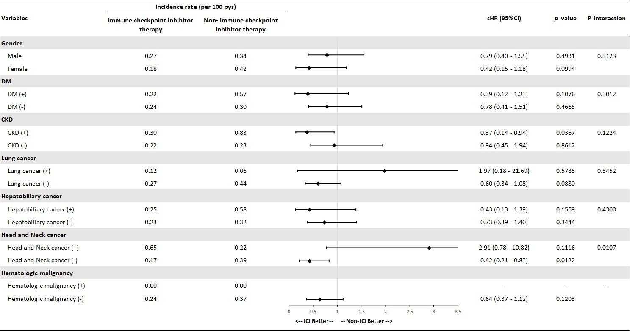
Supplemental Figure II
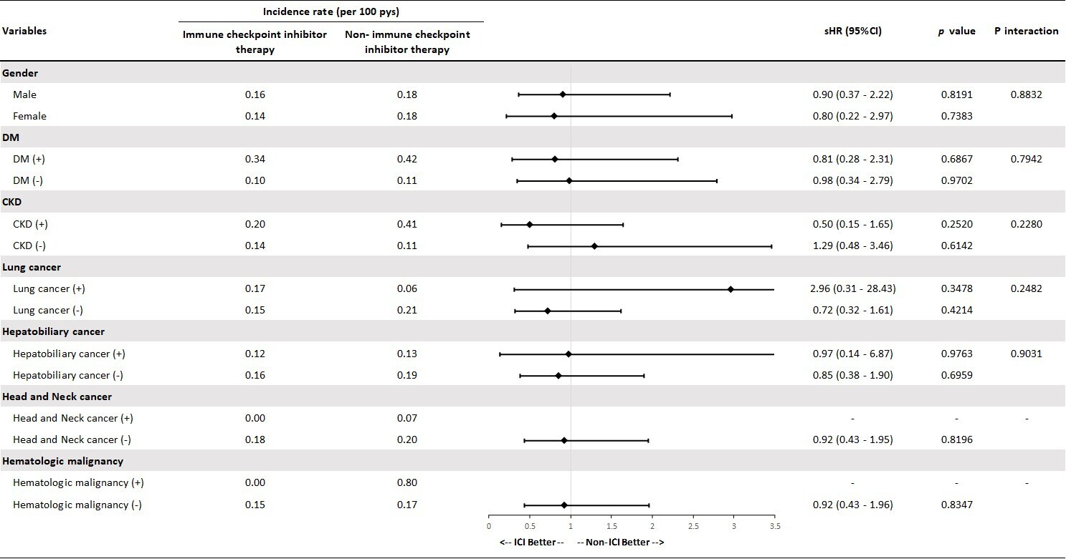

Supplemental Figure III
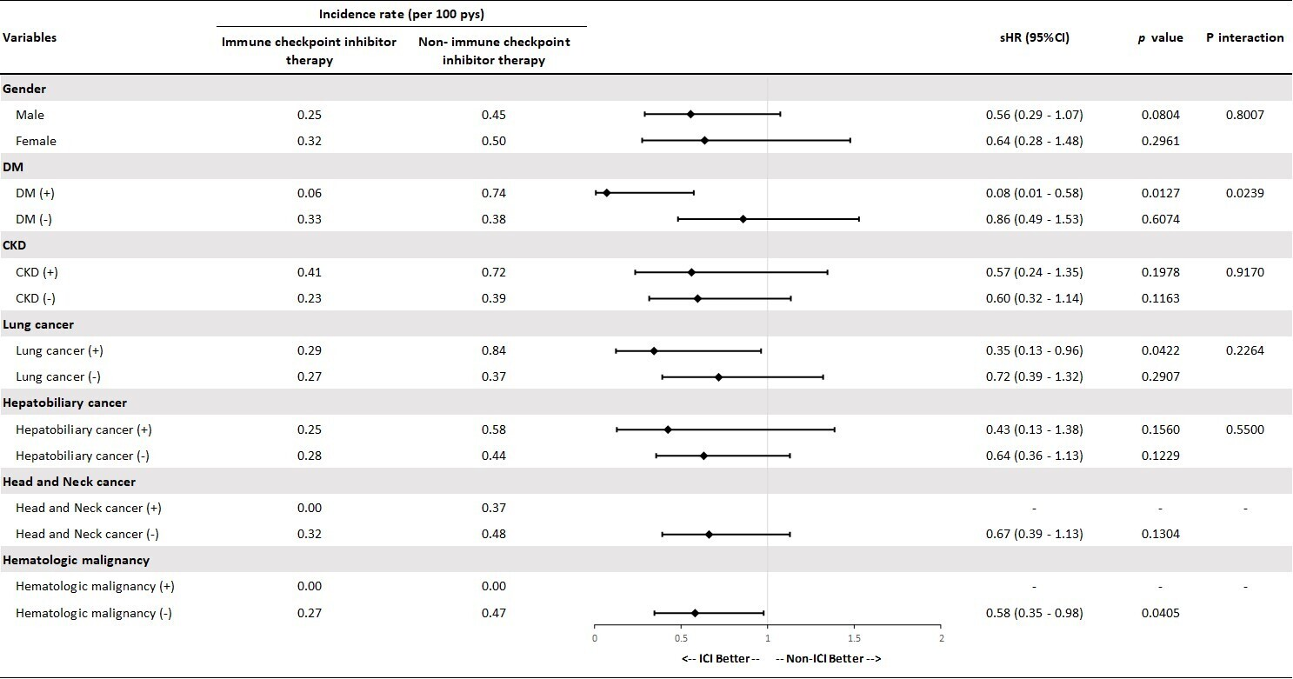

Supplemental Figure IV
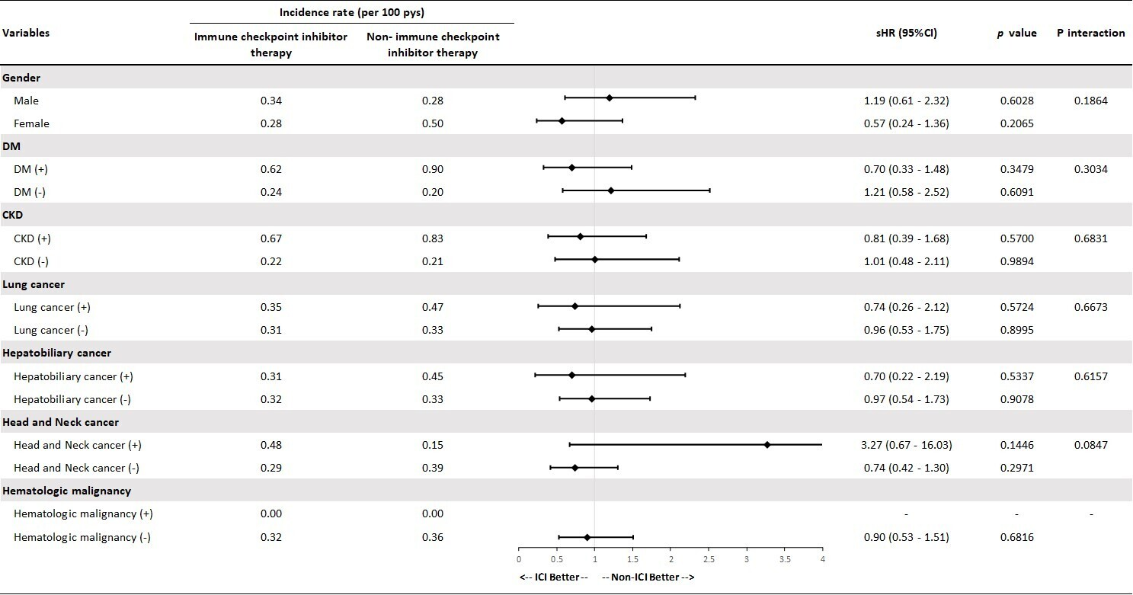

Supplemental Figure V
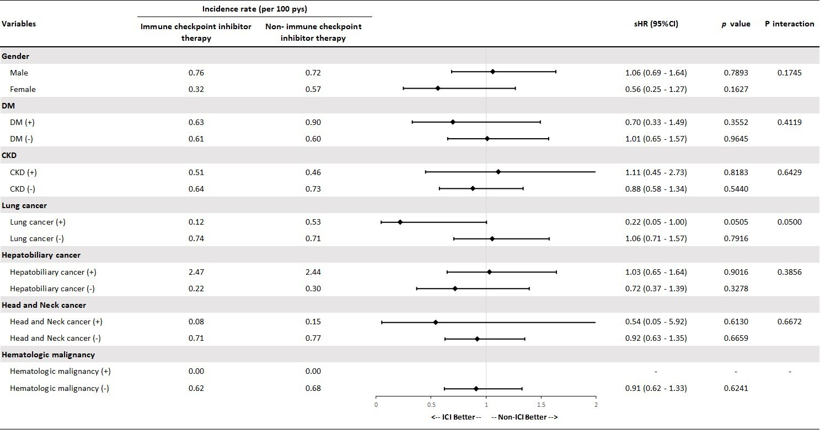

Supplemental Figure VI
