Supplementary Figure 2. Kaplan-Meier analysis of overall survival since date of diagnosis.

A. Survival of patients whose mean blood pressure readings qualified as hypertensive (i.e., >140 mm Hg) after TZB initiation vs those with well-controlled blood pressure; B. Patients who saw an increase in quantity of anti-hypertensives prescribed after TZB initiation vs those who did not (i.e. “other”).

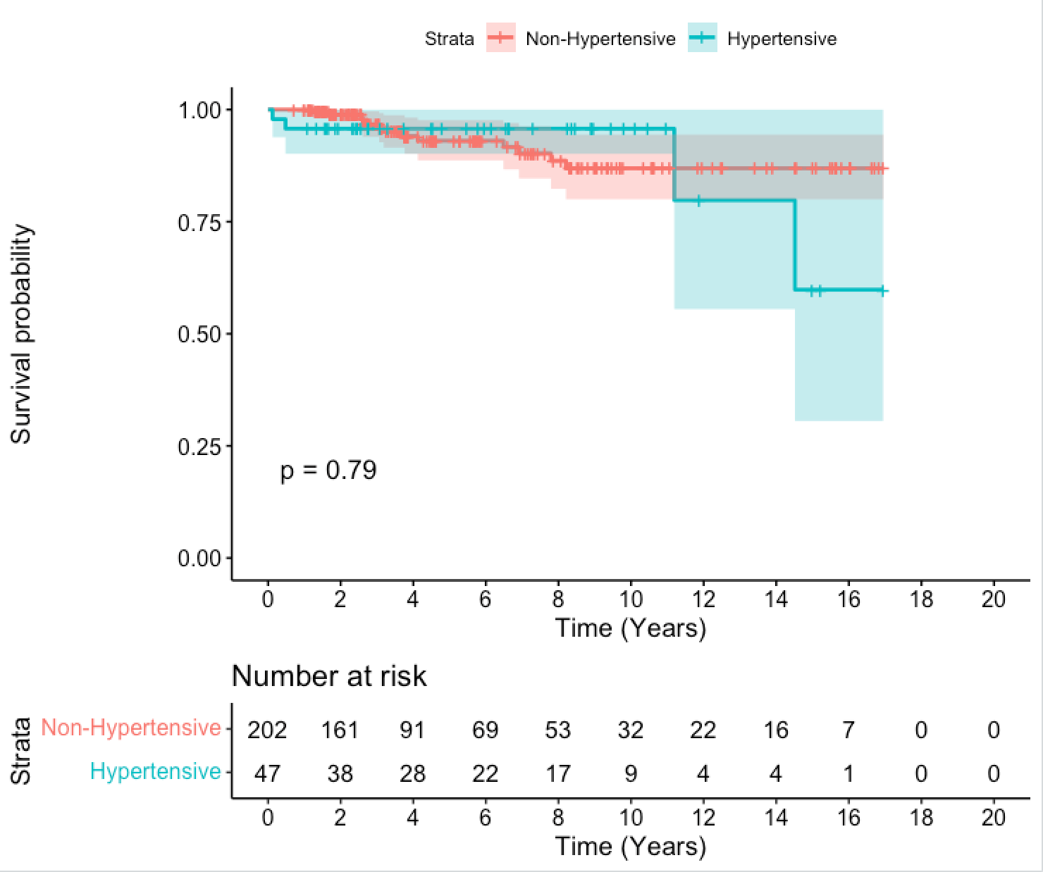
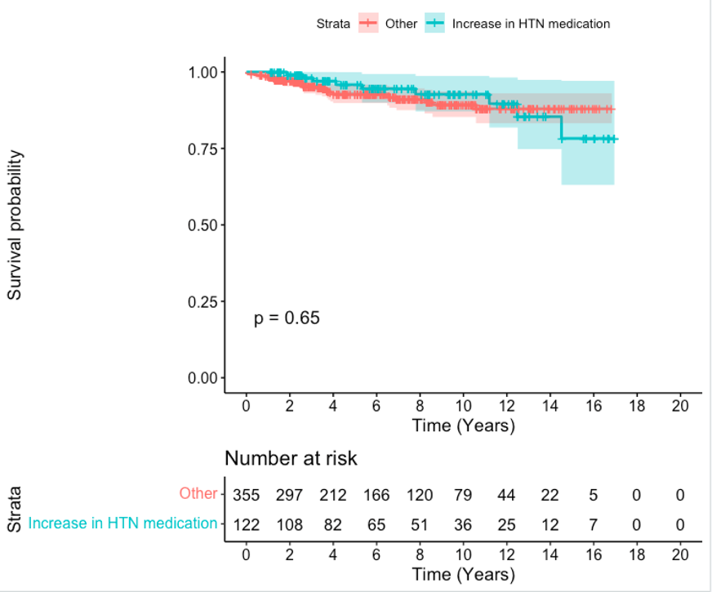
AΩ
B

TZB: trastuzumab

