Title.
Impact of Advanced Lung Cancer Inflammation Index on All-Cause Mortality among Patients with Heart Failure: A Systematic Review and Meta-analysis with Reconstructed Time-to-Event Data.
Running Title.
Advanced lung cancer inflammation index for heart failure
Authors.
Ahmed Mazen Amin¹, Ramy Ghaly², Hossam Elbenawi³, Abdelrahman Ewis¹, Ubaid Khan⁴, Khaled S M Elshaer⁵, Mohamed Abuelazm⁶, Basel Abdelazeem⁷, Brijesh Patel⁷, Farris K. Timimi³, Islam Y. Elgendy⁸.
Affiliations.
- Faculty of Medicine, Mansoura University, Mansoura, Egypt.
- Department of Internal Medicine, University of Missouri-Kansas City, Kansas City, MO, USA.
- Department of Cardiovascular Medicine, Mayo Clinic, Rochester, Minnesota, USA.
- Division of Cardiology, University of Maryland, School of Medicine, Baltimore, USA.
- Faculty of Medicine, Alfaisal University, Riyadh, Saudi Arabia.
- Faculty of Medicine, Tanta University, Tanta, Egypt.
- Department of Cardiology, West Virginia University, Morgantown, West Virginia, USA.
- Division of Cardiovascular Medicine, Gill Heart Institute, University of Kentucky, Lexington, KY, USA.

Contents:
Figures.
Figure S1: Quality assessment of the risk of bias in the included trials (ROBINS-I tool). The upper panel presents a schematic representation of risks (low = green, unclear = yellow, and high = red) for specific types of biases of each study in the review. The lower panel presents risks (low = green, unclear = yellow, and high = red) for the subtypes of biases of the combination of studies included in this review.
Figure S2: Quality assessment of the risk of bias in the included trials (QUIPS tool). The upper panel presents a schematic representation of risks (low = green, unclear = yellow, and high = red) for specific types of biases of each study in the review. The lower panel presents risks (low = green, unclear = yellow, and high = red) for the subtypes of biases of the combination of studies included in this review.
Figure S3: Sensitivity analysis of all-cause mortality (pairwise meta-analysis).
Figure S4: Grambsch-Therneau test and diagnostic plots based on Schoenfeld residuals.
Figure S5: log-log survival curve.

Tables.
Table S1: Search strategy.
Table S2: Adjustment factors for each study's prognostic meta-analysis model.
Table S3: between-study heterogeneity assessment by frailty model.

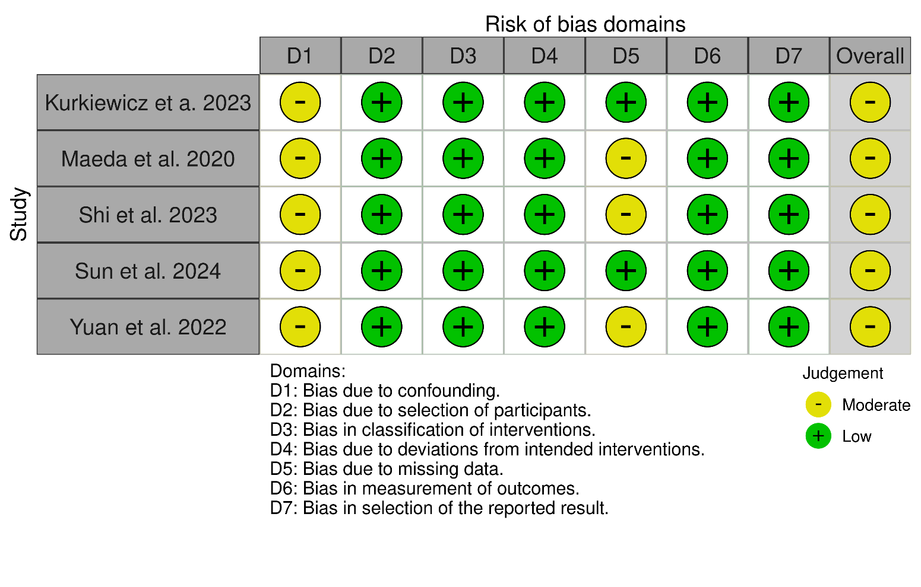
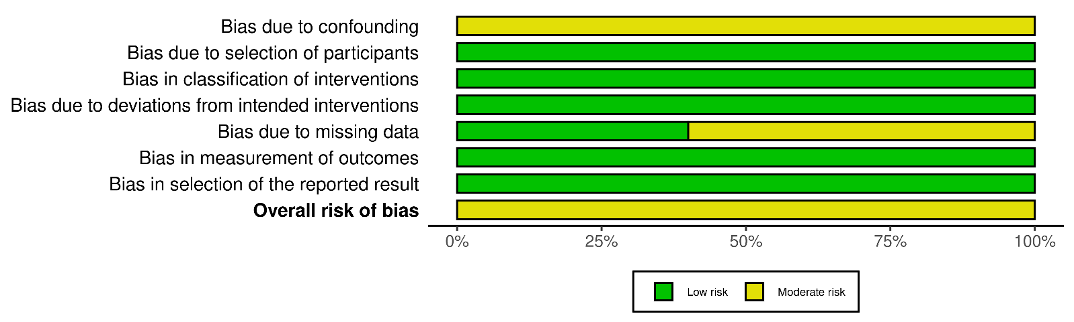
Figure S1: Quality assessment of risk of bias in the included trials (ROBINS-I tool). The upper panel presents a schematic representation of risks (low = green, unclear = yellow, and high = red) for specific types of biases of each study in the review. The lower panel presents risks (low = green, unclear = yellow, and high = red) for the subtypes of biases of the combination of studies included in this review.
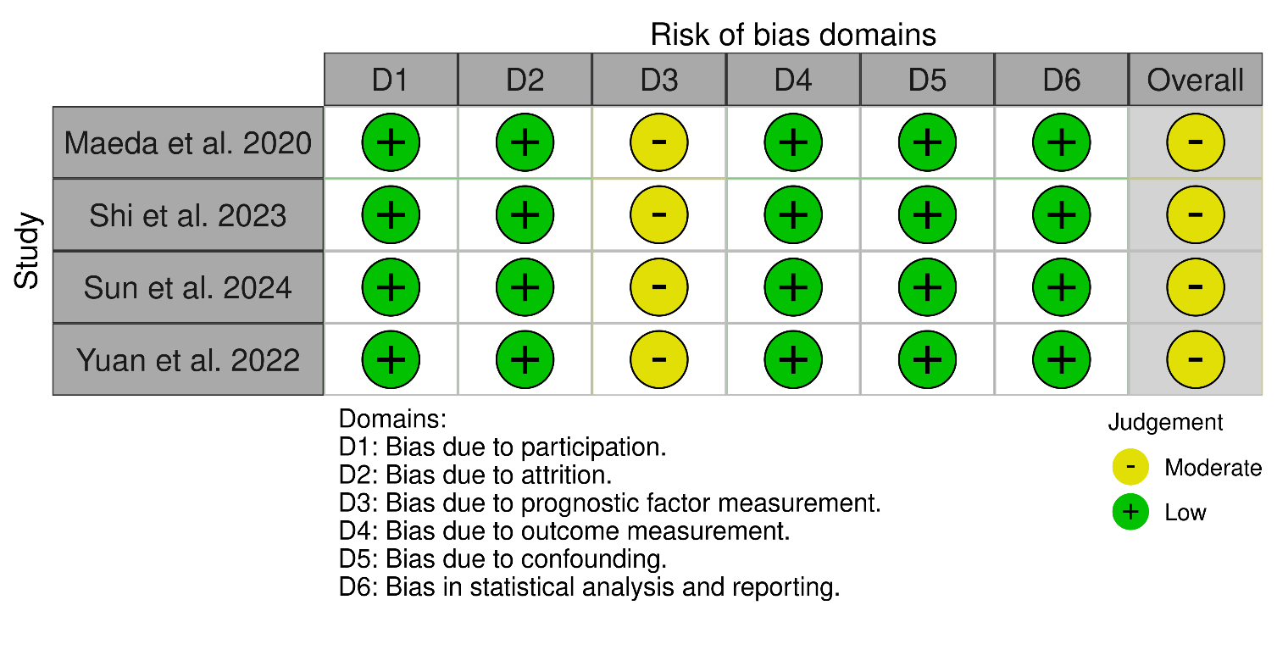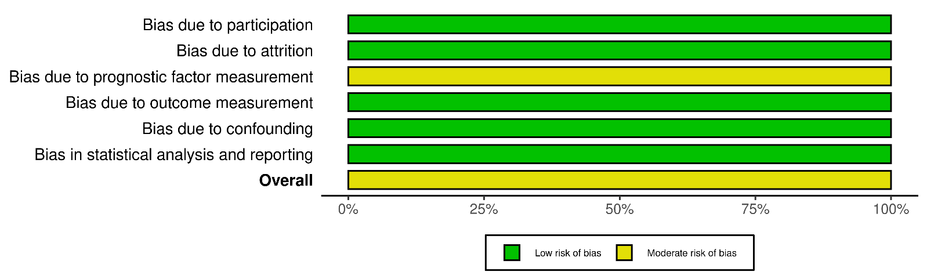
Figure S2: Quality assessment of risk of bias in the included trials (QUIPS tool). The upper panel presents a schematic representation of risks (low = green, unclear = yellow, and high = red) for specific types of biases of each study in the review. The lower panel presents risks (low = green, unclear = yellow, and high = red) for the subtypes of biases of the combination of studies included in this review.

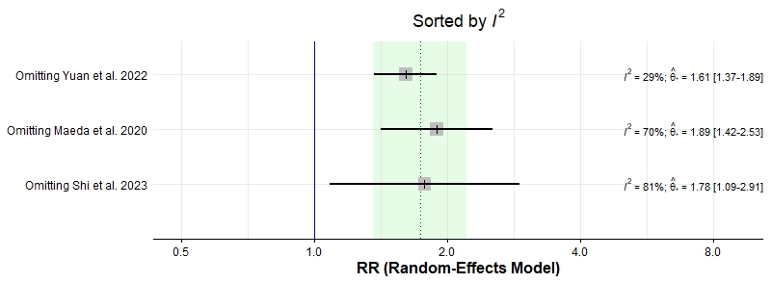
Figure S3: Sensitivty analysis of all-cause mortality (pairwise meta-analysis).

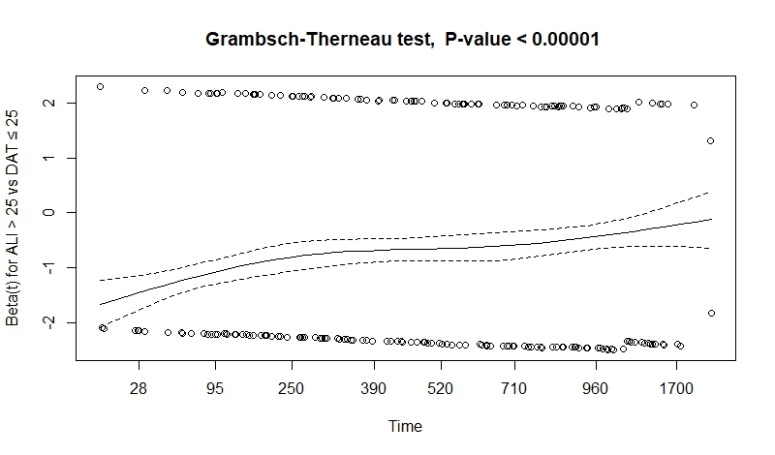
Figure S4: Grambsch-Therneau test and diagnostic plots based on Schoenfeld residuals.

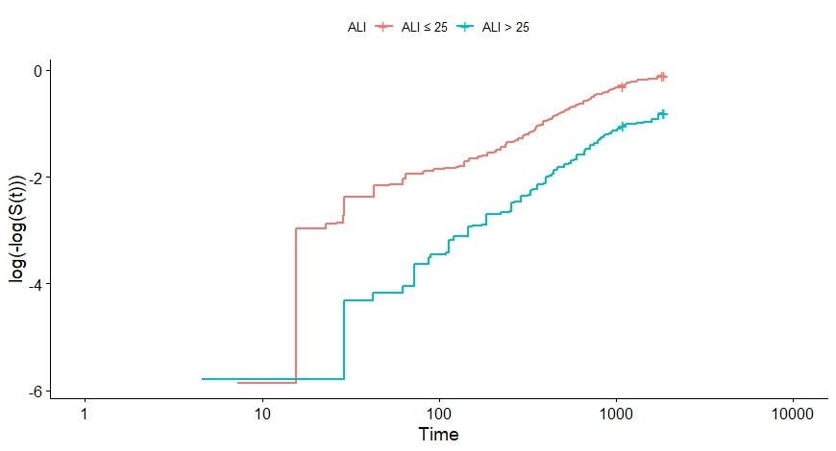
Figure S5: Log-log survival curve.

Database | Search Terms | Search Field | Search Results
Pubmed | ("advanced lung cancer inflammation index" OR ALI[Title/Abstract]) AND ("heart failure" OR "cardiac failure" OR "heart decompensation" OR HFrEF OR HFpEF) | All Field | 59
Cochrane | ("advanced lung cancer inflammation index") AND ("heart failure" OR "cardiac failure" OR "heart decompensation" OR HFrEF OR HFpEF) | All Field | 0
WOS | 1: ((ALL=(advanced lung cancer inflammation index)) OR TI=(ALI)) OR AB=(ALI) Results: 18709  2: ((((ALL=(heart failure)) OR ALL=(cardiac failure)) OR ALL=(heart decompensation)) OR ALL=(HFrEF )) OR ALL=(HFpEF) Results: 442070  3: #2 AND #1 Results: 327 | All Field | 327
SCOPUS | ("advanced lung cancer inflammation index" OR ALI) AND ("heart failure" OR "cardiac failure" OR "heart decompensation" OR HFrEF OR HFpEF) | Title, Abstract, Keywords | 130
EMBASE | #3. #1 AND #2 178  #2. 'heart failure':ti,ab,kw OR 'cardiac 404,368  decompensation':ti,ab,kw OR 'heart failure with  reduced ejection fraction':ti,ab,kw OR 'heart  failure with preserved ejection  fraction':ti,ab,kw  #1. 'advanced lung cancer inflammation 18,976  index':ti,ab,kw OR ali:ti,ab,kw | All Field | 178
Table S1: Search Strategy.

Study | Adjustment factors
Shi et al. 2023 | Age, NYHA class (reference: class IV), diastolic blood pressure, CRP, AST, Uric acid, Chlorine, Lg BNP, and GNRI.
Yuan et al. 2022 | Diastolic blood pressure, AST, Lg NT-proBNP.
Table S2: Adjustment factors for each study's prognostic meta-analysis model.
CRP: C-reactive protein, AST: aspartate aminotransferase, BNP: brain natriuretic peptide, GNRI: geriatric nutritional risk index.

Outcome | Chi-square | p-value
All-cause mortality | 82.4 | <0.001
Table S3: between-study heterogeneity assessment by frailty model.

