The NATDSS database
NATDSS is established by the National Cancer Center for monitoring the use of anti-tumor drugs in clinical practice at a national level. NATDSS is a representative database with demographically and geographically diverse information covering more than 10 million cancer patients from over 1400 hospitals in mainland China, including cancer hospitals and tier-three general hospitals with oncology departments. Clinical data from the Electronic Medical Record, Hospital Information System, Laboratory Information Management System, Picture Archiving and Communication System, and Pathology Information System were routinely retrieved to collect information on demographic characteristics, drug prescriptions, diagnoses, examinations, laboratory tests, treatments, surgery records, and follow-up. Based on the NATDSS database, the Chinese National Lung Cancer Cohort (CNLCC) was launched by the National Cancer Center, the Cancer Institute and Hospital, and the Chinese Academy of Medical Sciences, in collaboration with institution leaders, senior thoracic surgeons, oncologists, local principal investigators, pathologists and biostatisticians. The program retrieves mortality data from the national death registries of the China Centers for Disease Control and Prevention (CDC). Algorithm of natural language processing and other artificial intelligence aided techniques were applied to obtain structured variables.

The exposure density sampling (EDS) approach
EDS performs dynamic matching for exposures occurring over time, in contrast to outcome-dependent matching applied in a nested case-control study. For each exposed individual, i.e. ICI initiator, we matched up to 10 controls without replacement at the time of exposure from the risk set, namely those who were at risk for an event (myocarditis/death) and still non-exposed at that time. Except for time to exposure, we also matched for gender and other baseline characteristics including age, comorbidities, status of metastasis, and prior treatment interventions (specified below). The index date, namely the start of follow-up, was defined as the time of exposure for ICI users and the time of matching for controls. Controls for different ICI users were sampled from the risk sets with replacement to derive unbiased estimators. One individual could serve as a control for several ICI users and hence the total number of controls in the primary analysis is larger than the initial ICI non-users included. In that case, the earliest matching date was considered the index date for that individual. Besides, if a (as-yet unexposed) control was successfully matched several times and became exposed later, the index date would still be the earliest matching time, meanwhile, the exposure status was included as a time-dependent variable for this individual. A separate subset was created using patients who had PD1 drugs alone as exposed patients and their matched non-users as controls.

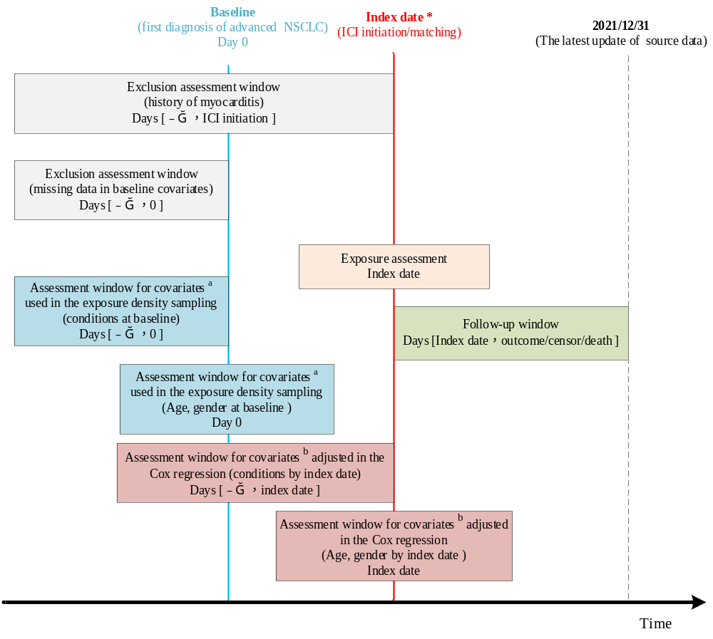
Supplementary Figure 1 Study design diagram with measurement of exposures, outcomes, and covariates.
* Index date is the start of at-risk time for Cox regression and defined as the date of ICI initiation for ICI users and the date of matching for controls, ranging from baseline and the end of study (2021/12/31).
ª Covariates used for matching in the exposure density sampling included gender, baseline age, and health conditions and intervention (prior treatment /comorbidities/metastasis) measured at baseline.
^{b} Covariates adjusted in the Cox regression included gender, index age, and health conditions and intervention (prior treatment /comorbidities/metastasis) measured by index date.
Abbreviation: ICI, Immune-Checkpoint-Inhibitor; NSCLC, non-small cell lung cancer.

Supplementary Figure 2 Kaplan-Meier curves for the 1-year cumulative event incidence.

* Index date is the start of at-risk time for Cox regression and is defined as the date of ICI initiation for ICI users and the date of matching for non-users.
Abbreviation: ICI, Immune-Checkpoint-Inhibitor

Supplementary Table 1. Detailed information on ICI use for 55219 eligible participants.
ICI | Drugs |  | Number of patients (%)
PD1 |  | Nivolumab |  | 724 (1.3%)
 |  | Pembrolizumab |  | 1973 (3.6%)
 |  | Camrelizumab |  | 2872 (5.2%)
 |  | Toripalimab |  | 968 (1.8%)
 |  | Sintilimab |  | 3295 (6.0%)
 |  | Tislelizumab |  | 1493 (2.7%)
 |  | Penpulimab |  | 48 (0.1%)
 |  | Zimberelimab |  | 8 (0.0%)
 |  | Geptanolimab |  | 8 (0.0%)
PDL1 |  | Durvalumab |  | 654 (1.2%)
 |  | Atezolizumab |  | 586 (1.1%)
 |  | Avelumab |  | 0 (0.0%)
CTLA-4 |  | Ipilimumab |  | 42 (0.1%)

Supplementary Table 2. Description of comorbidities in the present study.
Comorbidities | Measurement
Hypertension | The first diagnosis was identified through an algorithm-based search of clinical records with information of ICD codes (I10-I15) and related text.
Diabetes | The first diagnosis was identified through an algorithm-based search of clinical records with information of ICD codes (E10-E14) and related text.
COPD | The first diagnosis was identified through an algorithm-based search of clinical records with information of ICD codes (J44) and related text.
Coronary heart disease | The first diagnosis was identified through an algorithm-based search of clinical records with information of ICD codes (I25) and related text.
Myocardial infarction | The first diagnosis was identified through an algorithm-based search of clinical records with information of ICD codes (I21/I22/I23/I24) and related text.
Heart failure | The first diagnosis was identified through an algorithm-based search of clinical records with information of ICD codes (I50) and related text.
Autoimmunity disease | The first diagnosis was identified through an algorithm-based search of clinical records with information of ICD codes (I00, M06.8, M06.9, L40, M32, and K50-K52) and related text.

Supplementary Table 3. Drug list for chemotherapy, target therapy, and glucocorticoid.
Treatment | Drugs
Chemotherapy | Recombinant human vascular endostatin
Chemotherapy | Everolimus
Chemotherapy | Vinorelbine
Chemotherapy | Vincristine
Chemotherapy | Paclitaxel
Chemotherapy | Loboplatin
Chemotherapy | Cisplatin
Chemotherapy | Carboplatin
Chemotherapy | Nidaplatin
Chemotherapy | Pemetrexed
Chemotherapy | Docetaxel
Chemotherapy | Gemcitabine
Chemotherapy | Capecitabine
Chemotherapy | Irinotecan
Chemotherapy | Topotecan
Chemotherapy | Etoposide
Chemotherapy | Cyclophosphamide
Chemotherapy | Nimustine
Chemotherapy | Nitrokamustard
Chemotherapy | Ifosfamide
Chemotherapy | Hexamethylmelamine
Chemotherapy | Methotrex
Chemotherapy | Epirubixin
Chemotherapy | Bleomycin
Chemotherapy | Doxorubicin
Chemotherapy | Doxorubicin liposomes
Chemotherapy | Mitomycin
Chemotherapy | Sodium spotatoate
Chemotherapy | Elemicene
Chemotherapy | Vindesine
Target therapy | Osimertinib
Target therapy | Gefitinib
Target therapy | Erlotinib
Target therapy | Eclitinib
Target therapy | Afatinib
Target therapy | Dacotinib
Target therapy | Ametinib
Target therapy | Eflutinib
Target therapy | Anlotinib
Target therapy | Crizotinib
Target therapy | Savolitinib
Target therapy | Beretitinib
Target therapy | Ceritinib
Target therapy | Alectinib
Target therapy | Bevacizumab
Target therapy | Omalizumab
Target therapy | Ointozumab
Target therapy | Bariximab
Target therapy | Denosumab
Target therapy | Emmetrituzumab
Target therapy | Ramolurumab
Target therapy | Ranibizumab
Target therapy | Rituximab
Target therapy | Nexituzumab
Target therapy | Nilotuzumab
Target therapy | Palivizumab
Target therapy | Pertuzumab
Target therapy | Trastuzumab
Target therapy | Tocilizumab
Target therapy | Vedolizumab
Target therapy | Vedicitumab
Target therapy | Cetuximab
Target therapy | Enitumab
Glucocorticoid | Hydrocortisone
Glucocorticoid | Prednisolone
Glucocorticoid | Prednisone
Glucocorticoid | cortisone
Glucocorticoid | Halogmethasone
Glucocorticoid | Methylprednisone
Glucocorticoid | Mometasone furoate
Glucocorticoid | dexamethasone
Glucocorticoid | Betamethasone
Glucocorticoid | Methylprednisolone

Supplementary Table 4. Anti-cancer drug therapy for 55219 eligible participants.
Anti-cancer therapy | Number of patients (%)
Single agent ICI only | 1351 (2.4%)
ICIs only | 112 (0.2%)
Chemotherapy only | 23781 (43.1%)
Targeted therapy only | 2403 (4.4%)
Combination of chemotherapy plus targeted therapy | 7123 (12.9%)
Combination of ICI plus targeted therapy | 451 (0.8%)
Combination of ICI plus chemotherapy | 6268 (11.4%)
Combination of ICI plus chemotherapy plus targeted therapy | 3031 (5.5%)
None of the above | 10699 (19.4%)

Supplementary Table 5 Baseline characteristics for the matched cohort with the exposure group defined by users of PD1 (N=64429).
 | PD1 users  N (%) | Matched Controls ª  N (%) | SMD ^{b}
Total | 7953 | 56476
Gender (male) | 5961 (75.0%) | 43222 (76.5%) | 0.037
Age at baseline
Mean (SD) | 60 (9.27) | 61 (8.60) | 0.026
Median (quartile) | 61 (55, 67) | 61 (55, 67)
Birth year
<1950 | 972 (12.2%) | 7945 (14.1%) | 0.126
1950-1960 | 3280 (41.2%) | 24,751 (43.8%)
1960-1970 | 2812 (35.4%) | 19,315 (34.2%)
>1970 | 889 (11.2%) | 4465 (7.9%)
Family history of cancer
Yes | 547 (6.9%) | 3106 (5.5%) | 0.280
Missing | 572 (7.2%) | 9038 (16.0%)
Bone metastasis | 3014 (37.9%) | 21,912 (38.8%) | 0.019
Brain metastasis | 1510 (19.0%) | 10,388 (18.4%) | 0.015
Pericardial metastasis | 20 (0.3%) | 27 (0.0%) | 0.053
Liver metastasis | 976 (12.3%) | 5592 (9.9%) | 0.076
Contralateral Lung metastasis | 2897 (36.4%) | 20,391 (36.1%) | 0.007
Adrenal metastasis | 453 (5.7%) | 1988 (3.5%) | 0.104
High blood pressure | 1009 (12.7%) | 4437 (7.9%) | 0.160
Diabetes | 380 (4.8%) | 990 (1.8%) | 0.171
COPD | 70 (0.9%) | 157 (0.3%) | 0.079
Coronary heart disease | 3 (0.0%) | 3 (0.0%) | 0.022
Myocardial infarction | 1 (0.0%) | 1 (0.0%) | 0.013
Heart failure | 6 (0.1%) | 7 (0.0%) | 0.030
Autoimmunity disease | 3 (0.0%) | 3 (0.0%) | 0.022
Surgery | 318 (4.0%) | 763 (1.4%) | 0.165
Chemotherapy | 1872 (23.5%) | 10,288 (18.2%) | 0.131
Targeted therapy | 188 (2.4%) | 377 (0.7%) | 0.139
Glucocorticoid | 2170 (27.3%) | 11,924 (21.1%) | 0.144
Days from baseline to PD1 initiation
Median (quartile) | 111 (19, 363) | ——
Mean (SD) | 268 (383) | ——
ª up to 10 controls were matched for each ICI user using an “exposure density sampling” approach.
^{b} SMD, standardized mean difference (shown as an absolute value). An SMD >0.1 indicated a between-group imbalance of baseline characteristics.
Abbreviation: SD, standard deviation; COPD, chronic obstructive pulmonary disease; PD1, programmed cell death receptor-1.

Supplementary Table 6 Characteristics at index date for the matched cohort with the exposure group defined by users of any ICI, and PD1.
 | ICI users  N (%) | Matched  Controls ª N (%) | SMD ^{b} | PD-1 users  N (%) | Matched  Controls N (%) | SMD
Total | 8793 | 62,390 |  | 7953 | 56,476
Gender (male) | 6646 (75.6%) | 48,025 (77.0%) | 0.033 | 5961 (75.0%) | 43,222 (76.5%) | 0.037
Age at index date
Mean (SD) | 61 (9.13) | 61 (8.49) | 0.015 | 61 (9.17) | 61 (8.53)
Median (quartile) | 62 (55, 67) | 62 (55, 67) |  | 62 (55, 67) | 62 (55, 67) | 0.018
Birth year
<1950 | 1057 (12.0%) | 8584 (13.8%) | 0.126 | 972 (12.2%) | 7945 (14.1%) | 0.126
1950-1960 | 3655 (41.6%) | 27,561 (44.2%) |  | 3280 (41.2%) | 24,751 (43.8%)
1960-1970 | 3087 (35.1%) | 21,268 (34.1%) |  | 2812 (35.4%) | 19,315 (34.2%)
>1970 | 994 (11.3%) | 4977 (8.0%) |  | 889 (11.2%) | 4465 (7.9%)
Family history of cancer
Yes | 624 (7.1%) | 3428 (5.5%) | 0.283 | 547 (6.9%) | 3106 (5.5%) | 0.280
Missing | 622 (7.1%) | 9935 (15.9%) |  | 572 (7.2%) | 9038 (16.0%)
Bone metastasis | 3444 (39.2%) | 24,600 (39.4%) | 0.005 | 3120 (39.2%) | 22,409 (39.7%) | 0.009
Brain metastasis | 1834 (20.9%) | 12,384 (19.8%) | 0.025 | 1598 (20.1%) | 10,837 (19.2%) | 0.023
Pericardial metastasis | 25 (0.3%) | 41 (0.1%) | 0.052 | 24 (0.3%) | 40 (0.1%) | 0.054
Liver metastasis | 1264 (14.4%) | 7105 (11.4%) | 0.089 | 1061 (13.3%) | 5894 (10.4%) | 0.090
Contralateral Lung metastasis | 3284 (37.3%) | 22,327 (35.8%) | 0.032 | 3079 (38.7%) | 20,905 (37.0%) | 0.035
Adrenal metastasis | 616 (7.0%) | 2544 (4.1%) | 0.128 | 530 (6.7%) | 2182 (3.9%) | 0.126
Hypertension | 1279 (14.5%) | 5646 (9.0%) | 0.171 | 1130 (14.2%) | 5017 (8.9%) | 0.167
Diabetes | 516 (5.9%) | 1460 (2.3%) | 0.179 | 452 (5.7%) | 1280 (2.3%) | 0.176
COPD | 104 (1.2%) | 231 (0.4%) | 0.093 | 90 (1.1%) | 204 (0.4%) | 0.090
Coronary heart disease | 13 (0.1%) | 20 (0.0%) | 0.039 | 10 (0.1%) | 18 (0.0%) | 0.033
Myocardial infarction | 4 (0.0%) | 13 (0.0%) | 0.014 | 1 (0.0%) | 10 (0.0%) | 0.004
Heart failure | 13 (0.1%) | 39 (0.1%) | 0.026 | 13 (0.2%) | 37 (0.1%) | 0.029
Autoimmunity disease | 15 (0.2%) | 65 (0.1%) | 0.018 | 11 (0.1%) | 55 (0.1%) | 0.012
Surgery | 664 (7.6%) | 2902 (4.7%) | 0.121 | 630 (7.9%) | 2699 (4.8%) | 0.129
Chemotherapy | 6660 (75.8%) | 32,301 (51.8%) | 0.515 | 5992 (75.4%) | 29,493 (52.2%) | 0.496
Targeted therapy | 1516 (17.2%) | 5290 (8.5%) | 0.264 | 1437 (18.1%) | 4901 (8.7%) | 0.279
Glucocorticoid | 6193 (70.5%) | 32,918 (52.8%) | 0.370 | 5689 (71.6%) | 30,102 (53.3%) | 0.384
Days from baseline to ICI initiation
Median | 40 (8, 209) | —— |  | 43 (8, 220) | ——
Mean (SD) | 168 (280) | —— |  | 174 (283) | ——
ª up to 10 controls were matched for each exposed individual using an “exposure density sampling” approach.
^{b} SMD, standardized mean difference (shown as an absolute value). An SMD >0.1 indicated a between-group imbalance of baseline characteristics.
Abbreviation: ICI, Immune-Checkpoint-Inhibitor; SD, standard deviation; COPD, chronic obstructive pulmonary disease; PD1, programmed cell death receptor-1.

Supplementary Table 7 Characteristics at the index date of patients taking ICI therapy or targeted therapy in sensitivity analysis 4.
 | ICI therapy  N (%) | Targeted therapy  N (%) | SMD ª
Total | 11,199 | 9297
Gender (male) | 8364 (74.7%) | 5151 (55.4%) | 0.413
Age at index date
Mean (SD) | 61 (9.87) | 59 (10.57)
Median (quartile) | 62 (55, 68) | 59 (52, 66)
Birth year
<1950 | 1577 (14.1%) | 1306 (14.0%) | 0.135
1950-1960 | 4489 (40.1%) | 3267 (35.1%)
1960-1970 | 3755 (33.5%) | 3204 (34.5%)
>1970 | 1378 (12.3%) | 1520 (16.3%)
Family history of cancer
Yes | 808 (7.2%) | 577 (6.2%) | 0.160
Missing | 747 (6.7%) | 1036 (11.1%)
Bone metastasis | 4405 (39.3%) | 3466 (37.3%) | 0.042
Brain metastasis | 2463 (22.0%) | 2461 (26.5%) | 0.105
Pericardial metastasis | 95 (0.8%) | 74 (0.8%) | 0.006
Liver metastasis | 1864 (16.6%) | 1219 (13.1%) | 0.099
Contralateral Lung metastasis | 4224 (37.7%) | 2970 (31.9%) | 0.121
Adrenal metastasis | 1169 (10.4%) | 619 (6.7%) | 0.136
High blood pressure | 2137 (19.1%) | 1462 (15.7%) | 0.089
Diabetes | 1083 (9.7%) | 621 (6.7%) | 0.109
COPD | 310 (2.8%) | 149 (1.6%) | 0.080
Coronary heart disease | 109 (1.0%) | 69 (0.7%) | 0.025
Myocardial infarction | 52 (0.5%) | 15 (0.2%) | 0.054
Heart failure | 88 (0.8%) | 80 (0.9%) | 0.008
Autoimmunity disease | 86 (0.8%) | 103 (1.1%) | 0.035
Surgery | 1170 (10.4%) | 878 (9.4%) | 0.034
Chemotherapy | 8538 (76.3%) | 5786 (62.2%) | 0.307
Glucocorticoid | 7957 (71.1%) | 6611 (71.1%) | 0.001
ª SMD, standardized mean difference (shown as an absolute value). An SMD >0.1 indicated a between-group imbalance of baseline characteristics.
Abbreviation: ICI, Immune-Checkpoint-Inhibitor; SD, standard deviation; COPD, chronic obstructive pulmonary disease.

