Supplementary Figure 1. CVAE Risk Evaluation with Comorbidity
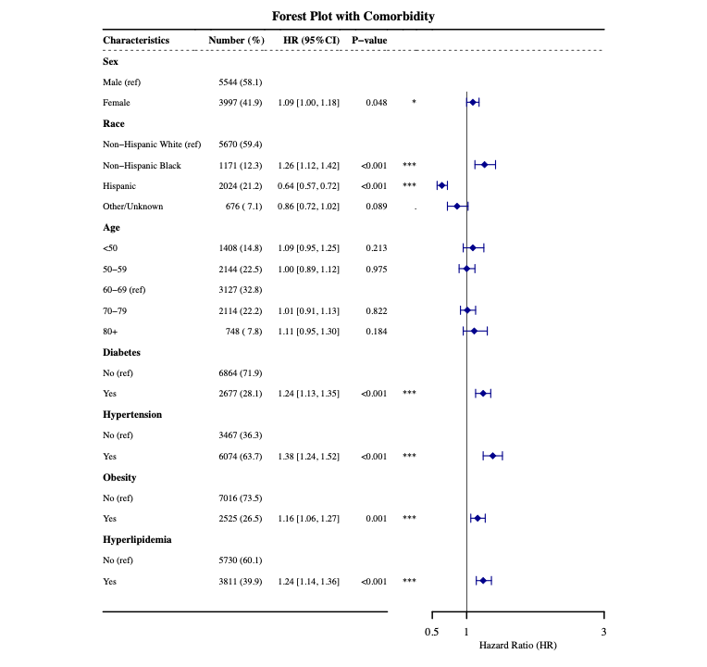

Supplementary Figure 2. CVAE Risk Evaluation with Comorbidity and Cancer Type
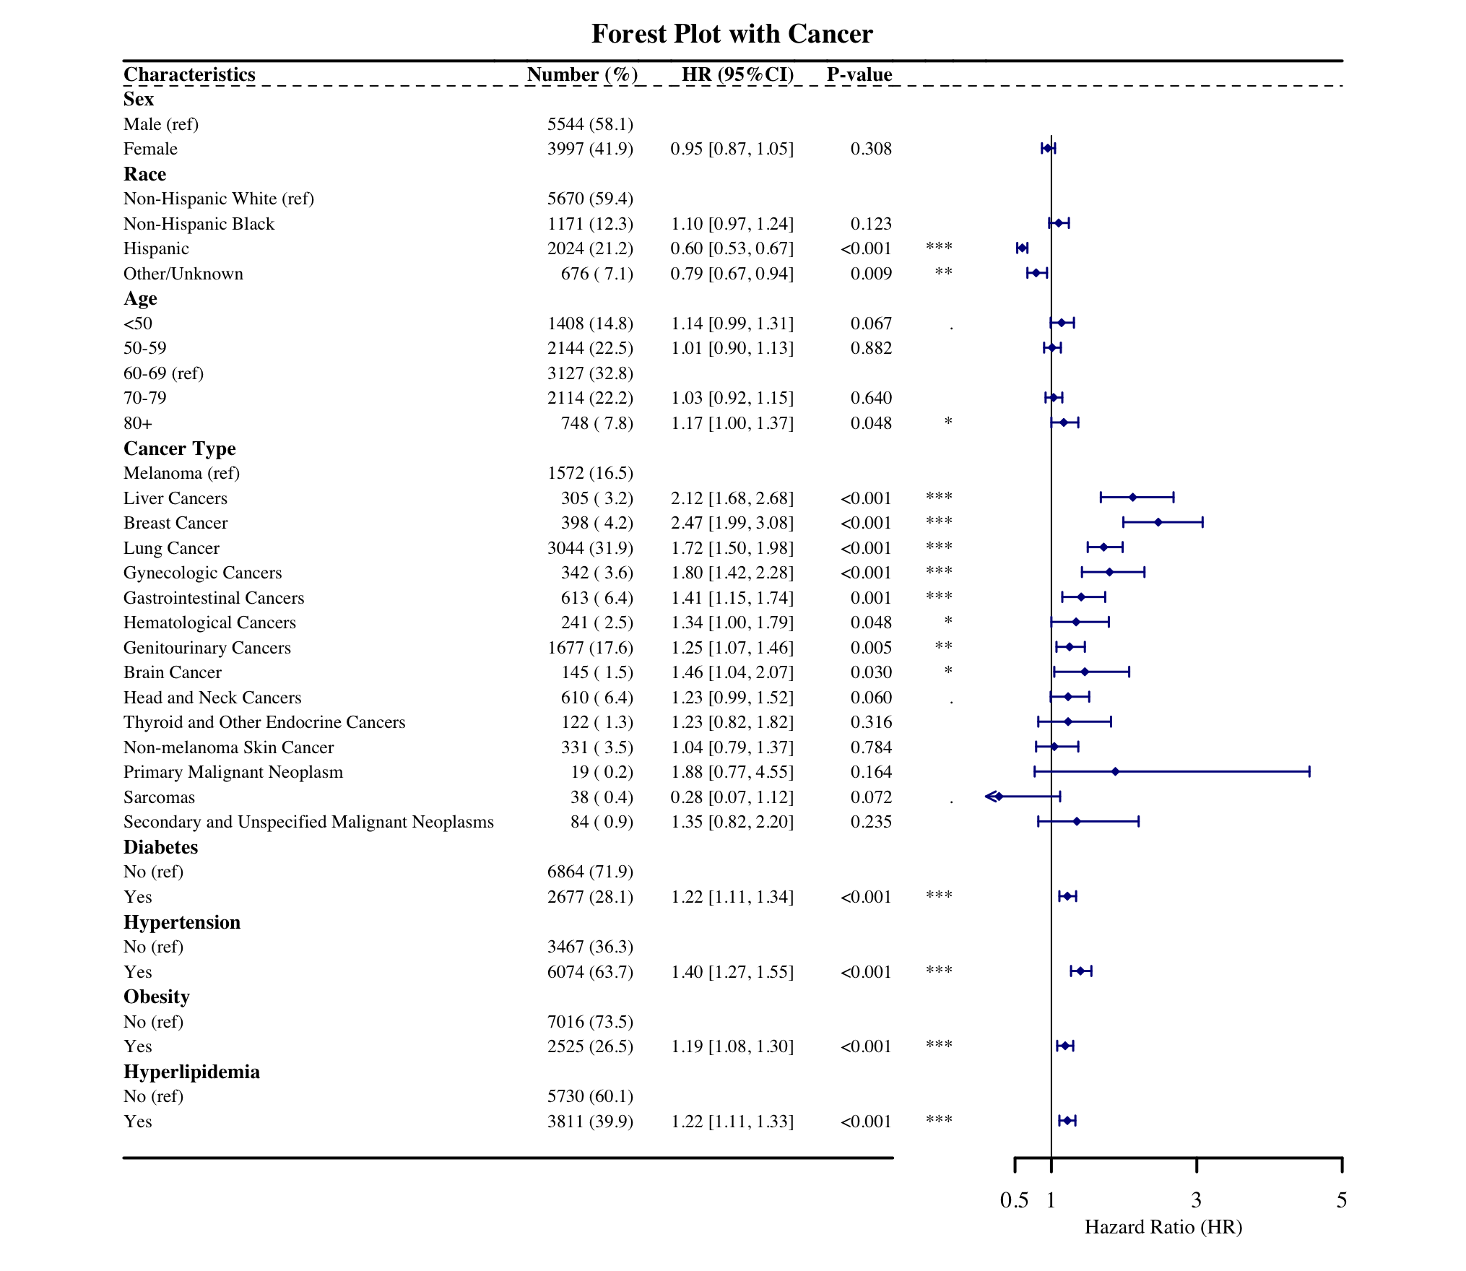

Supplementary Figure 3. Removing Sex Specific Forest Plot
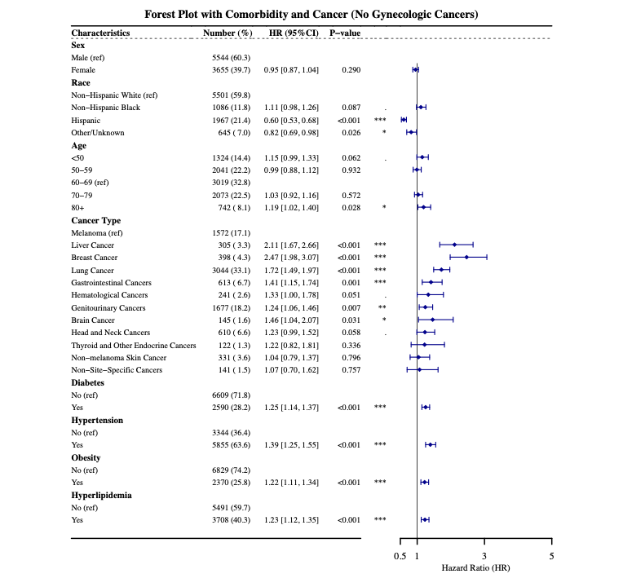

Supplementary Figure 4. Cumulative Incidence of CVAEs by Race and Ethnicity Across Cancer Types
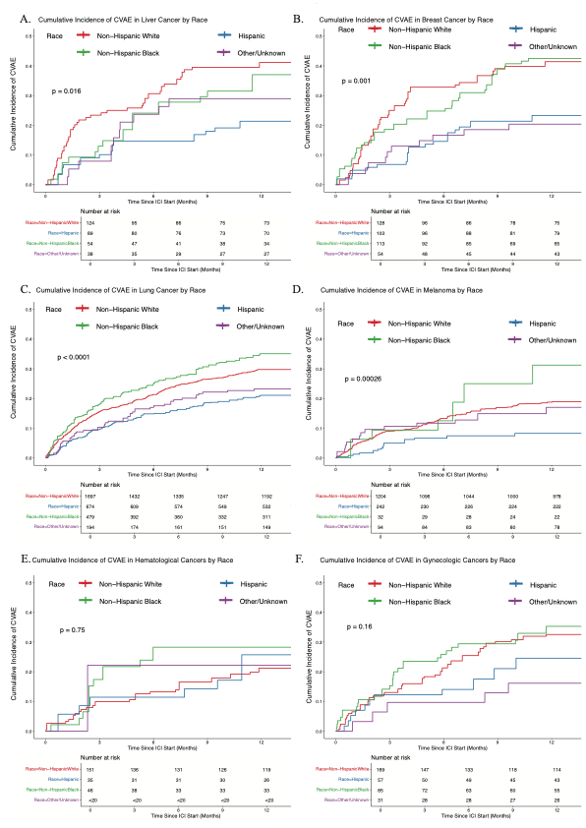
Supplementary Figure 5. CVAE Incidence Stratified by ICI Regimen Within Different Cancer Types
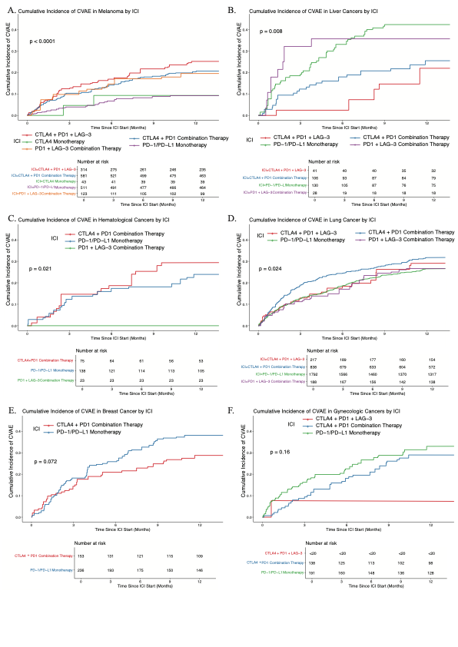
Supplementary Figure 6. Sex-Specific Differences in CVAE Incidence by Cancer Type
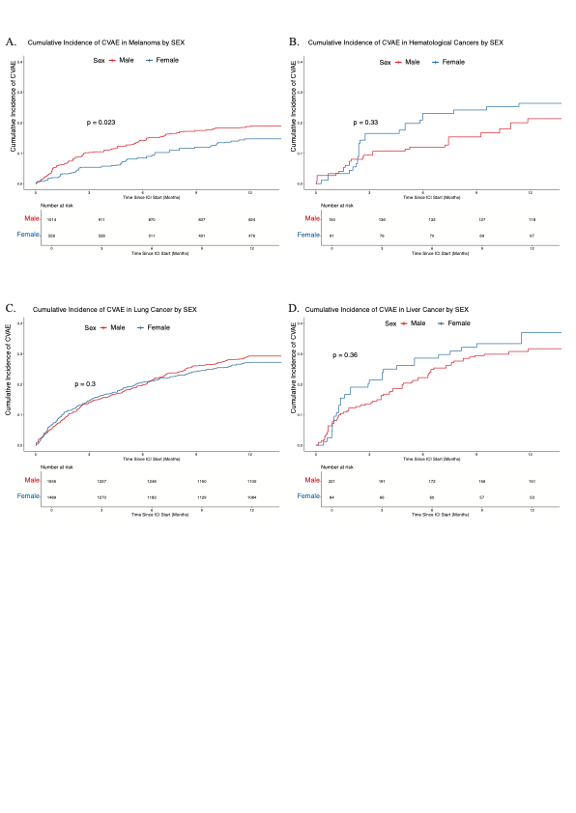

Supplementary Table 1. CVAE phenotypes
Conditions | Diagnosis Codes |  | Reference
Conditions | ICD-9 CM | ICD-10 CM | Reference
Myocardial Infarction | '410.00', '410.01', '410.02', '410.10', '410.11', '410.12', '410.20', '410.21', '4102.2', '410.30', '410.31', '410.32', '410.40', '410.41', '410.42', '410.50', '410.51', '410.52', '410.60', '410.61', '410.62', '410.70', '410.71', '410.72', '410.80', '410.81', '410.82', '410.90', '410.91', '410.92' | 'I21.01', 'I21.02', 'I21.09', 'I21.11', 'I21.19', 'I2121', 'I21.29', 'I21.3', 'I21.4', 'I22.0', 'I22.1', 'I22.2', 'I22.8', 'I22.9' | Computable phenotype for ASCVD in ADAPTABLE trial
Stroke | Nonfatal ischemic stroke: ‘430.x’, ‘431.x’, ‘433.x1’, ‘434.x1’, ‘435.x’, ‘436’, and ‘362.3’  Nonfatal hemorrhagic stroke: ‘431’ and ‘432’ | ‘I60.x’, ‘I61.x’, ‘I63.x’, ‘I64.x’, ‘H34.1’, and ‘G45.x’ | Computable phenotype for ASCVD in ADAPTABLE trial
Arrhythmias | Coronary_revascularization,'7850', '99601', '99604', 'V450', 'V533' | 'I44.1', 'I44.2', 'I44.30', 'I44.39', 'I45.6', 'I45.9', 'I47.x ', 'I48.x', 'I49.x', 'R00.0', 'R00.1', 'R00.8', 'T82.1', 'Z45.0', 'Z95.0' | Coding Algorithms for Defining Comorbidities in  ICD-9-CM and ICD-10 Administrative Data  Sentinal CARDIAC ARRHYTHMIAS REPORT
Pericarditis | '420.0' '420.90' '420.91' '420.99' '423.0' '423.1' '423.2' '423.3' '423.8' '423.9' | 'B33.22', 'B33.23', 'I30.0', 'I30.1', 'I30.8', 'I30.9', 'I32', | Risk of myocarditis and pericarditis after the COVID-19 mRNA vaccination in the USA: a cohort study in claims databases  Comparative Risks of Potential Adverse Events Following COVID-19mRNA Vaccination  Among Older US Adults
Myocarditis | '422’,'422.0’,'422.9’,  '422.90’,'422.99’,'429.0' | 'I400', 'I401', 'I408', 'I409', 'I41', 'I514' | Risk of myocarditis and pericarditis after the COVID-19 mRNA vaccination in the USA: a cohort study in claims databases  Comparative Risks of Potential Adverse Events Following COVID-19mRNA Vaccination  Among Older US Adults
Cardiomyopathy | ‘425’, ‘425.x’ | ‘I42’, ‘I42.x’ | Performance of Claims-Based Algorithms for Identifying Heart  Failure and Cardiomyopathy Among Patients Diagnosed with  Breast Cancer
Heart Failure | 398.91, 402.01, 402.11, 402.91, 404.01, 404.03, 404.11, 404.13, 404.91, 404.93, 428.0, 428.1, 428.20, 428.21, 428.22, 428.23, 428.30, 428.31, 428.32, 428.33, 428.40, 428.41, 428.42, 428.43, 428.9 | I09.81, I11.0, I13.0, I13.2, I50.1, I50.20, I50.21, I50.22, I50.23, I50.30, I50.31, I50.32, I50.33, I50.40, I50.41, I50.42, I50.43, I50.810, I50.811, I50.812, I50.813, I50.814, I50.82, I50.83, I50.84, I50.89, I50.9 | 2023 CCW Chronic Disease Algorithm

Conditions | Diagnosis Codes |  |  | Reference
Conditions | ICD-9-CM | ICD-10-PCS | CPT/HCPCS | Reference
Coronary Revascularization | 0066, 1755, 3601–3602, 3605–3607, 3609 | All codes beginning with 0270, 0271, 0272, 0273, 0274, 027C, 02C0, 02C1, 02C2, 02C3, 02C4, X2C0, X2C1 (e.g., 0270046, 02700ZZ, 027134Z, 02C03ZZ, X2C0361, etc.) | 92920–92996, C9600–C9608, G0290, G0291 | Computable phenotype for ASCVD in ADAPTABLE trial

