Supplementary Materials
Methods

Targeting of Mac-2 in Macrophages Using CRISPR/Cas9 System
Guide RNA Design and Validation: Guide RNAs targeting exon 3 of the mouse Mac-2 gene (Lgals3; Transcript ID: NM_010705.3 on chromosome 14) were designed using the TrueDesign Genome Editor (Invitrogen). Two sgRNAs were selected: Lgals3 C1 (AACGATGCCTTAGCTGGCTC) with a PAM sequence of TGG at chr14[47380055]+ and Lgals3 C2 (AAGGATATCCGGGTGCATGG) with a PAM sequence of GGG at chr14[47380092]+. In silico analysis was performed to minimize off-target effects, ensuring specificity for the Mac-2 gene.
Preparation of the CRISPR/Cas9 Complex: The CRISPR/Cas9 complex was assembled using Cas9 protein V2 (Thermo Fisher Scientific, #A36498), sgRNA (Lgals3 C1, Thermo Fisher Scientific, #A35534), and donor DNA carrying GFP-Blasticidin and RFP-Puromycin markers (TrueTag Knockout Enrichment Donor DNA Kit, Thermo Fisher Scientific, #A53815). The components were mixed in a 2:1:1 ratio with Opti-MEM medium, followed by the addition of Lipofectamine™ CRISPRMAX™ Cas9 Transfection Reagent (Thermo Fisher Scientific, #CMAX00015) in a 1:1 ratio with the CRISPR complex. The mixture was incubated at room temperature for 10 minutes before transfection.
Cell Culture and Transfection: RAW 264.7 macrophages (ATCC) were cultured in complete medium and seeded at 2 × 10⁵ cells per well in 12-well plates. After overnight incubation, the CRISPR/Cas9 complex was added, and transfection was carried out at 37°C with 5% CO₂ for 72 hours.
Monitoring Transfection Efficiency: Fluorescence microscopy was used to detect GFP and RFP expression, providing visual confirmation of transfection. Flow cytometry (Cytek Aurora) was performed to quantify transfection efficiency by measuring the percentage of GFP+ and RFP+ cells in the population.
Antibiotic Selection: To enrich transfected cells, resistance curves were generated for blasticidin (Thermo Fisher Scientific, #A1113903) and puromycin (Thermo Fisher Scientific, #A1113803). Based on IC50 values, cells were treated with blasticidin (7.5 µg/mL) and puromycin (1.5 µg/mL) for 3-10 days.
Validation of Knockout: Genomic DNA was extracted using the DNeasy Blood & Tissue Kit (Qiagen). PCR was performed using primers flanking the sgRNA target sites, and products were resolved on a 2% agarose gel to confirm successful editing. The absence of Mac-2 protein was validated by Western blot analysis using anti-Mac-2 antibodies (Thermo Fisher, PA5-34912, 1:1,000 dilutions). Negative controls included untransfected cells and cells transfected without sgRNA to verify specificity and assess potential off-target effect.
In Vivo Experimental Procedures and Tissue Analyses

Flow Cytometry of Blood and Tissue Cells
Cell Isolation and Flow Cytometry Preparation. Eight weeks post doxorubicin administration, mice were euthanized with CO2 followed by cervical dislocation. Hearts underwent retrograde perfusion with ice-cold PBS. Subsequently, ventricles and spleens were harvested, rinsed in PBS, minced, and treated with a mixture of collagenase D and DNAse in RPMI medium at 37°C with mild agitation. Resultant tissue suspensions were strained through a 70-μm filter, centrifuged, and erythrocytes were eliminated using NH4Cl/KHCO3. The resulting cells were resuspended in FACS buffer and further passed through a 40-µm strainer.
Staining and Analysis: For flow cytometry staining, cells were treated with an FC blocker and incubated on ice with antibodies (listed below Table S1). The cells were then rinsed and reconstituted in PBS. Zombie Red staining was performed after surface antibody treatment as per the manufacturer’s guidelines (BioLegend). Data were collected on a FACS Verse flow cytometer, and analysis was performed using FlowJo v. 10. Supplemental Table S2 shows gating strategy and subtype identification.
Gene Expression Analysis from Heart Tissue: Total RNA was extracted from snap-frozen left ventricular (LV) tissue using the E.Z.N.A.® Total RNA Kit I (Omega Bio-tek), and cDNA was synthesized using SuperScript™ III Reverse Transcriptase (Thermo Fisher). Quantitative real-time PCR was performed as described in Section previous method section using SsoFast™ EvaGreen Supermix (Bio-Rad). Expression of target genes (Il6, Ccl2, Col1a1, Mmp9, Casp3, Tfeb, Tnfa, and Nfkb1) was normalized to 18S rRNA and analyzed using the ΔΔCt method. Reactions were run in triplicate. Primer sequences are provided in Supplemental Table S3.
BNP Quantification by ELISA: BNP levels in mouse serum were measured using a Mouse/Rat BNP ELISA Kit (RayBiotech, #EIAM-BNP-1) following the manufacturer’s instructions. Serum samples were diluted 1:4 with the provided diluent, and absorbance was measured at 450 nm. Concentrations were determined from a standard curve.
Histological Assessment of Myocardium
Left ventricular (LV) tissue was fixed in 4% paraformaldehyde, sectioned transversely at 5-mm intervals, and paraffin-embedded.
Cardiomyocyte Size Analysis: Sections were stained with hematoxylin and eosin (H&E; Servicebio, G1005). Digital images were acquired at 20× magnification using a Leica Biosystem (ScanScope®, Aperio Technologies) and saved in TIFF format. Cardiomyocyte cross-sectional area was quantified using the ruler tool in ImageScope, focusing on large, circular myocytes with centrally located nuclei.
Fibrosis Quantification: Masson’s trichrome staining was performed using the Richard-Allan Scientific™ kit (Thermo Fisher, #22-110-648) per the manufacturer’s protocol. Collagen fibers stained blue, myocardium red, and nuclei black. Interstitial fibrosis was quantified using the Positive Pixel Count v9 algorithm (ImageScope), excluding perivascular regions with the negative pen tool, and expressed as a percentage of total myocardial area.

Supplementary Figures
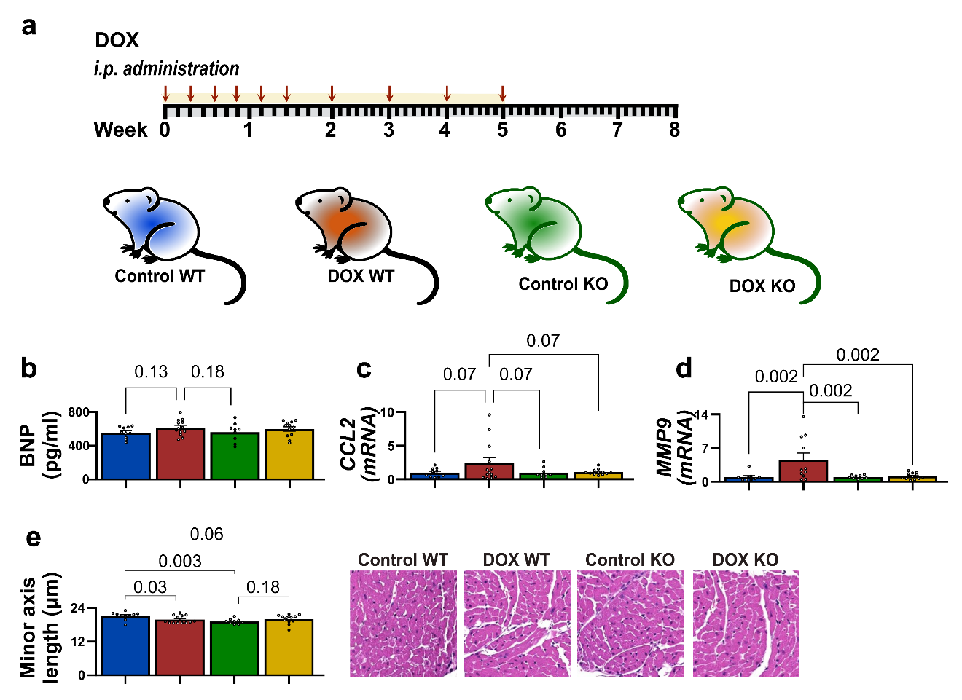

Figure S1: Effect of doxorubicin on cardiomyocyte morphology and inflammatory gene expression in wild-type and Mac-2 knockout mice. (a) Experimental timeline showing DOX or vehicle administration over 8 weeks in WT and KO mice. (b) Plasma brain natriuretic peptide (BNP) levels were unchanged across groups. (c–d) Post-DOX treatment, cardiac mRNA expression of CCL2 (c) and MMP9 (d) was elevated in WT hearts compared with controls and KO groups (p < 0.05; n = 9–13). (e) Quantification of cardiomyocyte minor axis length from hematoxylin and eosin (H&E)-stained sections. DOX WT mice exhibited reduced minor axis length (p < 0.05; n = 10–13). Representative H&E-stained sections are shown; scale bar, 20 µm. WT, wild-type; KO, Mac-2 knockout; DOX, doxorubicin.

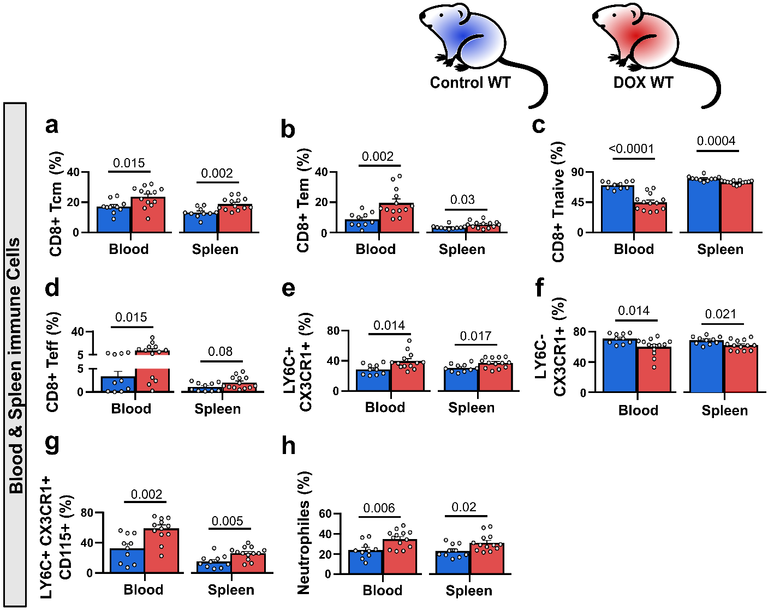
Figure S2. DOX Alters Blood and Spleen Memory T Cell Phenotypes and Proinflammatory Cell populations. (a-d) Flow cytometry of CD8⁺ T cell subsets in blood and spleen revealed increased proportion of central memory (Tcm), effector memory (Tem), and naïve (Tnaive) T cells in DOX-treated wild-type (DOX WT) mice compared to control wild-type (Control WT) mice, with minimal changes observed in effector (Teff) T cells (p < 0.05; n = 10-13). (e-g) Monocyte analysis showed elevated proportions of Ly6C⁺ CX3CR1⁺ subsets (e) and Ly6C⁺ CX3CR1⁺ CD115⁺ subsets (g) in the blood and spleen of DOX WT mice, while Ly6C⁻ monocytes (f) were reduced. (h) Neutrophil percentages were significantly higher in the blood and spleen of DOX WT mice than in Control WT mice (p < 0.05; n = 10-13). WT, wild type; DOX, doxorubicin.

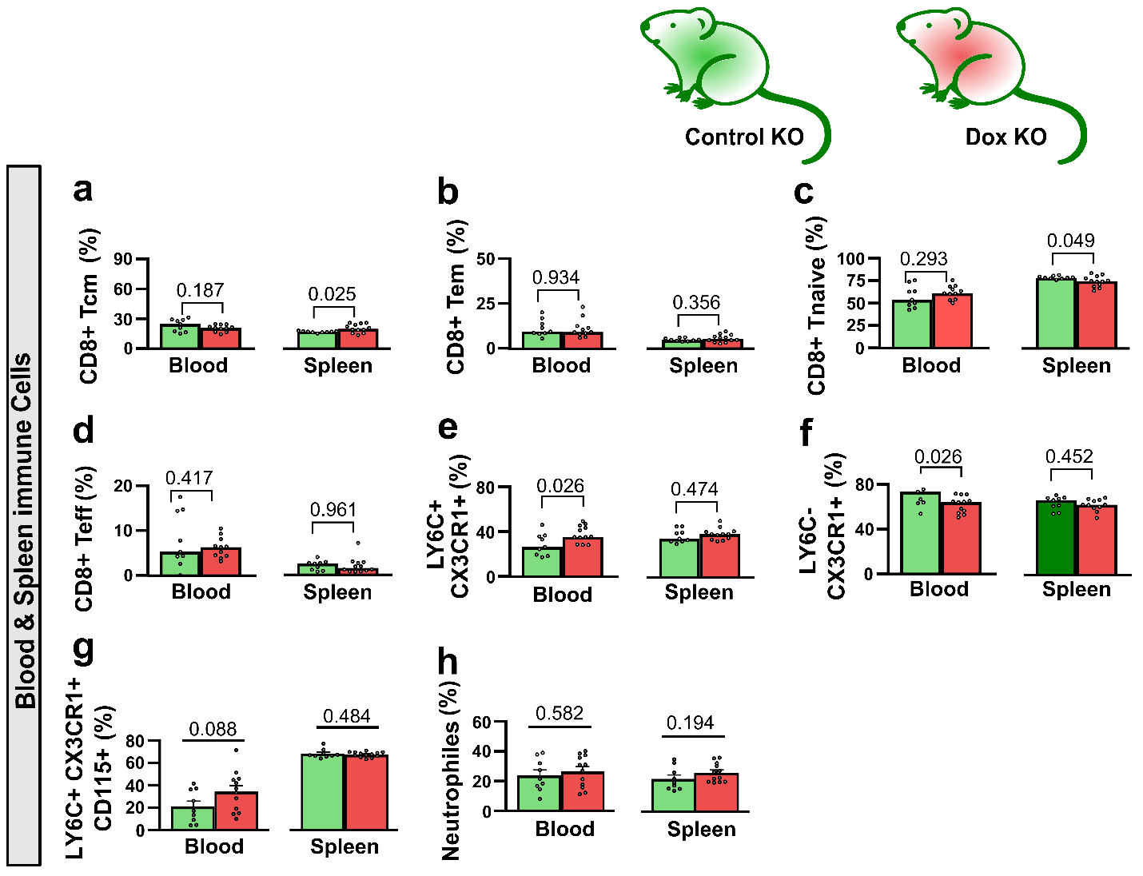 Figure S3: Analysis of Blood and Spleen Immune Cells in Mac-2 Knockout Mice Post-DOX Treatment. Flow cytometry analysis of blood and spleen immune cells in Mac-2 knockout (KO) mice treated with DOX or saline controls. (a-d) The number of CD8⁺ T cell subsets, including central memory (Tcm), effector memory (Tem), naïve (Tnaive), and effector (Teff), were compared. (e-g) Analysis of monocyte subsets (Ly6C⁺ CX3CR1⁺, Ly6C⁻ CX3CR1⁺, and Ly6C⁺ CX3CR1⁺ CD115⁺) in blood and spleen. (h) Neutrophil percentages were quantified in both tissues. Significant differences were observed in specific subsets, particularly Tcm in the spleen and Ly6C⁺ CX3CR1⁺ monocytes in the blood (p < 0.05; n = 10-13. KO, Mac-2 knockout; DOX, doxorubicin.

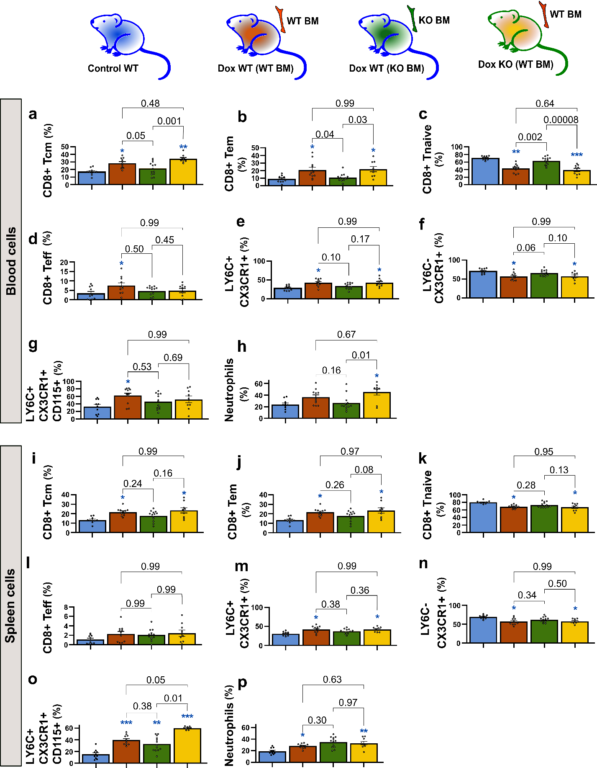
Figure S4: Alterations in Blood and Spleen Immune Cells After DOX Treatment in Bone Marrow-Transplanted Mice. (a-h) Blood Immune Cells: Flow cytometry analysis of blood immune cells showed higher proportions of central memory (Tcm), effector memory (Tem), and naïve (Tnaive) T cells, as well as Ly6C monocyte subsets and neutrophils, in DOX-treated mice receiving wild-type bone marrow [DOX WT (WT BM), brown bars; and DOX KO (WT BM), yellow bars] compared to those receiving Mac-2-deficient bone marrow (green bars) and controls (blue bars) (p < 0.05; n = 9-13). (i-p) Spleen Immune Cells: Analysis of splenic immune cells showed trends like those in blood, with significant differences in the numbers of Ly6C monocyte subsets. However, the proportion of CD8⁺ T cell subsets, proinflammatory and restorative monocytes, and neutrophils showed no notable alterations between experimental groups. Numerical p-values denote comparisons among BM transplanted groups (p < 0.05; n = 9–13), while stars represent significance relative to Control WT (*p < 0.05, **p < 0.001, ***p < 0.0001). WT, wild-type; KO, Mac-2 knockout; BM, bone marrow; DOX, doxorubicin.

Supplementary Tables
Table S1: Antibody details
Target protein-tag | BD Biosciences cat. #
F4/80-APC | 123122
CD44-APC | 103012
CD45-AF700 | 103128
CD45.1-AF700 | 110724
I-A/I-E-APC-Cy7 | 107652
MERTK-BV421 | 151510
CD115-BV421 | 135513
CD11b-BV510 | 101263
CD14-BV510 | 123323
CD4-BV605 | 100547
Ly6G-BV650 | 127641
CD45-BV711 | 103147
CD45.2-BV711 | 109847
CD8-BV711 | 100759
CX3CR1-BV785 | 149029
CD8-FITC | 100706
CD45.2-FITC | 109806
CCR2-PE | 150610
CD19-PE-Cy5 | 115510
CD5-PE-Cy5 | 100610
CD64-PE-Cy7 | 139314
CD62L-PE-Cy7 | 104418
Ly-6C-PerCP-Cy5. | 128012

Table S2: Gating Strategy and Subtype Identification
Cell Type | Gating Strategy | Markers
Viable Cells |  | Zombie Red⁻
Leukocytes |  | CD45⁺
Lineage Exclusion |  | CD19⁻, CD5⁻, Ly6G⁻
Cardiac Macrophages
Infiltrating Macrophages | Zombie Red⁻ CD45⁺ CD19⁻ CD5⁻ Ly6G⁻ CD64⁺ CCR2^hi | CD64⁺ CCR2^hi
 | Zombie Red⁻ CD45⁺ CD19⁻ CD5⁻ Ly6G⁻ F4/80⁺ CD64⁺ | F4/80⁺ CD64⁺ MHCII^hi
 | Zombie Red⁻ CD45⁺ CD19⁻ CD5⁻ Ly6G⁻ F4/80⁺ CD64⁺ Ly6C⁺ | F4/80⁺ CD64⁺ Ly6C⁺ MHCII^hi
 | Zombie Red⁻ CD45⁺ CD19⁻ CD5⁻ Ly6G⁻ F4/80⁺ CD64⁺ CX3CR1⁺ | F4/80⁺ CD64⁺ CX3CR1⁺ MHCII^hi
Restorative Macrophages | Zombie Red⁻ CD45⁺ CD19⁻ CD5⁻ Ly6G⁻ CD64⁺ CCR2^lo | CD64⁺ CCR2^lo
 | Zombie Red⁻ CD45⁺ CD19⁻ CD5⁻ Ly6G⁻ F4/80⁺ CD64⁺ | F4/80⁺ CD64⁺ MHCII^lo
 | Zombie Red⁻ CD45⁺ CD19⁻ CD5⁻ Ly6G⁻ F4/80⁺ CD64⁺ Ly6C- | F4/80⁺ CD64⁺ Ly6C⁻ MHCII^lo
 | Zombie Red⁻ CD45⁺ CD19⁻ CD5⁻ Ly6G⁻ F4/80⁺ CD64⁺ CX3CR1⁺ | F4/80⁺ CD64⁺ CX3CR1⁺ MHCII^lo
Cardiac Monocytes
Proinflammatory Monocytes | Zombie Red⁻ CD45⁺ CD19⁻ CD5⁻ Ly6G⁻ F4/80⁻CD64⁺ Ly6C⁺ CX3CR1⁺ CCR2^hi | Ly6C⁺ CX3CR1⁺ CCR2^hi
Restorative Monocytes | Zombie Red⁻ CD45⁺ CD19⁻ CD5⁻ Ly6G⁻ F4/80⁻ CD64⁺ Ly6C⁻ CX3CR1⁺ CCR2^lo | Ly6C⁻ CX3CR1⁺ CCR2^lo
Blood and Spleen Monocytes
Proinflammatory Monocytes | Zombie Red⁻ CD45⁺ CD11b⁺ Ly6C⁺ CX3CR1⁺ | Ly6C⁺ CX3CR1⁺
Restorative Monocytes | Zombie Red⁻ CD45⁺ CD11b⁺ Ly6C⁻ CX3CR1⁺ | Ly6C⁻ CX3CR1⁺
Blood and Spleen Neutrophiles | Zombie Red⁻ CD45⁺ CD11b⁺ Ly6G⁺ | Ly6G⁺
Blood and Spleen CD8⁺ T Cells
CD8+ T cells | Zombie Red⁻ CD45⁺ CD11b⁻ CD19⁻ CD4⁺ CD8⁺
Central Memory (Tcm) | Zombie Red⁻ CD45⁺ CD11b⁻ CD19⁻ CD4⁺ CD8⁺ | CD44⁺ CD62⁺
Effector Memory (Tem) | Zombie Red⁻ CD45⁺ CD11b⁻ CD19⁻ CD4⁺ CD8⁺ | CD44⁺ CD62⁻
Naïve | Zombie Red⁻ CD45⁺ CD11b⁻ CD19⁻ CD4⁺ CD8⁺ | CD44⁻ CD62⁺
Effector | Zombie Red⁻ CD45⁺ CD11b⁻ CD19⁻ CD4⁺ CD8⁺ | CD44⁻ CD62⁻

Table S3: Primers and sequences
Gene | Forward | Reverse
Galectin-3 | ACACGAAGCAGGACAATAACTG | TTGACCGCAACCTTGAAGTG
Ccl-2/Mcp-1 | CCCAATGAGTAGGCTGGAGA | GCTGAAGACCTTAGGGCAGA
Il-6 | CCGGAGAGGAGACTTCACAG | GGAAATTGGGGTAGGAAGGA
Tnfα | TCTTCTCATTCCTGCTTGTGG | GGTCTGGGCCATAGAACTGA
Il-10 | CCAAGCCTTATCGGAAATGA | TTTTCACAGGGGAGAAATCG
Cd-206/Mrc-1 | TTCAGCTATTGGACGCGAGG | GAATCTGACACCCAGCGGAA
Arg-1 | CTCCAAGCCAAAGTCCTTAGAG | AGGAGCTGTCATTAGGGACATC
Tfeb | GGACGCAGAGAACGGAGACG | CTGAAGGTCAATCTGTCCGC
Lamp-1 | CAGAGCGTTCAACATCAGCC | ACAGGCTAGAGCTGGCATTC
Sqstm-1/p-62 | GGACCCATCTACAGAGGCTG | GGTGGAGGGTGCTTCGAATA
Map-1/LC3B | GGGACCCTAACCCCATAGGA | TCTCCCCCTTGTATCGCTCT
Mmp-9 | CTTCTGGCGTGTGAGTTTCCA | ACTGCACGGTTGAAGCAAAGA
Caspase-3 | GAGCTTGGAACGGTACGCTA | GAGTCCACTGACTTGCTCCC
Tgf-β1 | CACTCCCGTGGCTTCTAGTG | GGACTGGCGAGCCTTAGTTT
Collagen-1 | CACCCCAATCTGGTTCCCTC | CATAAGCCAAGTGGGCAGGA
18s | CTTAGTTGGTGGAGCGATTTG | GGCTGAACGCCACTTGTCC
CCL2/MCP1, Monocyte chemoattractant protein-1; IL6, Interleukin 6; TNFα, tumor necrosis factor alpha; IL10, Interleukin 10; CD206/Mrc1, mannose receptor, C type 1; Arg1, Arginase 1; Tfeb, transcription factor EB (Tfeb); Lamp1, lysosomal-associated membrane protein 1; Sqstm-1/p-62, sequestosome 1; Map-1/LC3B, Microtubule Associated Protein 1 Light Chain 3 Beta)/LC3B; MMP9, Matrix Metallopeptidase 9; TGFβ1, transforming growth factor-beta; 18s, 18S ribosomal RNA.

Table S4: Echocardiogram data showing the left ventricular dimensions, volume and function
Parameters | Control WT (N=10) | DOX WT; (N=13) | Control KO (N=9) | DOX KO (N=13)
Heart Rate (BPM) | 475.36 ± 31.59  p=0.87 vs. DOX WT;  p=0.64 vs. Control KO;  p=0.65 vs. DOX KO | 486.99 ± 30.56  p=0.95 vs. Control KO;  p=0.97 vs. DOX KO | 495.39 ± 41.13  p>0.99 vs. DOX KO | 493.28 ± 36.88
Diameter; s (mm) | 2.37 ± 0.27  p=0.66 vs. DOX WT;  p>0.99 vs. Control KO;  p>0.99 vs. DOX KO | 2.49 ± 0.27  p=0.58 vs. Control KO;  p=0.97 vs. DOX KO | 2.35 ± 0.30  p=0.78 vs. DOX KO | 2.40 ± 0.14
Diameter; d (mm) | 3.97 ± 0.39  p=0.41 vs. DOX WT;  p=0.61 vs. Control KO;  p=0.77 vs. DOX KO | 3.76 ± 0.32  p>0.99 vs. Control KO;  p=0.92 vs. DOX KO | 3.79 ± 0.35  p=0.98 vs. DOX KO | 3.84 ± 0.21
Volume; s (µL) | 20.06 ± 5.54  p=0.67 vs. DOX WT;  p>0.99 vs. Control KO;  p>0.99 vs. DOX KO | 22.67 ± 6.06  p=0.62 vs. Control KO;  p>0.99 vs. DOX KO | 19.78 ± 6.12  p=0.70 vs. DOX KO | 20.34 ± 2.82
Volume; d (µL) | 70.18 ± 15.83  p=0.34 vs. DOX WT;  p=0.55 vs. Control KO;  p=0.66 vs. DOX KO | 60.98 ± 11.80  p>0.99 vs. Control KO;  p=0.94 vs. DOX KO | 62.28 ± 13.86  p>0.99 vs. DOX KO | 63.87 ± 8.06
LV Mass (mg) | 134.07 ± 27.04  p=0.57 vs. DOX WT;  p>0.99 vs. Control KO;  p=0.77 vs. DOX KO | 118.49 ± 21.34  p=0.69 vs. Control KO;  p=0.99 vs. DOX KO | 132.20 ± 39.51  p=0.86 vs. DOX KO | 122.41 ± 22.20
LVAW; s (mm) | 1.51 ± 0.19  p=0.91 vs. DOX WT;  p=0.82 vs. Control KO;  p>0.99 vs. DOX KO | 1.45 ± 0.24  p=0.42 vs. Control KO;  p=0.75 vs. DOX KO | 1.60 ± 0.27  p=0.92 vs. DOX KO | 1.53 ± 0.16
LVAW; d (mm) | 0.98 ± 0.08  p=0.76 vs. DOX WT;  p=0.68 vs. Control KO;  p=0.94 vs. DOX KO | 1.05 ± 0.17  p>0.99 vs. Control KO;  p=0.97 vs. DOX KO | 1.07 ± 0.21  P=0.92 vs. DOX KO | 1.02 ± 0.17
LVPW; s (mm) | 1.29 ± 0.19  p<0.001vs. DOX WT;  p=0.43 vs. Control KO;  p=0.008 vs. DOX KO | 1.0 ± 0.09  p=0.007 vs. Control KO;  p=0.22 vs. DOX KO | 1.2 ± 0.11  p=0.36 vs. DOX KO | 1.10 ± 0.09
LVPW; d (mm) | 0.78 ± 0.15  p=0.09 vs. DOX WT;  p=0.95 vs. Control KO;  p=0.27 vs. DOX KO | 0.67 ± 0.10  p=0.29 vs. Control KO;  p=0.92 vs. DOX KO | 0.75 ± 0.06  p=0.62 vs. DOX KO | 0.70 ± 0.08
Diameter s (ESD): End systolic diameter; Diameter d (EDD), End diastolic diameter; Volume s (ESV), end-systolic volume; Volume d (EDV), end-diastolic volume; SV, stroke volume; EF, ejection fraction; FS, Fractional Shortening; CO, Cardiac Output; LVAW s, left ventricular end-systolic anterior wall thickness; LVAW d, left ventricular end-diastolic anterior wall thickness; LVPW s, Left ventricular posterior wall end systole; LVPW d, Left ventricular posterior wall end diastole.
Table S5: Echocardiogram data showing the left ventricular dimensions, volume and function
Parameter | WT (N=10) | DOX WT; (WT BMT) (N=10) | DOX WT; (KO BMT) (N=13) | DOX KO (WT BMT) (N=9)
Heart Rate (BPM) | 475.4 ± 31.6  p=0.77 vs DOX WT; (WT BMT);  p=0.89 vs DOX WT; (KO BMT);  p=0.54 vs DOX KO (WT BMT) | 456.4 ± 46.3  p=0.32 vs DOX WT; (KO BMT);  p=0.12 vs DOX KO (WT BMT) | 488.7 ± 49.0  p=0.88 vs DOX KO (WT BMT) | 502.8 ± 35.5
Diameter;s (mm) | 2.37 ± 0.27  p=0.07 vs DOX WT; (WT BMT);  p=0.56 vs DOX WT; (KO BMT);  p=0.54 vs DOX KO (WT BMT) | 2.61 ± 0.21  p=0.53 vs DOX WT; (KO BMT);  p=0.68 vs DOX KO (WT BMT) | 2.49 ± 0.16  p>0.99 vs DOX KO (WT BMT) | 2.50 ± 0.16
Diameter;d (mm) | 3.97 ± 0.39  p=0.33 vs DOX WT; (WT BMT);  p=0.67 vs DOX WT; (KO BMT);  p=0.06 vs DOX KO (WT BMT) | 3.77 ± 0.21  p=0.91 vs DOX WT; (KO BMT);  p=0.77 vs DOX KO (WT BMT) | 3.85 ± 0.17  p=0.35 vs DOX KO (WT BMT) | 3.65 ± 0.20
Volume;s (µL) | 20.1 ± 5.5  p=0.08 vs DOX WT; (WT BMT);  p=0.67 vs DOX WT; (KO BMT);  p=0.65 vs DOX KO (WT BMT) | 25.3 ± 5.0  p=0.45 vs DOX WT; (KO BMT);  p=0.60 vs DOX KO (WT BMT) | 22.3 ± 3.6  p>0.99 vs DOX KO (WT BMT) | 22.6 ± 3.5
Volume;d (µL) | 70.2 ± 15.8  p=0.25 vs DOX WT; (WT BMT);  p=0.53 vs DOX WT; (KO BMT);  p=0.04 vs DOX KO (WT BMT) | 61.2 ± 8.0  p=0.92 vs DOX WT; (KO BMT);  p=0.79 vs DOX KO (WT BMT) | 64.1 ± 7.0  p=0.38 vs DOX KO (WT BMT) | 56.7 ± 7.1
LV Mass (mg) | 134.1 ± 27.0  p=0.27 vs DOX WT; (WT BMT);  p=0.50 vs DOX WT; (KO BMT);  p=0.29 vs DOX KO (WT BMT) | 115.8 ± 13.8  p=0.95 vs DOX WT; (KO BMT);  p>0.99 vs DOX KO (WT BMT) | 120.9 ± 15.2  p=0.95 vs DOX KO (WT BMT) | 115.8 ± 26.9
LVAW;s (mm) | 1.51 ± 0.19  p=0.45 vs DOX WT; (WT BMT);  p=0.87 vs DOX WT; (KO BMT);  p=0.98 vs DOX KO (WT BMT) | 1.39 ± 0.11  p=0.85 vs DOX WT; (KO BMT);  p=0.69 vs DOX KO (WT BMT) | 1.45 ± 0.15  p=0.98 vs DOX KO (WT BMT) | 1.48 ± 0.21
LVAW;d (mm) | 0.98 ± 0.08  p>0.99 vs DOX WT; (WT BMT);  p>0.99 vs DOX WT; (KO BMT);  p=0.38 vs DOX KO (WT BMT) | 0.98 ± 0.09  p>0.99 vs DOX WT; (KO BMT);  p=0.35 vs DOX KO (WT BMT) | 0.97 ± 0.12  p=0.24 vs DOX KO (WT BMT) | 1.07 ± 0.18
LVPW;s (mm) | 1.29 ± 0.19  p<0.001 vs DOX WT; (WT BMT);  p=0.03 vs DOX WT; (KO BMT);  p<0.001 vs DOX KO (WT BMT) | 1.01 ± 0.05  p=0.26 vs DOX WT; (KO BMT);  p>0.99 vs DOX KO (WT BMT) | 1.12 ± 0.15  p=0.23 vs DOX KO (WT BMT) | 1.00 ± 0.08
LVPW;d (mm) | 0.78 ± 0.15  p=0.49 vs DOX WT; (WT BMT);  p=0.69 vs DOX WT; (KO BMT);  p=0.08 vs DOX KO (WT BMT) | 0.71 ± 0.07  p=0.98 vs DOX WT; (KO BMT);  p=0.71 vs DOX KO (WT BMT) | 0.73 ± 0.08  p=0.43 vs DOX KO (WT BMT) | 0.66 ± 0.08
Diameter s (ESD): End systolic diameter; Diameter d (EDD), End diastolic diameter; Volume s (ESV), end-systolic volume; Volume d (EDV), end-diastolic volume; SV, stroke volume; EF, ejection fraction; FS, Fractional Shortening; CO, Cardiac Output; LVAW s, left ventricular end-systolic anterior wall thickness; LVAW d, left ventricular end-diastolic anterior wall thickness; LVPW s, Left ventricular posterior wall end systole; LVPW d, Left ventricular posterior wall end diastole.

