Additional file 1

Figure S1. Results of sensitivity analysis (composite 5-point MACE) in the overall patient population
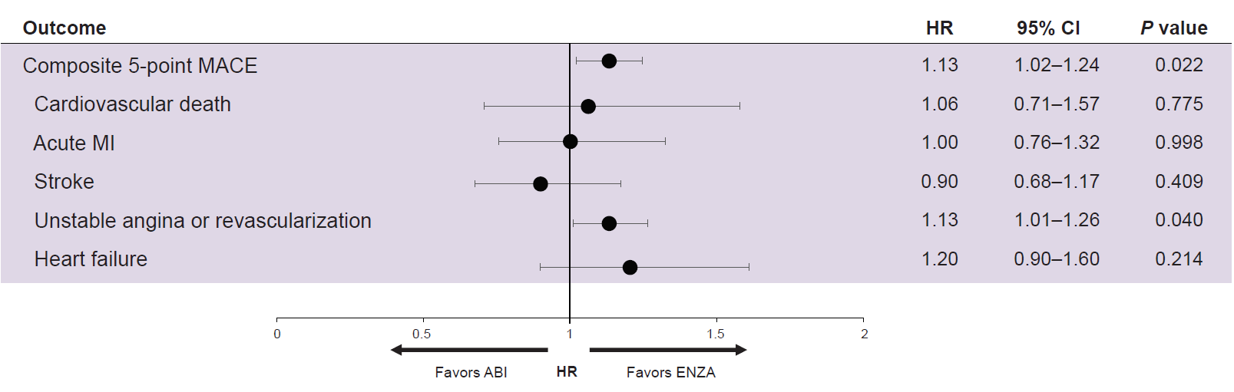
Composite 5-point MACE was defined as 4-point MACE plus CV-related death.
Abbreviations: ABI, abiraterone; CI, confidence interval; ENZA, enzalutamide; HR, hazard ratio; MACE, major adverse cardiovascular events; MI, myocardial infarction.

Figure S2. Results of sensitivity analysis (composite 5-point MACE) in patients with prior CVD
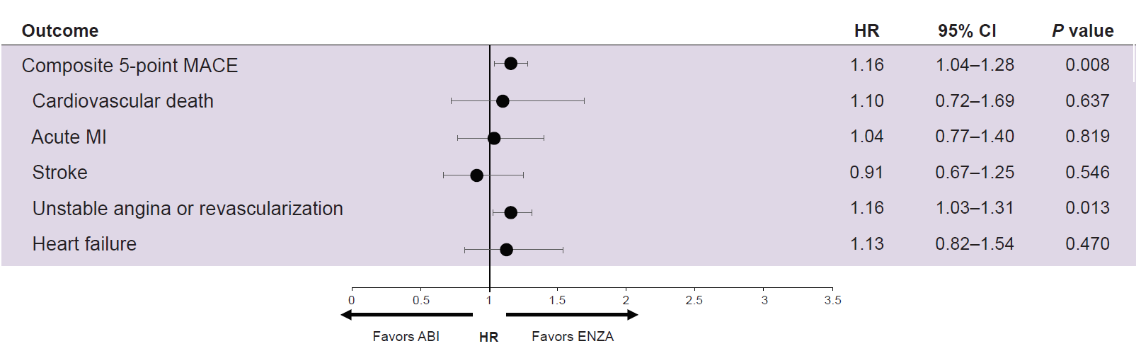
Composite 5-point MACE was defined as 4-point MACE plus CV-related death.
Abbreviations: ABI, abiraterone; CI, confidence interval; CVD, cardiovascular disease; ENZA, enzalutamide; HR, hazard ratio; MACE, major adverse cardiovascular events; MI, myocardial infarction.

Figure S3. Results of sensitivity analysis (composite 5-point MACE) in patients without prior CVD
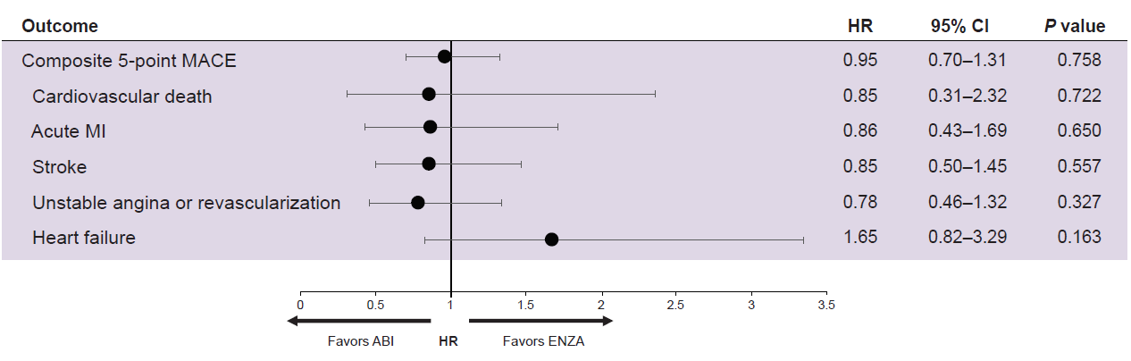
Composite 5-point MACE was defined as 4-point MACE plus CV-related death.
Abbreviations: ABI, abiraterone; CI, confidence interval; CVD, cardiovascular disease; ENZA, enzalutamide; HR, hazard ratio; MACE, major adverse cardiovascular events; MI, myocardial infarction.

Table S1. Patient selection and study population
Inclusion/exclusion criteria | Patient count
1. Patient has ≥1 diagnosis of prostate cancer between January 1, 2010 and December 31, 2022 | 4,010,315
2. Patient has ≥1 prescription claim for ENZA or ABI. The first occurrence will be defined as the index date (Day 0) | 48,437
3. Patient’s index date is between September 10, 2014 and May 31, 2017, excluding patients who have claims for both ABI and ENZA on index date | 29,028
4. Patient has ≥1 metastasis diagnosis within 90 days of index date (−90, 90) | 17,109
5. Patient is male and 65 or older on index date (Day 0) | 16,063
6. Patient has zero claims of clinical trial participation within 30 days before the index date (−30, 0) | 15,491
7. Patient is continuously enrolled in Medicare A/B/D for ≥1 year before the index date (−365, 0) | 11,629
8. Patient has evidence of medical castration with ADT lasting ≥8 weeks within 1 year before the index date (−365, 0) or surgical castration (i.e., orchiectomy) any time before the index date (−∞, 0) | 10,700
9. Patient has zero claims for chemotherapy (docetaxel, cabazitaxel, mitoxantrone, carboplatin, cisplatin, oxaliplatin), NHT, radium-223, immunotherapy, olaparib, and/or rucaparib before the index date (−∞, 0) | 7124
10. Patient has zero claims for chemotherapy (docetaxel, cabazitaxel, mitoxantrone, carboplatin, cisplatin, oxaliplatin), other NHT (NHT other than the index drug), radium-223, immunotherapy, olaparib, and/or rucaparib from index date to 28 days post-index date (0, 28) | 6958
11. Patient has zero claims for MACE during the 30 days before the index date (−30, 0) | 6319
Abbreviations: ABI, abiraterone; ADT, androgen-deprivation therapy; ENZA, enzalutamide; MACE, major adverse cardiovascular events; NHT, neoadjuvant hormone therapy.

Table S2. Study objectives and endpoints
Objectives | Endpoints
Primary
Compare the risk of MACE in chemotherapy-naïve patients with mCRPC who initiated treatment with ABI or ENZA | 4-point MACE (composite endpoint of first occurring CV event, including acute MI, stroke, unstable angina or revascularization, and heart failure)
Secondary
Compare the risk of MACE in chemotherapy-naïve patients with mCRPC who initiated treatment with ABI or ENZA using patient subgroups with or without prior CVD | 4-point MACE
Compare the risk of CV events in chemotherapy-naïve patients with mCRPC who initiated treatment with ABI or ENZA | Acute MI  Stroke (ischemic, hemorrhagic)  Unstable angina or revascularization  Heart failure  Atrial fibrillation  Venous thromboembolism
Exploratory
Compare CV-related HRU following ABI or ENZA initiation in chemotherapy-naïve patients with mCRPC | CV-related inpatient admission  CV-related outpatient encounters  CV-related outpatient ED encounters  Other CV-related outpatient encounters
Compare the risk of AVENGER-defined CV events [1, 2] in chemotherapy-naïve patients with mCRPC who initiated treatment with ABI or ENZA using an alternative definition based on CV-related hospitalization | A broader composite CV event, including acute coronary syndrome (MI and unstable angina), cerebrovascular stroke, heart failure, arrhythmia, peripheral arterial disease, venous thromboembolism, and other cardiac diseases
Abbreviations: ABI, abiraterone; CV, cardiovascular; CVD, CV disease; ED, emergency department; ENZA, enzalutamide; HRU, healthcare resource utilization; MACE, major adverse CV events; mCRPC, metastatic castration-resistant prostate cancer; MI, myocardial infarction.

Table S3. Baseline characteristics by overall population and by CV risk subgroup (matched cohorts)
 | Overall population |  |  | With prior CVD |  |  | Without prior CVD
 | Total | ENZA | ABI | Total | ENZA | ABI | Total | ENZA | ABI
Sample size | 5826 | 2913 | 2913 | 4404 | 2202 | 2202 | 1422 | 711 | 711
Age at the index date (years), mean (SD) | 78.9 (7.3) | 79.0 (7.5) | 78.9 (7.2) | 79.9 (7.2) | 80.0 (7.3) | 79.9 (7.0) | 75.8 (6.9) | 75.8 (7.2) | 75.8 (6.7)
Ethnicity, n (%)
Non-Hispanic White | 4702 (81) | 2330 (80) | 2372 (81) | 3561 (81) | 1759 (80) | 1802 (82) | 1141 (80) | 571 (80) | 570 (80)
Black/African American | 737 (13) | 385 (13) | 352 (12) | 570 (13) | 301 (14) | 269 (12) | 167 (12) | 84 (12) | 83 (12)
Hispanic | 105 (2) | 58 (20) | 47 (2) | 79 (2) | 44 (2) | 35 (2) | 26 (2) | 14 (2) | 12 (2)
Other/Unknown (includes missing) | 282 (5) | 140 (5) | 142 (5) | 194 (4) | 98 (4) | 96 (4) | 88 (6) | 42 (6) | 46 (6)
Prostate cancer medication and procedure history
Radical prostatectomy any time before index date, n (%) | 213 (4) | 112 (4) | 101 (3) | 153 (3) | 81 (4) | 72 (3) | 60 (4) | 31 (4) | 29 (4)
First-generation antiandrogensª any time before index date, n (%) | 4854 (83) | 2401 (82) | 2457 (84) | 3688 (84) | 1827 (83) | 1861 (85) | 1170 (82) | 574 (81) | 596 (84)
Opioid analgesics within 1 year before index date, n (%) | 2096 (36) | 1026 (35) | 1070 (37) | 1668 (38) | 811 (37) | 857 (39) | 428 (30) | 215 (30) | 213 (30)
Time from metastatic disease diagnosis to index date (months), mean (SD) | 15.4 (17.5) | 15.4 (17.7) | 15.5 (17.3) | 15.8 (17.7) | 15.9 (18.1) | 15.7 (17.4) | 15.5 (17.0) | 15.2 (16.9) | 15.9 (17.1)
Time from prostate cancer diagnosis date to index date (months), mean (SD) | 44.6 (24.3) | 45.4 (24.3) | 43.7 (24.3) | 46.0 (24.4) | 46.8 (24.3) | 45.1 (24.4) | 40.2 (23.6) | 41.0 (23.6) | 39.3 (23.6)
Time from ADT to index date (months), mean (SD) | 50.4 (23.8) | 50.9 (24.3) | 50.0 (23.3) | 52.7 (23.5) | 53.2 (24.2) | 52.2 (22.8) | 43.4 (23.3) | 43.7 (23.2) | 43.1 (23.4)
Site of metastatic disease at diagnosis, n (%)
Viscera | 818 (14) | 410 (14) | 408 (14) | 636 (14) | 317 (14) | 319 (14) | 182 (13) | 93 (13) | 89 (13)
Bone only | 3965 (68) | 1974 (68) | 1991 (68) | 2994 (68) | 1496 (68) | 1498 (68) | 971 (68) | 478 (67) | 493 (69)
Node only | 211 (4) | 114 (4) | 97 (3) | 154 (3) | 78 (3) | 76 (3) | 57 (4) | 36 (5) | 21 (3)
Bone and node only | 679 (12) | 333 (11) | 346 (12) | 498 (11) | 246 (11) | 252 (11) | 181 (13) | 87 (12) | 94 (13)
Other | 153 (3) | 82 (3) | 71 (2) | NA | NA | NA | NA | NA | NA
Modified Charlson Comorbidity Index any time before index date, n (%)
Cerebrovascular disease | 1935 (33) | 974 (34) | 961 (33) | 1935 (44) | 974 (44) | 961 (44) | NA | NA | NA
Chronic pulmonary disease | 2183 (37) | 1089 (37) | 1094 (38) | 1855 (42) | 920 (42) | 935 (42) | 328 (23) | 169 (24) | 159 (22)
Congestive heart failure | 1887 (32) | 957 (33) | 930 (32) | 1887 (43) | 957 (43) | 930 (42) | NA | NA | NA
Dementia | 422 (7) | 216 (7) | 206 (7) | 379 (9) | 195 (9) | 184 (8) | 43 (3) | 21 (3) | 22 (3)
Diabetes with chronic complication | 923 (16) | 474 (16) | 449 (15) | 801 (18) | 411 (19) | 390 (18) | 122 (9) | 63 (9) | 59 (8)
Diabetes without chronic complication | 2481 (43) | 1258 (43) | 1223 (42) | 2064 (47) | 1042 (47) | 1022 (46) | 417 (29) | 216 (31) | 201 (28)
Hemiplegia or paraplegia | 192 (3) | 106 (4) | 86 (3) | 172 (4) | 98 (4) | 74 (3) | 20 (1) | ^{b} | 12 (2)
Mild liver disease | 1167 (20) | 584 (20) | 583 (20) | 936 (21) | 469 (21) | 467 (21) | 231 (16) | 115 (16) | 116 (16)
Moderate or severe liver disease | 54 (1) | 19 (1) | 35 (1) | 48 (1) | 15 (1) | 33 (1) | ^{b} | ^{b} | ^{b}
Peripheral vascular disease | 2316 (40) | 1162 (40) | 1154 (40) | 2063 (47) | 1031 (47) | 1032 (47) | 253 (18) | 131 (18) | 122 (17)
Renal disease | 1814 (31) | 917 (31) | 897 (31) | 1628 (37) | 820 (37) | 808 (37) | 186 (13) | 97 (14) | 89 (13)
Other conditions any time before index date, n (%)
Hypertension | 5111 (88) | 2559 (88) | 2552 (88) | 4104 (93) | 2056 (93) | 2048 (93) | 1007 (71) | 503 (71) | 504 (71)
Stroke | 647 (11) | 330 (11) | 317 (11) | 647 (15) | 330 (15) | 317 (14) | NA | NA | NA
Acute coronary syndrome | 1115 (19) | 556 (19) | 559 (19) | 1115 (25) | 556 (25) | 559 (25) | NA | NA | NA
Angina pectoris | 356 (6) | 181 (6) | 175 (6) | 860 (20) | 441 (20) | 419 (19) | NA | NA | NA
Arrhythmia | 2854 (49) | 1421 (49) | 1433 (49) | 2854 (65) | 1421 (65) | 1433 (65) | NA | NA | NA
Myocardial infarction | 954 (16) | 477 (16) | 477 (16) | 954 (22) | 477 (22) | 477 (22) | NA | NA | NA
Congestive heart failure | 1887 (32) | 957 (33) | 930 (32) | 1887 (43) | 957 (43) | 930 (42) | NA | NA | NA
Hyperlipidemia | 4772 (82) | 2386 (82) | 2386 (82) | 3838 (87) | 1917 (87) | 1921 (87) | 934 (66) | 469 (66) | 465 (65)
Low-extremity arterial occlusive disease | 74 (1) | 35 (1) | 39 (1) | 70 (2) | 34 (2) | 36 (2) | ^{b} | ^{b} | ^{b}
Type 2 diabetes | 2508 (43) | 1270 (44) | 1238 (42) | 2087 (47) | 1056 (48) | 1031 (47) | 421 (30) | 214 (30) | 207 (29)
Chronic obstructive pulmonary disease | 307 (5) | 151 (5) | 156 (5) | 293 (7) | 144 (7) | 149 (7) | 14 (1) | ^{b} | ^{b}
Anemia | 3397 (58) | 1705 (59) | 1692 (58) | 2843 (65) | 1421 (65) | 1422 (65) | 554 (39) | 284 (40) | 270 (38)
Seizure | 238 (4) | 110 (4) | 128 (4) | 219 (5) | 101 (5) | 118 (5) | 19 (1) | ^{b} | ^{b}
Obesity | 1077 (18) | 542 (19) | 535 (18) | 903 (21) | 453 (21) | 450 (20) | 174 (12) | 89 (13) | 85 (12)
Transient ischemic attack | 475 (8) | 241 (8) | 234 (8) | 475 (11) | 241 (11) | 234 (11) | NA | NA | NA
Cardiomyopathy | 486 (8) | 246 (8) | 240 (8) | 486 (11) | 246 (11) | 240 (11) | NA | NA | NA
History of smoking | 2821 (48) | 1415 (49) | 1406 (48) | 2282 (52) | 1147 (52) | 1135 (52) | 539 (38) | 268 (38) | 271 (38)
CV-related prescription treatments (12 months before index), n (%)
Anticoagulant medications | 831 (14) | 410 (14) | 421 (14) | 792 (18) | 386 (18) | 406 (18) | 39 (3) | 24 (3) | 15 (2)
Antihypertensive medications | 4490 (77) | 2253 (77) | 2237 (77) | 3632 (82) | 1813 (82) | 1819 (83) | 858 (60) | 440 (62) | 418 (59)
Antiplatelet medications | 587 (10) | 305 (10) | 282 (10) | 576 (13) | 300 (14) | 276 (13) | 11 (1) | ^{b} | ^{b}
Type 2 diabetes medications | 1156 (22) | 583 (20) | 573 (20) | 927 (21) | 466 (21) | 461 (21) | 229 (16) | 117 (16) | 112 (16)
Lipid-lowering medications | 3214 (61) | 1604 (55) | 1610 (55) | 2705 (61) | 1353 (61) | 1352 (61) | 509 (36) | 251 (35) | 258 (36)
Antiarrythmics | 462 (9) | 255 (9) | 207 (7) | 440 (10) | 244 (11) | 196 (9) | 22 (2) | 11 (2) | 11 (2)
Antianginals | 330 (6) | 170 (6) | 160 (5) | 319 (7) | 161 (7) | 158 (7) | 11 (1) | ^{b} | ^{b}
Health resource utilization pre-index (12 months before index), n (%)
All-cause inpatient admissions | 1719 (30) | 878 (30) | 841 (29) | 1479 (34) | 751 (34) | 728 (33) | 240 (17) | 127 (18) | 113 (16)
All-cause ED encounters | 2298 (39) | 1145 (39) | 1153 (39) | 1890 (43) | 940 (43) | 950 (43) | 408 (29) | 205 (29) | 203 (29)
Prostate cancer-related inpatient admissions | 1156 (20) | 587 (20) | 569 (20) | 980 (22) | 500 (18) | 480 (22) | 176 (12) | 87 (12) | 89 (13)
Prostate cancer-related ED encounters | 943 (16) | 450 (15) | 493 (17) | 782 (18) | 369 (17) | 413 (19) | 161 (11) | 81 (11) | 80 (11)
CV-related inpatient admissions | 1029 (18) | 516 (18) | 513 (18) | 1029 (23) | 516 (23) | 513 (23) | NA | NA | NA
CV-related ED encounters | 1036 (18) | 520 (18) | 516 (18) | 1036 (24) | 520 (24) | 516 (23) | NA | NA | NA
ª Bicalutamide, flutamide, nilutamide.
^{b} Centers for Medicare & Medicaid Services policy prohibits reporting of counts <11 to avoid individual patient-level identification.
Variables not included in propensity score matching are denoted “NA.”
Abbreviations: ABI, abiraterone; ADT, androgen-deprivation therapy; CV, cardiovascular; CVD, CV disease; ED, emergency department; ENZA, enzalutamide; NA, not available; SD, standard deviation.

Table S4. CV-related healthcare utilization rates in ENZA- and ABI-treated patients (overall matched cohort)
 | ENZA | ABI | P value
CV-related inpatient admission (≥1) | 22.2 | 28.0 | <0.001
CV-related outpatient encounters (≥1) | 23.9 | 26.0 | 0.011
CV-related outpatient ED encounters (≥1) | ª | 0.2 | ª
Other CV-related outpatient encounters (≥1) | 23.9 | 26.0 | 0.011
Rate was calculated by “patients per patient-year of follow-up.” Follow-up period is from index date to death, the end of enrollment, or the end of the study period, whichever occurred earlier. P value was calculated on the rate difference using the z-distribution.
ª Centers for Medicare & Medicaid Services policy prohibits reporting of counts <11 to avoid individual patient-level identification. There were <11 patients in the ENZA-treated group who had CV-related outpatient ED encounters, so, they were not reported in this table.
Abbreviations: ABI, abiraterone; CV, cardiovascular; ED, emergency department; ENZA, enzalutamide.

Table S5. Risk of broader composite CV outcome in ABI- versus ENZA-treated patients (overall matched cohort)
 | HR (ABI vs ENZA)ª | 95% CI | P value
Overall population
AVENGER-defined CV events  (n = 2913 per group) | 1.20 | 1.05–1.37 | 0.009
By prior CVD subgroup
With prior CVD  (n = 2202 per group) | 1.18 | 1.01–1.36 | 0.034
Without prior CVD  (n = 711 per group) | 1.31 | 0.95–1.81 | 0.106
Broader composite CV event: A broader composite CV outcome than major adverse CV events, which is consistent with Hu et al. [1] and Merseburger et al [2]. CV conditions include acute coronary syndrome (myocardial infarction and unstable angina), cerebrovascular stroke, heart failure, arrhythmia, peripheral arterial disease, venous thromboembolism, and other cardiac diseases.
ª ENZA = comparator
Abbreviations: ABI, abiraterone; CI, confidence interval; CV, cardiovascular; CVD, CV disease; ENZA, enzalutamide; HR, hazard ratio.

References
1. Hu J, Aprikian AG, Vanhuyse M, Dragomir A. Comparative cardiovascular safety of novel hormonal agents in metastatic castration-resistant prostate cancer using real-world data. Clin Genitourin Cancer. 2022;20(1):17-24.
2. Merseburger AS, Dornstauder E, Ohlmann CH, Aprikian A, Junker S, Hahn P, et al. Cardiovascular risks and survival with abiraterone vs enzalutamide in chemotherapy-naive metastatic castration-resistant prostate cancer in Germany: AVENGER Study. Adv Ther. 2025;42(4):1919-34.

