Supplementary Figure legends
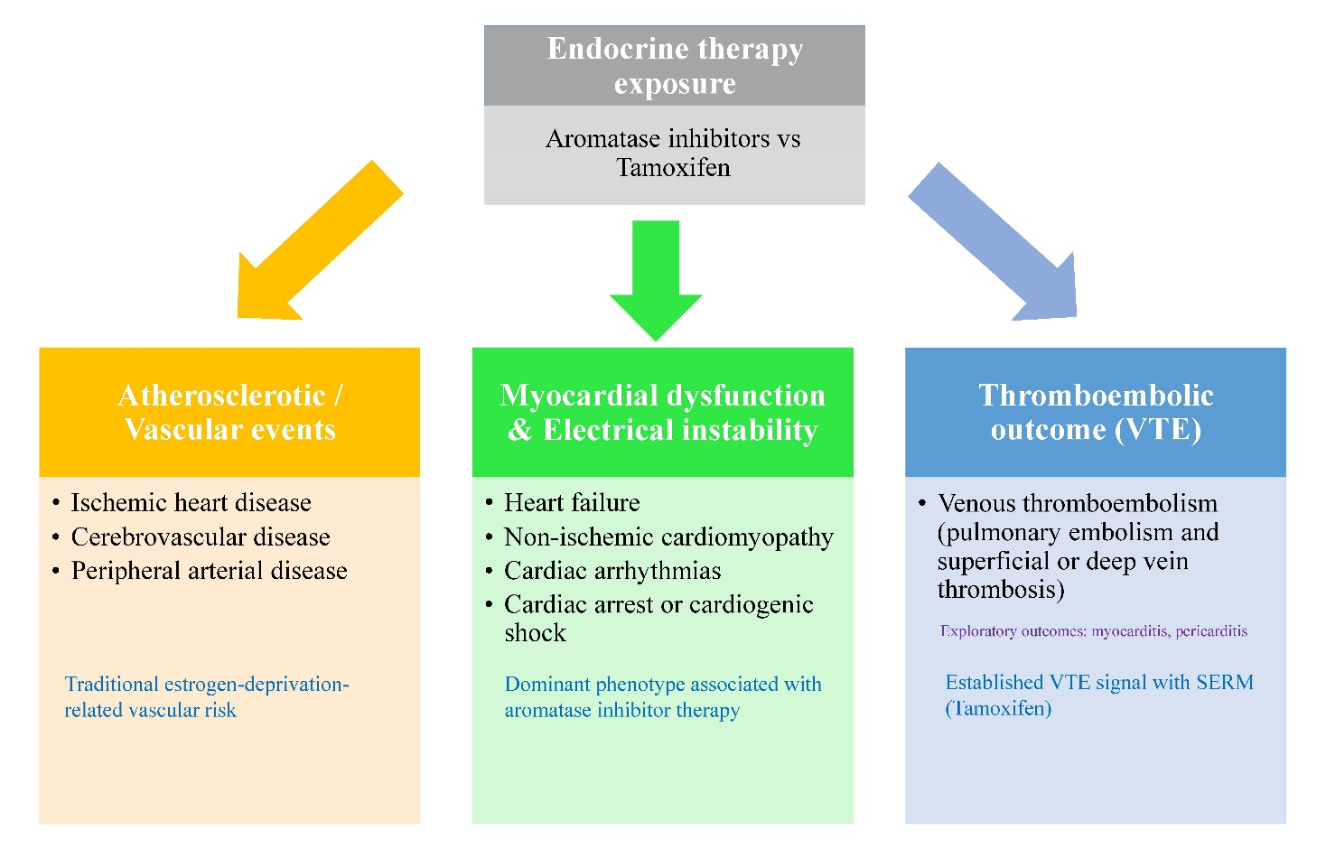
Supplementary Figure S1. Cardiovascular phenotype framework for endocrine therapy-associated risk in breast cancer survivors

Supplementary Figure S2. Cumulative incidence of specific category of cardiovascular diseases in the AIs-cohort vs. TAM-cohort.

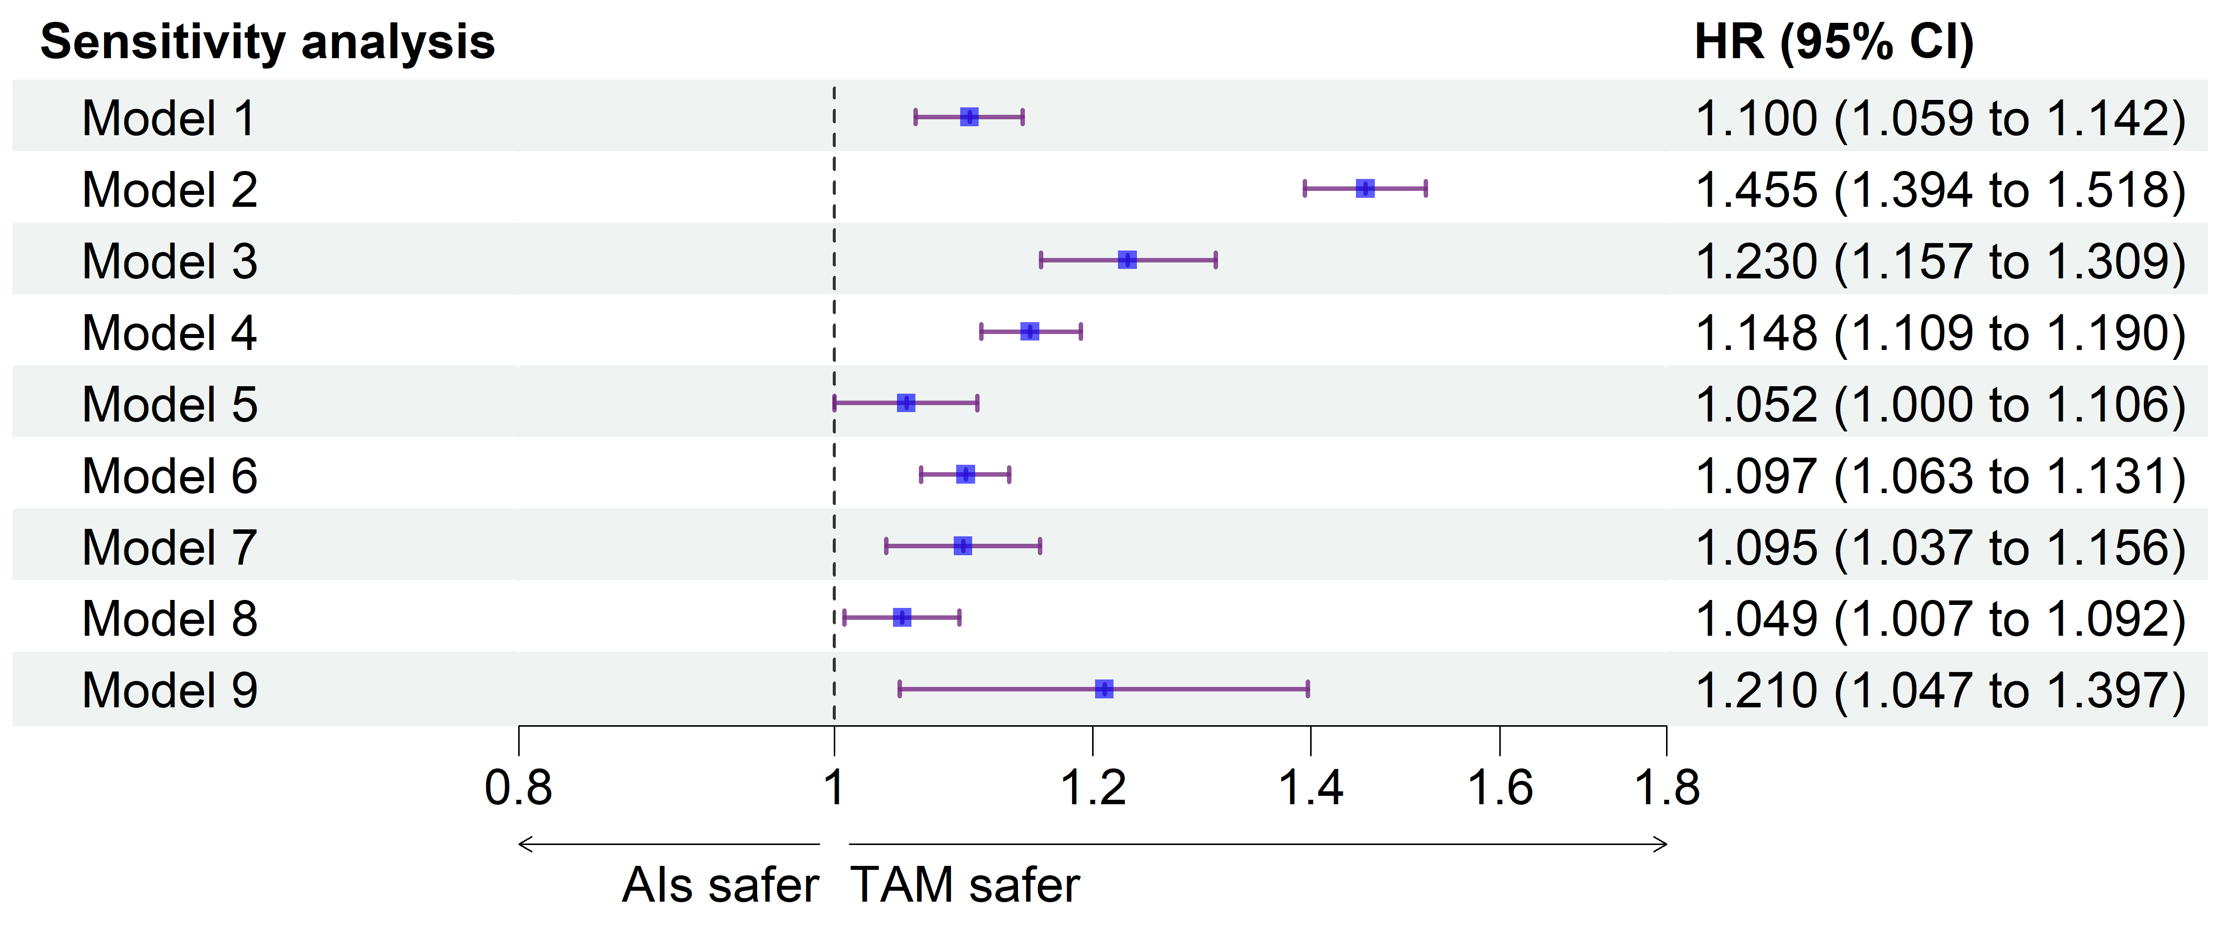Supplementary Figure S3. Forest plot depicting hazard ratios for the development of composite CVD outcome in nine sensitivity analyses.
Model 1: 12-month lag period.
Model 2: Exclusive-exposure analysis.
Model 3: Adherence-restricted cohort (≥5 prescriptions; first two within 3 months).
Model 4: Competing risk model including death.
Model 5: ER-positive patients only.
Model 6: Patients with prior cardiovascular disease matched on baseline CVD status.
Model 7: Prior targeted therapy, chemotherapy, or CDK4/6 inhibitor use excluded. Model 8: The US collaborative network
Model 9: The Asia-Pacific collaborative network (APAC)

Supplementary Table S1. STROBE Statement—Checklist of items that should be included in reports of cohort studies
 | Item No | Recommendation | Section and  paragraph
Title and abstract | 1 | (a) Indicate the study’s design with a commonly used term in the title or the abstract | Title and Abstract
Title and abstract | 1 | (b) Provide in the abstract an informative and balanced summary of what was done and what was found | Abstract, Methods and Finding
Introduction
Background/rationale | 2 | Explain the scientific background and rationale for the investigation being reported | Paragraph 1-3
Objectives | 3 | State specific objectives, including any prespecified hypotheses | Introduction, paragraph 4
Methods
Study design | 4 | Present key elements of study design early in the paper | Study design and population
Setting | 5 | Describe the setting, locations, and relevant dates, including periods of recruitment, exposure, follow-up, and data collection | Study design and population,  Covariates, & Outcomes
Participants | 6 | (a) Give the eligibility criteria, and the sources and methods of selection of participants. Describe methods of follow-up | Study design and population,  Covariates, & Outcomes
Participants | 6 | (b) For matched studies, give matching criteria and number of exposed and unexposed | Study design and population,  Covariates, & Outcomes
Variables | 7 | Clearly define all outcomes, exposures, predictors, potential confounders, and effect modifiers. Give diagnostic criteria, if applicable | Covariates, & Outcomes
Data sources/ measurement | 8* | For each variable of interest, give sources of data and details of methods of assessment (measurement). Describe comparability of assessment methods if there is more than one group | Covariates
Bias | 9 | Describe any efforts to address potential sources of bias | Sensitivity analyses & Subgroup analyses
Study size | 10 | Explain how the study size was arrived at | Study design and population
Quantitative variables | 11 | Explain how quantitative variables were handled in the analyses. If applicable, describe which groupings were chosen and why | Covariates
Statistical methods | 12 | (a) Describe all statistical methods, including those used to control for confounding | Statistical analysis
Statistical methods | 12 | (b) Describe any methods used to examine subgroups and interactions | Subgroup analyses
Statistical methods | 12 | (c) Explain how missing data were addressed | Statistical analysis
Statistical methods | 12 | (d) If applicable, explain how loss to follow-up was addressed | Outcomes
Statistical methods | 12 | (e) Describe any sensitivity analyses | Sensitivity analyses
Results
Participants | 13* | (a) Report numbers of individuals at each stage of study—eg numbers potentially eligible, examined for eligibility, confirmed eligible, included in the study, completing follow-up, and analysed | Study cohort characteristics
Participants | 13* | (b) Give reasons for non-participation at each stage | Study cohort characteristics
Participants | 13* | (c) Consider use of a flow diagram | Study cohort characteristics
Descriptive data | 14* | (a) Give characteristics of study participants (eg demographic, clinical, social) and information on exposures and potential confounders | Composite CVD outcome and phenotype-specific cardiovascular outcomes
Descriptive data | 14* | (b) Indicate number of participants with missing data for each variable of interest
Descriptive data | 14* | (c) Summarise follow-up time (eg, average and total amount) | Study cohort characteristics
Outcome data | 15* | Report numbers of outcome events or summary measures over time | Composite CVD outcome and phenotype-specific cardiovascular outcomes
Main results | 16 | (a) Give unadjusted estimates and, if applicable, confounder-adjusted estimates and their precision (eg, 95% confidence interval). Make clear which confounders were adjusted for and why they were included | Composite CVD outcome and phenotype-specific cardiovascular outcomes
Main results | 16 | (b) Report category boundaries when continuous variables were categorized | N/A
Main results | 16 | (c) If relevant, consider translating estimates of relative risk into absolute risk for a meaningful time period | Composite CVD outcome and phenotype-specific cardiovascular outcomes
Other analyses | 17 | Report other analyses done—eg analyses of subgroups and interactions, and sensitivity analyses | Subgroup analyses Sensitivity analyses
Discussion
Key results | 18 | Summarise key results with reference to study objectives | Paragraph 1
Limitations | 19 | Discuss limitations of the study, taking into account sources of potential bias or imprecision. Discuss both direction and magnitude of any potential bias | Strengths and limitations, pages 18-19
Interpretation | 20 | Give a cautious overall interpretation of results considering objectives, limitations, multiplicity of analyses, results from similar studies, and other relevant evidence | Pages 18-19
Generalisability | 21 | Discuss the generalisability (external validity) of the study results | Pages 18-19
Other information
Funding | 22 | Give the source of funding and the role of the funders for the present study and, if applicable, for the original study on which the present article is based | Page 19
*Give information separately for exposed and unexposed groups.

Supplementary Table S2. Complete list of diagnostic, laboratory, and medication codes included in the analysis
Description | Standardized code
Diagnosis | ICD-10-CM code
Breast cancer | C50
Malignancy | ICDO-3: C00-C80
Stroke | I60-I69
Transient ischemic attacks | G45
Atrial fibrillation, atrial flutter | I48
Tachycardia | R00.0, I47
Bradycardia | R00.1, I49.5, I49.8
Ventricular arrhythmias | I49
Pericarditis | I30-I32
Myocarditis | I40, I41, I51.4
Acute coronary disease | I24
Myocardial infarction | I21, I22
Ischemic cardiomyopathy | I25.5
Angina | I20
Heart failure | I50
Non-ischemic cardiomyopathy | I42
Pulmonary embolism | I26
Superficial or deep vein thrombosis | I80.0-I80.3, I80.8, I80.9, I81, I82
Peripheral arterial occlusive disease | I73.81, I73,89, I73.9, I74.01, I74.09, I74.11, I74.2 I74.5, I74.8, I74.9, I79.1, I79.8
Cardiac arrest | I46
Cardiogenic shock | R57.0
Acute appendicitis | K35
Endometrial cancer | C54.1
Hypertension | I10-I15
DM | E08-E13
Dyslipidemia | E78
Obesity | E66
CKD | N18
Chronic obstructive pulmonary diseases | J44
Sleep disorders | G47
Nicotine dependence | F17
Alcohol related disorders | F10
Medications | ATC code
Alkylating agents | L01A
Anthracyclines and related substances | L01DB
Taxanes | L01CD
Monoclonal antibodies | L01XC
Gonadotropin releasing hormone Analogues | L02AE
Leuprolide | L02AE02
Goserelin | L02AE03
Fulvestrant | L02BA03
Drugs used in diabetes | A10
Lipid modifying agents | C10
Antihypertensives | C02
Beta blocking agents | C07
Calcium channel blockers | C08
RAS agents | C09
Diuretics | C03
Antithrombotic agents | B01
Glucocorticoids | H02AB
NSAIDs | M01A
Aromatase inhibitors | L02BG
Tamoxifen | L02BA01
Measurements | TriNetX curated code
HbA1c (%) | 9037
BMI (kg/m²) | 9083
LDL-C (mg/dL) | 9002
HDL-C (mg/dL) | 9001
TG (mg/dL) | 9004
eGFR (mL/min/1.73 m²) | 8001
ICD-10-CM, International Classification of Diseases, Tenth Revision; DM, Diabetes mellitus; CKD, Chronic kidney disease; RAS agents, Agents acting on the renin-angiotensin system; NSAIDs, Non-steroidal anti-inflammatory drugs; HbA1c, Glycated Hemoglobin; BMI, Body Mass Index; LDL-C, low density lipoprotein cholesterol; HDL-C, high density lipoprotein cholesterol; TG, triglyceride; eGFR, estimated Glomerular filtration rate.

Supplementary Table S3. Baseline characteristics of study participants before propensity score matching
 | Mean ± SD or No. (%) |  | Std. diff.*
 | AIs | TAM | Std. diff.*
Number | 127,819 | 36,154
Age, year | 65.1 ± 8.2 | 60.0 ± 8.9 | 0.599
Race
White | 85337 (66.8) | 21739 (60.1) | 0.138
Black or African American | 11053 (8.6) | 2243 (6.2) | 0.093
Asian | 7283 (5.7) | 3244 (9) | 0.126
Other Race | 4785 (3.7) | 1818 (5) | 0.063
Unknown Race | 18350 (14.4) | 6838 (18.9) | 0.123
Comorbidities
Hypertension | 37047 (29) | 6864 (19) | 0.236
DM | 13781 (10.8) | 2266 (6.3) | 0.162
Dyslipidemia | 30727 (24) | 5414 (15) | 0.23
Overweight and obesity | 11373 (8.9) | 2009 (5.6) | 0.129
CKD | 3182 (2.5) | 552 (1.5) | 0.069
Chronic lower respiratory diseases | 2910 (2.3) | 469 (1.3) | 0.074
Sleep disorders | 8359 (6.5) | 1902 (5.3) | 0.054
Nicotine dependence | 4889 (3.8) | 921 (2.5) | 0.073
Alcohol related disorders | 714 (0.6) | 168 (0.5) | 0.013
Medication
Antineoplastic agents
Alkylating agents | 7895 (6.2) | 1923 (5.3) | 0.037
Anthracyclines and related substances | 4943 (3.9) | 1397 (3.9) | <0.001
Taxanes | 9843 (7.7) | 2150 (5.9) | 0.07
Monoclonal antibodies | 4070 (3.2) | 887 (2.5) | 0.044
Endocrine & Hormonal agents
Gonadotropin releasing hormone analogues | 419 (0.3) | 84 (0.2) | 0.018
Leuprolide | 263 (0.2) | 48 (0.1) | 0.018
Goserelin | 154 (0.1) | 32 (0.1) | 0.01
Fulvestrant | 206 (0.2) | 60 (0.2) | 0.001
Metabolic agents
Drugs used in diabetes | 11452 (9.0) | 1865 (5.2) | 0.149
Lipid modifying agents | 20599 (16.1) | 3184 (8.8) | 0.223
Cardiovascular agents
Antihypertensives | 7988 (6.2) | 1607 (4.4) | 0.08
Beta blocking agents | 17947 (14) | 3488 (9.6) | 0.136
Calcium channel blockers | 10240 (8.0) | 1742 (4.8) | 0.131
RAS agents | 19689 (15.4) | 3614 (10) | 0.163
Diuretics | 14916 (11.7) | 2713 (7.5) | 0.142
Anti-inflammatory agents
Antithrombotic agents | 22681 (17.7) | 4471 (12.4) | 0.151
Glucocorticoids | 46703 (36.5) | 11090 (30.7) | 0.124
NSAIDs | 32695 (25.6) | 8728 (24.1) | 0.033
Laboratory
HbA1c (%) | 6.3 ± 1.3 | 6.1 ± 1.2 | 0.179
BMI (kg/m²) | 29.7 ± 6.7 | 28.1 ± 6.6 | 0.236
LDL-C (mg/dL) | 108.7 ± 37.1 | 107.7 ± 35.3 | 0.027
HDL-C (mg/dL) | 57.2 ± 19.6 | 59.3 ± 19.4 | 0.108
Triglycerides (mg/dL) | 132.1 ± 79.5 | 129.1 ± 77.3 | 0.038
eGFR (mL/min/1.73 m²) | 77.5 ± 22.6 | 81.5 ± 23.1 | 0.172
AIs, aromatase inhibitors; TAM, Tamoxifen; Std. diff., standardized difference; SD, standard deviation; DM, Diabetes mellitus; CKD, Chronic kidney disease; RAS agents, Agents acting on the renin-angiotensin system; NSAIDs, Non-steroidal anti-inflammatory drugs; HbA1c, Glycated Hemoglobin; BMI, Body Mass Index; LDL-C, low density lipoprotein cholesterol; HDL-C, high density lipoprotein cholesterol; TG, triglyceride; eGFR, estimated Glomerular filtration rate. Laboratory test results were based on the most recent measurements prior to the index event.

Supplementary Table S4. Five-year cumulative incidence of composite cardiovascular and phenotype-specific outcomes in the AI and TAM cohorts.
 | AIs | TAM
Composite CVD outcome | 19.81 (19.29–20.30) | 18.38 (17.90–18.87)
Atherosclerotic/vascular phenotype | 8.17 (7.82–8.53) | 7.62 (7.29–7.96)
Cerebrovascular diseases | 5.28 (4.99–5.58) | 4.81 (4.54–5.08)
Ischemic heart diseases | 2.27 (2.08–2.47) | 2.28 (2.10–2.48)
Peripheral arterial occlusive disease | 1.32 (1.18–1.48) | 1.27 (1.13–1.42)
Myocardial dysfunction and electrical instability phenotype | 11.34 (10.92–11.77) | 11.03 (10.63–11.44)
Heart failure | 2.76 (2.55–2.99) | 2.49 (2.30–2.69)
Non-ischemic cardiomyopathy | 1.08 (0.95–1.23) | 0.88 (0.77–1.01)
Arrhythmias | 5.70 (5.40–6.01) | 5.40 (5.12–5.70)
Cardiac arrest or cardiogenic shock | 0.29 (0.23–0.38) | 0.29 (0.23–0.36)
Thromboembolic phenotype | 3.84 (3.60–4.10) | 3.68 (3.45–3.92)
Inflammatory cardiac disorders | 0.90 (0.78–1.03) | 0.69 (0.60–0.81)
Extended MACE | 9.64 (9.25–10.05) | 9.17 (8.80–9.55)
Cerebrovascular events included stroke and transient ischemic attack; cardiac arrhythmias included atrial fibrillation or flutter, tachycardia, bradycardia, and ventricular arrhythmias; inflammatory cardiac disorders included pericarditis and myocarditis; ischemic heart disease included acute coronary syndrome, myocardial infarction, ischemic cardiomyopathy, and angina; and the thromboembolic phenotype included pulmonary embolism, phlebitis and thrombophlebitis, portal vein thrombosis, and other venous embolism and thrombosis. Extended MACE included myocardial infarction, ischemic stroke, heart failure, ventricular arrhythmias, and cardiac arrest. AIs, aromatase inhibitors; TAM, tamoxifen; CVD, cardiovascular disease; MACE, major adverse cardiovascular events.
Supplementary Table S5. HRs and 95 confidence intervals for positive and negative control outcomes among breast cancer patients receiving AIs or TAM. The positive control (endometrial cancer) validates the study design, while the negative control (acute appendicitis) assesses potential residual confounding.
 | HR (95 CI)
Endometrial cancer (Positive control) | 0.368 (0.276–0.492)
Acute appendicitis (Negative control) | 1.404 (0.976–2.019)
Abbreviations: HRs, Hazard ratios; CI, Confidence interval

Supplementary Table S6. No-lag analyses of thromboembolic outcomes during the first year after endocrine therapy initiation.
Outcome definition | HR (95% CI)
Broad thromboembolic phenotype | 0.943 (0.812–1.095)
Conventional VTE | 0.873 (0.714–1.066)
The broad thromboembolic phenotype included pulmonary embolism, phlebitis and thrombophlebitis, portal vein thrombosis, and other venous embolism and thrombosis (ICD-10-CM codes I26, I80, I81, and I82). Conventional VTE was restricted to pulmonary embolism and acute lower-extremity deep vein thrombosis (ICD-10-CM codes I26, I80.1, I80.2, and I82.4). HRs compare AIs with TAM; therefore, an HR below 1.0 indicates a lower hazard among AI users. AIs, aromatase inhibitors; TAM, tamoxifen; VTE, venous thromboembolism; HR, hazard ratio; CI, confidence interval.

