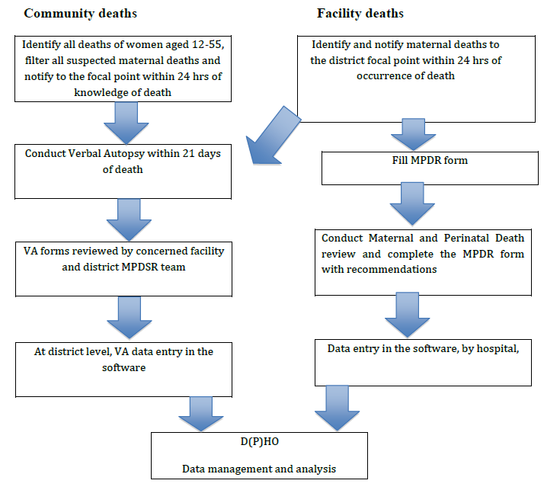
Appendix 3: Flow diagram of MPDR and MPDSR [23].

