Supplemental material
Figure 1. major artery infarctions 3
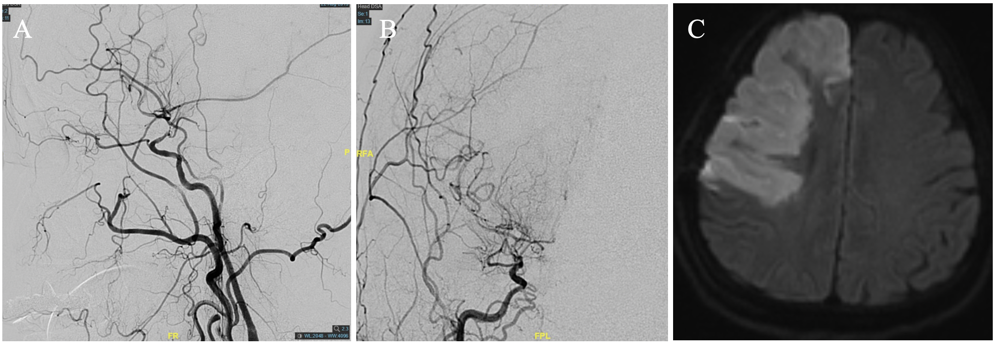
Preoperative DSA shows severe stenosis of terminal of right ICA(A and B), newly developed infarction of right ICA feeding area after revascularization.

Figure 2. major artery infarctions 4
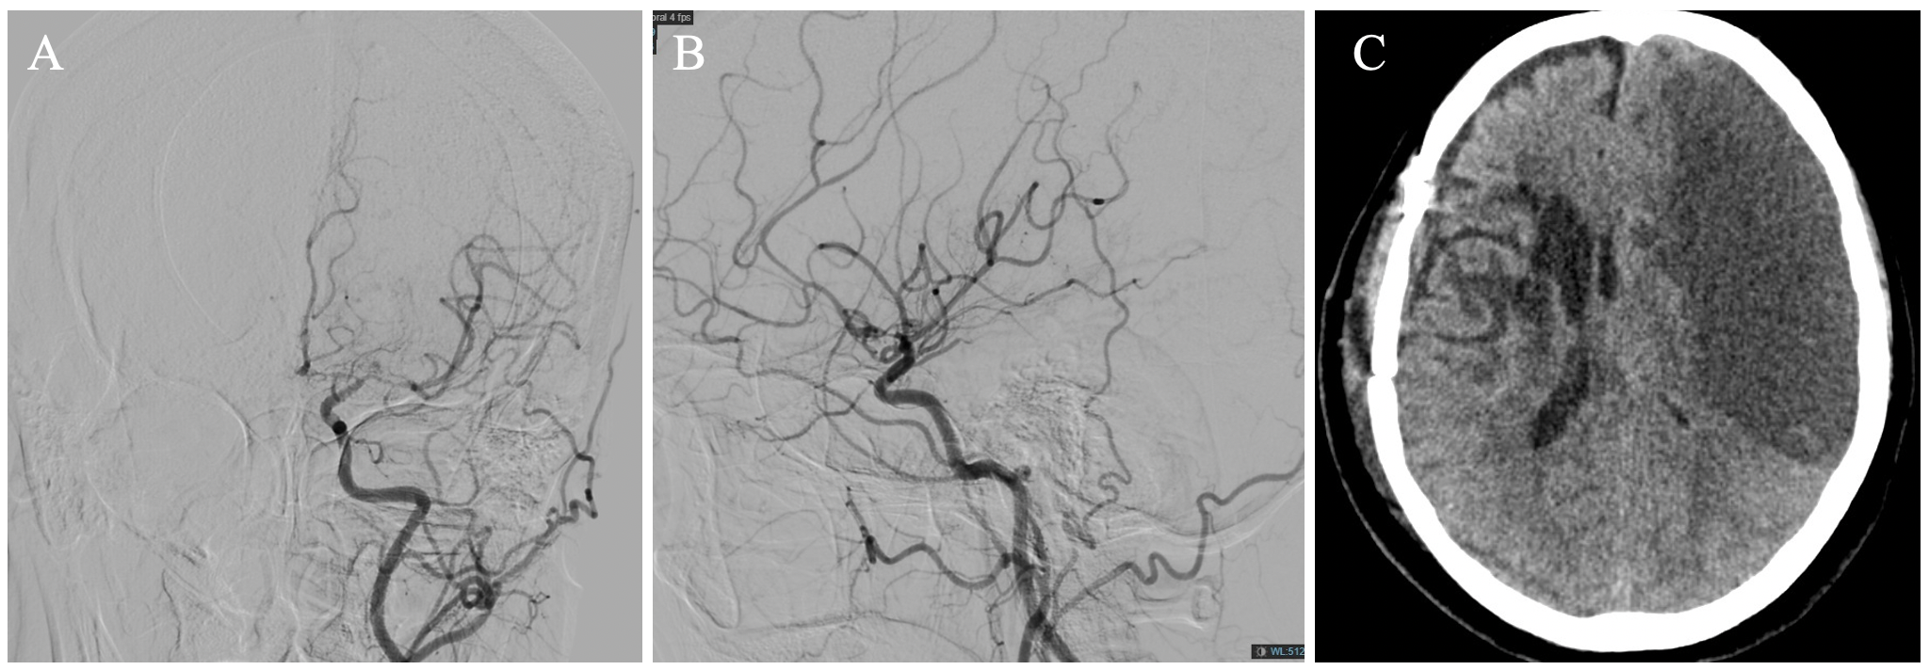
Preoperative DSA shows severe stenosis of first part of left ACA and MCA(A and B), newly developed infarction of left ACA and MCA feeding area after revascularization.

Figure 3
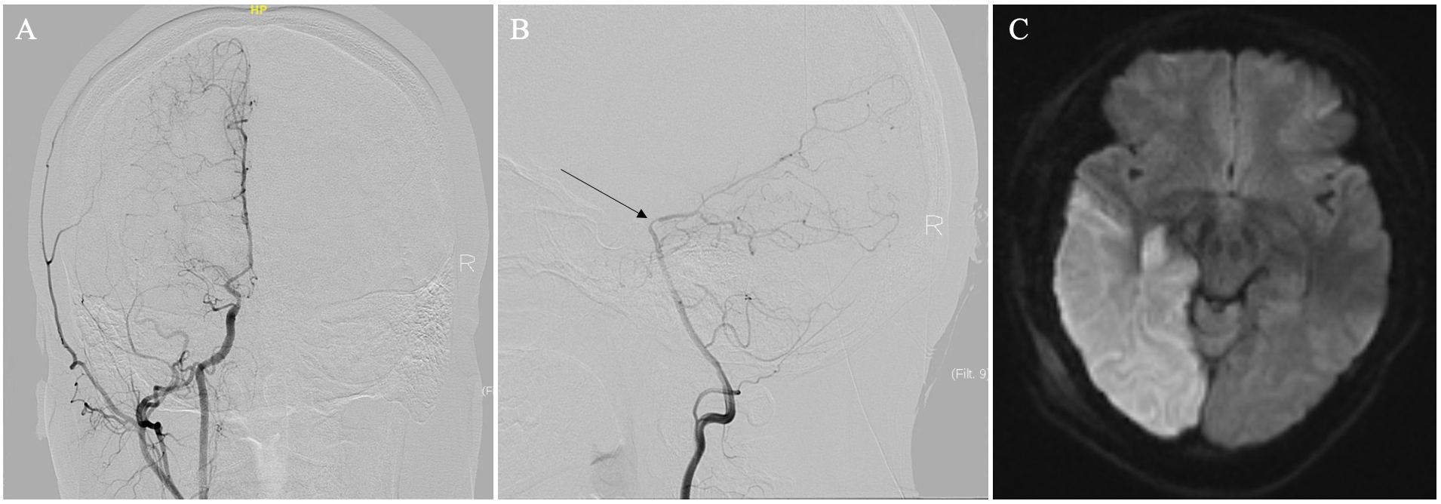
Preoperative DSA shows severe stenosis of first part of right PCA(B, arrow) and non-embryonal posterior cerebral artery(A), newly developed infarction of the right PCA feeding area after revascularization.

