8. Annexures:
Table 1-A: Timeline of the flood intervention protocol activation in Zambezia (2022)
DATE | ACTIVITIES
25thJanuary, 2022 | - IFRC and CVM meet for updates on the cyclone and discussions on logistics:  - Agreed that it is not feasible for trucking the NFIs for flood EAP from Chibuto warehouse (in southern Mozambique) to Mocuba (northern Mozambique). NFIs were pre-positioning in Chibuto in anticipation of the early warning that suggested flooding in southern Mozambique; rather than central and northern parts of the country.  o Alternatives discussed on logistics:  - CVM to procure a logistics service provider for trucking NFIs from other CVM warehouses in central and northern parts of the country.  - CVM to procure a logistics service provider for air transportation of NFIs.  - IFRC to approach Coca Cola for trucking.  - IFRC to ask for a quote from a courier service provider (DHL) or the national airline company (LAM) for air transportation of 7.5 tons of NFIs.  - GODE (the emergency committee of the CVM) led by the General Secretary of CVM met at 17:00h and decided to activate the Flood EAP.  - By 21.00h GODE decision and CVM fund request was received by IFRC.
26thJanuary, 2022 | - CVM activated the Zambezia provincial delegation to start preparing the implementation of EAP for floods, especially the dissemination of early warning messages. But no DRM specialists were available to lead this in the affected area. So, the dissemination of early warning messages was postponed.  - The provincial secretary of the CVM delegation in Zambezia and his technical Staff traveled from Quelimane city to Mocuba district to oversee the implementation of EAP.  - The administrative officer from Zambezia province (in Quelimane city) traveled to Caia and Mopeia districts (in Sofala province) to assess the availability of NFIs stock in the warehouses in these locations.  - IFRC Treasury in Geneva transferred funds.  - Flood and Cyclone EAP manager, and Communications manager deployed to Nampula to support the implementation of EAP for Cyclone in Nampula province  - Flood level threshold for intervention reached in Mocuba district.  - Cyclone level threshold for intervention NOT reached in Nampula Province
27thJanuary, 2022 | - Flood and Cyclone EAP and Communications manager deployed from Nampula to Mocuba to support flood EAP implementation  - CVM decided to activate its warehouses in Caia and Nampula to supply NFIs to Mocuba.  - CVM volunteers activated, and early warning message prepared for Mocuba.
28thJanuary, 2022 | In Mocuba district:  - 5:00 AM-Truck with NFI arrived from Nampula.  - 6:00 AM - Truck with NFI arriveds from Caia.  - 6:00 AM- Volunteers start digital assessments of beneficiaries using KOBO.  - 7:00 AM- Early warning messages communicated by part of the volunteers.  - 9:00 AM- Truck arrived from Mopeia (jerry-can warehouse).  - 10:00 AM- Meeting with INGD and community leaders to inform on the EAP mechanisms, responsibilities and what will be distributed.  - 12:00- Two distribution sites are prepared (Sacras & Samora Machel).  - 9:00-14:00- NFIs packed into kits.  - 14:00- Distribution of NFIs started, outreaching 850 households.  - 20:00- Early Action Activities completed.
29thJanuary, 2022 | - Mobilized all volunteers and staff to go back to Mocuba district committee CVM (High Laying Area).
1stFebruary, 2022 | - Team deployed back to Quelimane and Maputo.

ACRONYMS
CVM: Mozambique Red Cross (Cruz Vermelha de Moçambique) | IFRC: International Federation of the Red Cross
DRM: Disaster Risk Management | INGD: National Institute for Disaster Management (Instituto Nacional de Gestão de Desastres)
EAP: Early Action Protocol | LAM: Mozambique Airlines (Linhas Aereas de Moçambique)
FbF: Forecast Based Financing | NFIs: Non-Food Items
GODE: Emergency Operations Group

8-B: Detailed Results from the Propensity Score Matching

Loss of Assets
- Possession losses
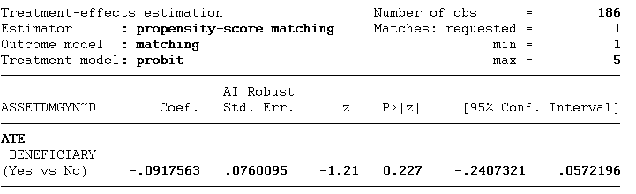

Loss of personal documentations

Propensity Score Matching
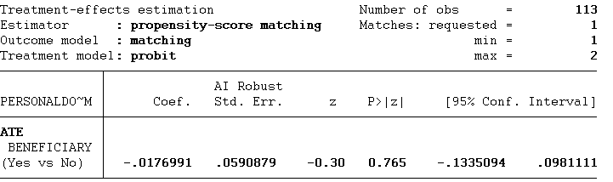

Injuries and Diseases
- Number of Injured People
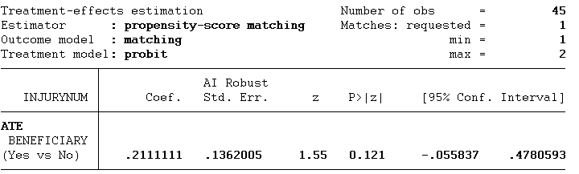

- Flu-like Symptoms
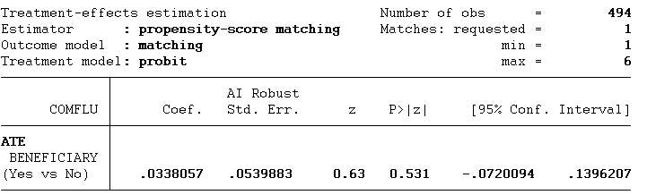

- Stomachache
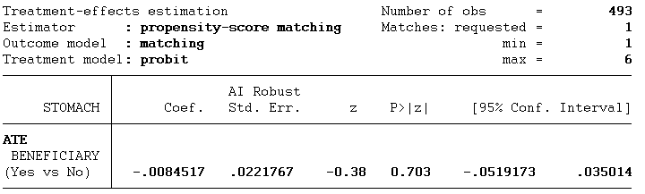

- Diarrhea
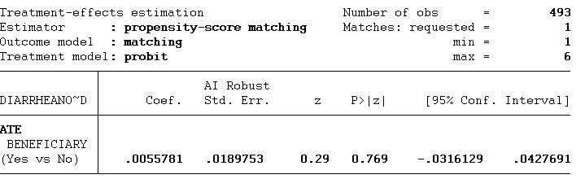

- Diarrhea with blood
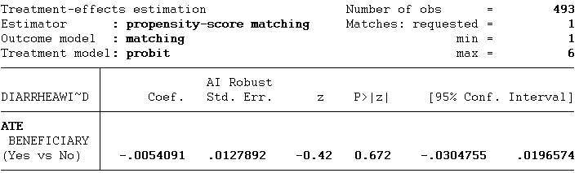

- Vomiting
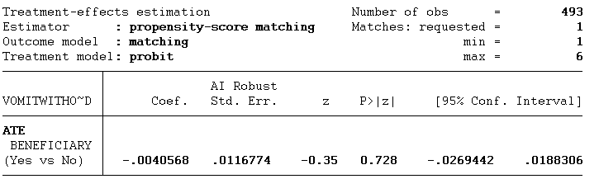

- Vomiting with blood
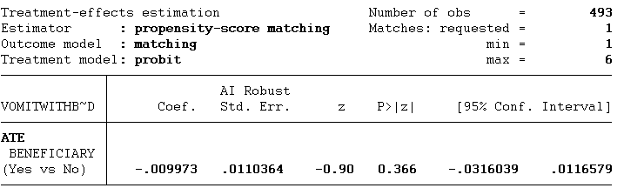

- Bloating of hands and/or feet
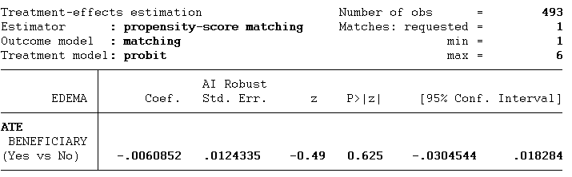

- Other Symptoms
