Table S1. The pup number and sex ratio.
 | Dam | Male | Female | Total
Control | 5 | 24 | 22 | 47
BPA | 6 | 29 | 31 | 60

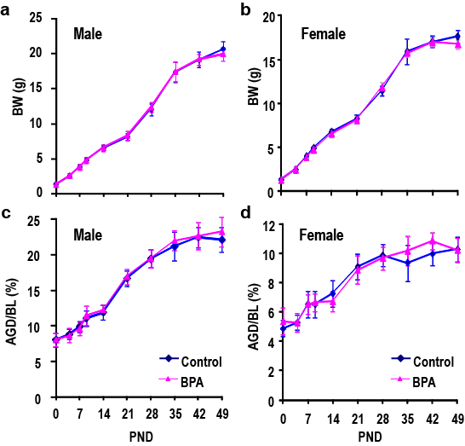

Figure S1. Effect of prenatal BPA exposure on body weight and anogenital distance (AGD). (a) Body weight change from birth through PND 49 of male mice (a) and female mice (b). AGD normalized by body length (BL) of male mice (c) and female mice (d).

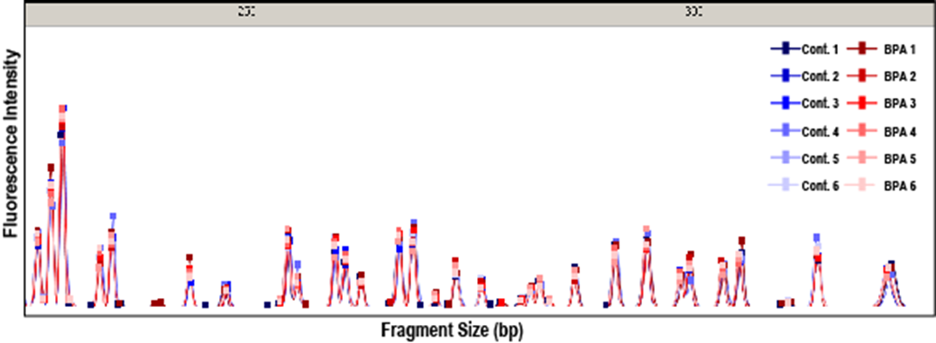

Figure S2. A typical MSD-AFLP peak chart after electrophoresis obtained by a selective primer set. Twelve electropherograms are seen on the chart (Control, 6 mice; BPA-treated, 6 mice).

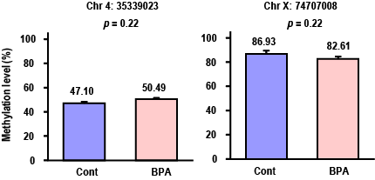

Figure S3. MSRE-PCR analysis of representative CpGs (Chr 4: 35339023 and Chr X: 74707008) showing the minimum q-value obtained from the MSD-AFLP data. There was no statistical significance in methylation levels of the two CpGs.

Table S2. The KEGG enrichment analysis of the effect on the DNA methylation.
BPA > Control |  |  |  |  | BPA < Control
KEGG pathway | SIZE | NES | FDR |  | KEGG pathway | SIZE | NES | FDR
N-Glycan Biosynthesis | 12 | 1.600 | 0.776 |  | Histidine Metabolism | 7 | -1.602 | 0.917
Fc Epsilon Ri Signaling Pathway | 22 | 1.450 | 1.000 |  | Alzheimers Disease | 36 | -1.533 | 0.953
T Cell Receptor Signaling Pathway | 28 | 1.443 | 1.000 |  | Dna Replication | 6 | -1.433 | 1.000
Aminoacyl Trna Biosynthesis | 8 | 1.397 | 1.000 |  | Ecm Receptor Interaction | 36 | -1.419 | 1.000
Mtor Signaling Pathway | 14 | 1.376 | 1.000 |  | Fatty Acid Metabolism | 5 | -1.415 | 1.000
B Cell Receptor Signaling Pathway | 24 | 1.336 | 1.000 |  | Pancreatic Cancer | 22 | -1.411 | 0.870
Ubiquitin Mediated Proteolysis | 25 | 1.317 | 1.000 |  | Nucleotide Excision Repair | 8 | -1.372 | 0.957
Purine Metabolism | 49 | 1.253 | 1.000 |  | Parkinsons Disease | 14 | -1.340 | 1.000
Viral Myocarditis | 17 | 1.247 | 1.000 |  | Pathways In Cancer | 112 | -1.291 | 1.000
Tight Junction | 45 | 1.235 | 1.000 |  | Maturity Onset Diabetes Of The Young | 6 | -1.282 | 1.000
Vasopressin Regulated Water Reabsorption | 15 | 1.233 | 1.000 |  | Antigen Processing And Presentation | 5 | -1.275 | 1.000
Type I Diabetes Mellitus | 5 | 1.226 | 1.000 |  | Arginine And Proline Metabolism | 10 | -1.268 | 1.000
Glycerophospholipid Metabolism | 20 | 1.221 | 1.000 |  | Porphyrin And Chlorophyll Metabolism | 7 | -1.224 | 1.000
O-Glycan Biosynthesis | 11 | 1.221 | 0.966 |  | Arrhythmogenic Right Ventricular Cardiomyopathy Arvc | 39 | -1.201 | 1.000
Spliceosome | 13 | 1.218 | 0.916 |  | Bladder Cancer | 12 | -1.198 | 1.000
Circadian Rhythm Mammal | 5 | 1.216 | 0.866 |  | Tyrosine Metabolism | 5 | -1.198 | 1.000
Ether Lipid Metabolism | 9 | 1.193 | 0.908 |  | Valine Leucine And Isoleucine Degradation | 11 | -1.194 | 1.000
Alanine Aspartate And Glutamate Metabolism | 7 | 1.184 | 0.895 |  | Wnt Signaling Pathway | 53 | -1.169 | 1.000
Leukocyte Transendothelial Migration | 31 | 1.180 | 0.862 |  | Amyotrophic Lateral Sclerosis Als | 19 | -1.162 | 1.000
Snare Interactions In Vesicular Transport | 10 | 1.170 | 0.860 |  | Tgf Beta Signaling Pathway | 15 | -1.159 | 1.000
Leishmania Infection | 7 | 1.160 | 0.850 |  | Gap Junction | 37 | -1.148 | 1.000
Type II Diabetes Mellitus | 16 | 1.158 | 0.820 |  | Basal Transcription Factors | 7 | -1.147 | 0.977
Glycerolipid Metabolism | 14 | 1.137 | 0.852 |  | Drug Metabolism Other Enzymes | 7 | -1.147 | 0.936
Inositol Phosphate Metabolism | 21 | 1.132 | 0.835 |  | Colorectal Cancer | 21 | -1.141 | 0.914
Taste Transduction | 15 | 1.122 | 0.832 |  | Prion Diseases | 8 | -1.132 | 0.910
Fc Gamma R Mediated Phagocytosis | 32 | 1.117 | 0.815 |  | Oxidative Phosphorylation | 11 | -1.131 | 0.879
Dorso Ventral Axis Formation | 9 | 1.113 | 0.797 |  | Cell Cycle | 23 | -1.111 | 0.915
Regulation Of Autophagy | 7 | 1.101 | 0.806 |  | P53 Signaling Pathway | 17 | -1.109 | 0.889
Phosphatidylinositol Signaling System | 30 | 1.099 | 0.783 |  | Tryptophan Metabolism | 7 | -1.102 | 0.876
Nicotinate And Nicotinamide Metabolism | 6 | 1.090 | 0.781 |  | Adipocytokine Signaling Pathway | 19 | -1.101 | 0.850
Small Cell Lung Cancer | 32 | 1.087 | 0.763 |  | Regulation Of Actin Cytoskeleton | 75 | -1.100 | 0.824
Calcium Signaling Pathway | 64 | 1.083 | 0.752 |  | Amino Sugar And Nucleotide Sugar Metabolism | 9 | -1.096 | 0.812
Sphingolipid Metabolism | 9 | 1.077 | 0.745 |  | Focal Adhesion | 78 | -1.082 | 0.829
Acute Myeloid Leukemia | 19 | 1.023 | 0.869 |  | Mismatch Repair | 5 | -1.076 | 0.822
Progesterone Mediated Oocyte Maturation | 24 | 1.017 | 0.861 |  | Glutathione Metabolism | 9 | -1.072 | 0.812
Glycosphingolipid Biosynthesis Lacto And Neolacto Series | 6 | 1.014 | 0.846 |  | Cytokine Cytokine Receptor Interaction | 44 | -1.048 | 0.856
Rig I Like Receptor Signaling Pathway | 10 | 1.008 | 0.839 |  | Melanoma | 23 | -1.031 | 0.885
Peroxisome | 16 | 0.964 | 0.933 |  | Dilated Cardiomyopathy | 45 | -1.028 | 0.869
Prostate Cancer | 33 | 0.956 | 0.929 |  | Chronic Myeloid Leukemia | 22 | -1.012 | 0.896
Erbb Signaling Pathway | 31 | 0.952 | 0.915 |  | Vascular Smooth Muscle Contraction | 43 | -0.995 | 0.921
Ppar Signaling Pathway | 14 | 0.951 | 0.896 |  | Olfactory Transduction | 8 | -0.994 | 0.901
Vibrio Cholerae Infection | 14 | 0.936 | 0.910 |  | Notch Signaling Pathway | 18 | -0.993 | 0.881
Butanoate Metabolism | 8 | 0.930 | 0.905 |  | Basal Cell Carcinoma | 20 | -0.991 | 0.867
Axon Guidance | 56 | 0.925 | 0.896 |  | Arachidonic Acid Metabolism | 11 | -0.991 | 0.848
Non Small Cell Lung Cancer | 18 | 0.890 | 0.957 |  | Hypertrophic Cardiomyopathy Hcm | 39 | -0.984 | 0.845
Chemokine Signaling Pathway | 59 | 0.874 | 0.975 |  | Intestinal Immune Network For Iga Production | 8 | -0.970 | 0.864
Thyroid Cancer | 10 | 0.853 | 1.000 |  | Pathogenic Escherichia Coli Infection | 9 | -0.960 | 0.869
Complement And Coagulation Cascades | 11 | 0.850 | 0.986 |  | Lysine Degradation | 10 | -0.960 | 0.853
Cysteine And Methionine Metabolism | 6 | 0.848 | 0.970 |  | Hedgehog Signaling Pathway | 19 | -0.957 | 0.841
Endometrial Cancer | 18 | 0.846 | 0.956 |  | Mapk Signaling Pathway | 94 | -0.932 | 0.883
Toll Like Receptor Signaling Pathway | 19 | 0.835 | 0.960 |  | Natural Killer Cell Mediated Cytotoxicity | 27 | -0.926 | 0.879
Lysosome | 41 | 0.829 | 0.955 |  | Long Term Depression | 29 | -0.922 | 0.873
Vegf Signaling Pathway | 26 | 0.826 | 0.941 |  | Pyrimidine Metabolism | 21 | -0.905 | 0.896
Endocytosis | 60 | 0.806 | 0.960 |  | Cardiac Muscle Contraction | 18 | -0.894 | 0.905
Jak Stat Signaling Pathway | 26 | 0.791 | 0.970 |  | Fructose And Mannose Metabolism | 6 | -0.875 | 0.929
Glioma | 25 | 0.778 | 0.974 |  | Oocyte Meiosis | 28 | -0.844 | 0.981
Long Term Potentiation | 28 | 0.767 | 0.976 |  | Neurotrophin Signaling Pathway | 42 | -0.842 | 0.967
Citrate Cycle Tca Cycle | 5 | 0.766 | 0.960 |  | Nod Like Receptor Signaling Pathway | 5 | -0.841 | 0.953
Homologous Recombination | 7 | 0.749 | 0.969 |  | Rna Degradation | 15 | -0.833 | 0.951
Galactose Metabolism | 7 | 0.736 | 0.972 |  | Adherens Junction | 39 | -0.832 | 0.937
Insulin Signaling Pathway | 38 | 0.735 | 0.957 |  | Ribosome | 5 | -0.826 | 0.934
Selenoamino Acid Metabolism | 5 | 0.713 | 0.970 |  | Cytosolic Dna Sensing Pathway | 5 | -0.822 | 0.926
Glycosphingolipid Biosynthesis Ganglio Series | 6 | 0.712 | 0.956 |  | Pyruvate Metabolism | 11 | -0.818 | 0.919
Glycosaminoglycan Degradation | 8 | 0.671 | 0.981 |  | Renal Cell Carcinoma | 23 | -0.805 | 0.927
Propanoate Metabolism | 10 | 0.659 | 0.978 |  | Cell Adhesion Molecules Cams | 37 | -0.772 | 0.968
Apoptosis | 24 | 0.584 | 1.000 |  | Gnrh Signaling Pathway | 40 | -0.748 | 0.991
Primary Immunodeficiency | 5 | 0.583 | 0.995 |  | Huntingtons Disease | 30 | -0.734 | 0.997
Metabolism Of Xenobiotics By Cytochrome P450 | 8 | 0.572 | 0.985 |  | Systemic Lupus Erythematosus | 10 | -0.732 | 0.985

NES, normalized enrichment score; FDR, false discovery rate q-value.

