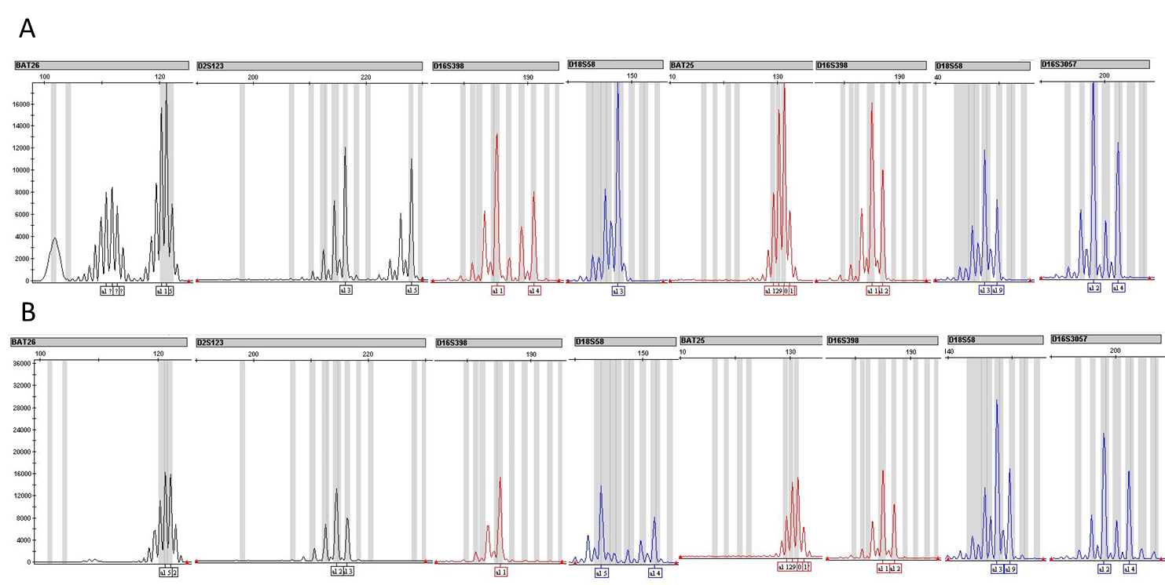

Supplementary Fig 1: (A) Representing MSI case and (B) Representing MSS case. Here Comparison was done by Tumor and blood sample of studied patient.

