Supplementary Information

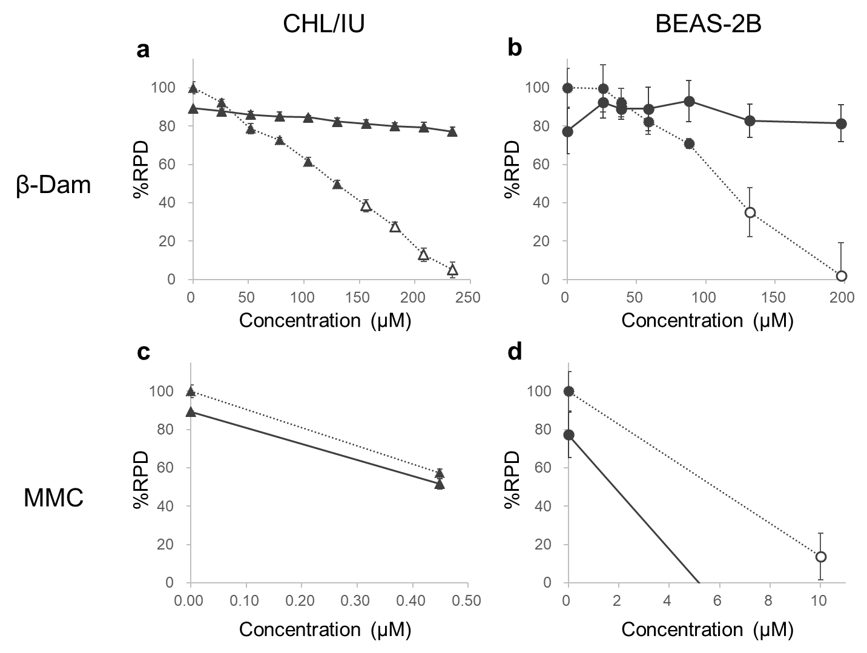

Supplementary Figure 1. Effect of N-acetyl-l-cysteine (NAC) on relative population doubling (RPD) in CHL/IU and BEAS-2B cells exposed to β-damascone (β-Dam) or mitomycin C (MMC).
RPD values (%RPD) were measured after 27 hours of exposure to β-Dam or MMC in CHL/IU cells (a, c). The same measurements were conducted in BEAS-2B cells (b, d) after 24 hours of exposure to each chemical. The solid and dotted lines represent the values obtained with or without NAC co-treatment, respectively. The closed and open symbols represent the values obtained at concentrations causing more than and less than 40% RPD, respectively. Each result represents the mean and standard error of the mean for three independent experiments.
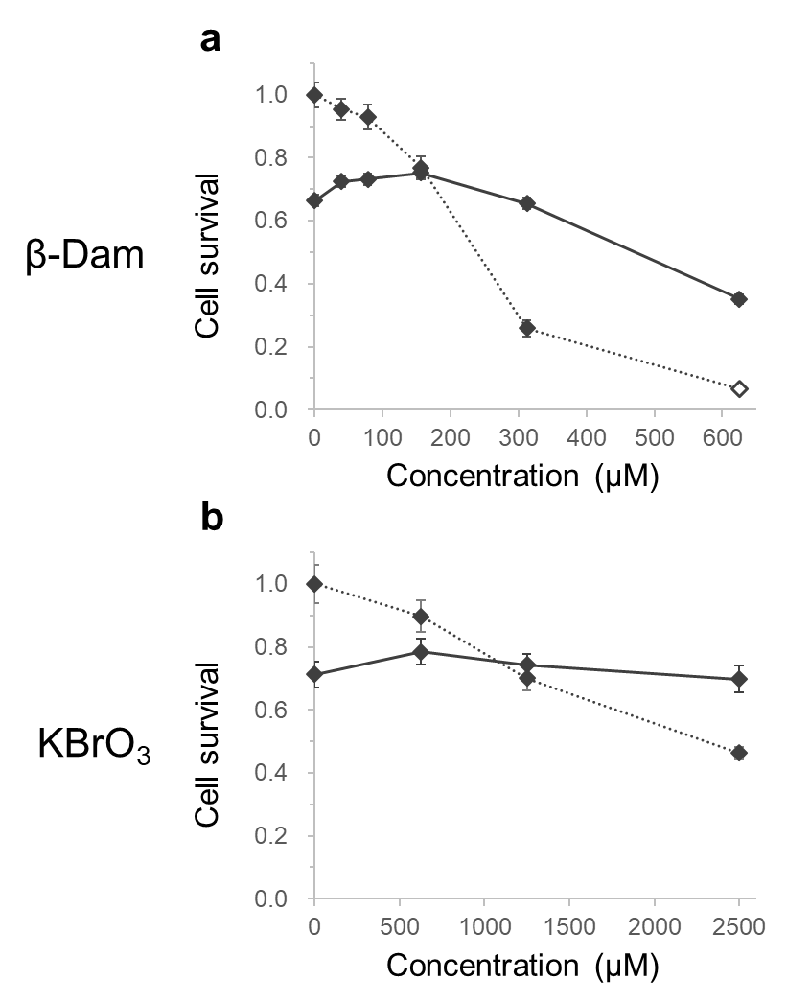

Supplementary Figure 2. Effect of N-acetyl-l-cysteine (NAC) on relative cell survival in mouse embryonic stem reporter cell lines exposed to β-damascone (β-Dam) or potassium bromate (KBrO₃).
Cell survival levels after 24 hours of exposure to β-Dam (a) or KBrO₃ (b) were calculated from the normalized cell count. The solid and dotted lines represent the values obtained in the co-treatment with or without NAC, respectively. The closed and open symbols represent the values obtained at concentrations causing more than and less than 25% relative cell survival, respectively. Each result represents the mean and standard error of the mean for three independent experiments.

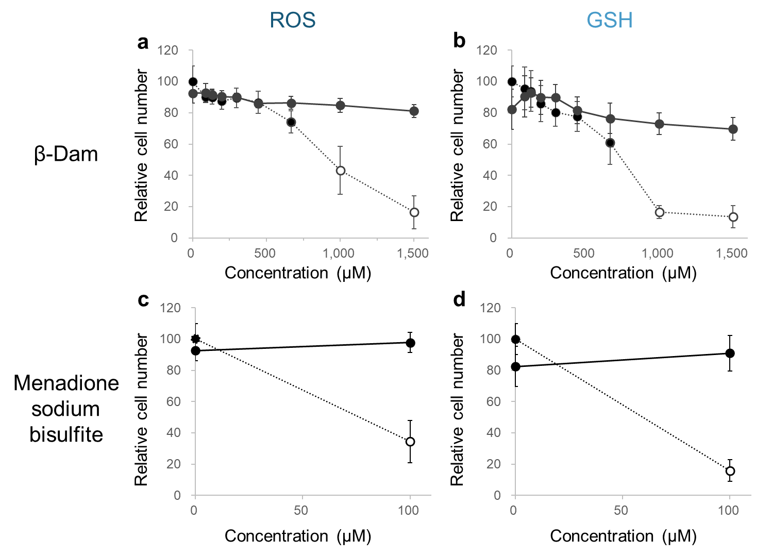

Supplementary Figure 3. Effect of N-acetyl-l-cysteine (NAC) on the relative cell number in BEAS-2B cells exposed to β-damascone (β-Dam) or menadione.
The relative cell number was calculated after 24 hours of exposure to β-Dam or menadione sodium bisulfite in BEAS-2B cells for measuring reactive oxygen species (ROS) (a, c) and glutathione (GSH) (b, d) levels. The solid and dotted lines represent the values obtained with or without NAC co-treatment, respectively. The closed and open symbols represent the values obtained at concentrations causing more than and less than 50% relative cell number, respectively. Each result represents the mean and standard error of the mean for three independent experiments.

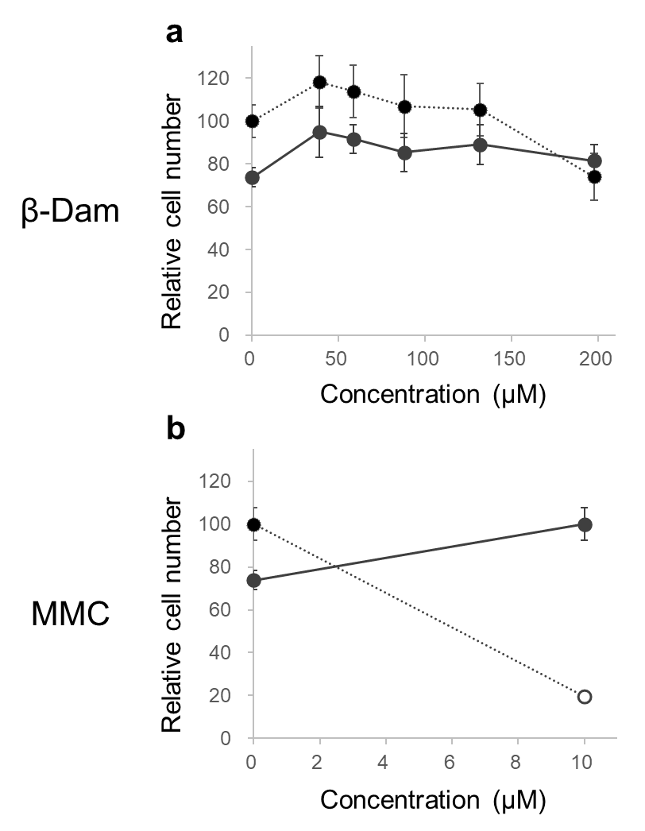

Supplementary Figure 4. Effect of N-acetyl-l-cysteine (NAC) on the relative cell number in BEAS-2B cells exposed to β-damascone (β-Dam) or mitomycin C (MMC).
The relative cell number was calculated after 24 hours of exposure to β-Dam (a) or MMC (b) in BEAS-2B cells for measuring γH2AX foci. The solid and dotted lines represent the values obtained with or without NAC co-treatment, respectively. The closed and open symbols represent the values obtained at concentrations causing more than and less than 50% relative cell number, respectively. Each result represents the mean and standard error of the mean for three independent experiments.

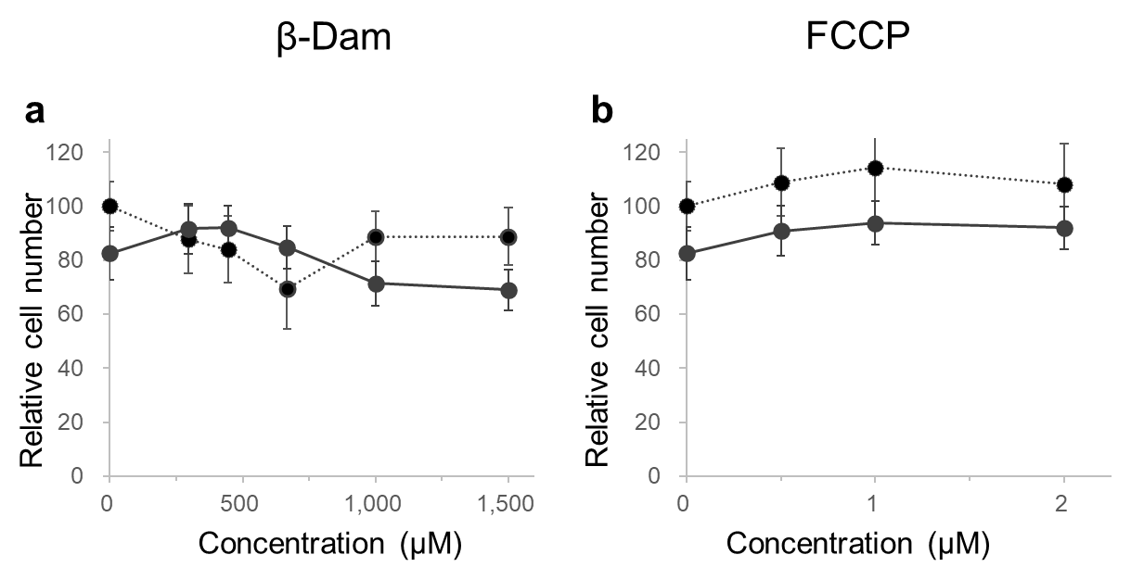

Supplementary Figure 5. Effect of N-acetyl-L-cysteine (NAC) on the relative cell number in BEAS-2B cells exposed to β-damascone (β-Dam) or mitochondrial poison.
The relative cell number was calculated after 4 hours of exposure to β-Dam (a) or a mitochondrial poison, carbonyl cyanide 4-(trifluoromethoxy) phenyl-hydrazone (FCCP) (b) in BEAS-2B cells. The solid and dotted lines represent the values obtained with or without NAC co-treatment, respectively. Each result represents the mean and standard error of the mean for three independent experiments.

