Pamphlet Cover Page: “Your child’s nutrients (health) in CSB-Oil porridge”
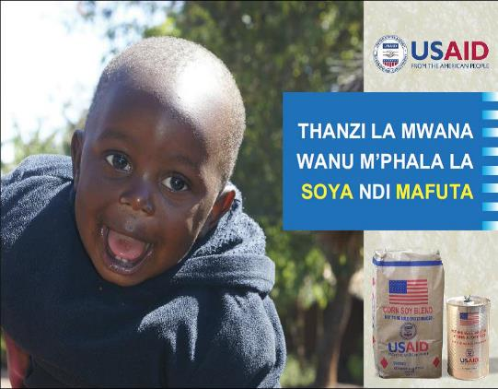

Banner
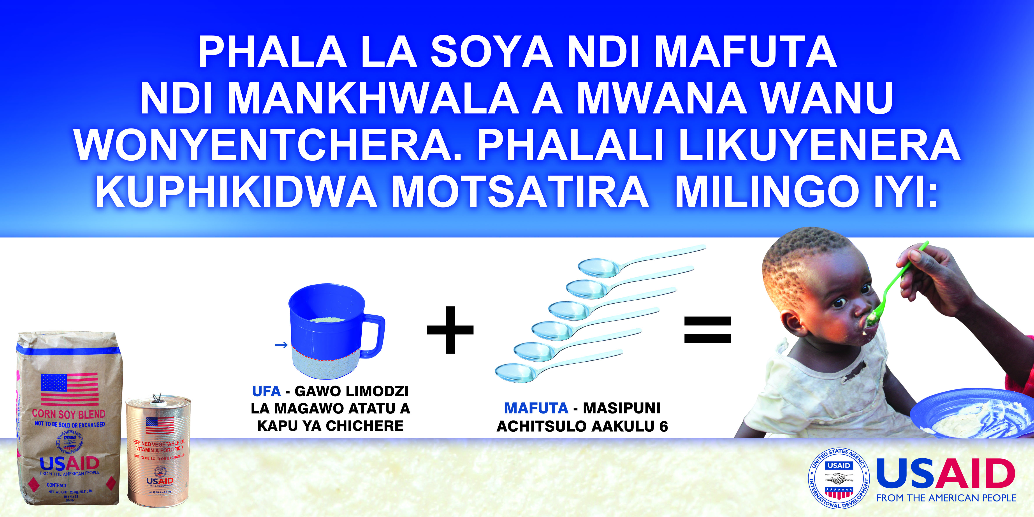

Two kg CSB packets
