Supplemental Materials
Short-term effects of air pollutants on hospitalization for childhood respiratory diseases in Suzhou City: a time-stratified case-crossover study

Ruoqi Zhang^{ab+}, Jiawei Chen^{a+}, Mengru Wang^{b}, Zhengrong Chen^{a*}, Hongpeng Sun^{b*1}

⁺Ruoqi Zhang and Jiawei Chen are the co-first authors
Ruoqi Zhang Email:564626235@qq.com
Jiawei Chen Email:976612014@qq.com
Mengru Wang Email:1511771528@qq.com
*Correspondence:
Hongpeng Sun Email:hpsun@suda.edu.cn
Zhengrong Chen Email:chenzhengrong@suda.edu.cn
ªDepartment of Respiratory Medicine, Children’s Hospital of Soochow University, Suzhou, China
^{b}School of Public Health, Medical College of Soochow University, Suzhou 215123, China
¹Handling of correspondence at all stages of review and publication and after publication

Table of Contents
Table S1 Spearman correlation coefficients between air pollutants and meteorological factors during the study period
Table S2 Association between air pollutants and hospitalization for respiratory diseases in children on different lag days
Table S3 Association between air pollutants and hospitalizations for respiratory diseases in different subgroups on the optimal lag day
Table S4 Association between air pollutants and hospitalization for respiratory diseases in a two-pollutant model
Table S5 Model accuracy when k takes different values

Table S1 Spearman correlation coefficients between air pollutants and meteorological factors during the study period
 | PM_{2.5} | PM₁₀ | SO₂ | CO | NO₂ | O₃ | Temp | Rh | Hpa
PM_{2.5} | 1.00
PM₁₀ | 0.85ª | 1.00
SO₂ | 0.52ª | 0.56 ª | 1.00
CO | 0.75ª | 0.64ª | 0.59ª | 1.00
NO₂ | 0.69ª | 0.71ª | 0.58ª | 0.61ª | 1.00
O₃ | -0.10ª | 0.03 | 0.01 | -0.15ª | -0.25ª | 1.00
Temp | -0.45ª | -0.35ª | -0.28ª | -0.35ª | -0.42ª | 0.57ª | 1.00
Rh | -0.10ª | -0.32ª | -0.38ª | 0.01 | -0.12ª | -0.28ª | 0.22ª | 1.00
Hpa | 0.37ª | 0.32ª | 0.27ª | 0.28ª | 0.41ª | -0.48ª | -0.89ª | -0.33ª | 1.00
ªp<0.001
^{b}p<0.0
Table S2 Association between air pollutants and hospitalization for respiratory diseases in children on different lag days
 | PM_{2.5} |  |  | PM₁₀ |  |  | SO₂ |  |  | NO₂ |  |  | O₃ |  |  | CO
Lag days | P | OR | 95%CI | P | OR | 95%CI | P | OR | 95%CI | P | OR | 95%CI | P | OR | 95%CI | P | OR | 95%CI
0 | 0.1011 | 1.009 | 0.998-1.020 | 0.0479 | 1.009 | 1.000-1.017 | 0.2432 | 1.058 | 0.962-1.164 | 0.0424 | 1.016 | 1.001-1.032 | 0.7153 | 0.999 | 0.991-1.006 | 0.1455 | 1.086 | 0.972-1.213
1 | 0.0047 | 1.015 | 1.005-1.026 | 0.0027 | 1.013 | 1.004-1.021 | 0.0249 | 1.116 | 1.014-1.228 | 0.0003 | 1.029 | 1.013-1.045 | 0.9756 | 1.000 | 0.993-1.007 | 0.0125 | 1.150 | 1.030-1.283
2 | 0.2565 | 1.006 | 0.996-1.017 | 0.1184 | 1.007 | 0.998-1.015 | 0.8544 | 1.009 | 0.916-1.111 | 0.1141 | 1.013 | 0.997-1.029 | 0.8360 | 0.999 | 0.992-1.006 | 0.0219 | 1.138 | 1.019-1.271
3 | 0.9219 | 0.999 | 0.989-1.010 | 0.6853 | 0.998 | 0.990-1.007 | 0.4179 | 0.961 | 0.872-1.059 | 0.4321 | 1.006 | 0.991-1.022 | 0.3654 | 0.997 | 0.990-1.004 | 0.3254 | 1.057 | 0.946-1.181
4 | 0.3366 | 0.995 | 0.984-1.006 | 0.1930 | 0.994 | 0.986-1.003 | 0.3094 | 0.952 | 0.865-1.047 | 0.6246 | 1.004 | 0.988-1.020 | 0.5088 | 1.002 | 0.995-1.010 | 0.0650 | 0.900 | 0.805-1.007
5 | 0.9098 | 1.001 | 0.990-1.011 | 0.7451 | 1.001 | 0.993-1.010 | 0.5754 | 1.028 | 0.933-1.134 | 0.0575 | 1.015 | 1.000-1.032 | 0.9028 | 1.000 | 0.992-1.007 | 0.8980 | 1.007 | 0.900-1.127
6 | 0.2447 | 1.006 | 0.996-1.017 | 0.0606 | 1.008 | 1.000-1.017 | 0.9695 | 1.002 | 0.909-1.105 | 0.2103 | 1.010 | 0.994-1.026 | 0.9909 | 1.000 | 0.993-1.007 | 0.0807 | 1.105 | 0.988-1.236
7 | 0.9130 | 1.001 | 0.990-1.011 | 0.2143 | 1.005 | 0.997-1.014 | 0.3322 | 1.048 | 0.953-1.154 | 0.2077 | 1.010 | 0.994-1.026 | 0.7178 | 0.999 | 0.992-1.006 | 0.2634 | 1.065 | 0.954-1.189
0-1 | 0.0097 | 1.016 | 1.004-1.029 | 0.0043 | 1.014 | 1.004-1.024 | 0.0481 | 1.117 | 1.001-1.247 | 0.0015 | 1.028 | 1.011-1.046 | 0.8562 | 0.999 | 0.991-1.008 | 0.0186 | 1.169 | 1.026-1.330
0-2 | 0.0157 | 1.017 | 1.003-1.031 | 0.0059 | 1.015 | 1.004-1.026 | 0.1409 | 1.096 | 0.970-1.239 | 0.0034 | 1.029 | 1.009-1.049 | 0.8210 | 0.999 | 0.990-1.008 | 0.0050 | 1.235 | 1.066-1.432
0-3 | 0.0503 | 1.015 | 1.000-1.031 | 0.0342 | 1.013 | 1.001-1.024 | 0.3814 | 1.062 | 0.928-1.214 | 0.0091 | 1.028 | 1.007-1.049 | 0.6416 | 0.998 | 0.987-1.008 | 0.0070 | 1.253 | 1.064-1.475
0-4 | 0.1325 | 1.013 | 0.996-1.030 | 0.1181 | 1.010 | 0.997-1.023 | 0.5637 | 1.043 | 0.903-1.205 | 0.0122 | 1.029 | 1.006-1.052 | 0.8697 | 0.999 | 0.988-1.010 | 0.0620 | 1.185 | 0.992-1.416
0-5 | 0.1766 | 1.012 | 0.994-1.031 | 0.1491 | 1.010 | 0.996-1.024 | 0.5610 | 1.047 | 0.897-1.221 | 0.0094 | 1.032 | 1.008-1.056 | 0.8772 | 0.999 | 0.987-1.011 | 0.0951 | 1.177 | 0.972-1.426
0-6 | 0.1369 | 1.015 | 0.995-1.034 | 0.0828 | 1.013 | 0.998-1.028 | 0.6645 | 1.037 | 0.880-1.222 | 0.0109 | 1.033 | 1.007-1.059 | 0.8881 | 0.999 | 0.987-1.012 | 0.0487 | 1.229 | 1.001-1.509
0-7 | 0.1603 | 1.015 | 0.994-1.036 | 0.0595 | 1.015 | 0.999-1.031 | 0.5609 | 1.054 | 0.883-1.257 | 0.0094 | 1.036 | 1.009-1.064 | 0.8237 | 0.998 | 0.985-1.012 | 0.0346 | 1.267 | 1.017-1.579

Table S3 Association between air pollutants and hospitalizations for respiratory diseases in different subgroups on the optimal lag day
 | PM_{2.5} lag0-2 |  | PM₁₀ lag0-2 |  | SO₂ lag01 |  | NO₂ lag0-7 |  | CO lag0-7(1mg/m³)
Subgroup | OR（95%CI） | P | OR（95%CI） | P | OR（95%CI） | P | OR（95%CI） | P | OR（95%CI） | P
Admission stage |  | 0.717 |  | 0.544 |  | 0.688 |  | 0.510 |  | 0.644
Pre-COVID-19 pandemic | 1.014(0.998-1.031) |  | 1.011(0.998-1.024) |  | 1.099(0.971-1.244) |  | 1.023(0.989-1.057) |  | 1.214(0.927-1.588)
Post-COVID-19 pandemic | 1.025(0.999-1.051) |  | 1.025(1.005-1.045) |  | 1.219(0.929-1.600) |  | 1.060(1.013-1.109) |  | 1.435(0.967-2.130)
Sex |  | 0.771 |  | 0.449 |  | 0.523 |  | 0.940 |  | 0.359
Boys | 1.020(1.002-1.038) |  | 1.021(1.007-1.034) |  | 1.173(1.021-1.348) |  | 1.036(1.002-1.072) |  | 1.109(0.839-1.466)
Girls | 1.012(0.990-1.033) |  | 1.005(0.989-1.022) |  | 1.032(0.869-1.226) |  | 1.032(0.991-1.076) |  | 1.513(1.076-2.126)
Age
Infants and toddlers | 1.008(0.992-1.025) | ref | 1.009(0.997-1.022) | ref | 0.993(0.873-1.130) | ref | 1.012(0.980-1.045) | ref | 1.061(0.816-1.381) | ref
Preschool- age | 1.018(0.989-1.049) | 0.765 | 1.015(0.993-1.037) | 0.811 | 1.276(1.006-1.620) | 0.297 | 1.079(1.021-1.142) | 0.298 | 1.350(0.846-2.153) | 0.590
School-age and above | 1.057(1.016-1.100) | 0.251 | 1.039(1.009-1.070) | 0.349 | 1.849(1.323-2.585) | 0.017 | 1.087(1.008-1.173) | 0.363 | 2.666(1.446-4.914) | 0.016
Season |  | 0.862 |  | 0.789 |  | 0.808 |  | 0.987 |  | 0.398
Warm | 1.021(0.990-1.053) |  | 1.018(1.000-1.037) |  | 1.162(0.931-1.451) |  | 1.034(0.980-1.091) |  | 1.061(0.756-1.488)
Cold | 1.015(1.000-1.031) |  | 1.012(0.999-1.026) |  | 1.100(0.968-1.250) |  | 1.035(1.002-1.069) |  | 1.440(1.073-1.933)

Table S4 Association between air pollutants and hospitalization for respiratory diseases in a two-pollutant model
 | Two-pollutant models | OR | 95%CI | P
PM_{2.5}ª |  | 1.017 | 1.003-1.031 | 0.0157
 | +SO₂ | 1.017 | 1.000-1.034 | 0.0558
 | +O₃ | 1.019 | 1.005-1.034 | 0.0090
PM₁₀ª |  | 1.015 | 1.004-1.026 | 0.0059
 | +SO₂ | 1.015 | 1.002-1.028 | 0.0200
 | +O₃ | 1.017 | 1.005-1.028 | 0.0034
SO₂^{b} |  | 1.117 | 1.001-1.247 | 0.0481
 | +PM_{2.5} | 1.039 | 0.906-1.191 | 0.5815
 | +PM₁₀ | 1.034 | 0.907-1.179 | 0.6182
 | +NO₂ | 1.004 | 0.874-1.154 | 0.9506
 | +CO | 1.055 | 0.923-1.205 | 0.4310
 | +O₃ | 1.119 | 1.002-1.250 | 0.0455
CO^{c} |  | 1.267 | 1.017-1.579 | 0.0346
 | +SO₂ | 1.322 | 1.021-1.710 | 0.0339
 | +O₃ | 1.298 | 1.034-1.630 | 0.0247
NO₂^{c} |  | 1.036 | 1.009-1.064 | 0.0094
 | +SO₂ | 1.049 | 1.014-1.084 | 0.0051
 | +O₃ | 1.037 | 1.009-1.065 | 0.0084
a: lag0-2d
b: lag0-1d
c: lag0-7d

Table S5 Model accuracy when k takes different values
K | Accuracy
5 | 0.8086
6 | 0.8382
7 | 0.8109
8 | 0.8360
9 | 0.8246
10 | 0.8383
11 | 0.8314
12 | 0.8451
13 | 0.8428
14 | 0.8451
15 | 0.8451
16 | 0.8451
17 | 0.8383
18 | 0.8383
19 | 0.8383
20 | 0.8428

Figure of Contents
Fig. S1 Time series plot of air pollutant concentrations and hospitalizations for respiratory illnesses during the pre-COVID-19 period
Fig. S2 Time series plot of air pollutant concentrations and hospitalizations for respiratory illnesses during the post-COVID-19 period
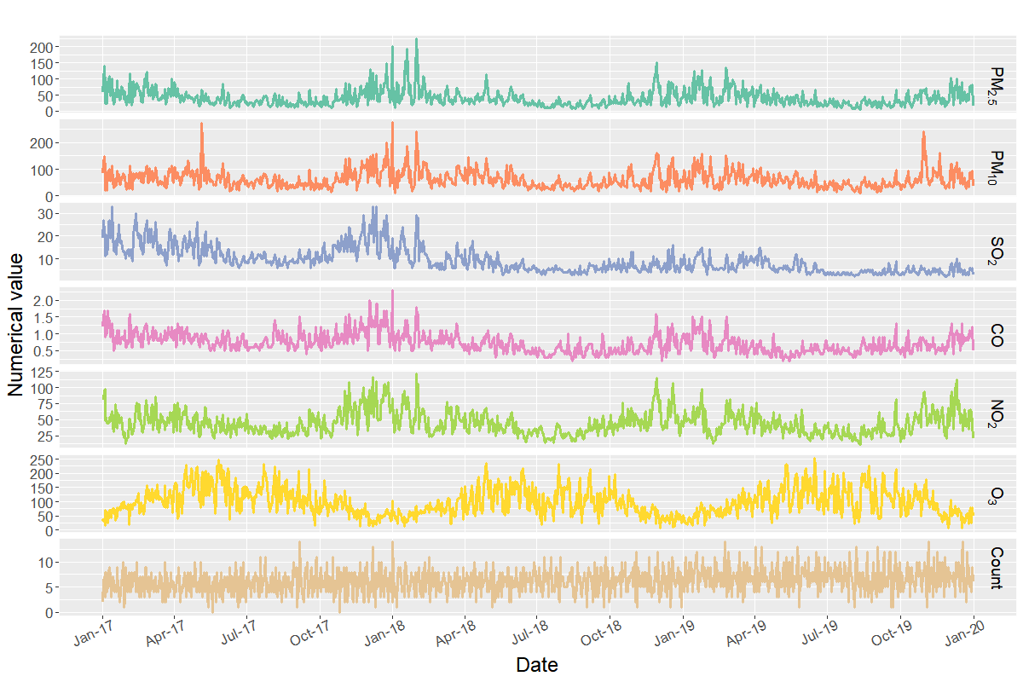
Fig. S1 Time series plot of air pollutant concentrations and hospitalizations for respiratory illnesses during the pre-COVID-19 period

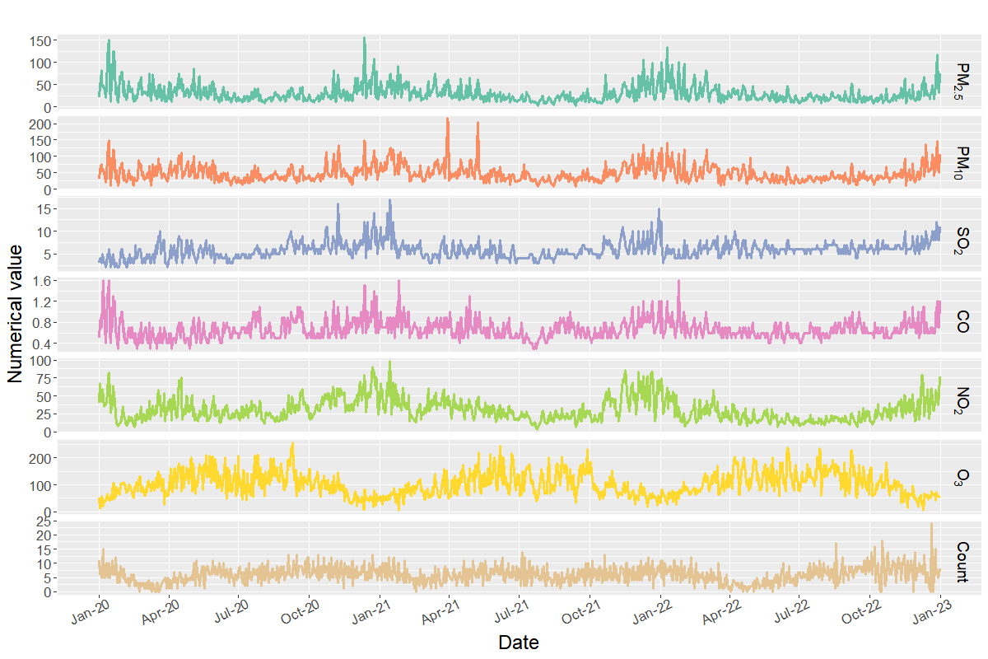
Fig. S2 Time series plot of air pollutant concentrations and hospitalizations for respiratory illnesses during the post-COVID-19 period

