The total number of fracture case with control (non-fracture case) matched based on gender, Age, and BMI
Call:
matchit(formula = any_fracture ~ Gender + RIDAGEYR + BMXBMI,
data = dat1, method = "nearest", caliper = 0.25 * ps.sd,
ratio = 4)

Summary of balance for all data:
Means Treated Means Control SD Control Mean Diff eQQ Med eQQ Mean eQQ Max
distance 0.1288 0.0470 0.0669 0.0818 0.0824 0.0815 0.1267
Gender 0.5176 0.5093 0.4999 0.0083 0.0000 0.0094 1.0000
RIDAGEYR 59.3138 29.9022 22.3947 29.4116 36.0000 29.3981 39.0000
BMXBMI 29.5852 25.1154 7.9437 4.4699 4.4000 4.5089 19.9000

Summary of balance for matched data:
Means Treated Means Control SD Control Mean Diff eQQ Med eQQ Mean eQQ Max
distance 0.1278 0.1278 0.0758 0.0001 0.0051 0.0058 0.0179
Gender 0.5176 0.5212 0.4997 -0.0035 0.0000 0.0047 1.0000
RIDAGEYR 59.2376 58.9680 12.6522 0.2696 1.0000 1.1529 14.0000
BMXBMI 29.4998 30.1055 7.8318 -0.6058 0.2000 0.7365 19.9000

Percent Balance Improvement:
Mean Diff. eQQ Med eQQ Mean eQQ Max
distance 99.9117 93.8234 92.9173 85.8333
Gender 57.3773 0.0000 49.7647 0.0000
RIDAGEYR 99.0833 97.2222 96.0782 64.1026
BMXBMI 86.4478 95.4545 83.6663 0.0000

Sample sizes:
Control Treated
All 7917 1311
Matched 4351 1140
Unmatched 3566 171
Discarded 0 0

The jitter plot for the distribution of propensity score (ratio 1:4)
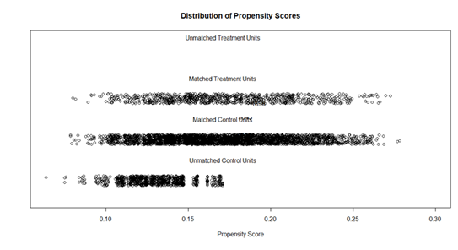
The histogram to check case (fracture case) distribution with control (non-fracture)
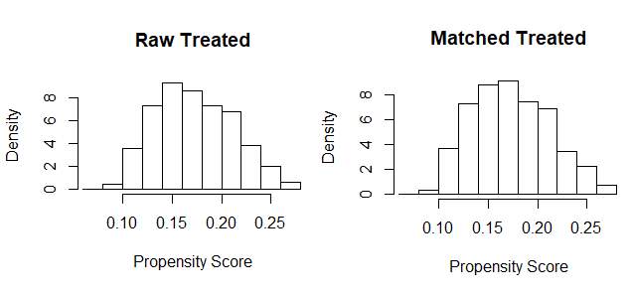
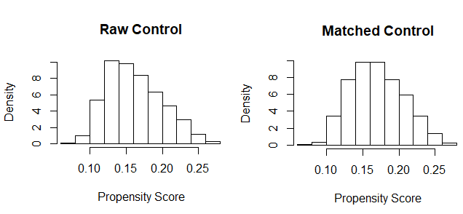
The QQ normality check plot
