Clinical Effectiveness of Cinnamon Supplementation on Cardiovascular Health: A GRADE-Assessed Systematic Review and Dose-Response Meta-Analysis of Randomized Controlled Trials

Supplementary materials: Supplementary Tables 1-2, Supplementary Figure 1-11, and Supplementary References.

Supplementary Table 1. Search strategy to find potential eligible randomised controlled trials (July 2024)
Groups | Descriptors
Intervention | Cinnamon* OR Cinnamomum* OR “cinnamomum cassia” OR “cinnamomum zeylanicum” OR “cinnamomum aromaticum” OR “Cinnamomum camphora*” OR cinnamaldehyde OR “Cinnamomum Verum” OR “true cinnamon” OR “Lankan cinnamon” OR “cinnamon cassia” OR “Chinese cinnamon*” OR “cinnamon extract” OR “cinnamon Bark” OR cinnamo* OR cinnamic OR Cinnamomum OR true cinnamon OR “Ceylon cinnamon” OR Darchini OR “cinnamic aldehyde”
Design | Intervention OR “Intervention Study” OR “Intervention Studies” OR “controlled trial” OR random* OR placebo OR “clinical trial” OR Trial OR “randomized controlled trial” OR “randomized clinical trial” OR RCT OR blinded OR “double blind” OR “double blinded” OR trial* OR “Pragmatic Clinical Trial” OR “Cross-Over Studies” OR “Cross-Over” OR “Cross-Over Study” OR parallel OR “parallel study” OR “parallel trial”

PubMed
Number of localized studies: 1,110
 | Descriptors | Number of studies reached
#1 | Cinnamon*[Title/Abstract] OR Cinnamomum*[Title/Abstract] OR "cinnamomum cassia"[Title/Abstract] OR "cinnamomum zeylanicum"[Title/Abstract] OR "cinnamomum aromaticum"[Title/Abstract] OR "Cinnamomum camphora*"[Title/Abstract] OR cinnamaldehyde[Title/Abstract] OR "Cinnamomum Verum"[Title/Abstract] OR "true cinnamon"[Title/Abstract] OR "Lankan cinnamon"[Title/Abstract] OR "cinnamon cassia"[Title/Abstract] OR "Chinese cinnamon*"[Title/Abstract] OR "cinnamon extract"[Title/Abstract] OR "cinnamon Bark"[Title/Abstract] OR cinnamo*[Title/Abstract] OR cinnamic[Title/Abstract] OR Cinnamomum[Title/Abstract] OR true cinnamon[Title/Abstract] OR "Ceylon cinnamon"[Title/Abstract] OR Darchini[Title/Abstract] OR "cinnamic aldehyde"[Title/Abstract] OR "Cinnamomum zeylanicum"[Mesh] OR "Cinnamomum aromaticum"[Mesh] OR "Cinnamomum"[Mesh] OR "Cinnamomum camphora"[Mesh] | 14,504
#2 | Intervention[Title/Abstract] OR "Intervention Study"[Title/Abstract] OR "Intervention Studies"[Title/Abstract] OR "controlled trial"[Title/Abstract] OR random*[Title/Abstract] OR placebo[Title/Abstract] OR "clinical trial"[Title/Abstract] OR Trial[Title/Abstract] OR "randomized controlled trial"[Title/Abstract] OR "randomized clinical trial"[Title/Abstract] OR RCT[Title/Abstract] OR blinded[Title/Abstract] OR "double blind"[Title/Abstract] OR "double blinded"[Title/Abstract] OR trial*[Title/Abstract] OR "Pragmatic Clinical Trial"[Title/Abstract] OR "Cross-Over Studies"[Title/Abstract] OR "Cross-Over"[Title/Abstract] OR "Cross-Over Study"[Title/Abstract] OR parallel[Title/Abstract] OR "parallel study"[Title/Abstract] OR "parallel trial"[Title/Abstract] OR "Clinical Trial" [Publication Type] OR "Randomized Controlled Trial" [Publication Type] OR "Controlled Clinical Trial" [Publication Type] OR "Random Allocation"[Mesh] OR "Randomized Controlled Trials as Topic"[Mesh] OR "Pragmatic Clinical Trial" [Publication Type] OR "Pragmatic Clinical Trials as Topic"[Mesh] OR "Double-Blind Method"[Mesh] OR "Single-Blind Method"[Mesh] OR "Cross-Over Studies"[Mesh] | 3,681,225
#3 | #1 AND #2 | 1,110

Web of Science
Number of localized studies: 1,889
 | Descriptors | Number of studies reached
#1 | TS=(Cinnamon* OR Cinnamomum* OR “cinnamomum cassia” OR “cinnamomum zeylanicum” OR “cinnamomum aromaticum” OR “Cinnamomum camphora*” OR cinnamaldehyde OR “Cinnamomum Verum” OR “true cinnamon” OR “Lankan cinnamon” OR “cinnamon cassia” OR “Chinese cinnamon*” OR “cinnamon extract” OR “cinnamon Bark” OR cinnamo* OR cinnamic OR Cinnamomum OR true cinnamon OR “Ceylon cinnamon” OR dalchini OR “cinnamic aldehyde”) | 32,170
#2 | TS=(Intervention OR “Intervention Study” OR “Intervention Studies” OR “controlled trial” OR random* OR placebo OR “clinical trial” OR Trial OR “randomized controlled trial” OR “randomized clinical trial” OR RCT OR blinded OR “double blind” OR “double blinded” OR trial* OR “Pragmatic Clinical Trial” OR “Cross-Over Studies” OR “Cross-Over” OR “Cross-Over Study” OR parallel OR “parallel study” OR “parallel trial”) | 5,586,808
#3 | #1 AND #2 | 1,889

Scopus
Number of localized studies: 1,324
 | Descriptors | Number of studies reached
#1 | TITLE-ABS-KEY ( cinnamon* OR cinnamomum* OR "cinnamomum cassia" OR "cinnamomum zeylanicum" OR "cinnamomum aromaticum" OR "Cinnamomum camphora*" OR cinnamaldehyde OR "Cinnamomum Verum" OR "true cinnamon" OR "Lankan cinnamon" OR "cinnamon cassia" OR "Chinese cinnamon*" OR "cinnamon extract" OR "cinnamon Bark" OR cinnamo* OR cinnamic OR cinnamomum OR true AND cinnamon OR "Ceylon cinnamon" OR darchini OR "cinnamic aldehyde" ) | 10,562
#2 | TITLE-ABS-KEY ( intervention OR "Intervention Study" OR "Intervention Studies" OR "controlled trial" OR random* OR placebo OR "clinical trial" OR trial OR "randomized controlled trial" OR "randomized clinical trial" OR rct OR blinded OR "double blind" OR "double blinded" OR trial* OR "Pragmatic Clinical Trial" OR "Cross-Over Studies" OR "Cross-Over" OR "Cross-Over Study" OR parallel OR "parallel study" OR "parallel trial" ) | 7,944,873
#3 | #1 AND #2 | 1,324

Embase
Number of localized studies: 2,817
 | Descriptors | Number of studies reached
#1 | 'cinnamon'/exp OR 'cinnamomum'/exp OR 'cinnamomum zeylanicum'/exp OR 'cinnamomum cassia'/exp OR 'cinnamomum camphora'/exp OR 'cinnamomum cassia extract'/exp OR 'cinnamomum zeylanicum extract'/exp OR 'cinnamomum tamala'/exp | 6,390
#2 | 'randomized controlled trial'/exp OR 'randomized controlled trial (topic)'/exp OR 'pragmatic trial'/exp OR 'clinical trial'/exp OR 'clinical trial (topic)'/exp OR 'intervention study'/exp OR 'controlled study'/exp OR 'controlled clinical trial'/exp OR 'double blind procedure'/exp OR 'single blind procedure'/exp OR 'crossover procedure'/exp OR 'parallel design'/exp | 11,771,726
#3 | #1 AND #2 | 2,817

Cochrane
Number of localized studies: 790
Limits: TRIALS
 | Descriptors | Number of studies reached
#1 | (Cinnamon* OR Cinnamomum* OR “cinnamomum cassia” OR “cinnamomum zeylanicum” OR “cinnamomum aromaticum” OR (Cinnamomum NEXT camphora*) OR cinnamo* OR cinnamaldehyde OR “Cinnamomum Verum” OR “true cinnamon” OR “Lankan cinnamon” OR “cinnamon cassia” OR (Chinese NEXT cinnamon*) OR “cinnamon extract” OR “cinnamon Bark” OR cinnamic OR Cinnamomum OR true cinnamon OR “Ceylon cinnamon” OR Darchini OR “cinnamic aldehyde”):ti,ab,kw | 790

Supplementary Table 2. A summary of excluded articles after full text review
Author, Year (Ref.) | Reason
Altschuler, 2007 (1) | Relevance to Research Scope
Hlebowicz, 2007 (2) | Quality and Completeness of Data
Solomon, 2007 (3) | Quality and Completeness of Data
Pham, 2007(4) | Relevance to Research Scope
Wang, 2007 (5) | Quality and Completeness of Data
Tang, 2008 (6) | Quality and Completeness of Data
Hlebowicz, 2009 (7) | Quality and Completeness of Data
Mettler, 2009 (8) | Quality and Completeness of Data
Solomon, 2009 (9) | Quality and Completeness of Data
Mishra, 2010(10) | Relevance to Research Scope
Otto, 2010 (11) | Quality and Completeness of Data
Markey, 2011 (12) | Quality and Completeness of Data
Magistrelli, 2012 (13) | Quality and Completeness of Data
Hoehn, 2012(14) | Relevance to Research Scope
Zahmatkesh, 2012 (15) | Language and Accessibility
Kort, 2013 (16) | Quality and Completeness of Data
Mashhadi, 2013 (17) | Relevance to Research Scope
Mashhadi, 2013 (18) | Relevance to Research Scope
Soare, 2014 (19) | Relevance to Research Scope
Bernardo, 2015 (20) | Quality and Completeness of Data
Liu, 2015 (21) | Relevance to Research Scope
Salehpour, 2015 (22) | Relevance to Research Scope
Amairabadi, 2016 (23) | Language and Accessibility
Gutierrez, 2016 (24) | Quality and Completeness of Data
Torabi, 2016 (25) | Language and Accessibility
Sahib, 2016(26) | Quality and Completeness of Data
Crawford, 2016(27) | Quality and Completeness of Data
Wiweko, 2017 (28) | Relevance to Research Scope
Hochkogler, 2018 (29) | Relevance to Research Scope
Nakhaei, 2018 (30) | Language and Accessibility
Talaat, 2018 (31) | Relevance to Research Scope
Zahedifar, 2018 (32) | Language and Accessibility
Bhatia, 2019 (33) | Relevance to Research Scope
Furlan, 2019(34) | Relevance to Research Scope
Harfika, 2019 (35) | Quality and Completeness of Data
Hendre, 2019 (36) | Relevance to Research Scope
Khan, 2019 (37) | Relevance to Research Scope
Khorvash, 2019 (38) | Quality and Completeness of Data
Mehta, 2019 (39) | Relevance to Research Scope
Parseh, 2019 (40) | Language and Accessibility
Sfar, 2019 (41) | Relevance to Research Scope
Maleki, 2019(42) | Language and Accessibility
Jafar, 2020 (43) | Relevance to Research Scope
Khedr, 2020 (44) | Relevance to Research Scope
Mirmiranpour, 2020 (45) | Quality and Completeness of Data
Mohammad, 2021(46) | Relevance to Research Scope
Ahmad, 2021 (47) | Relevance to Research Scope
Chiou, 2021 (48) | Relevance to Research Scope
Patil, 2021 (49) | Quality and Completeness of Data
Permadi, 2021 (50) | Relevance to Research Scope
Sadiq, 2021 (51) | Relevance to Research Scope
Amin, 2022 (52) | Language and Accessibility
Bahri, 2022 (53) | Relevance to Research Scope
Bhuvaneswari, 2022 (54) | Relevance to Research Scope
Rachid, 2022 (55) | Relevance to Research Scope
Soares, 2022 (56) | Relevance to Research Scope
Lira Neto, 2023 (57) | Quality and Completeness of Data
Nawaz, 2023 (58) | Relevance to Research Scope
Delgadillo-Centeno, 2023(59) | Relevance to Research Scope
Farooq, 2023(60) | Relevance to Research Scope
Zelicha, 2023(61) | Quality and Completeness of Data
Zelicha, 2024(62) | Quality and Completeness of Data
Kuwabara, 2024(63) | Quality and Completeness of Data
Tanabe, 2024(64) | Quality and Completeness of Data

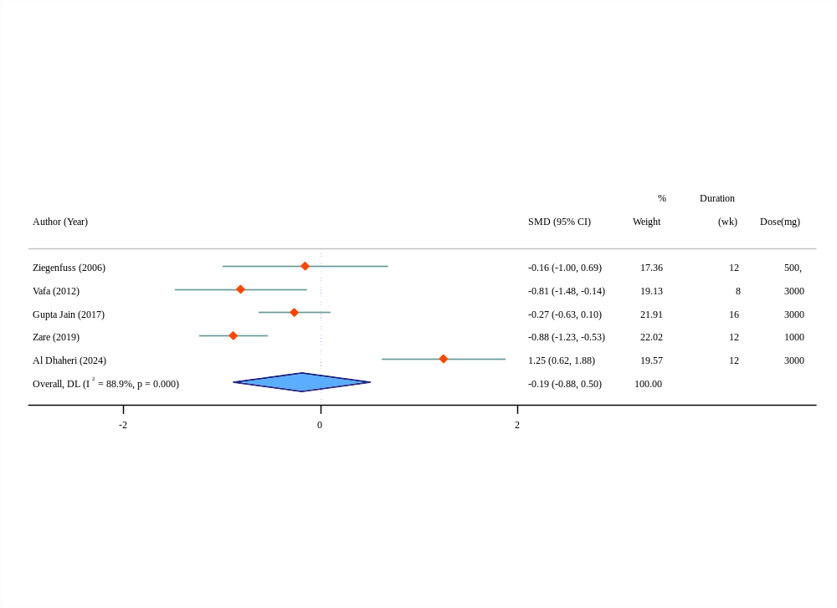
(a)
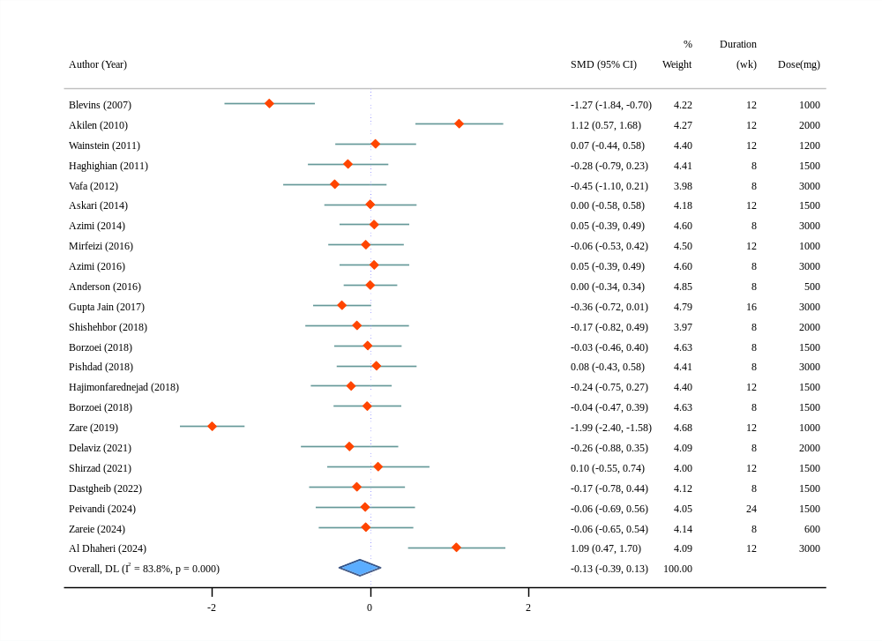
(b)
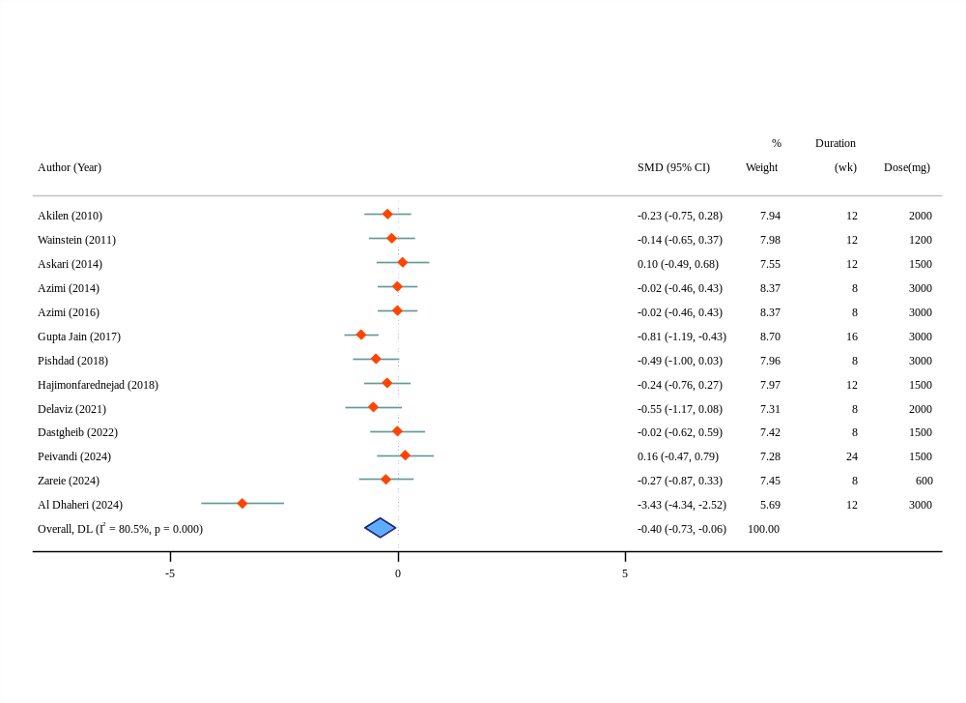
(c)
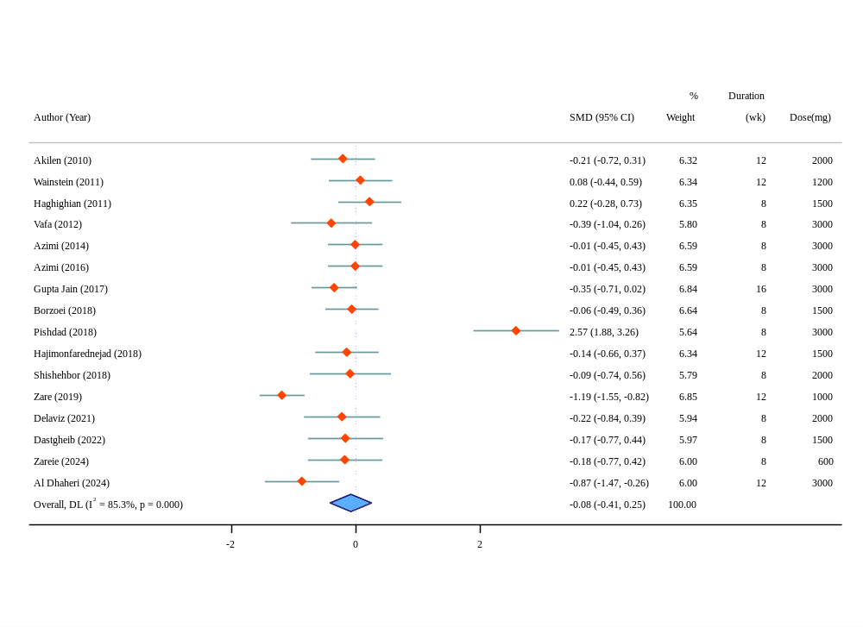
(d)
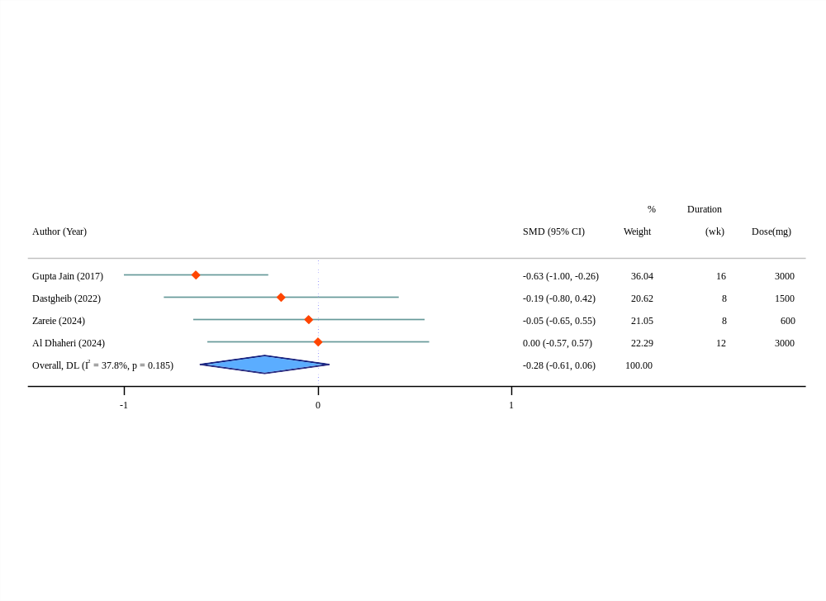
(e)
Supplementary Figure 1. Forest plot of the effects of cinnamon supplementation on anthropometric measures (a: body fat percentage, b: body mass index, c: waist circumference, d: weight, e: waist-to-hip ratio)
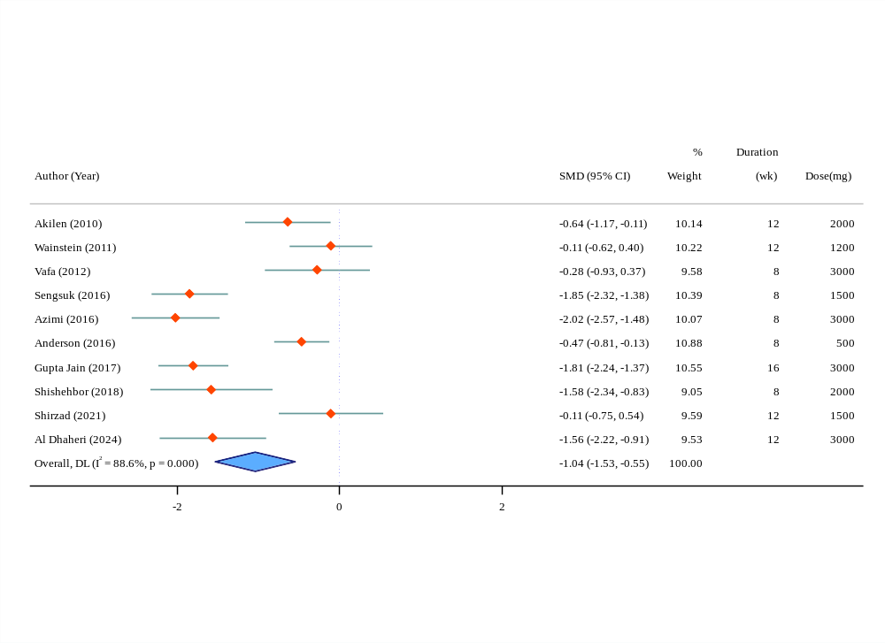
(a)
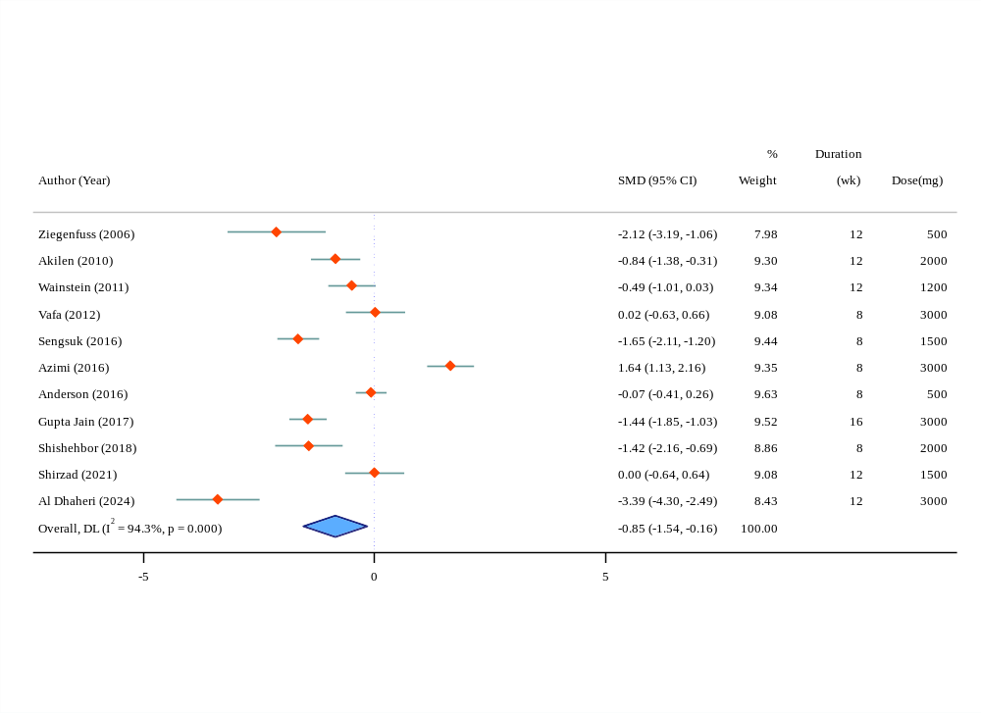
(b)
Supplementary Figure 2. Forest plot of the effects of cinnamon supplementation on blood pressure (a: diastolic blood pressure, b: systolic blood pressure)
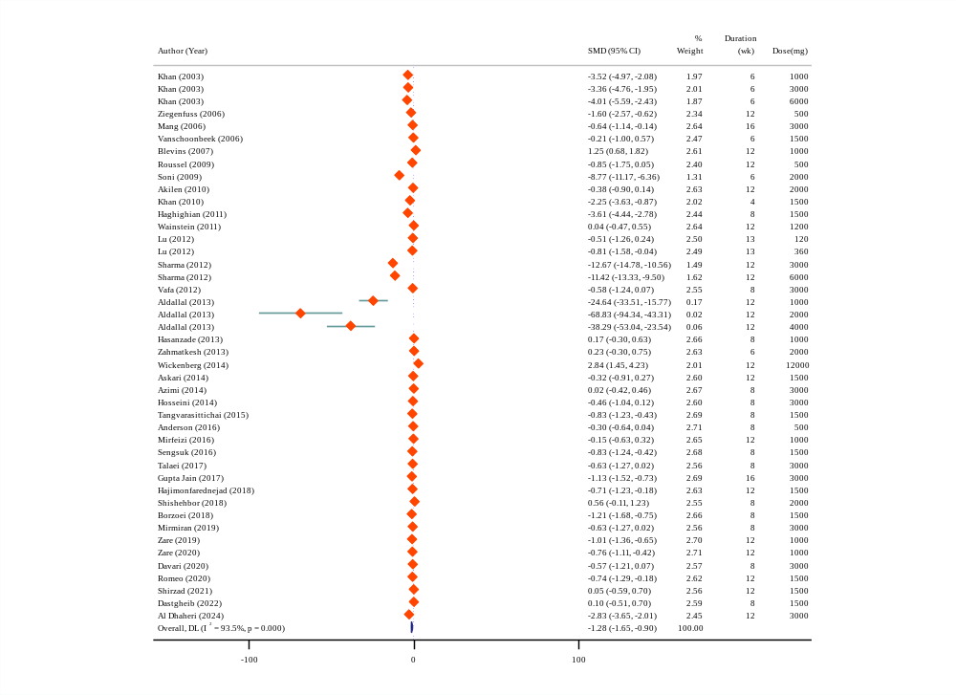
(a)
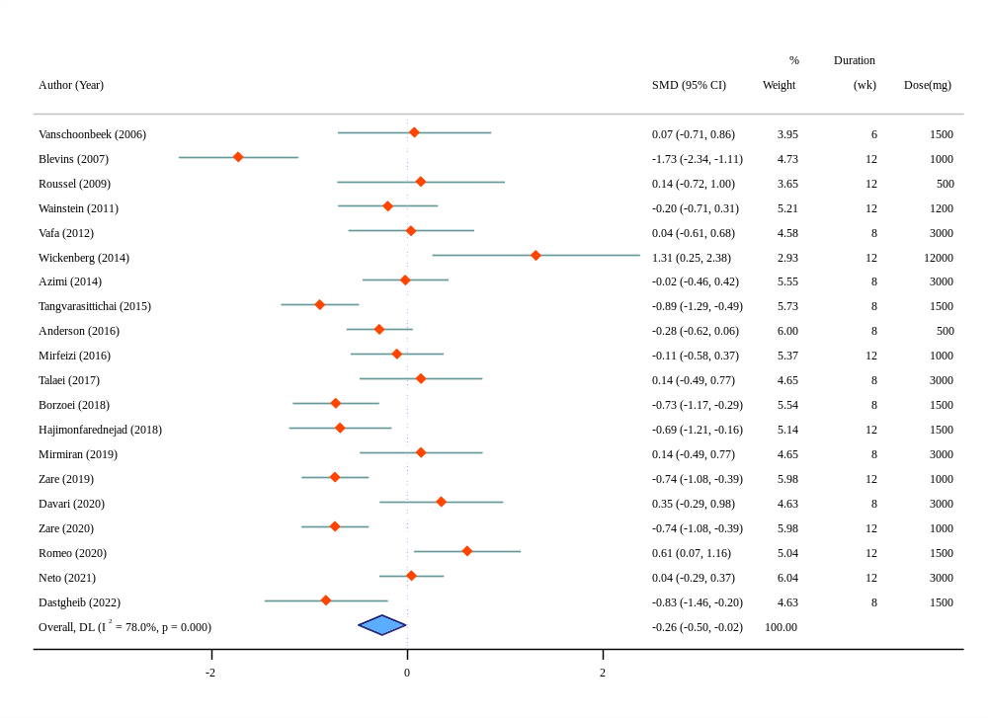
(b)
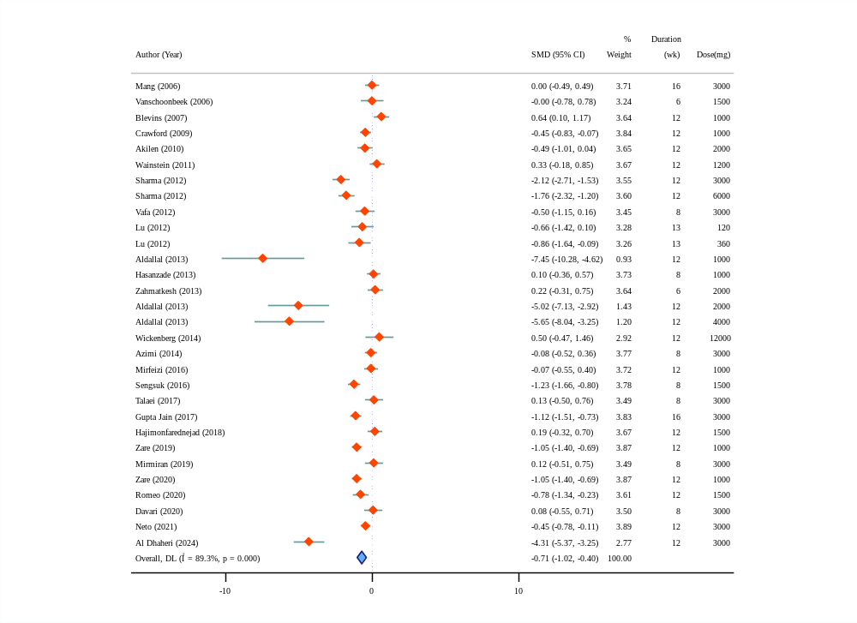
(c)
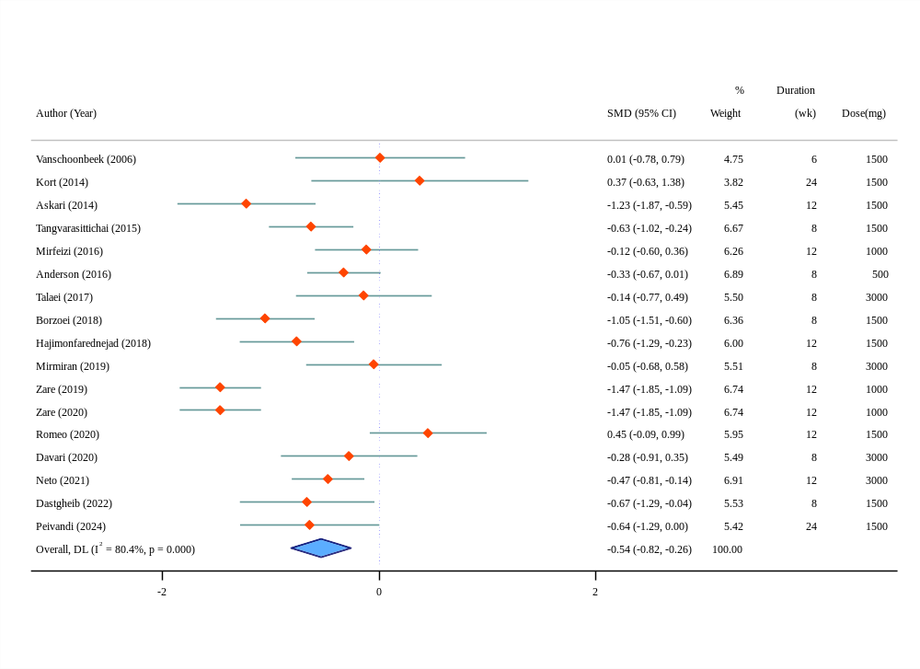
(d)
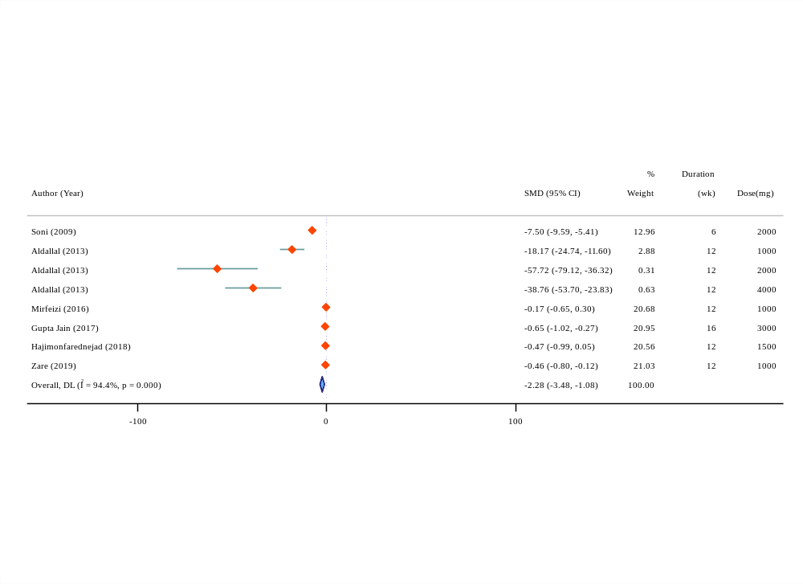
(e)
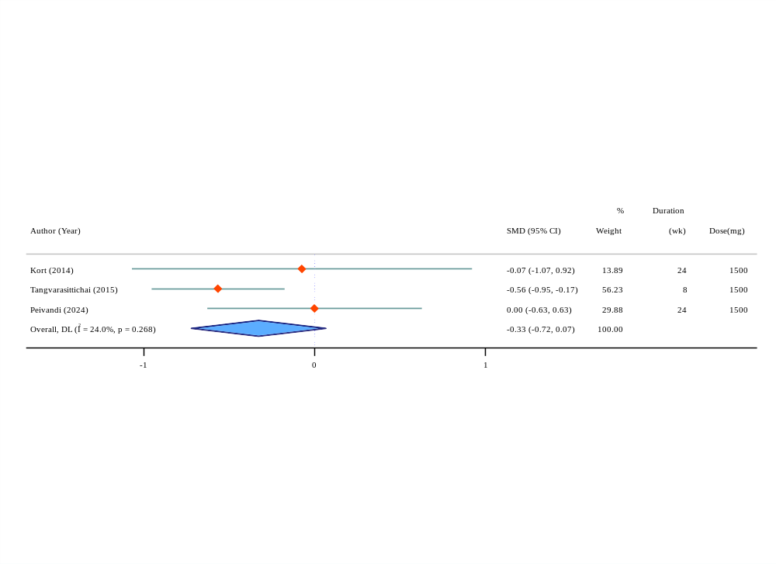
(f)
Supplementary Figure 3. Forest plot of the effects of cinnamon supplementation on glycemic profile (a: fasting glucose, b: fasting insulin, c: hemoglobin A1c, d: homeostatic model assessment of insulin resistance, e: postprandial blood glucose, f: quantitative insulin sensitivity check index)
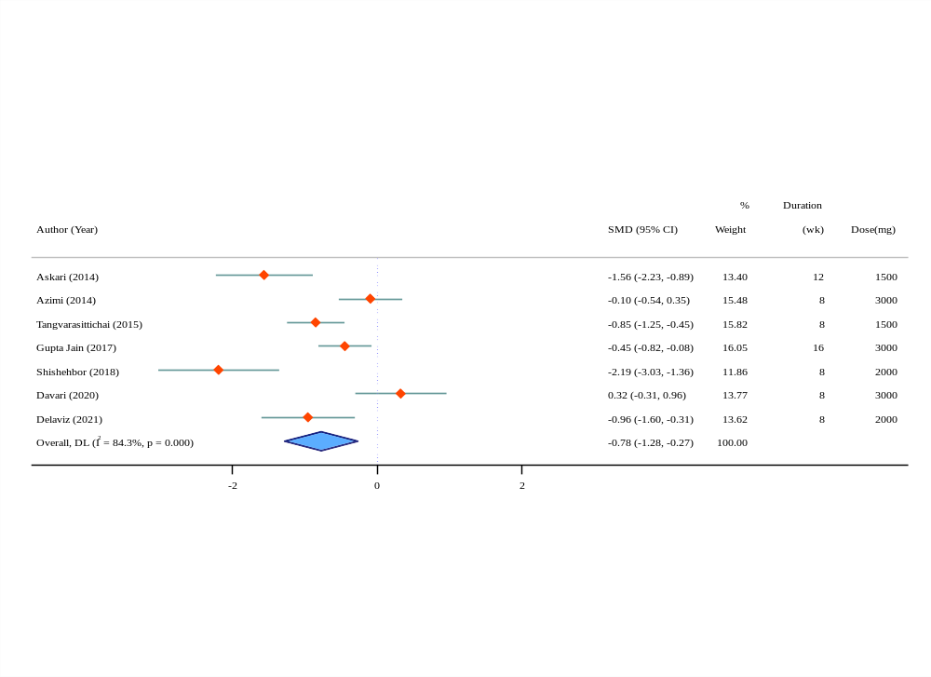
(a)
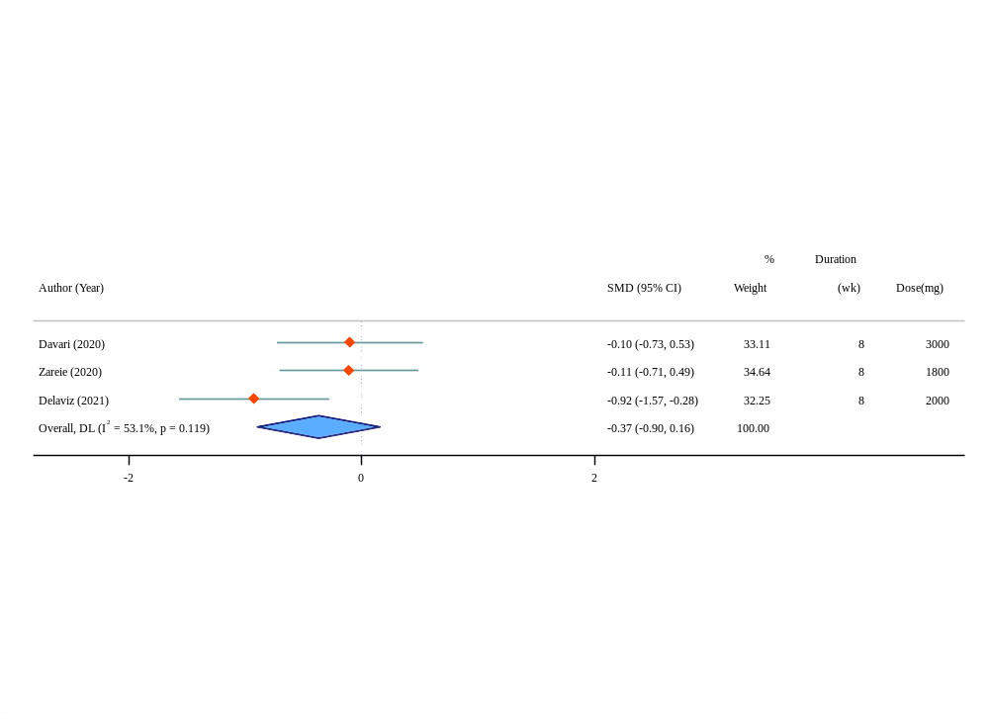
(b)
Supplementary Figure 4. Forest plot of the effects of cinnamon supplementation on inflammatory markers (a: C-reactive protein, b: interleukin-6)
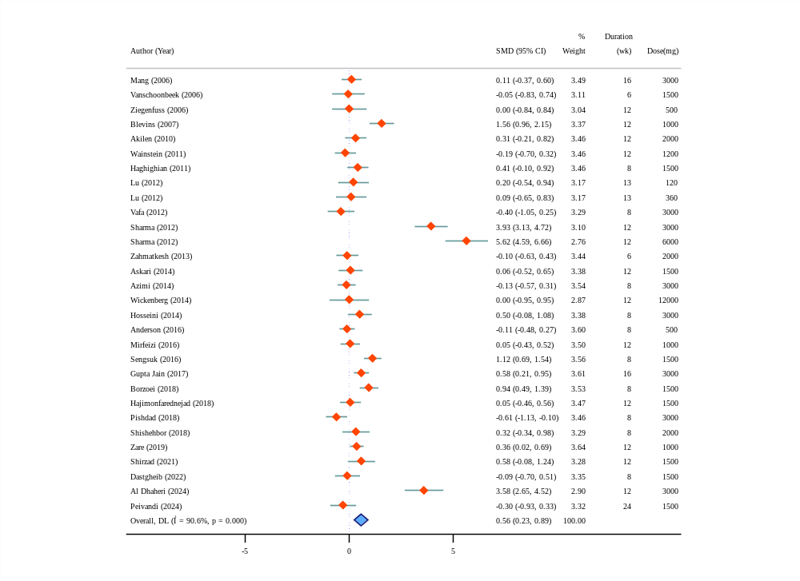
(a)
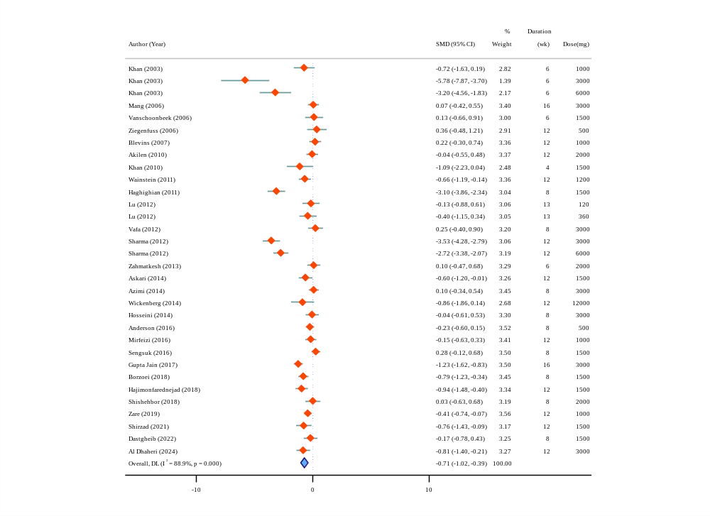
(b)
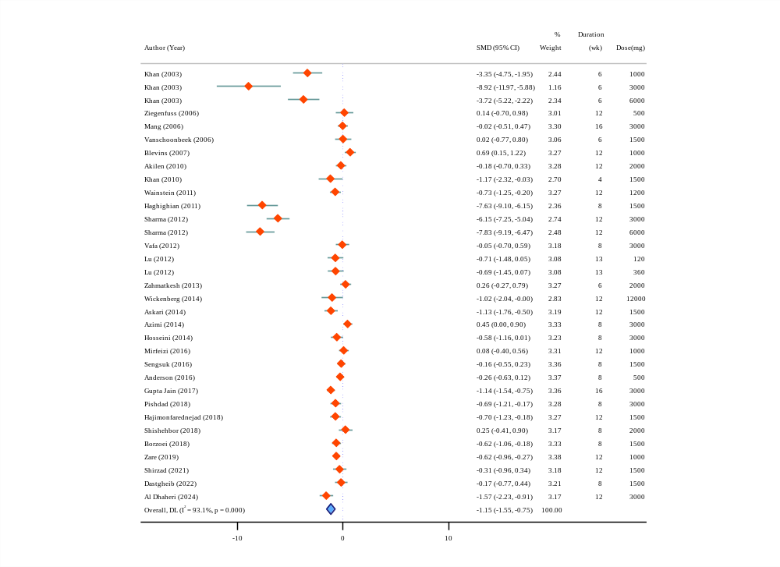
(c)
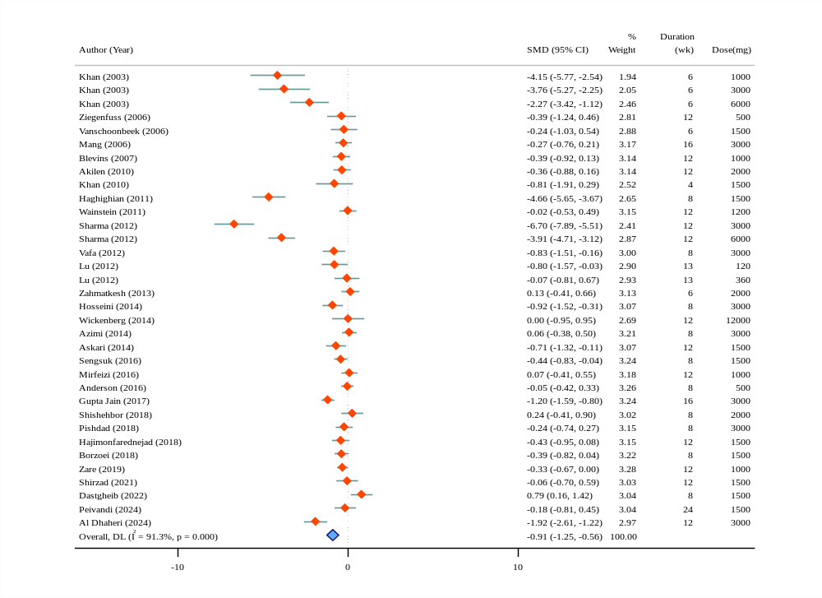
(d)
Supplementary Figure 5. Forest plot of the effects of cinnamon supplementation on lipid profile (a: high-density lipoprotein, b: low-density lipoprotein, c: total cholesterol, d: triglycerides)
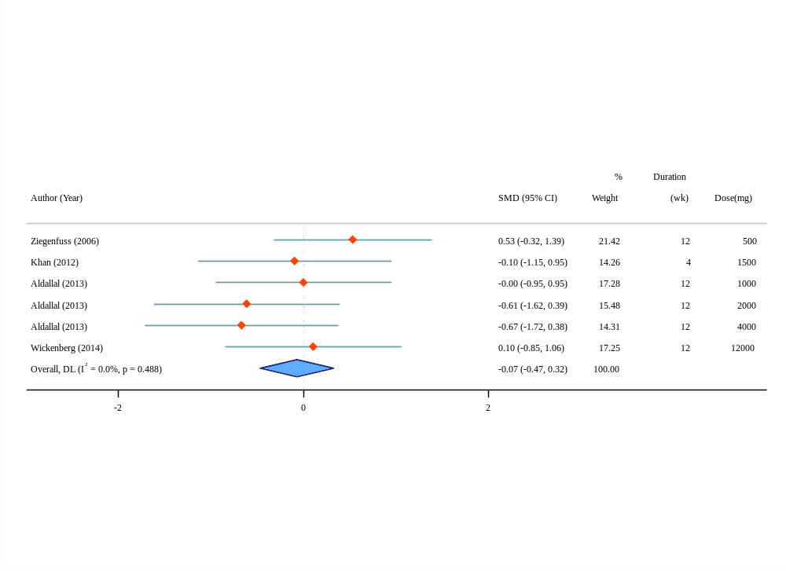
(a)
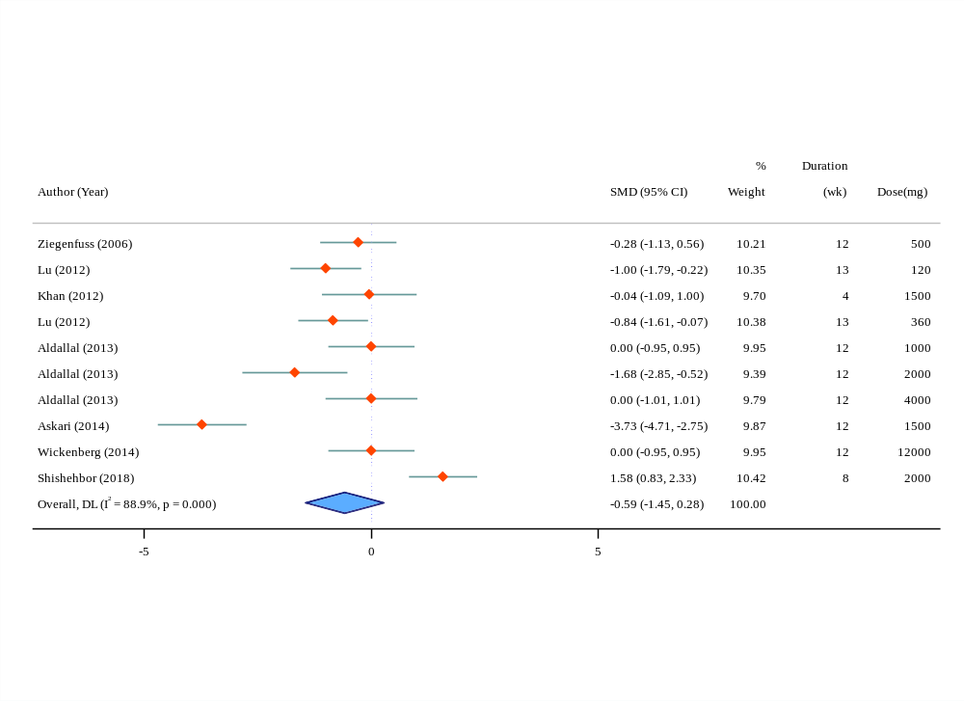
(b)
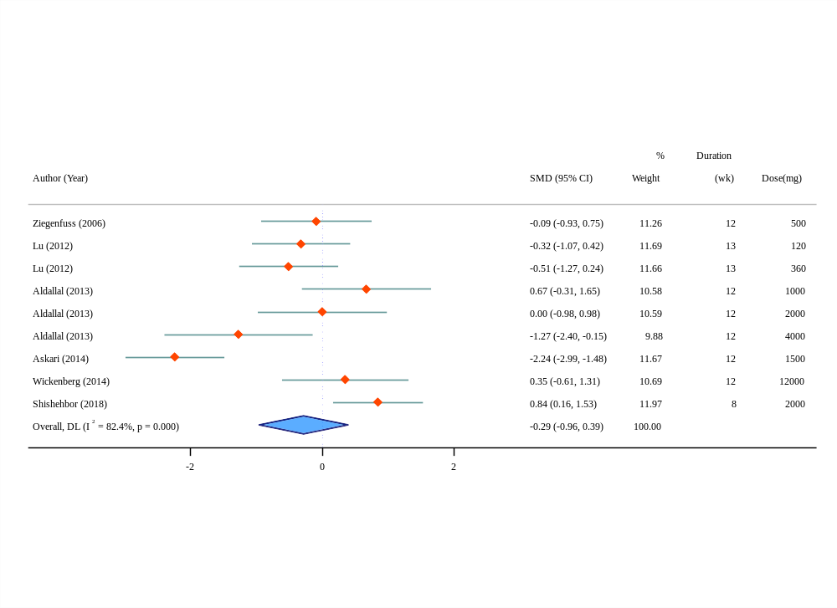
(c)
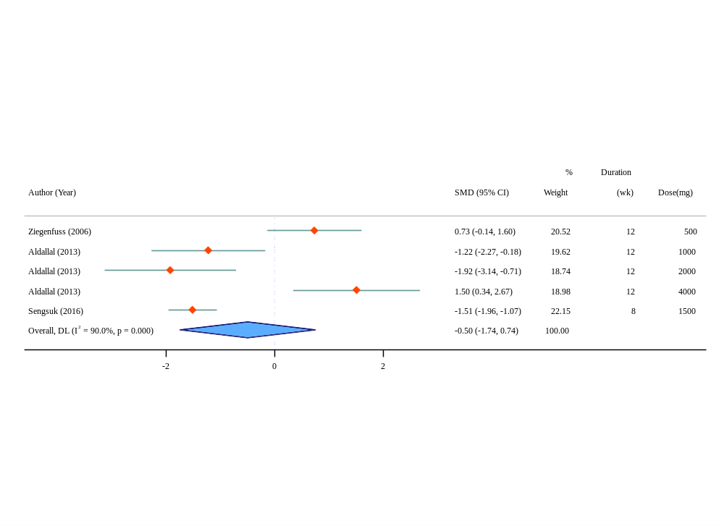
(d)
Supplementary Figure 6. Forest plot of the effects of cinnamon supplementation on liver function tests (a: alkaline phosphatase, b: alanine aminotransferase, c: aspartate aminotransferase, d: blood urea nitrogen)
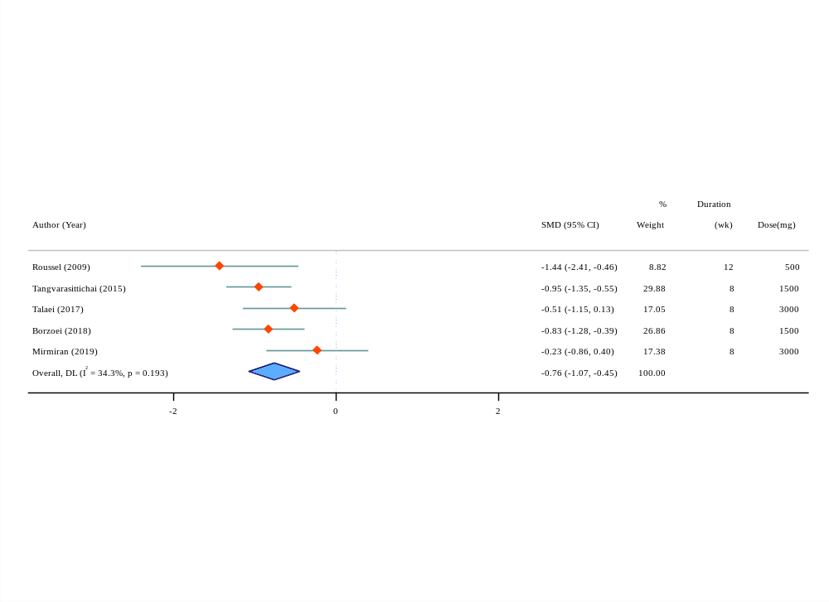
(a)
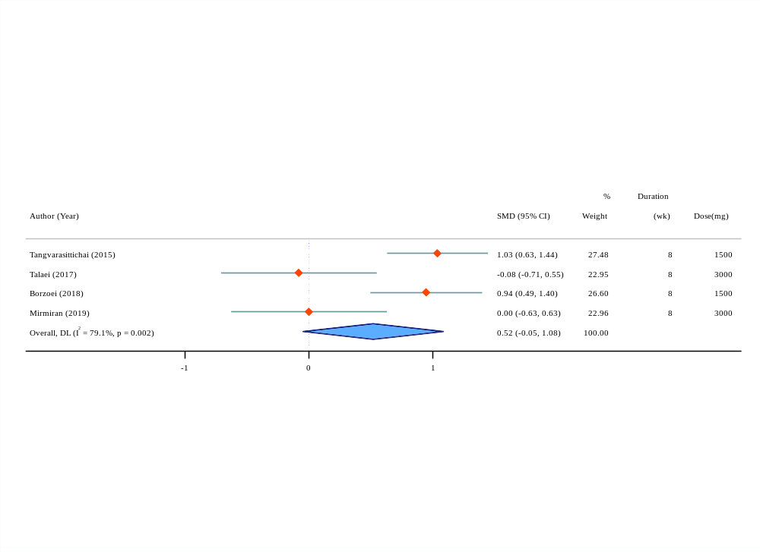
(b)
Supplementary Figure 7. Forest plot of the effects of cinnamon supplementation on oxidative stress parameters (a: malondialdehyde, b: total antioxidant capacity)
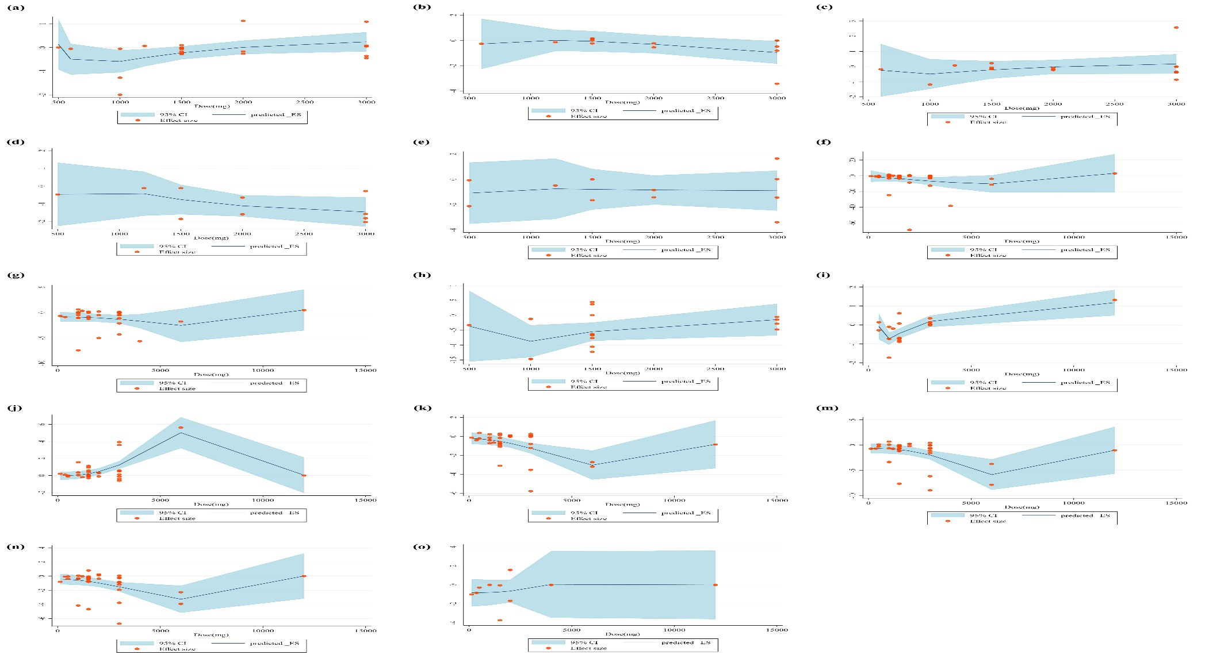
Supplementary Figure 8. Non-linear dose-response relations between cinnamon dosage (mg/d) and cardiovascular disease outcomes (a: body mass index, b: waist circumference, c: weight, d: diastolic blood pressure, e: systolic blood pressure, f: fasting glucose, g: hemoglobin a1c, h: homeostatic model assessment of insulin resistance, i: fasting insulin, j: high-density lipoprotein, k: low-density lipoprotein, m: total cholesterol, n: triglycerides, o: alanine aminotransferase)
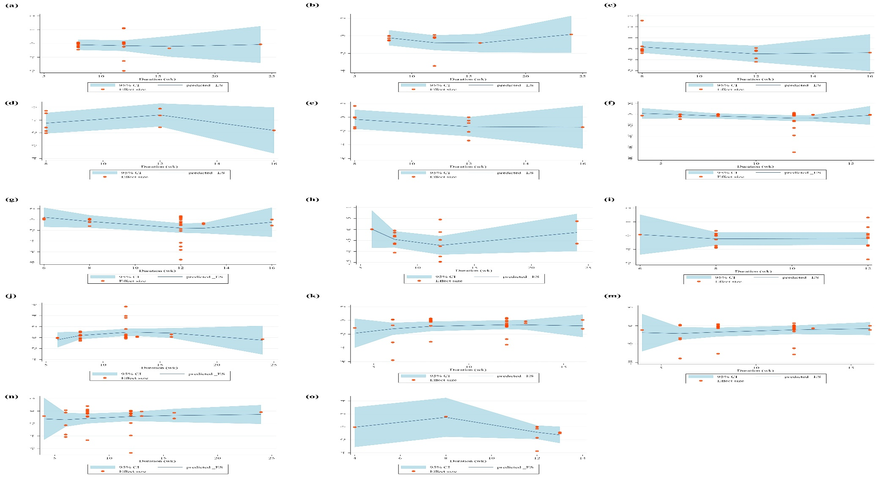
Supplementary Figure 9. Non-linear dose-response relations between duration of intervention and cardiovascular disease outcomes (a: body mass index, b: waist circumference, c: weight, d: diastolic blood pressure, e: systolic blood pressure, f: fasting glucose, g: hemoglobin a1c, h: homeostatic model assessment of insulin resistance, i: fasting insulin, j: high-density lipoprotein, k: low-density lipoprotein, m: total cholesterol, n: triglycerides, o: alanine aminotransferase)
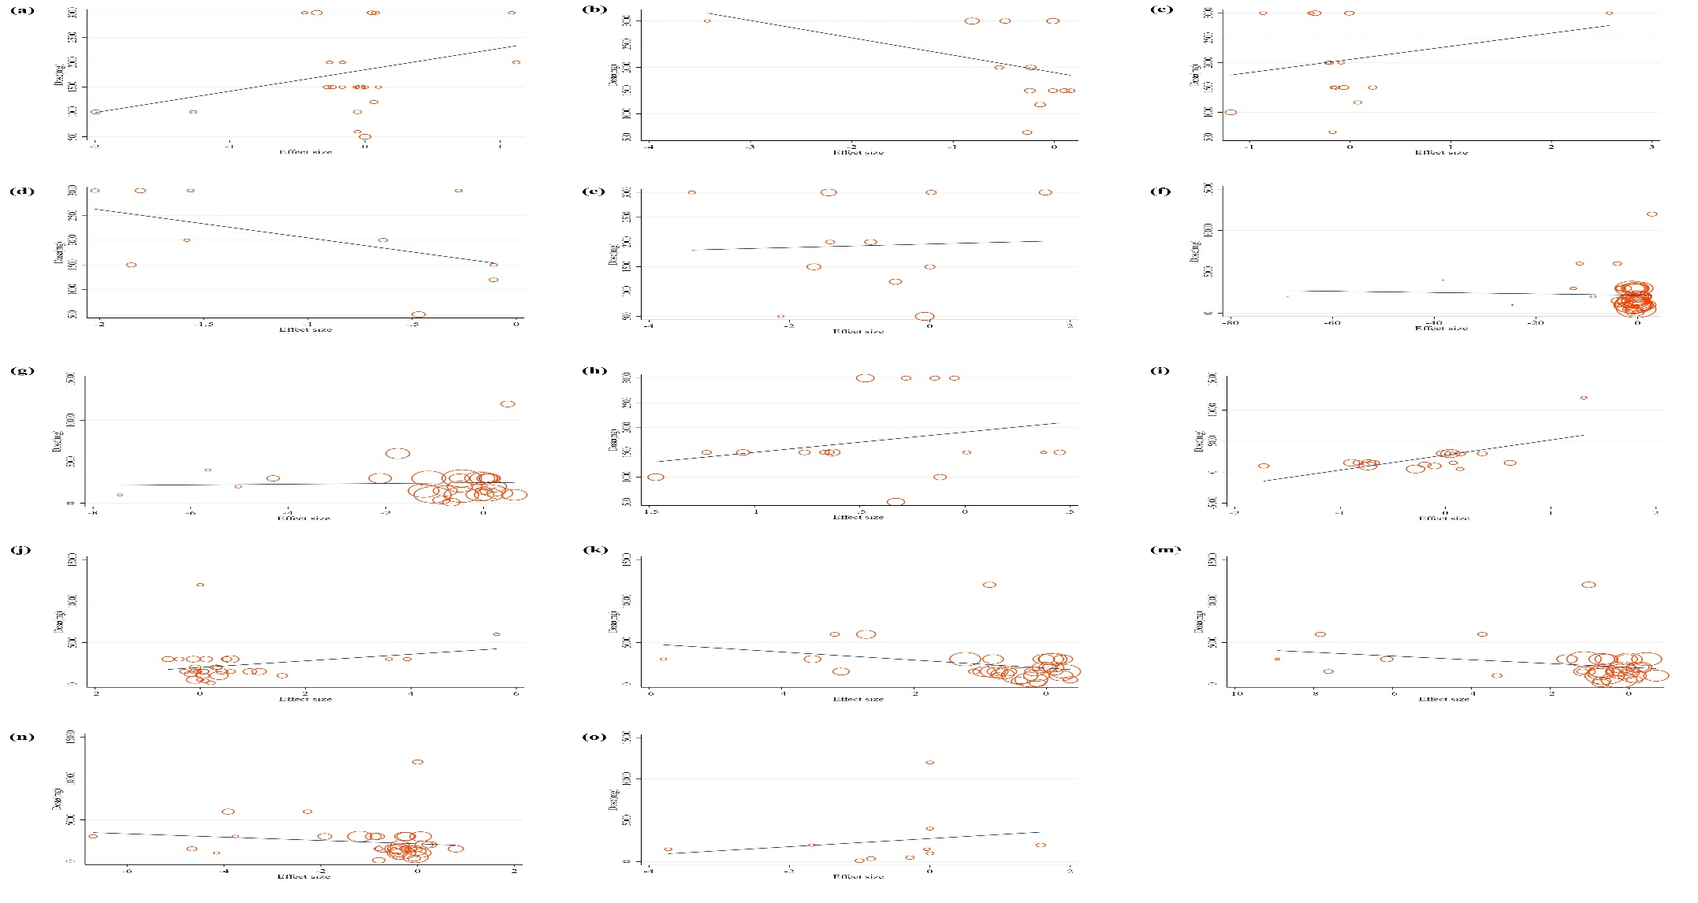
Supplementary Figure 10. Random-effects meta-regression plots of the association between cinnamon dosage (mg/d) and cardiovascular disease outcomes (a: body mass index, b: waist circumference, c: weight, d: diastolic blood pressure, e: systolic blood pressure, f: fasting glucose, g: hemoglobin a1c, h: homeostatic model assessment of insulin resistance, i: fasting insulin, j: high-density lipoprotein, k: low-density lipoprotein, m: total cholesterol, n: triglycerides, o: alanine aminotransferase)
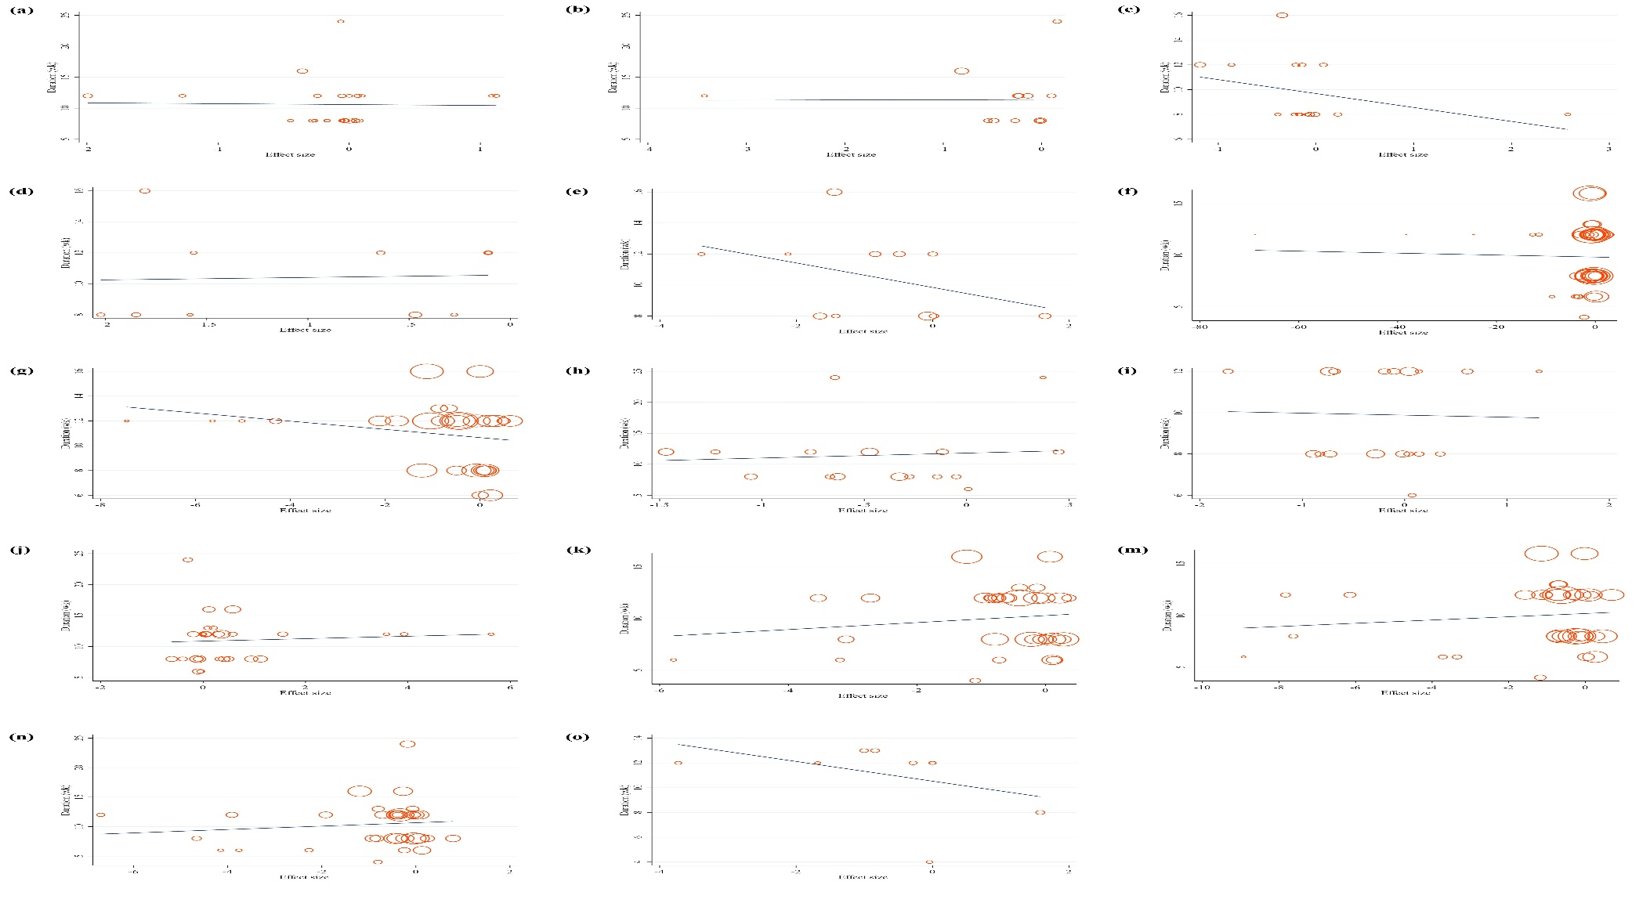
Supplementary Figure 11. Random-effects meta-regression plots of the association between duration of intervention and cardiovascular disease outcomes (a: body mass index, b: waist circumference, c: weight, d: diastolic blood pressure, e: systolic blood pressure, f: fasting glucose, g: hemoglobin a1c, h: homeostatic model assessment of insulin resistance, i: fasting insulin, j: high-density lipoprotein, k: low-density lipoprotein, m: total cholesterol, n: triglycerides, o: alanine aminotransferase)

Supplemental References

1. Altschuler JA, Casella SJ, MacKenzie TA, Curtis KM. The effect of cinnamon on A1C among adolescents with type 1 diabetes. Diabetes care. 2007;30(4):813-6.
2. Hlebowicz J, Darwiche G, Björgell O, Almér L-O. Effect of cinnamon on postprandial blood glucose, gastric emptying, and satiety in healthy subjects. The American journal of clinical nutrition. 2007;85(6):1552-6.
3. Solomon T, Blannin A. Effects of short‐term cinnamon ingestion on in vivo glucose tolerance. Diabetes, Obesity and Metabolism. 2007;9(6):895-901.
4. Pham AQ, Kourlas H, Pham DQ. Cinnamon supplementation in patients with type 2 diabetes mellitus. Pharmacotherapy. 2007;27(4):595-9.
5. Wang JG, Anderson RA, Graham III GM, Chu MC, Sauer MV, Guarnaccia MM, et al. The effect of cinnamon extract on insulin resistance parameters in polycystic ovary syndrome: a pilot study. Fertility and sterility. 2007;88(1):240-3.
6. Tang M, Larson-Meyer DE, Liebman M. Effect of cinnamon and turmeric on urinary oxalate excretion, plasma lipids, and plasma glucose in healthy subjects. The American journal of clinical nutrition. 2008;87(5):1262-7.
7. Hlebowicz J, Hlebowicz A, Lindstedt S, Björgell O, Höglund P, Holst JJ, et al. Effects of 1 and 3 g cinnamon on gastric emptying, satiety, and postprandial blood glucose, insulin, glucose-dependent insulinotropic polypeptide, glucagon-like peptide 1, and ghrelin concentrations in healthy subjects. The American journal of clinical nutrition. 2009;89(3):815-21.
8. Mettler S, Schwarz I, Colombani PC. Additive postprandial blood glucose–attenuating and satiety-enhancing effect of cinnamon and acetic acid. Nutrition research. 2009;29(10):723-7.
9. Solomon TP, Blannin AK. Changes in glucose tolerance and insulin sensitivity following 2 weeks of daily cinnamon ingestion in healthy humans. European journal of applied physiology. 2009;105:969-76.
10. Mishra A, Bhatti R, Singh A, Singh Ishar MP. Ameliorative effect of the cinnamon oil from Cinnamomum zeylanicum upon early stage diabetic nephropathy. Planta Med. 2010;76(5):412-7.
11. Otto AD. Cinnamon as a supplemental treatment for impaired glucose tolerance and type 2 diabetes. Current diabetes reports. 2010;10(3):170-2.
12. Markey O, McClean CM, Medlow P, Davison GW, Trinick TR, Duly E, et al. Effect of cinnamon on gastric emptying, arterial stiffness, postprandial lipemia, glycemia, and appetite responses to high-fat breakfast. Cardiovascular diabetology. 2011;10(1):1-10.
13. Magistrelli A, Chezem JC. Effect of ground cinnamon on postprandial blood glucose concentration in normal-weight and obese adults. Journal of the Academy of Nutrition and Dietetics. 2012;112(11):1806-9.
14. Hoehn AN, Stockert AL. The Effects of Cinnamomum Cassia on Blood Glucose Values are Greater than those of Dietary Changes Alone. Nutr Metab Insights. 2012;5:77-83.
15. Zahmatkesh M, Fallah Huseini H, Hajiaghaee R, Heidari M, Mehrafarin A, Tavakoli-far B. The Effects of Cinnamomum zeylanicum J. Presl on Blood Glucose Level in Patients with Type 2 Diabetes, a Double-blind Clinical Trial. Journal of Medicinal Plants. 2012;11(41):258-63.
16. Kort D, Sullivan C, Kostolias A, DePinho J, Lobo R. Cinnamon supplementation improves menstrual cyclicity in women with polycystic ovary syndrome. Fertility and Sterility. 2013;100(3):S349.
17. Mashhadi NS, Ghiasvand R, Askari G, Feizi A, Hariri M, Darvishi L, et al. Influence of ginger and cinnamon intake on inflammation and muscle soreness endued by exercise in Iranian female athletes. International journal of preventive medicine. 2013;4(Suppl 1):S11.
18. Mashhadi NS, Ghiasvand R, Hariri M, Askari G, Feizi A, Darvishi L, et al. Effect of ginger and cinnamon intake on oxidative stress and exercise performance and body composition in Iranian female athletes. International journal of preventive medicine. 2013;4(Suppl 1):S31.
19. Soare A, Weiss EP, Holloszy JO, Fontana L. Multiple dietary supplements do not affect metabolic and cardiovascular health. Aging (Albany NY). 2014;6(2):149.
20. Bernardo MA, Silva ML, Santos E, Moncada MM, Brito J, Proença L, et al. Effect of cinnamon tea on postprandial glucose concentration. Journal of diabetes research. 2015;2015.
21. Liu Y, Cotillard A, Vatier C, Bastard J-P, Fellahi S, Stevant M, et al. A dietary supplement containing cinnamon, chromium and carnosine decreases fasting plasma glucose and increases lean mass in overweight or obese pre-diabetic subjects: a randomized, placebo-controlled trial. PLoS one. 2015;10(9):e0138646.
22. Salehpour S, Parsay S, Onsori S, Setvand S. A Double-Blind, Placebo-Controlled Comparison of Cinnamon Extract to Metformin Effects upon Insulin Resistance, Apolipoprotein B:Apolipoprotein A1 Ratio, and BMI of Obese Adolescent Girls with Polycystic Ovary Syndrome. 2015.
23. Amirabadi F, Asadi M, Tabrizi A. The effect of endurance training and use of cinnamon supplement on antioxidant index and lipid peroxidation as additional care in middle-aged female diabetic type II patients. Journal of Diabetes Nursing. 2016;4(3):48-59.
24. Gutierrez JL, Bowden RG, Willoughby DS. Cassia cinnamon supplementation reduces peak blood glucose responses but does not improve insulin resistance and sensitivity in young, sedentary, obese women. Journal of Dietary Supplements. 2016;13(4):461-71.
25. Torabi S, Asad MR, Tabrizi A. The effect of endurance training with cinnamon supplementation on plasma concentrations of liver enzymes (ALT, AST) in women with type II diabetes. Tehran University Medical Journal. 2016;74(6):433-41.
26. Sahib AS. Anti-diabetic and antioxidant effect of cinnamon in poorly controlled type-2 diabetic Iraqi patients: A randomized, placebo-controlled clinical trial. J Intercult Ethnopharmacol. 2016;5(2):108-13.
27. Crawford P, Thai C, Obholz J, Schievenin J, True M, Shah SA, et al. Assessment of the effeCt of lIfestyle iNtervention plus water-soluble ciNnAMon extract On loweriNg blood glucose in pre-diabetics, a randomized, double-blind, multicenter, placebo controlled trial: study protocol for a randomized controlled trial. Trials. 2016;17:9.
28. Wiweko B, Susanto CA. The effect of metformin and cinnamon on serum anti-mullerian hormone in women having PCOS: A Double-blind, randomized, controlled trial. Journal of human reproductive sciences. 2017;10(1):31.
29. Hochkogler CM, Hoi JK, Lieder B, Müller N, Hans J, Widder S, et al. Cinnamyl isobutyrate decreases plasma glucose levels and total energy intake from a standardized breakfast: A randomized, crossover intervention. Molecular nutrition & food research. 2018;62(17):1701038.
30. Nakhaei K, Ghofrani M, Fazel Bakhsheshi M, Nakhaei H. Effect of circuit resistance training and cinnamon supplement on body composition and Omentin-1 in overweight women. The Iranian Journal of Obstetrics, Gynecology and Infertility. 2018;20(11):74-82.
31. Talaat B, Ammar IMM. The added value of cinnamon to metformin in controlling symptoms of polycystic ovary syndrome, a randomized controlled trial. Middle East Fertility Society Journal. 2018;23(4):440-5.
32. Zahedifar A, Khodashenas M, Bijari B, Zahedifar F. Effects of cinnamon on fasting blood sugar and hemoglobin A1C in patients with type II diabetes mellitus: A randomized clinical trial. Journal of Mazandaran University of Medical Sciences. 2018;27(156):80-8.
33. Shivani B, Shubhra S. EFFECT OF JAPAN WATER THERAPY INFUSED WITH CINNAMON ON BODY WEIGHT, WAIST/HIP RATIO, AND BODY MASS INDEX OF OVERWEIGHT AND OBESE SUBJECTS. Asian Journal of Pharmaceutical and Clinical Research. 2019;12(9):302-5.
34. Furlan CPB, Valle SC, Maróstica Jr MR, Östman E, Björck I, Tovar J. Effect of bilberries, lingonberries and cinnamon on cardiometabolic risk-associated markers following a hypercaloric-hyperlipidic breakfast. Journal of functional foods. 2019;60:103443.
35. Harfika A, Hardinsyah H, Dewi M, editors. Combinations of Green Tea, Green Coffee, and Cinnamon for Development of Herbal Beverage for Hypercholesterolemia. Annals Of Nutrition and Metabolism; 2019: KARGER ALLSCHWILERSTRASSE 10, CH-4009 BASEL, SWITZERLAND.
36. Hendre AS, Sontakke AV, Patil SR, Phatak RS. Effect of cinnamon supplementation on fasting blood glucose and insulin resistance in patients with type 2 diabetes. Pravara Medical Review. 2019;11(2):4-8.
37. Khan AA, Begum W. Efficacy of Darchini in the management of polycystic ovarian syndrome: a randomized clinical study. Journal of Herbal Medicine. 2019;15:100249.
38. Khorvash F, Askari G, Zarei A. The effect of cinnamon on migraine treatment and blood levels of CGRP and IL-6: A double-blinded randomized controlled clinical trial. Journal of the Neurological Sciences. 2019;405:106-7.
39. Mehta A, Mehta S, Thakurdesai P. Efficacy and safety of standardized cinnamon bark extract for the prevention of chemo-therapy-induced weight loss and alopecia in patients with breast cancer: A randomized, double-blind, and placebo-controlled study. Asian J Pharm Clin Res. 2019;12:163-8.
40. Parseh S, Shakerian S, Alizadeh AA. Effect of Chronic Aerobic/Resistive exercises with supplementation of cinnamon on insulin resistance in women with polycystic ovary syndrome in Ahvaz City in 2017. Journal of Arak University of Medical Sciences. 2019;22(1):15-26.
41. Sfar M, Hfaiedh KB, Mahrez KB, Skhiri HA, Rayana CB, Chemli R, et al. Effect of cinnamon supplementation on resistin and ghrelin in obese diabetic men. Indian Journal of Traditional Knowledge (IJTK). 2019;18(4):694-701.
42. Maleki S, Behpoor N, Tadibi V. Effect of 8 weeks of resistance training and supplementation of cinnamon on plasma levels of leptin and adiponectin in overweight women. Journal of Practical Studies of Biosciences in Sport. 2020;8(16):132-42.
43. Jafar N, Qalbi FN, Thaha RM, Hadju V, Hidayanti H, Salam A, et al. Effect of cinnamomum burmannii stew on glucose fasting blood levels in adult prediabetes in Makassar. Journal of Medical Sciences. 2020.
44. Khedr NF, Ebeid AM, Khalil RM. New insights into weight management by orlistat in comparison with cinnamon as a natural lipase inhibitor. Endocrine. 2020;67:109-16.
45. Mirmiranpour H, Huseini HF, Derakhshanian H, Khodaii Z, Tavakoli-Far B. Effects of probiotic, cinnamon, and synbiotic supplementation on glycemic control and antioxidant status in people with type 2 diabetes; a randomized, double-blind, placebo-controlled study. Journal of Diabetes & Metabolic Disorders. 2020;19:53-60.
46. Mohammad S, Fadhil N, Mahmood M. Effects of metformin and cinnamon on 1, 5 anhydroglucitol, adiponectin and ghrelin on newly diagnosed type 2 diabetes mellitus patients. Jordan Medical Journal. 2021;55(4).
47. Ahmad H, Kashif S, Afreen A, Safdar M, Ahmed Z. Comparative effect of Fenugreek and Cinnamon on management of newly diagnosed cases of Type-2 Diabetes Mellitus. Food Science and Technology. 2021;42.
48. Chiou Y-L, Chyau C-C, Li T-J, Kuo C-F, Kang Y-Y, Chen C-C, et al. Hepatoprotective effect of Antrodia cinnamomea mycelium in patients with nonalcoholic steatohepatitis: a randomized, double-blind, placebo-controlled trial. Journal of the American College of Nutrition. 2021;40(4):349-57.
49. Patil M, Patil V. EFFICACY OF CINNAMON CONSUMPTION FOR REDUCING BLOOD PRESSURE IN ADULT HYPERTENSIVE MALES. Journal of Hypertension. 2021;39:e320.
50. Permadi W, Hestiantoro A, Ritonga MA, Ferrina AI, Iswari WA, Sumapraia K, et al. Administration of cinnamon and lagersroemia speciosa extract on lipid profile of polycystic ovarian syndrome women with high body mass index. Journal of Human Reproductive Sciences. 2021;14(1):16.
51. Sadiq A, Abid N, Jasin O, Mohammed Ali B. Effect of cinnamon on blood sugar and anthropometric measurement in type two diabetes patients. Bionatura. 2021;6.
52. Amin M, Haji-Gholami A, Ansari H, Moghaddas A. The Effect of Ginger and Cinnamon Consumption on Chemotherapy-Induced Nausea and Vomiting: A Double-Blind Randomized Clinical Trial. Journal of Isfahan Medical School. 2022;40(672):349-55.
53. Bahri S, Adnyana IK, Hasan MF, Apriantono T, Juniarsyah AD. The Effect of Cinnamon Extract on Recovery and Performance of Weightlifting Athletes. Sport Mont. 2022;20(2):57-61.
54. Bhuvaneswari G, Hemamalini M, Vijayalakshmi R. Efficacy of cinnamon, exercise and counselling (Multi–interventional Package) on insulin resistance among young girls with Polycystic Ovarian Syndrome. Journal of Pharmaceutical Negative Results. 2022:2463-8.
55. Rachid AP, Moncada M, Mesquita MFd, Brito J, Bernardo MA, Silva ML. Effect of aqueous cinnamon extract on the postprandial glycemia levels in patients with type 2 diabetes mellitus: a randomized controlled trial. Nutrients. 2022;14(8):1576.
56. Soares APdC, de Faria NC, Graciano GF, Dos Santos ALS, Valenzuela VDC, Toulson Davisson Correia MI, et al. Cinnamon Infusion Reduces Satiety and Increases Energy Intake: A Randomized Crossover Trial. Annals of Nutrition and Metabolism. 2022;78(5):265-72.
57. Lira Neto JCG, Araújo MFMd, Araújo AVEC, Figueira JNR, Maranhão TA, Damasceno MMC. Effectiveness of cinnamon in the reduction of lipid levels in people with diabetes: a randomized clinical trial. Revista Gaúcha de Enfermagem. 2023;44:e20230051.
58. Nawaz S, Naimal M, Qamar HMH, Hassan A, Mehmood A, Ullah R, et al. Chemical characterization and bio evaluation of cinnamon (Cinnamomum verum) extract against glycated haemoglobin and hyperglycemia in human female subjects with polycystic ovarian syndrome. Pakistan Journal of Pharmaceutical Sciences. 2023;36.
59. Delgadillo-Centeno JS, Grover-Páez F, Hernández-González SO, Ramos-Zavala MG, Cardona-Müller D, López-Castro A, et al. Cinnamomum cassia on Arterial Stiffness and Endothelial Dysfunction in Type 2 Diabetes Mellitus: Outcomes of a Randomized, Double-Blind, Placebo-Controlled Clinical Trial. J Med Food. 2023;26(6):428-34.
60. Farooq F, Hussain Z, Hanief MI, Fida Z. Safety and efficacy of cinnamomum zeylanicum Blume in non-alcoholic fatty liver disease: a single-blind randomized standard controlled trial. World J Pharm Res. 2023;12:540-56.
61. Zelicha H, Yang J, Henning SM, Huang J, Lee R-P, Thames G, et al. P03-086-23 Effect of Cinnamon Spice on Continuous Glucose Monitoring Response in Obese Individuals with Pre-Diabetes; A Randomized Controlled Crossover Trial. Current Developments in Nutrition. 2023;7.
62. Zelicha H, Yang J, Henning SM, Huang J, Lee RP, Thames G, et al. Effect of cinnamon spice on continuously monitored glycemic response in adults with prediabetes: a 4-week randomized controlled crossover trial. Am J Clin Nutr. 2024;119(3):649-57.
63. Kuwabara Y, Hirose A, Lee H, Kakinuma T, Baba A, Takara T. Effects of Highly Bioavailable Curcumin Supplementation on Common Cold Symptoms and Immune and Inflammatory Functions in Healthy Japanese Subjects: A Randomized Controlled Study. J Diet Suppl. 2024;21(1):71-98.
64. Tanabe Y, Kondo E, Sagayama H, Shimizu K, Yasumatsu M, Nakamura D, et al. Impact of curcumin supplementation on exercise performance and muscle damage after a soccer match: a double-blind placebo-controlled cross-over study. Eur J Appl Physiol. 2024;124(7):2161-70.

