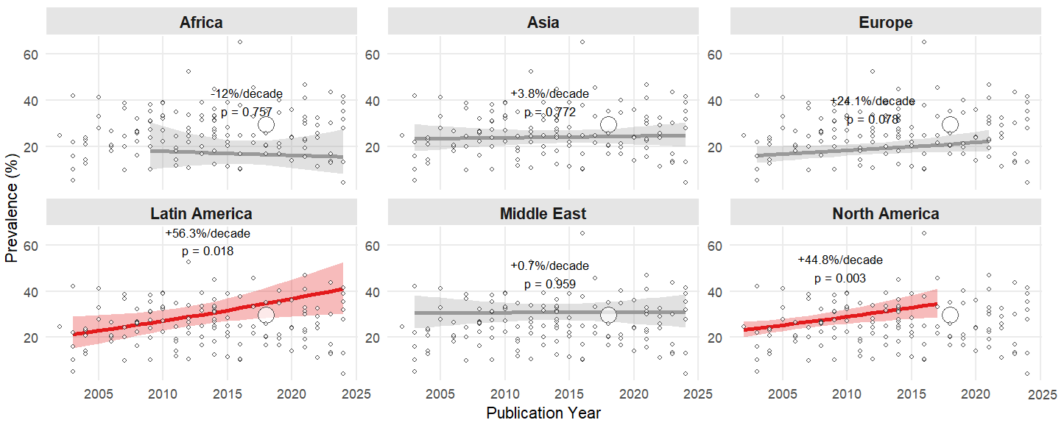
(B)
(A)
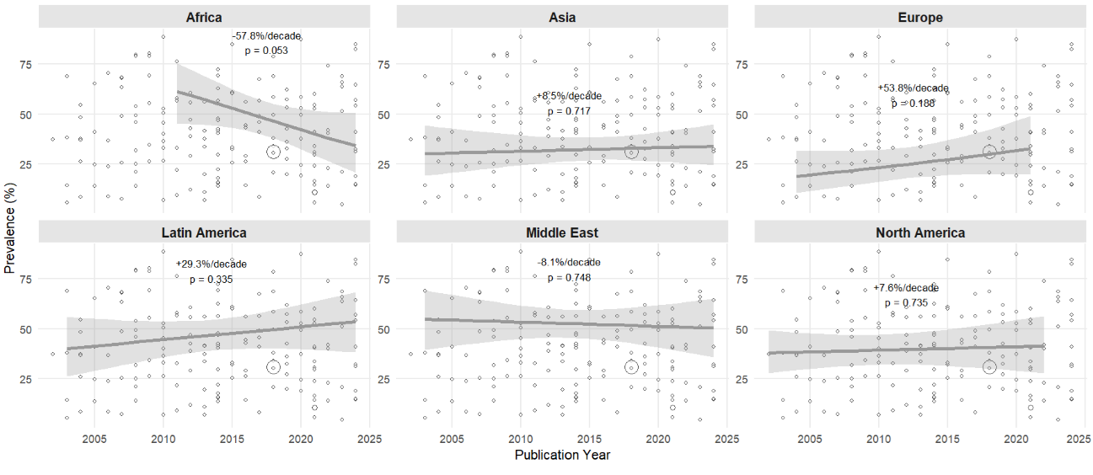
(C)
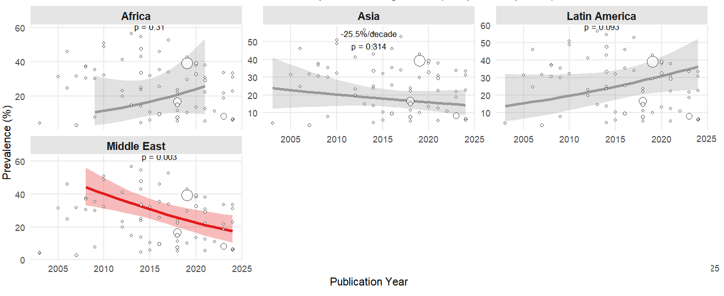
(D)
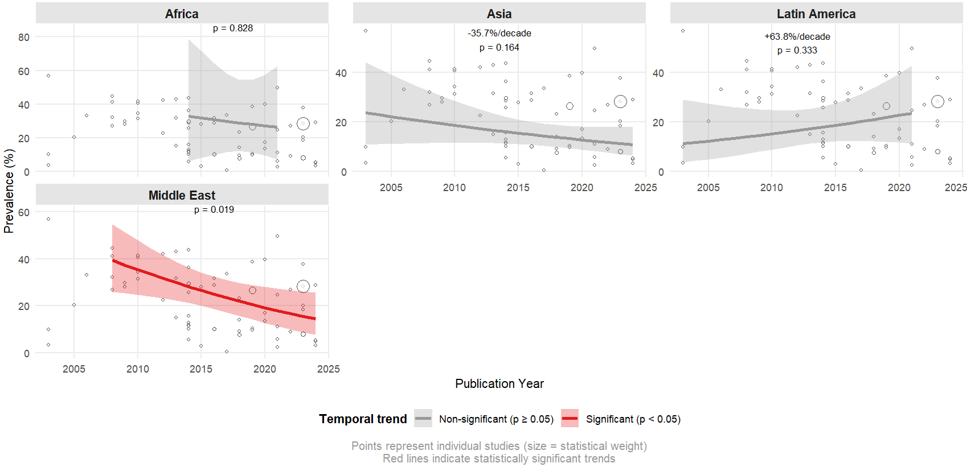
Supplementary Material 6. Regional temporal trends in dyslipidemia prevalence by continent: meta-regression analysis of (A) hypertriglyceridemia, (B) hypercholesterolemia, (C) low HDL-C, and (D) high LDL-C across six world regions (2000-2025)

