(a)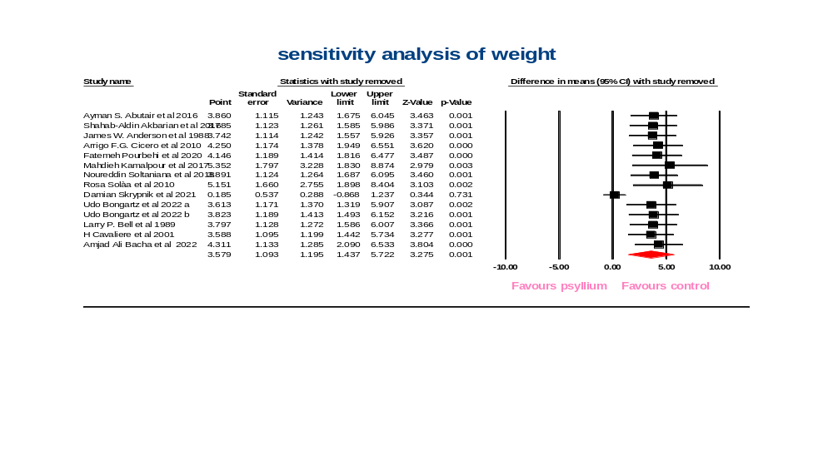(b)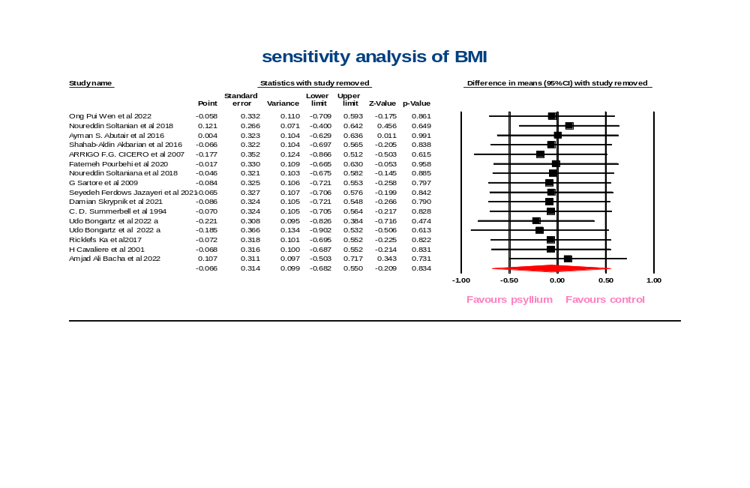
(c)
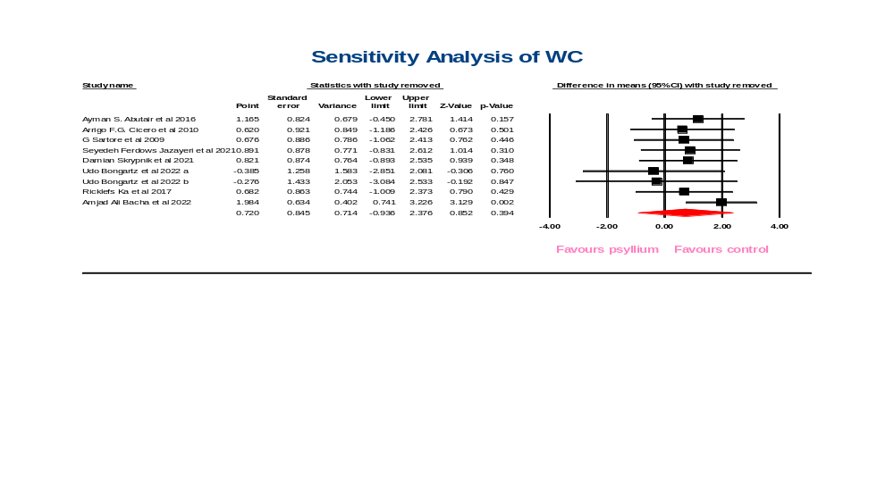(d)
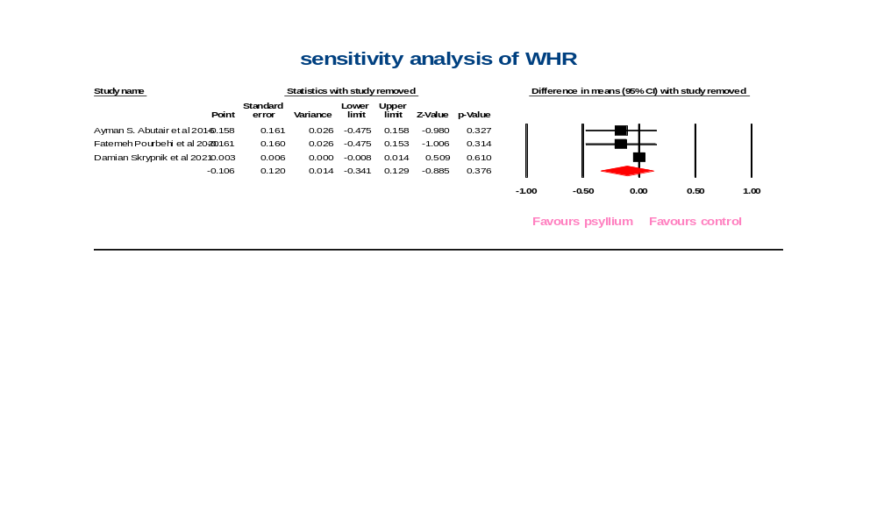
Supplementary figure 1 Sensitivity Analysis of psyllium on weight (a), BMI (b), WC (c), WHR (d)
(a)
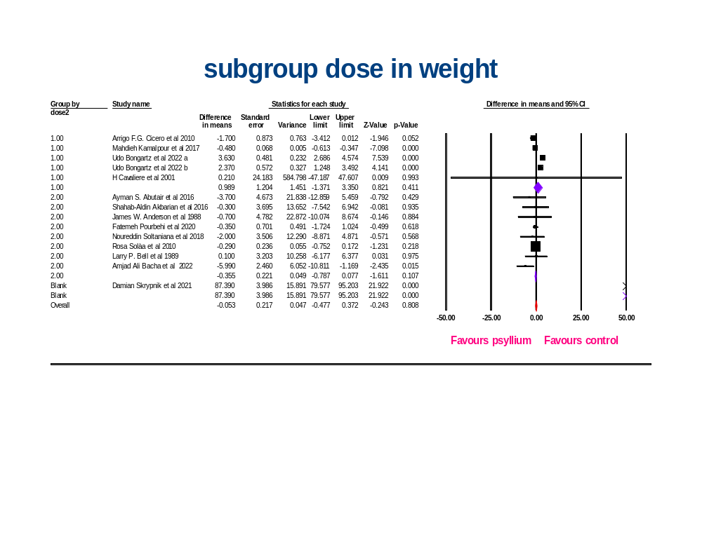

(b)
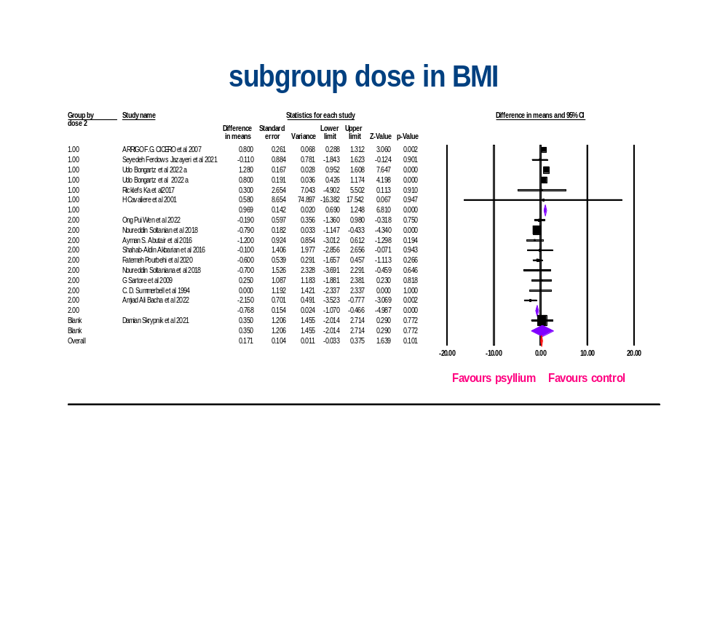

Supplementary figure 2: dosage subgroup analyses for the effects of psyllium on weight (a), BMI (b)

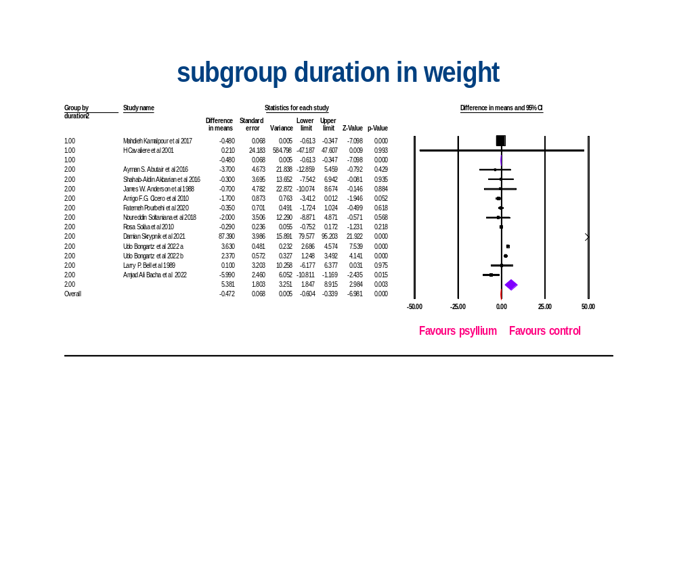

Supplementary figure 3: duration subgroup analyses for the effects of psyllium on weight

(a)
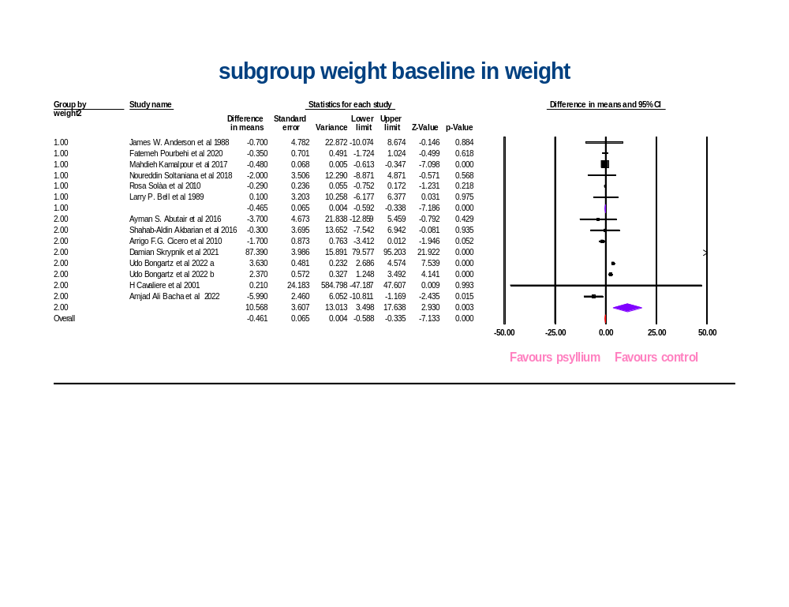

(b)
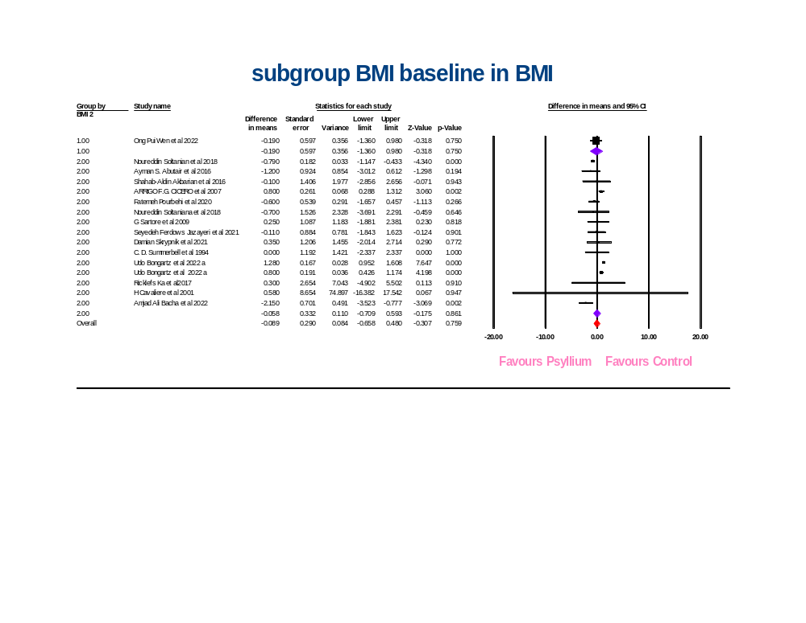

(c)
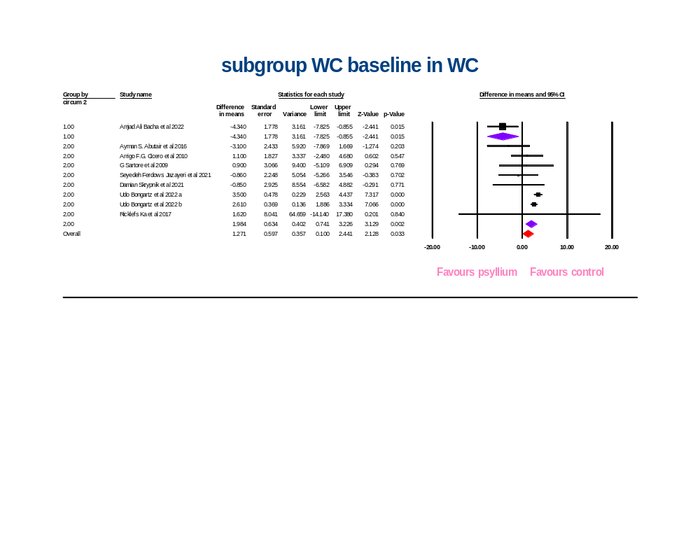Supplementary figure 4: baseline subgroup analyses for the effects of psyllium on weight (a), BMI (b), and WC (C)

(a)
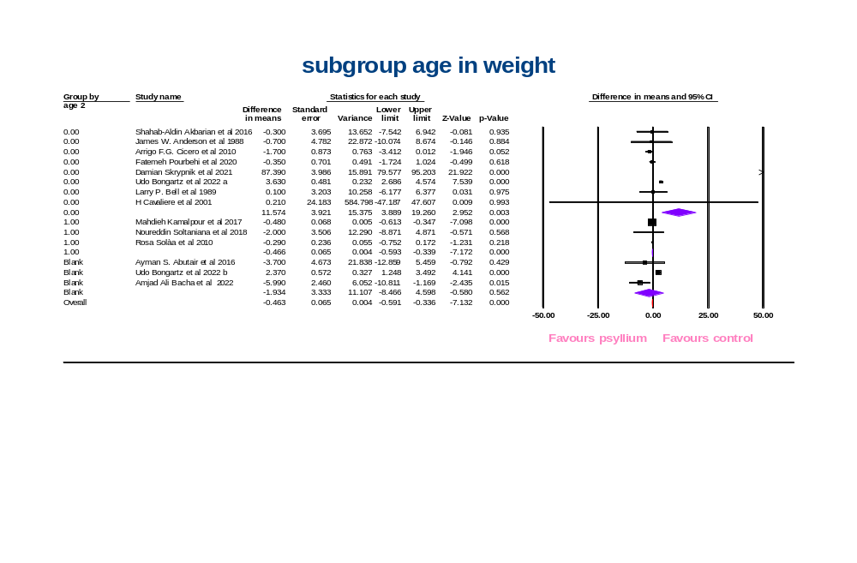

(b)
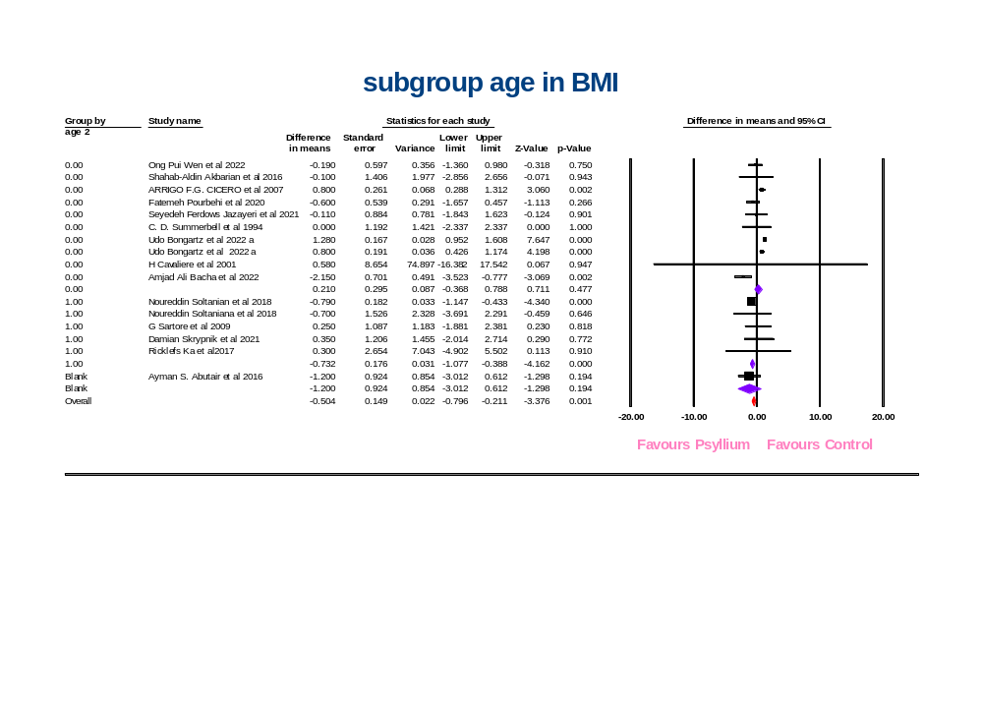

(c)
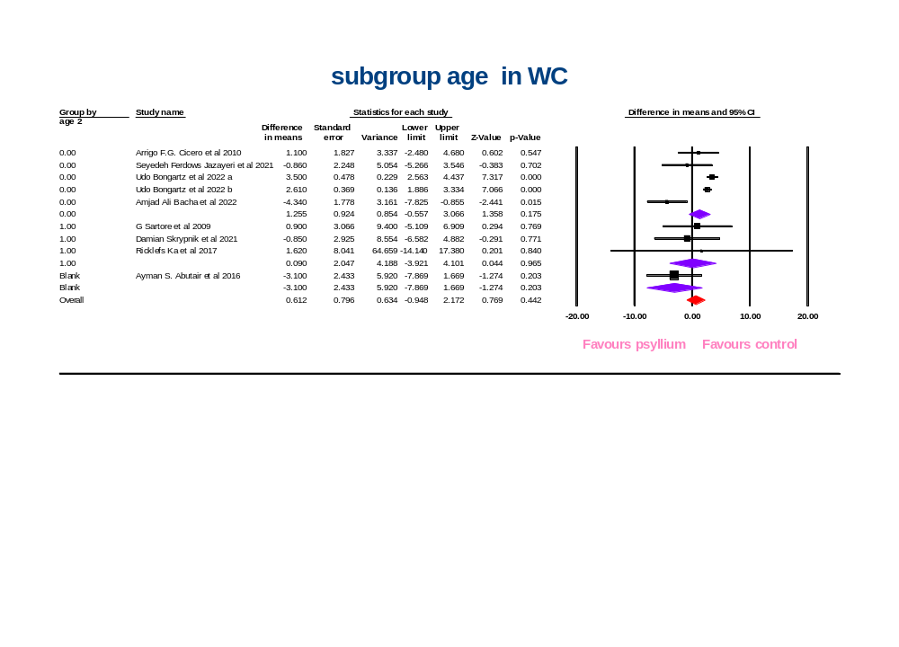Supplementary figure 5: age subgroup analyses for the effects of psyllium on weight (a), BMI (b), and WC (C)
(a)
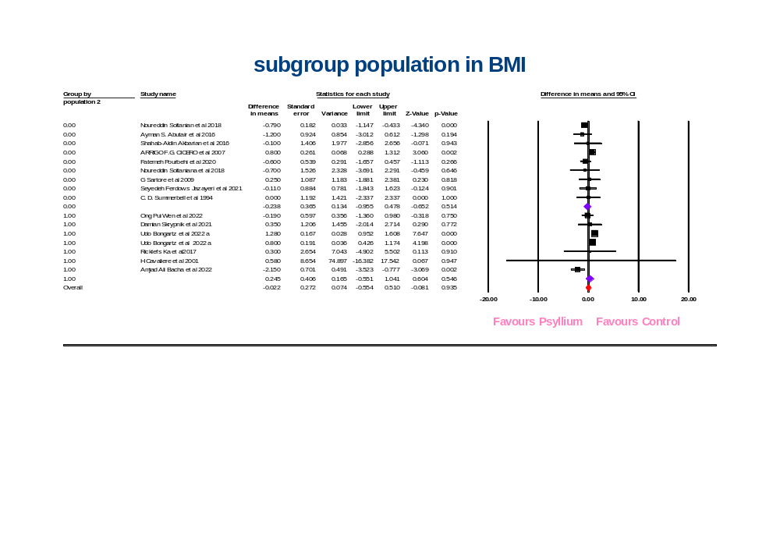

(b) 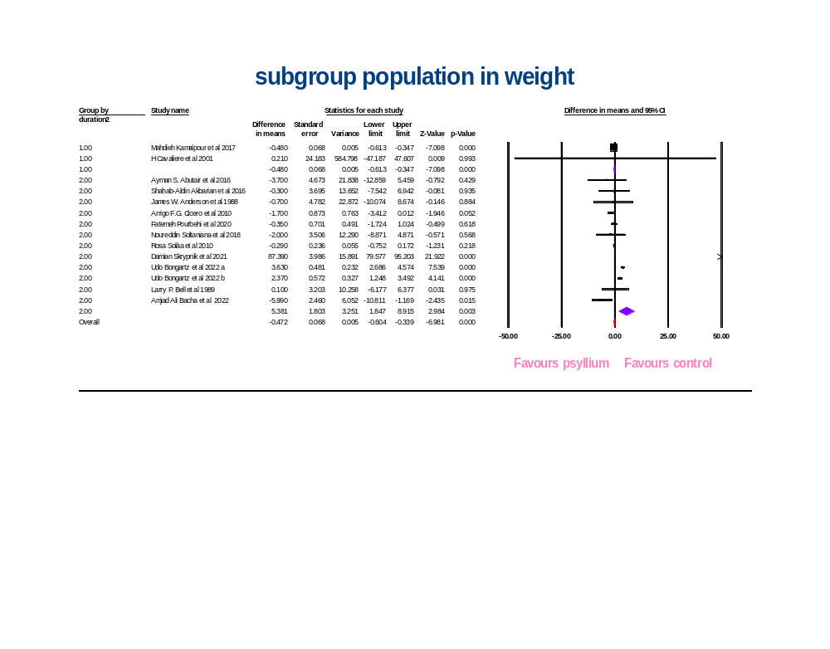

(c)
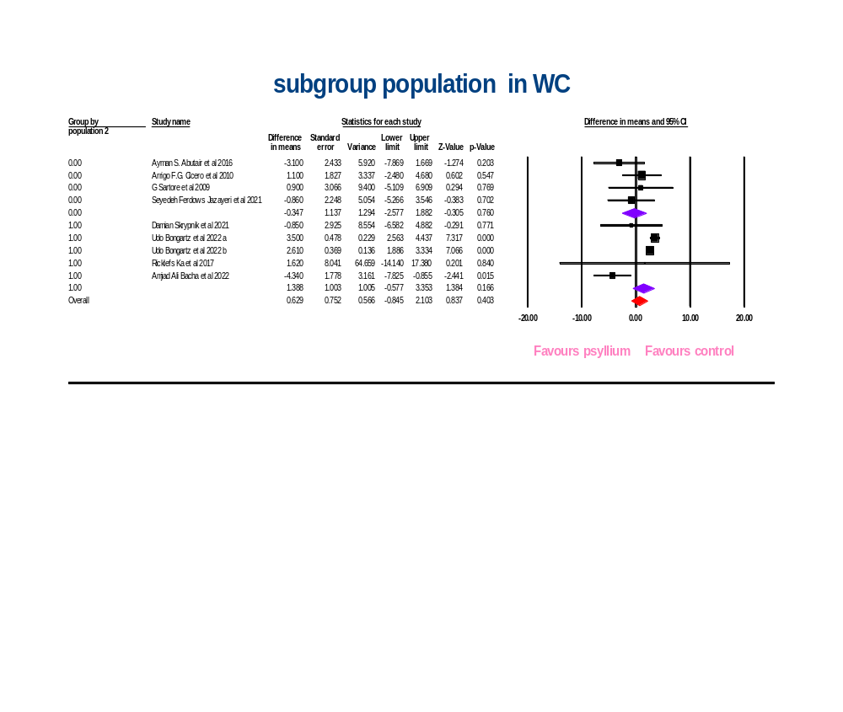
Supplementary figure 6: population subgroup analyses for the effects of psyllium on weight (a), BMI (b), and WC (C)

(a)
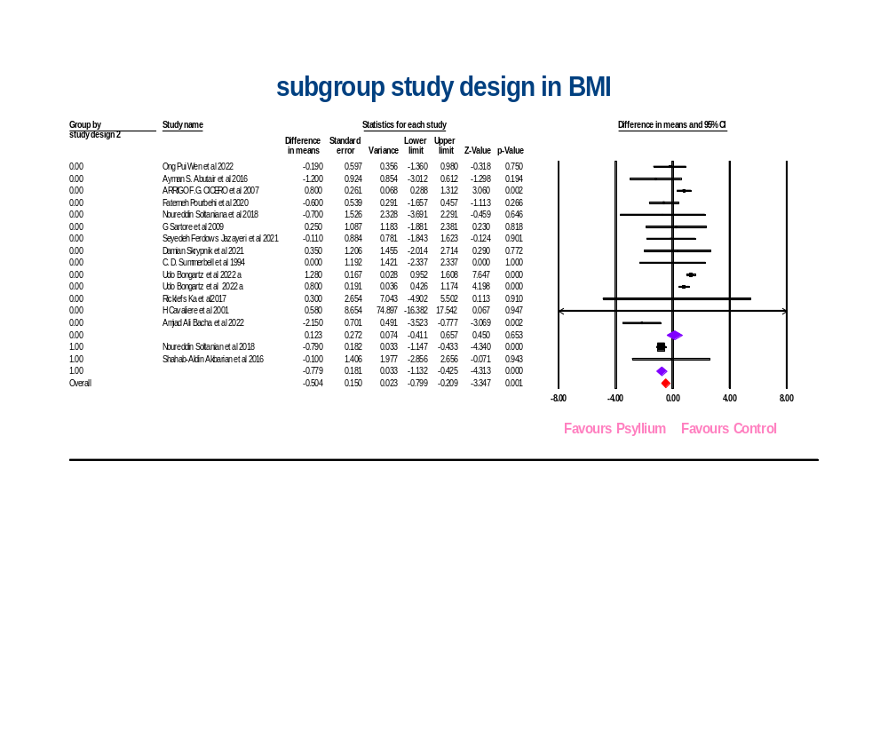

(b)
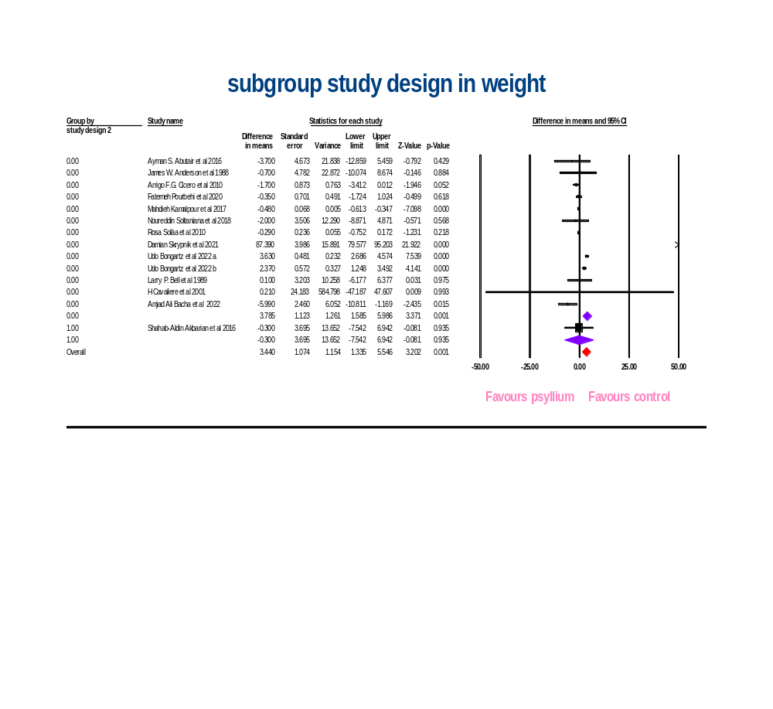

(c)
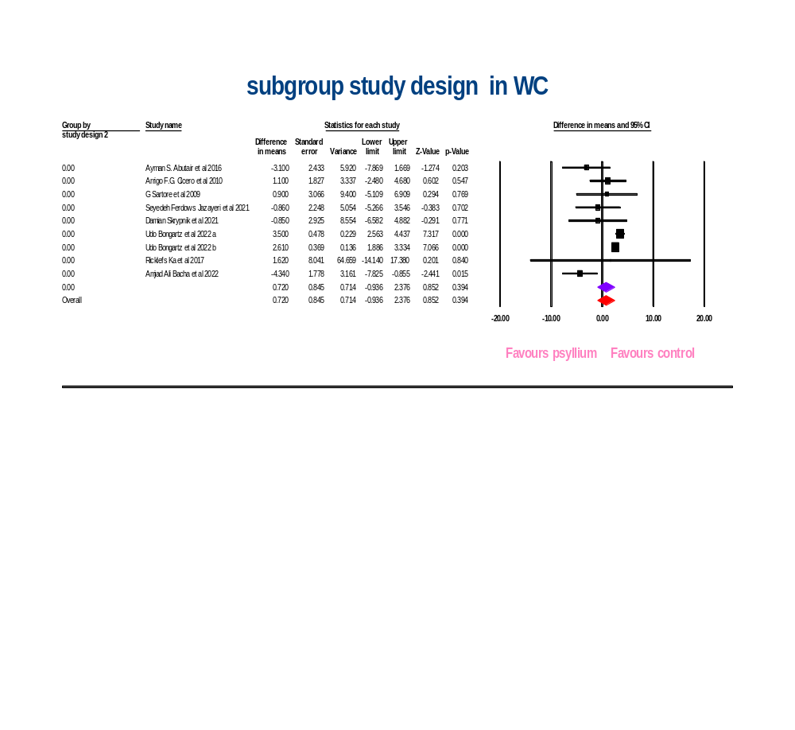
Supplementary figure 7: study design subgroup analyses for the effects of psyllium on weight (a), BMI (b), and WC (c)

(a)
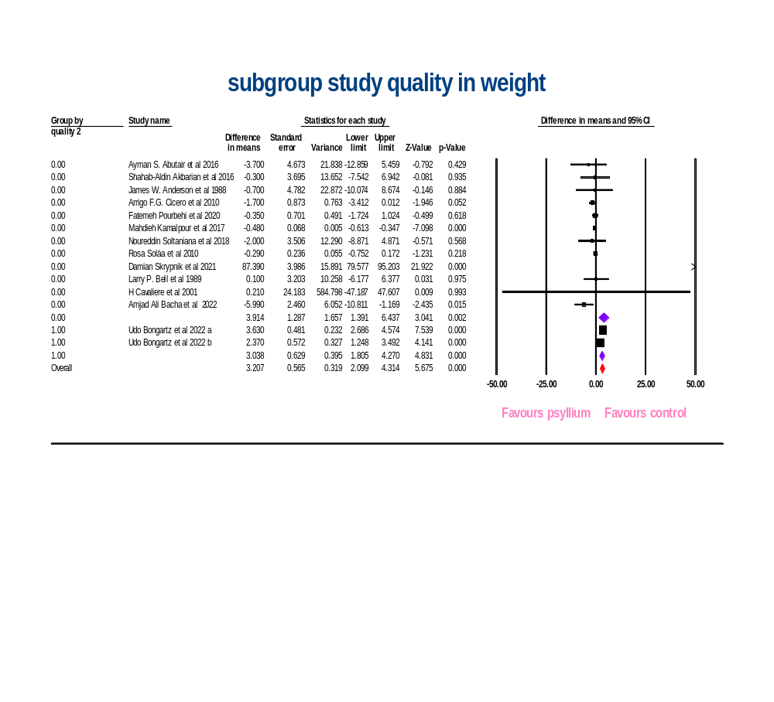

(b)
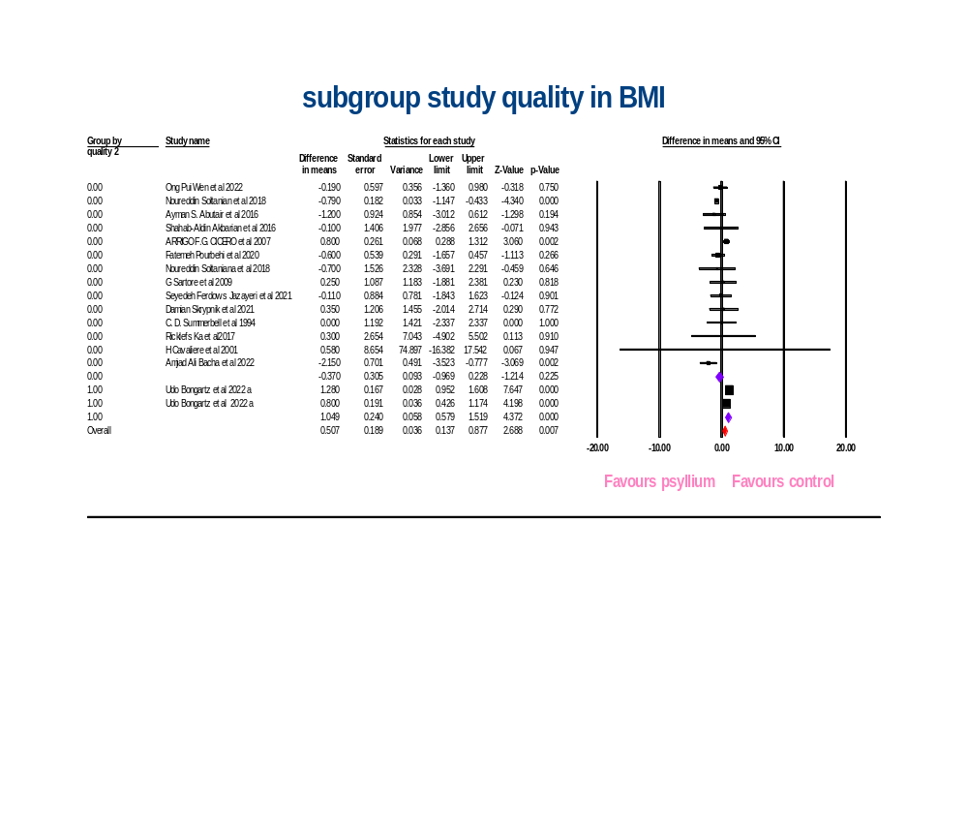

(c)
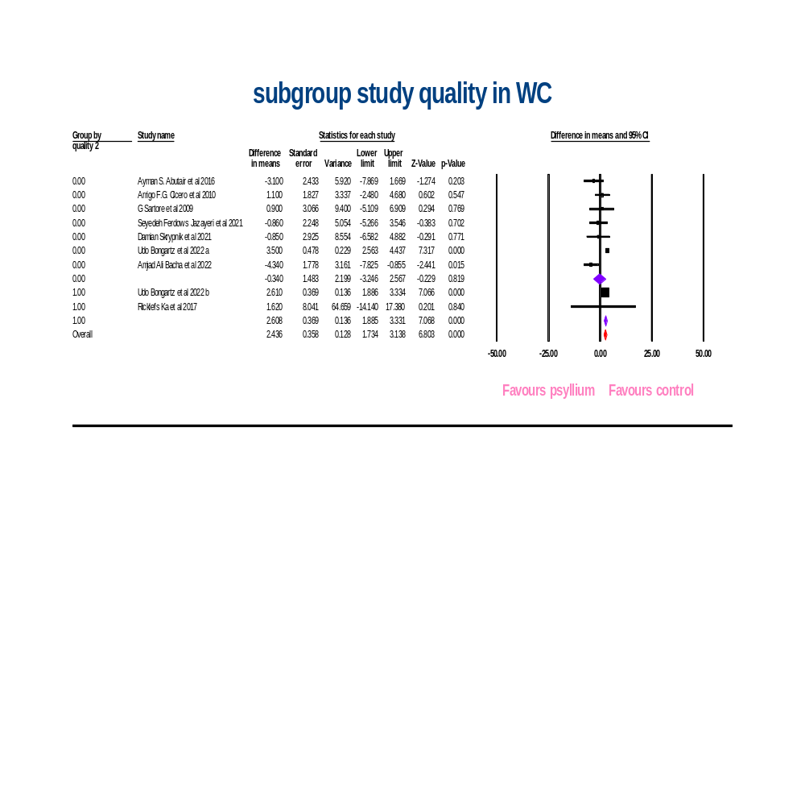
Supplementary figure 8: quality subgroup analyses for the effects of psyllium on weight (a), BMI (b), WC (c)

(a)
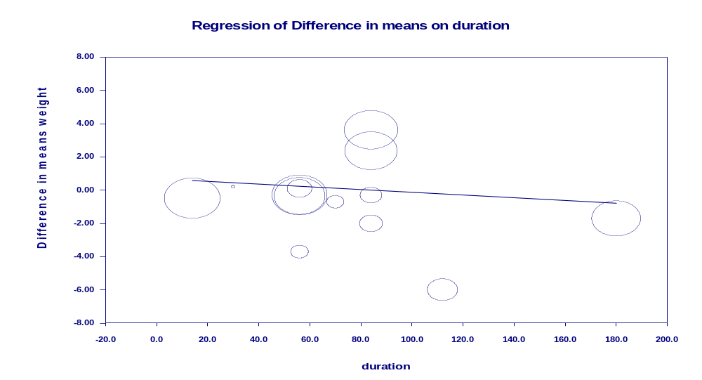

(b)
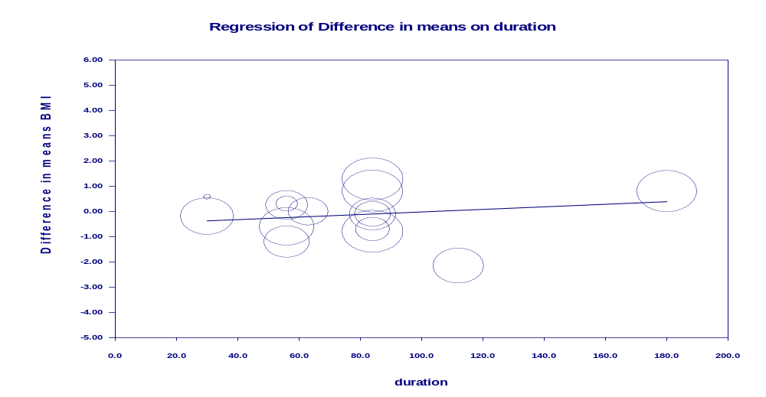

(c)
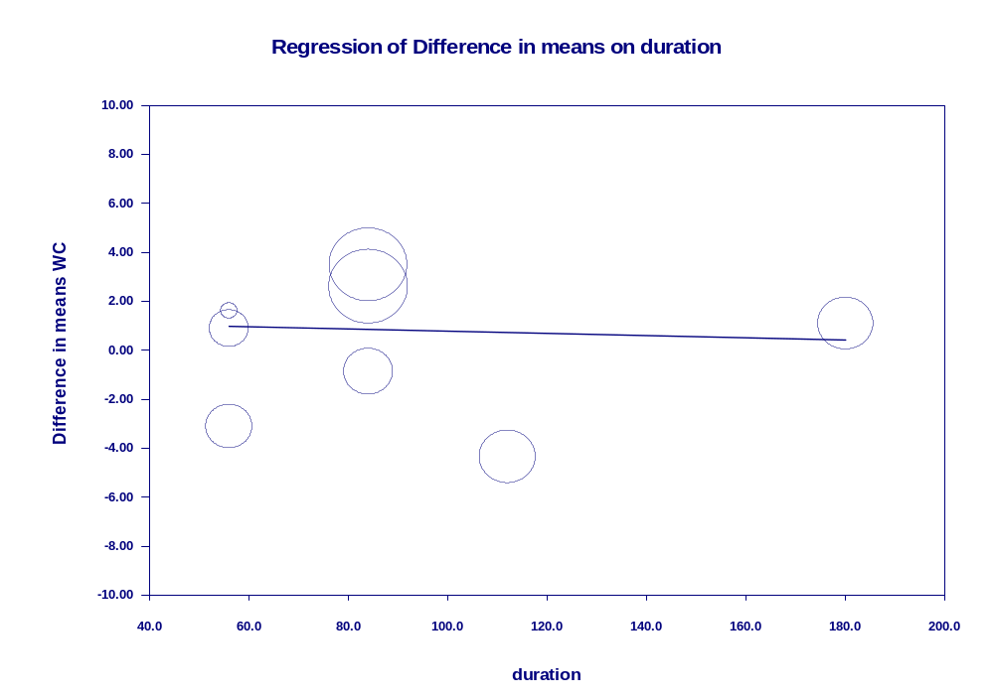
Supplementary figure 9: Random-effects meta-regression plots of the association between mean changes in weight (a), BMI (b), WC (c) and intervention duration

(a)
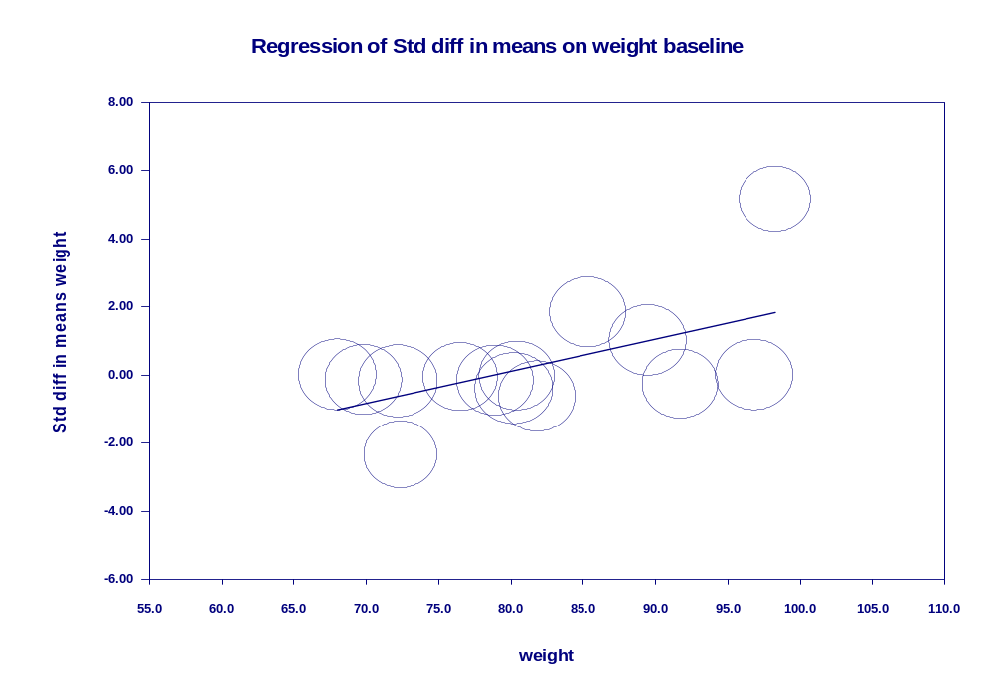
(b)
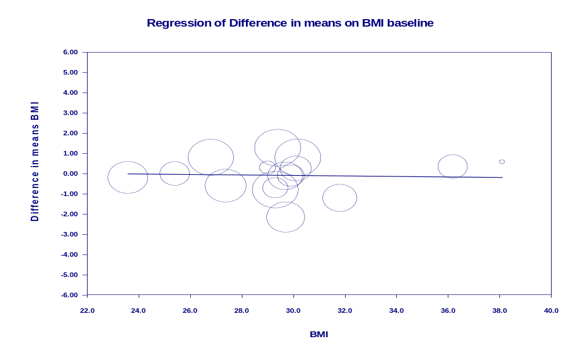

(c)
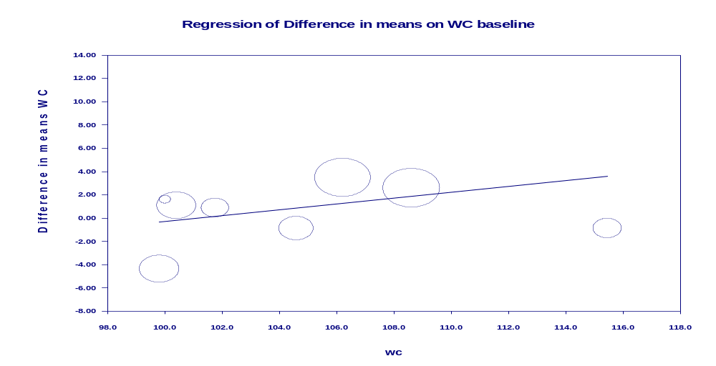

Supplementary figure 10: Random-effects meta-regression plots of the association between mean changes in weight (a), BMI (b), WC (c) and intervention baseline

(a)
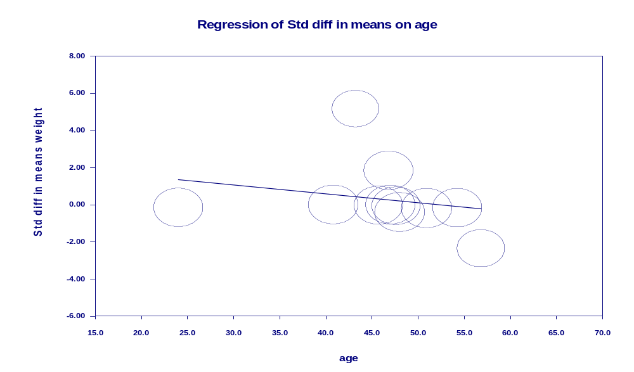

(b)
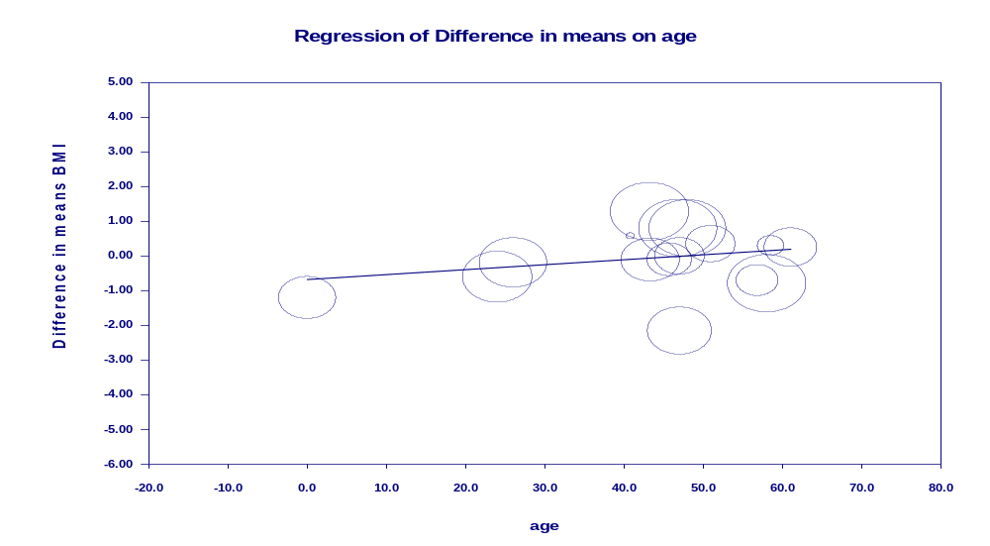
(c)
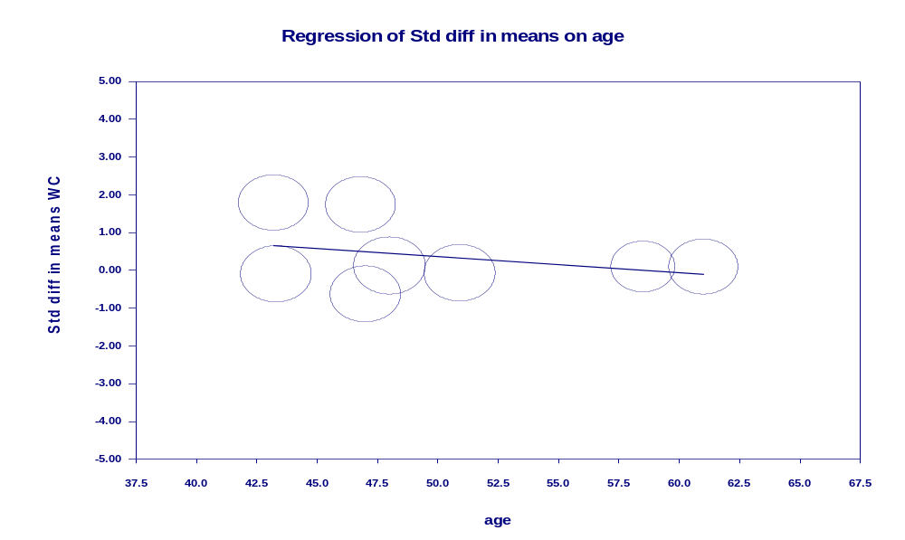
Supplementary figure 11: Random-effects meta-regression plots of the association between mean changes in weight (a), BMI (b), WC (c) and intervention age

(a)
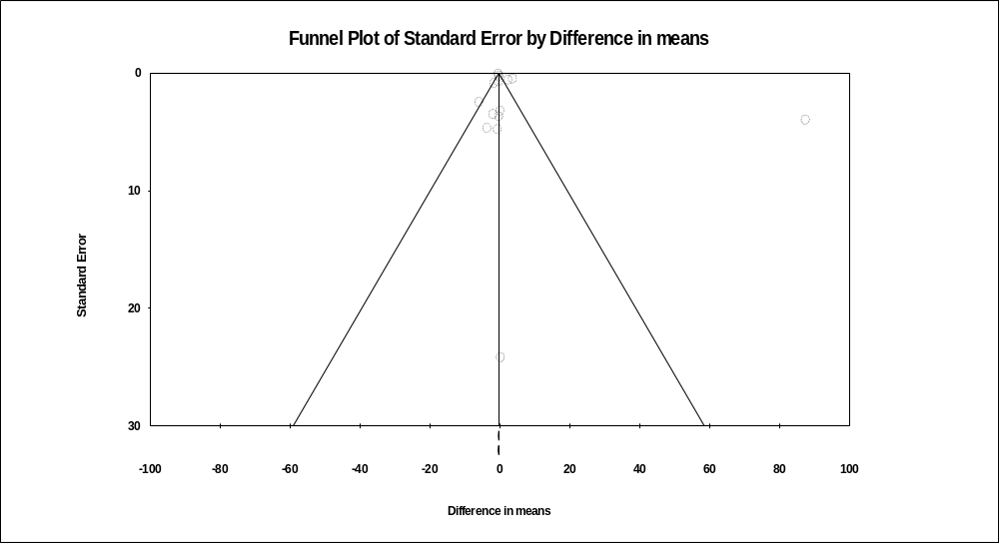
(b)
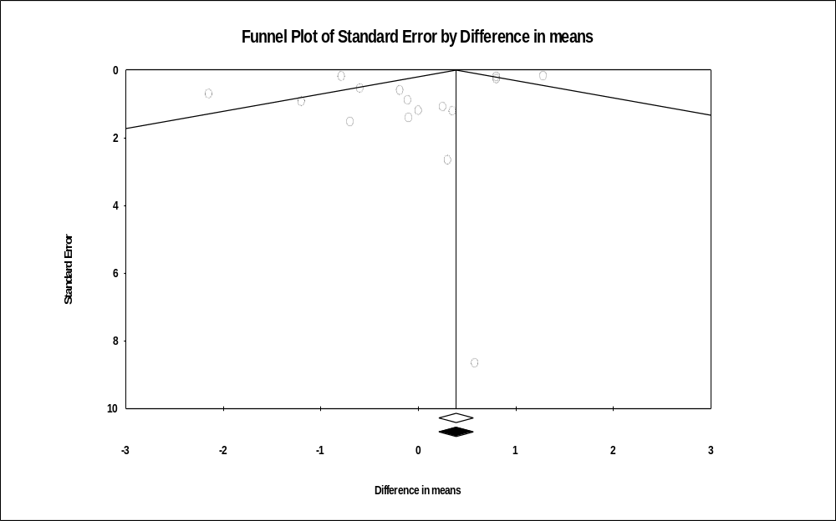

(c)
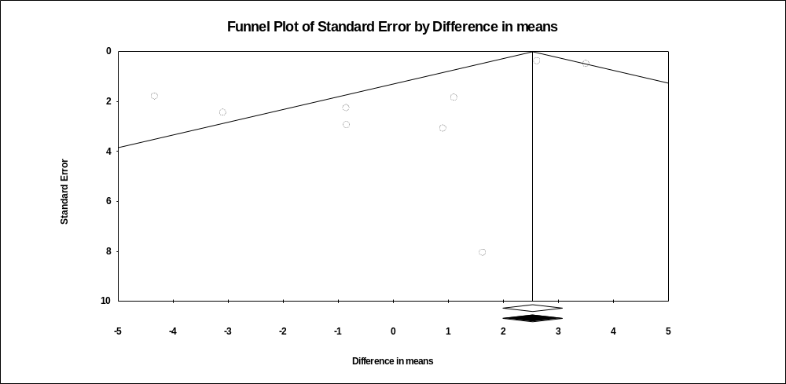
(d) 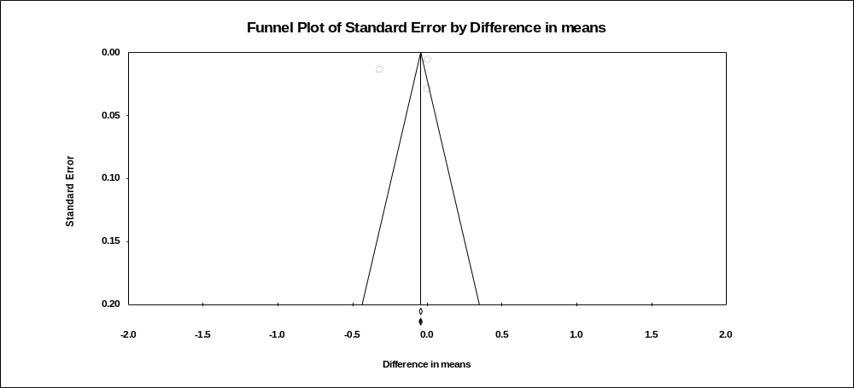
Supplementary figure 12: Publication bias of psyllium on weight (a), BMI (b), WC (c), and WHR (d)

