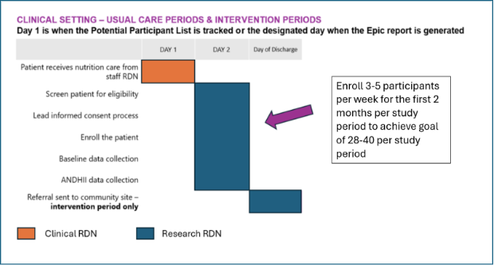
Figure S 1. Clinical Setting Encounter Timeline for Usual and Intervention Periods
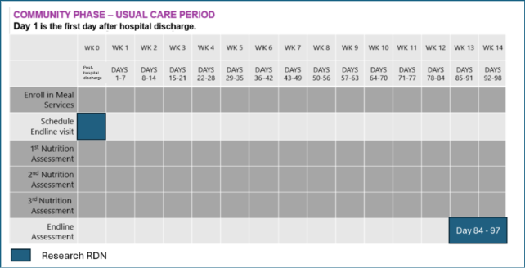
Figure S 2. Community Setting Encounter Timeline for Participants in Usual Care Period

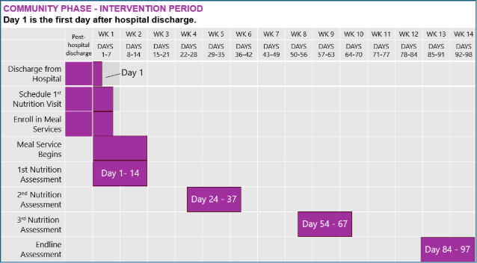
Figure S 3. Community Setting Encounter Timeline for Participants in Intervention Period

