Figure 2 Flow diagram of the item reduction process
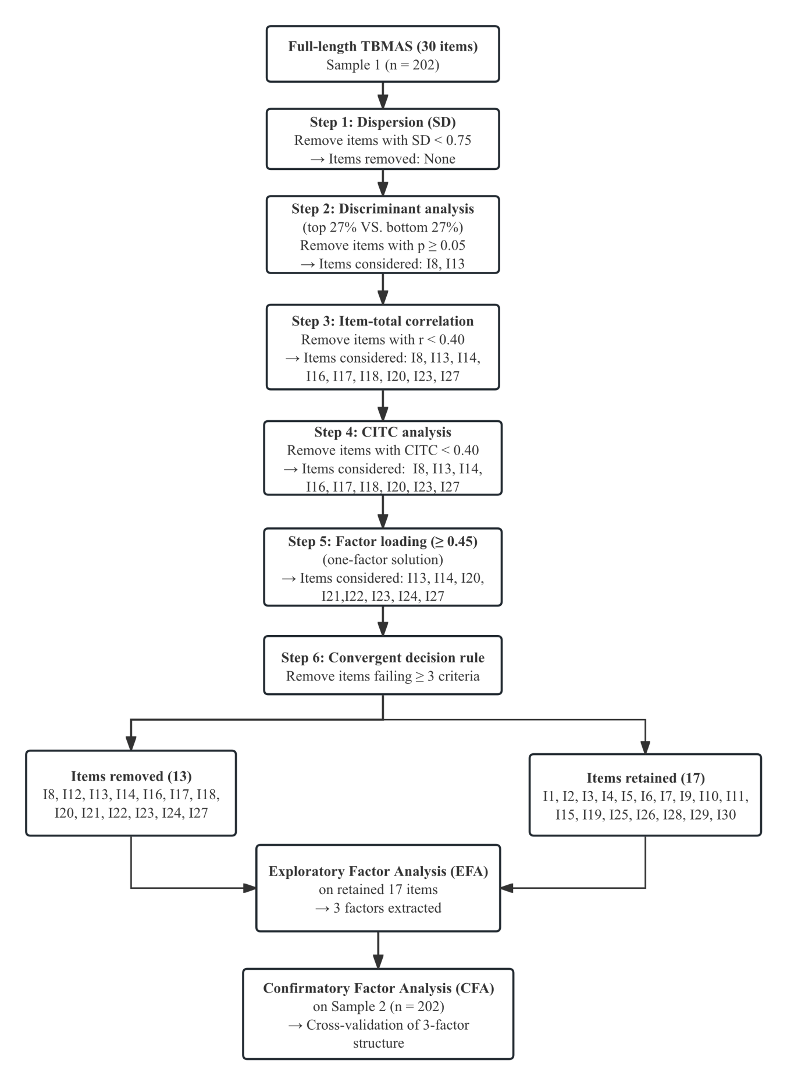
Table 4 Summary of item retention criteria and thresholds used in CTT analysis
Criterion | Statistical Measure | Threshold for Retention | Threshold for Removal | Rationale
1. Dispersion (variability) | Standard Deviation (SD) | SD ≥ 0.75 | SD < 0.75 | Items with low SD lack sufficient variability to discriminate between respondents¹
2. Discriminant validity (group difference) | Independent t-test (top 27% vs. bottom 27% of total score) | p < 0.05 | p ≥ 0.05 (non-significant) | Items that do not differ between high- and low-scoring groups fail to measure the intended construct²
3. Item-total correlation | Pearson correlation (item score vs. total score) | r ≥ 0.40 | r < 0.40 | Low correlation indicates the item does not align well with the overall scale³
4. Corrected Item-Total Correlation (CITC) | CITC (item vs. total score excluding that item) | CITC ≥ 0.40 | CITC < 0.40 | Low CITC suggests the item weakens internal consistency⁴
5. Factor loading (one-factor solution) | Extraction value / Factor loading | Loading ≥ 0.45 | Loading < 0.45 | Low loading indicates the item shares insufficient variance with the latent construct^{5, 6}
Decision Rule | Convergent performance across multiple criteria | Item retained if it fails ≤ 2 criteria | Item removed if it fails ≥ 3 criteria | Items failing only one criterion were reviewed by consensus; removal required theoretical justification^{7, 8}
References

- Clark LA, Watson D. Constructing validity: New developments in creating objective
measuring instruments. Psychological Assessment. 2019;31(12):1412-1427.
- DeVellis RF. Scale Development: Theory and Applications. 5th ed. Thousand Oaks, CA:
Sage Publications; 2021.
- Tabachnick BG, Fidell LS. Using Multivariate Statistics. 7th ed. Boston: Pearson Education
Inc; 2019.
- Polit DF, Beck CT. Nursing Research: Generating and Assessing Evidence for Nursing
Practice. 10th ed. Philadelphia: Wolters Kluwer; 2017.
- Hair JF, Black WC, Babin BJ, Anderson RE. Multivariate Data Analysis. 8th ed. Andover:
Cengage Learning; 2019.
- Howard MC. A review of exploratory factor analysis decisions and overview of current
practices. International Journal of Human-Computer Interaction. 2016;32(1):51-62.
7 Streiner DL, Norman GR, Cairney J. Health Measurement Scales. 5th ed. Oxford: Oxford University Press; 2015.
8 Boateng GO, Neilands TB, Frongillo EA, et al. Best practices for developing and validating
scales. Frontiers in Public Health. 2018;6:149.

Table 5 Mapping of original TBMAS nine dimensions to TBMAS-SF three factors
Original TBMAS Dimension (9 dimensions) | Original Item Numbers | TBMAS-SF Factor | TBMAS-SF Item Numbers | TBMAS-SF Factor Label
I. Communication with healthcare provider | I1, I2, I3, I4, I5, I6 | Factor 1 | I1, I2, I3, I4, I5, I6 | I. Communication with healthcare provider + Personal conscientiousness
II. Personal traits | I7, I8, I9, I10, I11 | Factor 1 & Factor 2 | I7 (Factor 1), I9, I10, I11 (Factor 2)
III. Confidence in curing TB | I12, I13, I14, I15 | Factor 2 | I15 | II. Personal behavior and patient support
IV. Social support | I16, I17, I18, I19 | Factor 2 | I19
V. Mood disorders | I20, I21, I22 | Deleted | – | (Not retained in short form)
VI. Living habits | I23, I24 | Deleted | – | (Not retained in short form)
VII. Active coping behavior | I25, I26 | Factor 3 | I25, I26 | III. Patient response and accessibility of healthcare services
VIII. Forgetfulness | I27, I28 | Factor 3 | I28
IX. Access to healthcare | I29, I30 | Factor 3 | I29, I30

TBMAS and TBMAS-SF

Tuberculosis Medication Adherence Scale (TBMAS)
INSTRUCTIONS: Please carefully read each of the following questions and answer them based on your current situation. Because everyone has different experiences with tuberculosis treatment, there is no right or wrong approach. Each question has 5 answers, represented by 1 (strongly disagree), 2 (disagree), 3 (neutral), 4 (agree), and 5 (strongly agree). Write an answer in the blank ______or check [ √ ] the best answer to each question. There are a total of 30 questions in the table.
 | Item | 1 | 2 | 3 | 4 | 5
I | communication with healthcare provider
1 | I am satisfied with healthcare worker’s attitude.
2 | Healthcare worker described TB to me clearly.
3 | Healthcare worker explained my condition to me clearly.
4 | Healthcare worker explained the method of taking medicine clearly.
5 | Healthcare worker explained the side-effects of medicine clearly.
6 | Healthcare worker led me to believe that my TB can be cured.
II | personal traits
7 | I often keep my things neat and clean.
8 | I am strict with myself to follow my plan.
9 | I often seek the most effective way in doing things.
10 | I often set clear target.
11 | I am organized and systematic in approaching my target.
III | confidence in curing TB
12 | I am very confident to completely cure TB.
13 | My treatment regimen is very simple.
14 | I am very confident in taking TB medicine regularly for 6 months.
15 | I am very confident in tolerating side-effects.
IV | social support
16 | I am satisfied with the support between our family members.
17 | My family members often remind me to take medicine.
18 | My friends often remind me to do things.
19 | People around me often give me necessary help.
V | mood disorders
20 | I sometimes feel depressed.
21 | When I do something wrong, I feel frustrated and want to give up.
22 | I sometimes feel helpless and want other people’s help.
VI | living habits
23 | I sleep and wake up regularly every day.
24 | I have meals regularly every day.
VII | active coping behavior
25 | I actively pursued knowledge on TB when I knew I had been infected.
26 | I often ask the doctor about my condition since I know I have been
VIII | forgetfulness
27 | I sometimes forgot to do important things I planned to do.
28 | My memory is good.
IX | access to healthcare
29 | It’s convenient to refill my TB medicine.
30 | The TB control institution I visit meets my need.

中文原版结核病患者遵医行为评定量表
请您仔细阅读以下每一个问题，然后根据自己的实际情况认真填写。因为在结核病的治疗过程中，每个人都会有不同的经历，所以这里不存在正确或错误的问题。每个问题有5 个答案分别用 1（非常不同意）、2（比较不同意）、3（一般）、4（比较同意）、5（非常同意）来表示，每个问题都要回答并且只能有一个答案，您可以在每道题目后面的括号内写上最符合您答案的选项，也可以直接在最符合您的答案上打√。看懂方法后请回答，全表共有30个问题。
 | Item | 1 | 2 | 3 | 4 | 5
I | 医患交流
1 | 我对就诊过程中医务人员的服务态度非常满意。
2 | 就诊过程中，医务人员向我详细介绍了结核病相关知识。
3 | 就诊过程中，医务人员向我详细介绍了病情。
4 | 医务人员向我详细说明了服药方法。
5 | 医务人员向我详细说明了服药过程中可能出现的副反应。
6 | 医务人员让我相信结核病是可以治愈的。
II | 行为特点
7 | 我总是保持自己的物品干净整洁。
8 | 我善于严格要求自己去执行计划。
9 | 我善于寻找最有效的方法去解决问题。
10 | 我做事情目标非常明确。
11 | 我做事情非常具有系统性和条理性。
III | 治疗信心
12 | 我有完全治愈结核的信心
13 | 我的治疗方案比较简单
14 | 我有信心坚持服药6个月
15 | 我有克服药物副作用的信心
IV | 社会支持
16 | 我对从家人得到的帮助满意
17 | 我的家人之间能提醒一些重要事情
18 | 周围朋友常提醒我一些重要事情
19 | 周围朋友能给我必要的关心和帮助
V | 心理特点
20 | 我时常会觉得闷闷不乐
21 | 事情出错时，我会觉得沮丧想要放弃
22 | 我常常觉得无助，并希望他人帮我解决问题
VI | 生活习惯
23 | 我每天睡觉和起床时间很规律
24 | 我一日三餐很有规律
VII | 应对方式
25 | 我非常关注结核病相关知识
26 | 我会经常向医生询问病情
VIII | 记忆力
27 | 我有时会忘记一些该做的事情
28 | 我的记忆力较好
IX | 卫生服务可及性
29 | 我到结防机构就诊方便
30 | 我所就诊的结防机构设备较齐全

Short Form Version of the Tuberculosis Medication Adherence（TBMAS-SF）
INSTRUCTIONS:Please carefully read each of the following questions and answer them based on your current situation. Because everyone has different experiences with tuberculosis treatment, there is no right or wrong approach. Each question has 5 answers, represented by 1 (strongly disagree), 2 (disagree), 3 (neutral), 4 (agree), and 5 (strongly agree). Write an answer in the blank ______or check [ √ ] the best answer to each question.There are a total of 17 questions in the table.
 | Item | 1 | 2 | 3 | 4 | 5
I | communication with healthcare provider
1 | I am satisfied with healthcare worker’s attitude.
2 | Healthcare worker described TB to me clearly.
3 | Healthcare worker explained my condition to me clearly.
4 | Healthcare worker explained the method of taking medicine clearly.
5 | Healthcare worker explained the side-effects of medicine clearly.
6 | Healthcare worker led me to believe that my TB can be cured.
7 | I often keep my things neat and clean.
II | Personal behavior and patient support
9 | I often seek the most effective way in doing things.
10 | I often set clear target.
11 | I am organized and systematic in approaching my target.
15 | I am very confident in tolerating side-effects.
19 | People around me often give me necessary help.
III | Patient response and accessibility of healthcare services
25 | I actively pursued knowledge on TB when I knew I had been infected.
26 | I often ask the doctor about my condition since I know I have been
28 | My memory is good.
29 | It’s convenient to refill my TB medicine.
30 | The TB control institution I visit meets my need.

中文精简版结核遵医行为量表
请您仔细阅读以下每一个问题，然后根据自己的实际情况认真填写。因为在结核病的治疗过程中，每个人都会有不同的经历，所以这里不存在正确或错误的问题。每个问题有5 个答案分别用 1（非常不同意）、2（比较不同意）、3（一般）、4（比较同意）、5（非常同意）来表示，每个问题都要回答并且只能有一个答案，您可以在每道题目后面的括号内写上最符合您答案的选项，也可以直接在最符合您的答案上打√。看懂方法后请回答，全表共有17个问题。
 | Item | 1 | 2 | 3 | 4 | 5
I | 医患交流
1 | 我对就诊过程中医务人员的服务态度非常满意。
2 | 就诊过程中，医务人员向我详细介绍了结核病相关知识。
3 | 就诊过程中，医务人员向我详细介绍了病情。
4 | 医务人员向我详细说明了服药方法。
5 | 医务人员向我详细说明了服药过程中可能出现的副反应。
6 | 医务人员让我相信结核病是可以治愈的。
7 | 我总是保持自己的物品干净整洁。
II | 患者行为与治疗支持
9 | 我善于寻找最有效的方法去解决问题。
10 | 我做事情目标非常明确。
11 | 我做事情非常具有系统性和条理性。
15 | 我有克服药物副作用的信心
19 | 周围朋友能给我必要的关心和帮助
III | 患者应对与医疗服务可及性
25 | 我非常关注结核病相关知识
26 | 我会经常向医生询问病情
28 | 我的记忆力较好
29 | 我到结防机构就诊方便
30 | 我所就诊的结防机构设备较齐全

