Methods Results

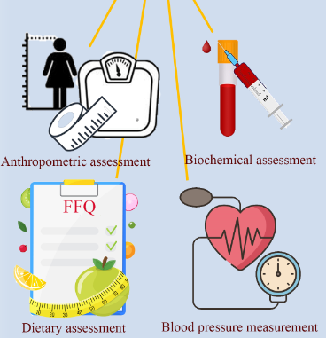


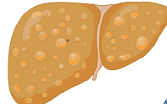

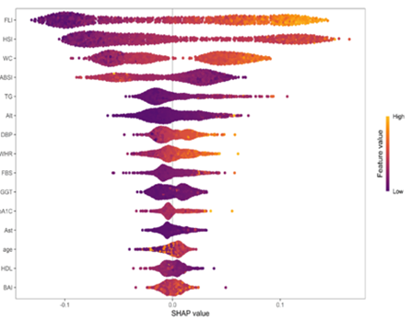
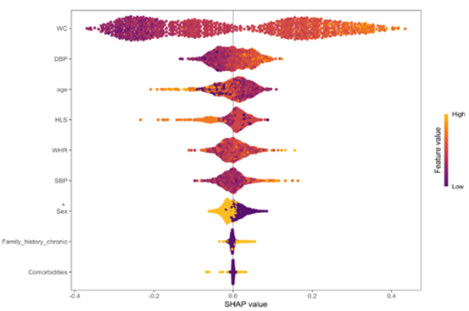
Selected models: RF/GBM due to the strongest performance (AUC 0.77)
Physical activity assessment using (IPAQ) metric
Data from3120 adults (43.1% female) of the Amol Cohort Study (AmolCS)

Measurements
Abdominal
Ultrasonography
Using six machine learning algorithms:
  - Neural Networks (NN)
  - Recursive Partitioning and Regression Trees (RPART)
  - Random Forest (RF)
  - Generalized Boosted Models (GBM)
  - Support Vector Machines (SVM)
  - k-Nearest Neighbors (k-NN)

Predictive model for MASLD

(A): All variables
(B): no-invasive, low-cost variables
Conclusion: Interpretable ML models (RF/GBM) accurately estimate MASLD probability using low-cost, non-invasive measures, highlighting waist circumference and hepatic indices (FLI/HSI) with clear sex-specific patterns.

