Supplementary Materials
Association of Four Nutritional Indicators with All-Cause and Cardiovascular Mortality Among Older Chinese Adults: A Prospective Cohort Study

Contents
Supplementary Figure S1. Study participant flowchart
Supplementary Figure S2. Distributions of nutritional indices
Supplementary Figure S3. Kaplan–Meier curves for cardiovascular mortality
Supplementary Figure S4. Decision-curve analysis — all-cause mortality
Supplementary Figure S5. Decision-curve analysis — cardiovascular mortality
Supplementary Table S1. Cox models — cardiovascular mortality
Supplementary Table S2. Outlier-excluded sensitivity — all-cause
Supplementary Table S3. Outlier-excluded sensitivity — cardiovascular
Supplementary Table S4. Fine–Gray competing-risk — cardiovascular
Supplementary Table S5. Subgroup analyses — all-cause
Supplementary Table S6. Subgroup analyses — cardiovascular
Supplementary Table S7. Multiple imputation — all-cause
Supplementary Table S8. Multiple imputation — cardiovascular
Supplementary Table S9. Incremental value (cNRI, IDI) — all-cause
Supplementary Table S10. Incremental value (cNRI, IDI) — cardiovascular

Supplementary Figures
Supplementary Figure S1. Study participant flowchart. From 2,546 participants in the 2014–2018 CLHLS cohort with blood-biomarker data, 159 were excluded for missing nutritional-index components or covariates, 82 for age <65 years, 6 for non-positive follow-up time, 244 for missing or invalid height or weight, and 248 for missing follow-up/vital-status information, yielding 1,807 participants for the final analysis.
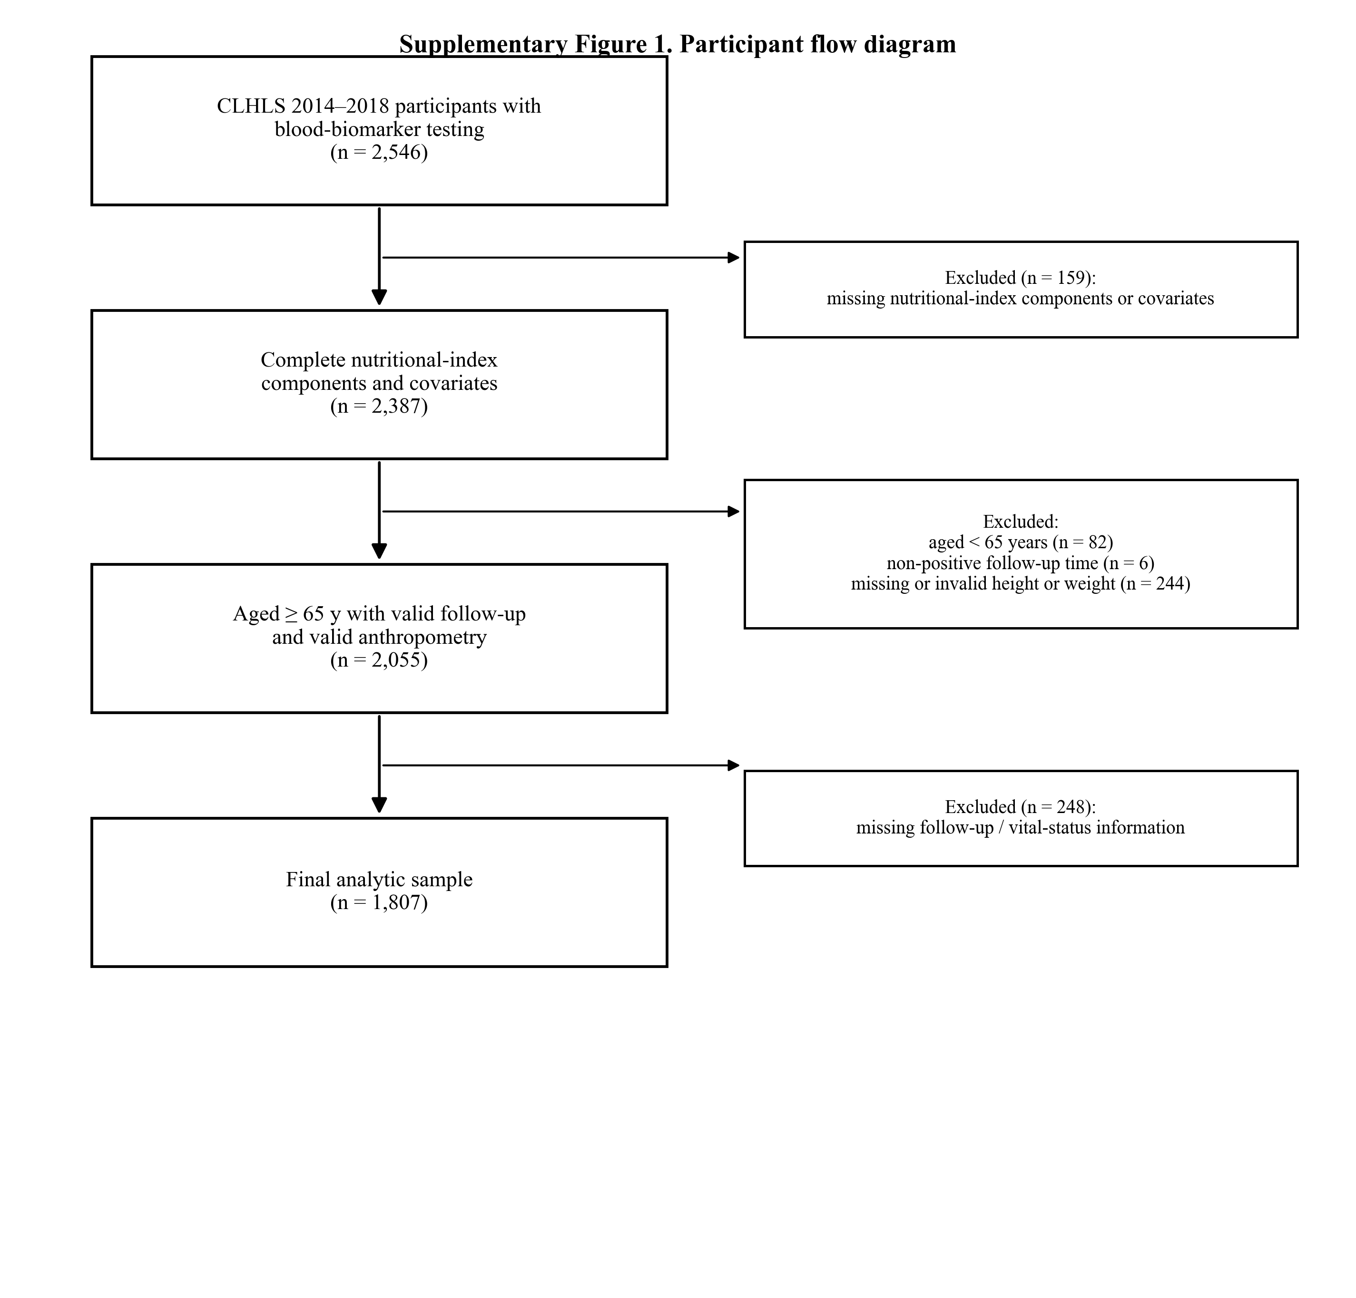

Supplementary Figure S2. Distributions of GNRI, PNI, HALP, and ln(CONUT+1) after restriction to the 1st–99th percentiles. GNRI and PNI are approximately symmetric, HALP is right-skewed, and ln(CONUT+1) is multimodal because the underlying CONUT score is discrete.
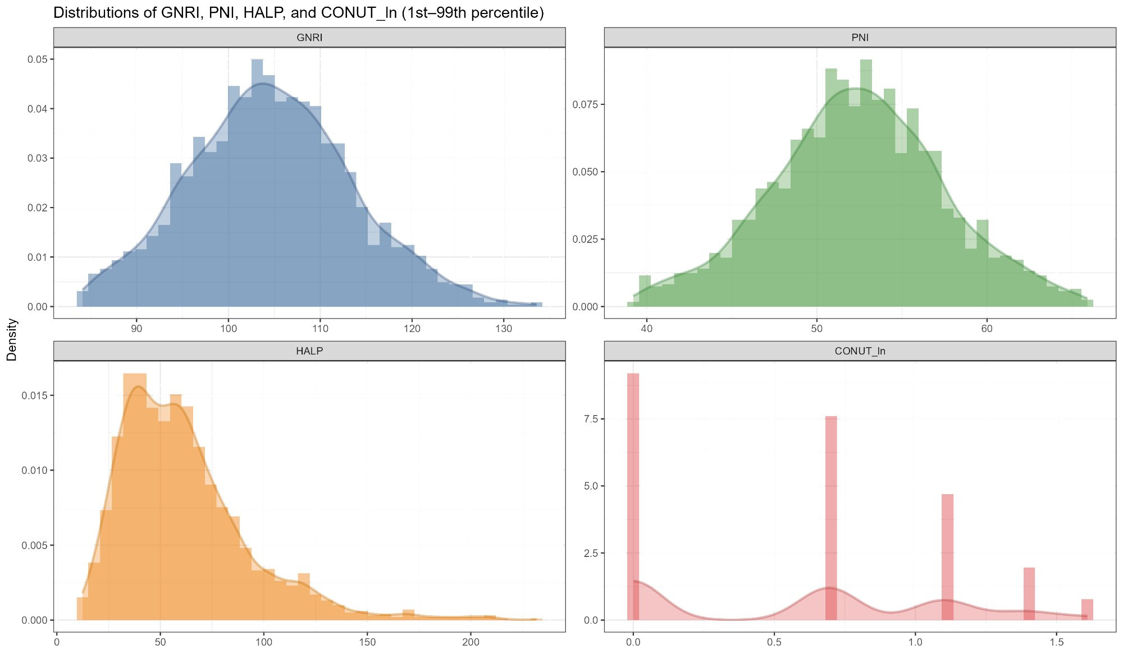

Supplementary Figure S3. Kaplan–Meier survival curves for cardiovascular mortality stratified by biomarker-based risk groups (High Risk, Low Risk, No Risk). Log-rank p < 0.001 for GNRI, PNI, and HALP; p = 0.009 for ln(CONUT+1).
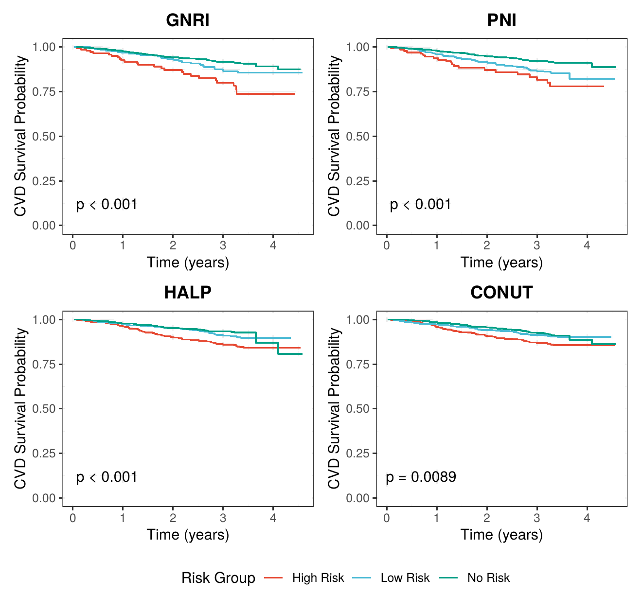

Supplementary Figure S4. Decision-curve analysis for 3-year all-cause mortality. Net benefit of the clinical model (Model 3 covariates) alone and after adding each nutritional index, compared with treat-all and treat-none strategies.
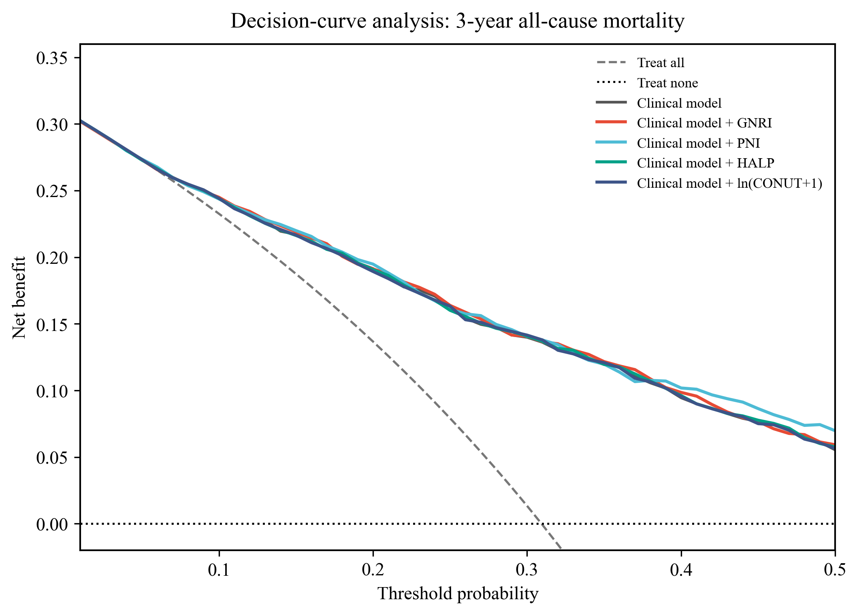

Supplementary Figure S5. Decision-curve analysis for 3-year cardiovascular mortality (cause-specific; non-cardiovascular death treated as a competing event). Net benefit of the clinical model alone and after adding each nutritional index, compared with treat-all and treat-none strategies.
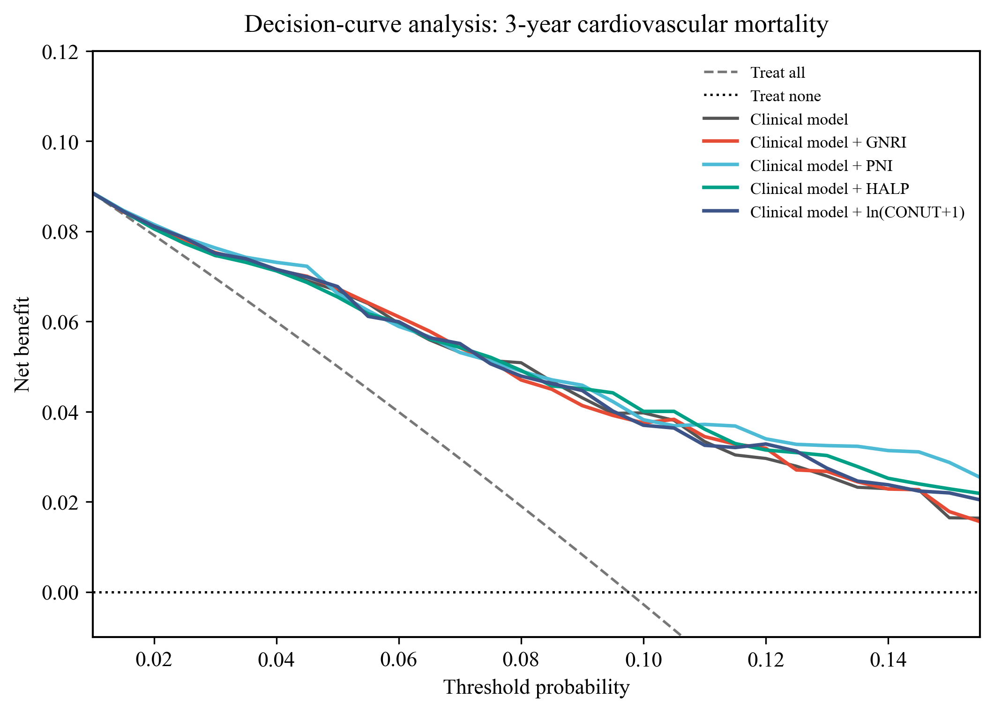

Supplementary Tables
Supplementary Table S1. Association of nutritional indices with cardiovascular mortality: Cox proportional hazards models.
Model 0: unadjusted; Model 1: sex and age; Model 2: additionally education, marital status, smoking, and alcohol; Model 3: additionally creatinine, BUN, CRP, hypertension, diabetes, and CVD history. Each model column combines the effect estimate, 95% CI, and p value. Effect estimates and p values are shown to three decimal places; p < 0.001 is reported as such. HR, hazard ratio; CI, confidence interval; sHR, subdistribution hazard ratio.
Exposure / category | Model 0  HR (95% CI); p | Model 1  HR (95% CI); p | Model 2  HR (95% CI); p | Model 3  HR (95% CI); p
Continuous analyses (per 1-unit increase)

GNRI | 0.960 (0.946–0.976)  p < 0.001 | 0.986 (0.969–1.003)  p = 0.109 | 0.986 (0.969–1.004)  p = 0.122 | 0.983 (0.966–1.001)  p = 0.065
PNI | 0.917 (0.892–0.943)  p < 0.001 | 0.948 (0.921–0.975)  p < 0.001 | 0.946 (0.919–0.973)  p < 0.001 | 0.945 (0.918–0.973)  p < 0.001
HALP | 0.992 (0.987–0.997)  p = 0.003 | 0.995 (0.990–0.999)  p = 0.048 | 0.995 (0.990–0.999)  p = 0.038 | 0.995 (0.990–0.999)  p = 0.033
ln(CONUT+1) | 1.753 (1.320–2.326)  p < 0.001 | 1.467 (1.103–1.952)  p = 0.009 | 1.492 (1.120–1.989)  p = 0.006 | 1.423 (1.066–1.900)  p = 0.017
Categorical analyses

GNRI
T1 | 1.000 (Ref)  p = Ref | 1.000 (Ref)  p = Ref | 1.000 (Ref)  p = Ref | 1.000 (Ref)  p = Ref
T2 | 0.721 (0.510–1.020)  p = 0.065 | 0.977 (0.687–1.391)  p = 0.898 | 0.982 (0.689–1.398)  p = 0.919 | 0.969 (0.676–1.388)  p = 0.862
T3 | 0.492 (0.336–0.720)  p < 0.001 | 0.903 (0.603–1.353)  p = 0.621 | 0.924 (0.616–1.385)  p = 0.701 | 0.877 (0.578–1.331)  p = 0.539
P for Trend | P-trend < 0.001 | P-trend = 0.633 | P-trend = 0.711 | P-trend = 0.551
PNI
T1 | 1.000 (Ref)  p = Ref | 1.000 (Ref)  p = Ref | 1.000 (Ref)  p = Ref | 1.000 (Ref)  p = Ref
T2 | 0.638 (0.454–0.896)  p = 0.010 | 0.761 (0.541–1.071)  p = 0.117 | 0.757 (0.537–1.066)  p = 0.111 | 0.768 (0.542–1.088)  p = 0.138
T3 | 0.359 (0.241–0.536)  p < 0.001 | 0.526 (0.349–0.792)  p = 0.002 | 0.522 (0.346–0.786)  p = 0.002 | 0.527 (0.348–0.798)  p = 0.002
P for Trend | P-trend < 0.001 | P-trend = 0.002 | P-trend = 0.002 | P-trend = 0.002
HALP
T1 | 1.000 (Ref)  p = Ref | 1.000 (Ref)  p = Ref | 1.000 (Ref)  p = Ref | 1.000 (Ref)  p = Ref
T2 | 0.619 (0.437–0.876)  p = 0.007 | 0.736 (0.518–1.044)  p = 0.086 | 0.722 (0.508–1.025)  p = 0.068 | 0.730 (0.511–1.042)  p = 0.083
T3 | 0.476 (0.325–0.695)  p < 0.001 | 0.606 (0.413–0.892)  p = 0.011 | 0.596 (0.404–0.878)  p = 0.009 | 0.580 (0.392–0.860)  p = 0.007
P for Trend | P-trend < 0.001 | P-trend = 0.009 | P-trend = 0.007 | P-trend = 0.006
ln(CONUT+1)
T1 | 1.000 (Ref)  p = Ref | 1.000 (Ref)  p = Ref | 1.000 (Ref)  p = Ref | 1.000 (Ref)  p = Ref
T2 | 1.150 (0.776–1.702)  p = 0.486 | 1.052 (0.709–1.562)  p = 0.801 | 1.060 (0.713–1.577)  p = 0.773 | 1.075 (0.722–1.601)  p = 0.721
T3 | 1.840 (1.288–2.629)  p < 0.001 | 1.488 (1.035–2.140)  p = 0.032 | 1.510 (1.050–2.171)  p = 0.026 | 1.444 (0.999–2.086)  p = 0.050
P for Trend | P-trend < 0.001 | P-trend = 0.028 | P-trend = 0.023 | P-trend = 0.047

Supplementary Table S2. Sensitivity analysis: outlier-excluded results for all-cause mortality.
Model 0: unadjusted; Model 1: sex and age; Model 2: additionally education, marital status, smoking, and alcohol; Model 3: additionally creatinine, BUN, CRP, hypertension, diabetes, and CVD history. Each model column combines the effect estimate, 95% CI, and p value. Effect estimates and p values are shown to three decimal places; p < 0.001 is reported as such. HR, hazard ratio; CI, confidence interval; sHR, subdistribution hazard ratio.
Exposure / category | Model 0  HR (95% CI); p | Model 1  HR (95% CI); p | Model 2  HR (95% CI); p | Model 3  HR (95% CI); p
Continuous analyses (per 1-unit increase)

GNRI | 0.939 (0.929–0.949)  p < 0.001 | 0.974 (0.963–0.986)  p < 0.001 | 0.975 (0.964–0.986)  p < 0.001 | 0.972 (0.960–0.984)  p < 0.001
PNI | 0.908 (0.891–0.925)  p < 0.001 | 0.950 (0.933–0.968)  p < 0.001 | 0.950 (0.932–0.968)  p < 0.001 | 0.947 (0.929–0.966)  p < 0.001
HALP | 0.993 (0.990–0.996)  p < 0.001 | 0.998 (0.995–1.001)  p = 0.118 | 0.998 (0.995–1.001)  p = 0.132 | 0.997 (0.994–1.000)  p = 0.078
ln(CONUT+1) | 1.459 (1.222–1.741)  p < 0.001 | 1.189 (0.995–1.420)  p = 0.056 | 1.193 (0.998–1.427)  p = 0.053 | 1.177 (0.983–1.408)  p = 0.076
Categorical analyses

GNRI
T1 | 1.000 (Ref)  p = Ref | 1.000 (Ref)  p = Ref | 1.000 (Ref)  p = Ref | 1.000 (Ref)  p = Ref
T2 | 0.635 (0.467–0.863)  p = 0.004 | 0.820 (0.602–1.118)  p = 0.210 | 0.805 (0.590–1.097)  p = 0.170 | 0.808 (0.590–1.105)  p = 0.181
T3 | 0.281 (0.214–0.370)  p < 0.001 | 0.557 (0.420–0.738)  p < 0.001 | 0.559 (0.422–0.741)  p < 0.001 | 0.547 (0.410–0.730)  p < 0.001
P for Trend | P-trend < 0.001 | P-trend < 0.001 | P-trend < 0.001 | P-trend < 0.001
PNI
T1 | 1.000 (Ref)  p = Ref | 1.000 (Ref)  p = Ref | 1.000 (Ref)  p = Ref | 1.000 (Ref)  p = Ref
T2 | 0.519 (0.387–0.696)  p < 0.001 | 0.824 (0.611–1.111)  p = 0.204 | 0.800 (0.592–1.080)  p = 0.145 | 0.744 (0.548–1.009)  p = 0.057
T3 | 0.295 (0.224–0.387)  p < 0.001 | 0.568 (0.429–0.751)  p < 0.001 | 0.557 (0.421–0.738)  p < 0.001 | 0.523 (0.392–0.698)  p < 0.001
P for Trend | P-trend < 0.001 | P-trend < 0.001 | P-trend < 0.001 | P-trend < 0.001
HALP
T1 | 1.000 (Ref)  p = Ref | 1.000 (Ref)  p = Ref | 1.000 (Ref)  p = Ref | 1.000 (Ref)  p = Ref
T2 | 0.549 (0.442–0.681)  p < 0.001 | 0.676 (0.544–0.840)  p < 0.001 | 0.673 (0.542–0.837)  p < 0.001 | 0.664 (0.533–0.827)  p < 0.001
T3 | 0.586 (0.474–0.725)  p < 0.001 | 0.810 (0.653–1.005)  p = 0.056 | 0.820 (0.660–1.019)  p = 0.072 | 0.793 (0.636–0.989)  p = 0.040
P for Trend | P-trend < 0.001 | P-trend = 0.028 | P-trend = 0.035 | P-trend = 0.019
ln(CONUT+1)
T1 | 1.000 (Ref)  p = Ref | 1.000 (Ref)  p = Ref | 1.000 (Ref)  p = Ref | 1.000 (Ref)  p = Ref
T2 | 0.907 (0.722–1.140)  p = 0.404 | 0.857 (0.681–1.078)  p = 0.187 | 0.846 (0.671–1.067)  p = 0.158 | 0.863 (0.684–1.089)  p = 0.215
T3 | 1.296 (1.049–1.602)  p = 0.016 | 1.039 (0.839–1.288)  p = 0.724 | 1.040 (0.839–1.289)  p = 0.723 | 1.038 (0.836–1.289)  p = 0.735
P for Trend | P-trend < 0.001 | P-trend = 0.122 | P-trend = 0.111 | P-trend = 0.170

Supplementary Table S3. Sensitivity analysis: outlier-excluded results for cardiovascular mortality.
Model 0: unadjusted; Model 1: sex and age; Model 2: additionally education, marital status, smoking, and alcohol; Model 3: additionally creatinine, BUN, CRP, hypertension, diabetes, and CVD history. Each model column combines the effect estimate, 95% CI, and p value. Effect estimates and p values are shown to three decimal places; p < 0.001 is reported as such. HR, hazard ratio; CI, confidence interval; sHR, subdistribution hazard ratio.
Exposure / category | Model 0  HR (95% CI); p | Model 1  HR (95% CI); p | Model 2  HR (95% CI); p | Model 3  HR (95% CI); p
Continuous analyses (per 1-unit increase)

GNRI | 0.957 (0.938–0.978)  p < 0.001 | 0.990 (0.969–1.012)  p = 0.389 | 0.991 (0.969–1.013)  p = 0.396 | 0.990 (0.967–1.013)  p = 0.372
PNI | 0.920 (0.888–0.953)  p < 0.001 | 0.959 (0.925–0.994)  p = 0.021 | 0.957 (0.923–0.992)  p = 0.016 | 0.957 (0.922–0.993)  p = 0.020
HALP | 0.992 (0.985–0.998)  p = 0.011 | 0.996 (0.990–1.002)  p = 0.166 | 0.995 (0.989–1.002)  p = 0.145 | 0.994 (0.988–1.001)  p = 0.080
ln(CONUT+1) | 1.396 (0.996–1.957)  p = 0.053 | 1.147 (0.817–1.611)  p = 0.429 | 1.174 (0.835–1.651)  p = 0.357 | 1.160 (0.824–1.633)  p = 0.394
Categorical analyses

GNRI
T1 | 1.000 (Ref)  p = Ref | 1.000 (Ref)  p = Ref | 1.000 (Ref)  p = Ref | 1.000 (Ref)  p = Ref
T2 | 0.708 (0.480–1.044)  p = 0.081 | 1.003 (0.675–1.490)  p = 0.989 | 0.996 (0.670–1.481)  p = 0.985 | 0.996 (0.665–1.491)  p = 0.984
T3 | 0.447 (0.288–0.693)  p < 0.001 | 0.848 (0.535–1.346)  p = 0.485 | 0.856 (0.538–1.360)  p = 0.051 | 0.848 (0.526–1.368)  p = 0.499
P for Trend | P-trend < 0.001 | P-trend = 0.521 | P-trend = 0.543 | P-trend = 0.531
PNI
T1 | 1.000 (Ref)  p = Ref | 1.000 (Ref)  p = Ref | 1.000 (Ref)  p = Ref | 1.000 (Ref)  p = Ref
T2 | 0.650 (0.441–0.959)  p = 0.030 | 0.762 (0.516–1.125)  p = 0.171 | 0.748 (0.506–1.105)  p = 0.145 | 0.755 (0.509–1.120)  p = 0.162
T3 | 0.409 (0.263–0.637)  p < 0.001 | 0.619 (0.394–0.974)  p = 0.038 | 0.612 (0.389–0.963)  p = 0.034 | 0.626 (0.396–0.991)  p = 0.046
P for Trend | P-trend < 0.001 | P-trend = 0.031 | P-trend = 0.027 | P-trend = 0.037
HALP
T1 | 1.000 (Ref)  p = Ref | 1.000 (Ref)  p = Ref | 1.000 (Ref)  p = Ref | 1.000 (Ref)  p = Ref
T2 | 0.585 (0.393–0.871)  p = 0.008 | 0.703 (0.471–1.048)  p = 0.083 | 0.689 (0.462–1.027)  p = 0.068 | 0.670 (0.447–1.003)  p = 0.052
T3 | 0.475 (0.310–0.727)  p < 0.001 | 0.625 (0.406–0.963)  p = 0.033 | 0.618 (0.400–0.955)  p = 0.030 | 0.577 (0.371–0.898)  p = 0.015
P for Trend | P-trend < 0.001 | P-trend = 0.025 | P-trend = 0.022 | P-trend = 0.011
ln(CONUT+1)
T1 | 1.000 (Ref)  p = Ref | 1.000 (Ref)  p = Ref | 1.000 (Ref)  p = Ref | 1.000 (Ref)  p = Ref
T2 | 1.021 (0.660–1.578)  p = 0.927 | 0.959 (0.619–1.486)  p = 0.853 | 0.970 (0.624–1.508)  p = 0.893 | 1.026 (0.659–1.599)  p = 0.909
T3 | 1.375 (0.912–2.073)  p = 0.129 | 1.111 (0.733–1.683)  p = 0.619 | 1.135 (0.749–1.722)  p = 0.550 | 1.174 (0.772–1.786)  p = 0.454
P for Trend | P-trend = 0.121 | P-trend = 0.594 | P-trend = 0.525 | P-trend = 0.442

Supplementary Table S4. Sensitivity analysis: Fine–Gray competing risk models for cardiovascular mortality.
Model 0: unadjusted; Model 1: sex and age; Model 2: additionally education, marital status, smoking, and alcohol; Model 3: additionally creatinine, BUN, CRP, hypertension, diabetes, and CVD history. Each model column combines the effect estimate, 95% CI, and p value. Effect estimates and p values are shown to three decimal places; p < 0.001 is reported as such. HR, hazard ratio; CI, confidence interval; sHR, subdistribution hazard ratio.
Exposure / category | Model 0  sHR (95% CI); p | Model 1  sHR (95% CI); p | Model 2  sHR (95% CI); p | Model 3  sHR (95% CI); p
Continuous analyses (Fine–Gray, per 1-unit increase)

GNRI | 0.971 (0.955–0.987)  p < 0.001 | 0.993 (0.977–1.010)  p = 0.410 | 0.994 (0.979–1.009)  p = 0.430 | 0.992 (0.974–1.009)  p = 0.350
PNI | 0.934 (0.909–0.960)  p < 0.001 | 0.961 (0.934–0.990)  p = 0.008 | 0.960 (0.932–0.989)  p = 0.007 | 0.959 (0.930–0.989)  p = 0.007
HALP | 0.993 (0.987–0.999)  p = 0.032 | 0.996 (0.991–1.001)  p = 0.098 | 0.996 (0.991–1.000)  p = 0.077 | 0.995 (0.990–1.001)  p = 0.085
ln(CONUT+1) | 1.608 (1.199–2.157)  p = 0.002 | 1.352 (0.998–1.833)  p = 0.052 | 1.374 (1.012–1.866)  p = 0.042 | 1.325 (0.971–1.809)  p = 0.076
Categorical analyses (Fine–Gray)

GNRI
T1 | 1.000 (Ref)  p = Ref | 1.000 (Ref)  p = Ref | 1.000 (Ref)  p = Ref | 1.000 (Ref)  p = Ref
T2 | 0.835 (0.590–1.180)  p = 0.310 | 1.101 (0.767–1.582)  p = 0.600 | 1.109 (0.774–1.588)  p = 0.570 | 1.104 (0.763–1.598)  p = 0.600
T3 | 0.598 (0.409–0.873)  p = 0.008 | 1.027 (0.673–1.567)  p = 0.900 | 1.053 (0.694–1.599)  p = 0.810 | 1.012 (0.657–1.560)  p = 0.960
P for Trend
PNI
T1 | 1.000 (Ref)  p = Ref | 1.000 (Ref)  p = Ref | 1.000 (Ref)  p = Ref | 1.000 (Ref)  p = Ref
T2 | 0.700 (0.498–0.983)  p = 0.039 | 0.836 (0.590–1.184)  p = 0.310 | 0.834 (0.588–1.184)  p = 0.310 | 0.841 (0.587–1.204)  p = 0.340
T3 | 0.412 (0.276–0.614)  p < 0.001 | 0.576 (0.378–0.877)  p = 0.010 | 0.569 (0.374–0.865)  p = 0.008 | 0.576 (0.376–0.883)  p = 0.011
P for Trend
HALP
T1 | 1.000 (Ref)  p = Ref | 1.000 (Ref)  p = Ref | 1.000 (Ref)  p = Ref | 1.000 (Ref)  p = Ref
T2 | 0.690 (0.487–0.976)  p = 0.036 | 0.809 (0.568–1.153)  p = 0.240 | 0.795 (0.557–1.133)  p = 0.200 | 0.803 (0.558–1.157)  p = 0.240
T3 | 0.524 (0.358–0.767)  p < 0.001 | 0.650 (0.441–0.960)  p = 0.030 | 0.637 (0.429–0.946)  p = 0.025 | 0.627 (0.418–0.940)  p = 0.024
P for Trend
ln(CONUT+1)
T1 | 1.000 (Ref)  p = Ref | 1.000 (Ref)  p = Ref | 1.000 (Ref)  p = Ref | 1.000 (Ref)  p = Ref
T2 | 1.135 (0.768–1.678)  p = 0.520 | 1.047 (0.704–1.559)  p = 0.820 | 1.047 (0.702–1.561)  p = 0.820 | 1.057 (0.707–1.582)  p = 0.790
T3 | 1.715 (1.201–2.447)  p = 0.003 | 1.404 (0.969–2.035)  p = 0.073 | 1.426 (0.985–2.064)  p = 0.060 | 1.373 (0.937–2.011)  p = 0.100
P for Trend

Supplementary Table S5. Subgroup analyses for all-cause mortality.
Model 0: unadjusted; Model 1: sex and age; Model 2: additionally education, marital status, smoking, and alcohol; Model 3: additionally creatinine, BUN, CRP, hypertension, diabetes, and CVD history. Each model column combines the effect estimate, 95% CI, and p value. Effect estimates and p values are shown to three decimal places; p < 0.001 is reported as such. HR, hazard ratio; CI, confidence interval; sHR, subdistribution hazard ratio.
Subgroup / level | n (%) | GNRI  HR (95% CI); p | PNI  HR (95% CI); p | HALP  HR (95% CI); p | ln(CONUT+1)  HR (95% CI); p
Overall | 1807 (100.0%) | 0.985 (0.976–0.994)  p = 0.002 | 0.948 (0.934–0.962)  p < 0.001 | 0.999 (0.997–1.001)  p = 0.181 | 1.350 (1.161–1.569)  p < 0.001
Age (years) |  | P-interaction = 0.005 | P-interaction = 0.268 | P-interaction = 0.241 | P-interaction = 0.084
≤80 | 636 (35.2%) | 0.956 (0.925–0.988)  p = 0.007 | 0.939 (0.887–0.993)  p = 0.027 | 1.002 (0.998–1.006)  p = 0.373 | 1.818 (1.065–3.104)  p = 0.029
>80 | 1171 (64.8%) | 0.989 (0.979–0.999)  p = 0.027 | 0.950 (0.935–0.966)  p < 0.001 | 0.998 (0.996–1.001)  p = 0.135 | 1.299 (1.110–1.521)  p = 0.001
Sex |  | P-interaction < 0.001 | P-interaction = 0.466 | P-interaction = 0.027 | P-interaction = 0.980
Female | 925 (51.2%) | 0.998 (0.989–1.006)  p = 0.570 | 0.940 (0.921–0.959)  p < 0.001 | 0.996 (0.992–0.999)  p = 0.010 | 1.393 (1.149–1.689)  p < 0.001
Male | 882 (48.8%) | 0.966 (0.951–0.980)  p < 0.001 | 0.960 (0.938–0.983)  p < 0.001 | 1.001 (0.998–1.003)  p = 0.537 | 1.293 (1.016–1.647)  p = 0.037
Residence |  | P-interaction = 0.895 | P-interaction = 0.661 | P-interaction = 0.419 | P-interaction = 0.300
Rural | 1438 (79.6%) | 0.985 (0.975–0.996)  p = 0.006 | 0.951 (0.935–0.967)  p < 0.001 | 0.999 (0.997–1.001)  p = 0.310 | 1.272 (1.072–1.508)  p = 0.006
Urban | 369 (20.4%) | 0.994 (0.973–1.016)  p = 0.605 | 0.938 (0.904–0.973)  p < 0.001 | 0.998 (0.991–1.005)  p = 0.497 | 1.606 (1.150–2.244)  p = 0.005
Education |  | P-interaction = 0.004 | P-interaction = 0.983 | P-interaction = 0.284 | P-interaction = 0.813
Uneducated | 1114 (61.6%) | 0.991 (0.980–1.001)  p = 0.092 | 0.945 (0.928–0.962)  p < 0.001 | 0.998 (0.995–1.000)  p = 0.076 | 1.376 (1.154–1.640)  p < 0.001
Educated | 693 (38.4%) | 0.971 (0.953–0.989)  p = 0.002 | 0.968 (0.940–0.996)  p = 0.026 | 1.002 (0.999–1.005)  p = 0.228 | 1.156 (0.860–1.555)  p = 0.336
Marital status |  | P-interaction < 0.001 | P-interaction = 0.318 | P-interaction = 0.002 | P-interaction = 0.968
Non-married | 1071 (59.3%) | 0.993 (0.983–1.003)  p = 0.184 | 0.942 (0.926–0.958)  p < 0.001 | 0.996 (0.994–0.999)  p = 0.012 | 1.376 (1.162–1.631)  p < 0.001
Married | 736 (40.7%) | 0.957 (0.936–0.978)  p < 0.001 | 0.976 (0.944–1.009)  p = 0.148 | 1.003 (1.000–1.005)  p = 0.021 | 1.269 (0.907–1.775)  p = 0.164
Smoking |  | P-interaction = 0.308 | P-interaction = 0.047 | P-interaction = 0.006 | P-interaction = 0.323
Never | 1396 (77.3%) | 0.987 (0.977–0.998)  p = 0.017 | 0.940 (0.924–0.956)  p < 0.001 | 0.996 (0.994–0.999)  p = 0.009 | 1.394 (1.177–1.651)  p < 0.001
Current/former | 411 (22.7%) | 0.971 (0.951–0.993)  p = 0.008 | 0.975 (0.941–1.011)  p = 0.171 | 1.002 (0.999–1.004)  p = 0.189 | 1.190 (0.850–1.665)  p = 0.311
Alcohol drinking |  | P-interaction = 0.019 | P-interaction = 0.605 | P-interaction = 0.331 | P-interaction = 0.825
Never | 1439 (79.6%) | 0.989 (0.979–0.999)  p = 0.035 | 0.946 (0.930–0.961)  p < 0.001 | 0.998 (0.996–1.000)  p = 0.111 | 1.328 (1.125–1.569)  p < 0.001
Current/former | 368 (20.4%) | 0.965 (0.942–0.988)  p = 0.003 | 0.967 (0.927–1.008)  p = 0.110 | 1.000 (0.997–1.003)  p = 0.857 | 1.400 (0.968–2.024)  p = 0.074
Cardiovascular disease |  | P-interaction = 0.035 | P-interaction = 0.475 | P-interaction = 0.005 | P-interaction = 0.258
No | 1554 (86.0%) | 0.991 (0.981–1.001)  p = 0.082 | 0.946 (0.930–0.963)  p < 0.001 | 0.998 (0.995–1.000)  p = 0.051 | 1.293 (1.096–1.526)  p = 0.002
Yes | 253 (14.0%) | 0.964 (0.943–0.985)  p = 0.001 | 0.958 (0.925–0.992)  p = 0.016 | 1.004 (1.000–1.008)  p = 0.029 | 1.570 (1.074–2.297)  p = 0.020
Diabetes |  | P-interaction = 0.950 | P-interaction = 0.166 | P-interaction = 0.071 | P-interaction = 0.469
No | 1598 (88.4%) | 0.986 (0.976–0.996)  p = 0.007 | 0.953 (0.937–0.968)  p < 0.001 | 0.999 (0.998–1.001)  p = 0.611 | 1.319 (1.123–1.548)  p < 0.001
Yes | 209 (11.6%) | 0.975 (0.947–1.005)  p = 0.105 | 0.906 (0.861–0.953)  p < 0.001 | 0.993 (0.986–1.001)  p = 0.086 | 1.526 (0.967–2.407)  p = 0.069
hs-CRP |  | P-interaction < 0.001 | P-interaction = 0.776 | P-interaction = 0.354 | P-interaction = 0.907
Low | 907 (50.2%) | 0.999 (0.996–1.003)  p = 0.766 | 0.950 (0.926–0.974)  p < 0.001 | 0.998 (0.995–1.001)  p = 0.170 | 1.352 (1.062–1.720)  p = 0.014
High | 900 (49.8%) | 0.962 (0.949–0.974)  p < 0.001 | 0.948 (0.929–0.966)  p < 0.001 | 1.000 (0.997–1.002)  p = 0.810 | 1.356 (1.114–1.650)  p = 0.002
Creatinine |  | P-interaction < 0.001 | P-interaction = 0.510 | P-interaction = 0.115 | P-interaction = 0.179
Low | 904 (50.0%) | 0.963 (0.948–0.977)  p < 0.001 | 0.952 (0.931–0.973)  p < 0.001 | 1.000 (0.997–1.002)  p = 0.835 | 1.551 (1.236–1.946)  p < 0.001
High | 903 (50.0%) | 0.997 (0.991–1.004)  p = 0.381 | 0.938 (0.917–0.958)  p < 0.001 | 0.996 (0.993–1.000)  p = 0.040 | 1.261 (1.027–1.549)  p = 0.027
Blood urea nitrogen |  | P-interaction = 0.037 | P-interaction = 0.860 | P-interaction = 0.806 | P-interaction = 0.324
Low | 904 (50.0%) | 0.972 (0.956–0.987)  p < 0.001 | 0.951 (0.928–0.974)  p < 0.001 | 0.999 (0.997–1.002)  p = 0.511 | 1.433 (1.130–1.817)  p = 0.003
High | 903 (50.0%) | 0.992 (0.980–1.004)  p = 0.177 | 0.945 (0.926–0.964)  p < 0.001 | 0.998 (0.995–1.001)  p = 0.224 | 1.293 (1.060–1.577)  p = 0.011

Supplementary Table S6. Subgroup analyses for cardiovascular mortality.
Model 0: unadjusted; Model 1: sex and age; Model 2: additionally education, marital status, smoking, and alcohol; Model 3: additionally creatinine, BUN, CRP, hypertension, diabetes, and CVD history. Each model column combines the effect estimate, 95% CI, and p value. Effect estimates and p values are shown to three decimal places; p < 0.001 is reported as such. HR, hazard ratio; CI, confidence interval; sHR, subdistribution hazard ratio.
Subgroup / level | n (%) | GNRI  HR (95% CI); p | PNI  HR (95% CI); p | HALP  HR (95% CI); p | ln(CONUT+1)  HR (95% CI); p
Overall | 1807 (100.0%) | 0.980 (0.970–1.000)  p = 0.065 | 0.950 (0.920–0.970)  p < 0.001 | 0.990 (0.990–1.000)  p = 0.033 | 1.420 (1.070–1.900)  p = 0.017
Age (years) |  | P-interaction = 0.119 | P-interaction = 0.007 | P-interaction = 0.948 | P-interaction = 0.025
≤80 | 636 (35.2%) | 0.950 (0.890–1.000)  p = 0.050 | 0.840 (0.760–0.930)  p = 0.001 | 1.000 (0.980–1.010)  p = 0.779 | 3.550 (1.350–9.310)  p = 0.010
>80 | 1171 (64.8%) | 0.990 (0.970–1.010)  p = 0.225 | 0.960 (0.930–0.990)  p = 0.006 | 0.990 (0.990–1.000)  p = 0.055 | 1.280 (0.940–1.730)  p = 0.113
Sex |  | P-interaction = 0.888 | P-interaction = 0.989 | P-interaction = 0.112 | P-interaction = 0.743
Female | 925 (51.2%) | 0.990 (0.960–1.010)  p = 0.251 | 0.950 (0.910–0.980)  p = 0.006 | 0.990 (0.980–1.000)  p = 0.013 | 1.560 (1.070–2.290)  p = 0.021
Male | 882 (48.8%) | 0.980 (0.960–1.010)  p = 0.192 | 0.950 (0.910–0.990)  p = 0.015 | 1.000 (0.990–1.000)  p = 0.557 | 1.310 (0.840–2.050)  p = 0.229
Residence |  | P-interaction = 0.295 | P-interaction = 0.116 | P-interaction = 0.277 | P-interaction = 0.315
Rural | 1438 (79.6%) | 0.980 (0.960–1.000)  p = 0.037 | 0.940 (0.910–0.970)  p < 0.001 | 0.990 (0.990–1.000)  p = 0.022 | 1.470 (1.060–2.030)  p = 0.022
Urban | 369 (20.4%) | 1.020 (0.980–1.060)  p = 0.368 | 0.980 (0.920–1.050)  p = 0.650 | 1.000 (0.990–1.010)  p = 0.752 | 1.150 (0.600–2.220)  p = 0.672
Education |  | P-interaction = 0.291 | P-interaction = 0.783 | P-interaction = 0.069 | P-interaction = 0.984
Uneducated | 1114 (61.6%) | 0.980 (0.960–1.010)  p = 0.142 | 0.940 (0.910–0.980)  p = 0.001 | 0.990 (0.980–1.000)  p = 0.008 | 1.510 (1.080–2.120)  p = 0.016
Educated | 693 (38.4%) | 0.980 (0.950–1.020)  p = 0.307 | 0.970 (0.910–1.020)  p = 0.200 | 1.000 (1.000–1.010)  p = 0.528 | 1.050 (0.590–1.860)  p = 0.863
Marital status |  | P-interaction = 0.836 | P-interaction = 0.935 | P-interaction = 0.293 | P-interaction = 0.774
Non-married | 1071 (59.3%) | 0.980 (0.960–1.000)  p = 0.101 | 0.940 (0.910–0.980)  p = 0.001 | 0.990 (0.990–1.000)  p = 0.023 | 1.450 (1.040–2.020)  p = 0.029
Married | 736 (40.7%) | 0.990 (0.960–1.030)  p = 0.616 | 0.960 (0.910–1.020)  p = 0.219 | 1.000 (0.990–1.010)  p = 0.948 | 1.390 (0.770–2.480)  p = 0.272
Smoking |  | P-interaction = 0.374 | P-interaction = 0.209 | P-interaction = 0.030 | P-interaction = 0.492
Never | 1396 (77.3%) | 0.980 (0.960–1.000)  p = 0.020 | 0.930 (0.900–0.960)  p < 0.001 | 0.990 (0.980–1.000)  p = 0.004 | 1.560 (1.120–2.160)  p = 0.009
Current/former | 411 (22.7%) | 1.000 (0.960–1.040)  p = 0.965 | 0.970 (0.910–1.030)  p = 0.315 | 1.000 (1.000–1.010)  p = 0.827 | 1.150 (0.630–2.090)  p = 0.659
Alcohol use |  | P-interaction = 0.725 | P-interaction = 0.231 | P-interaction = 0.161 | P-interaction = 0.174
Never | 1439 (79.6%) | 0.980 (0.960–1.000)  p = 0.100 | 0.940 (0.910–0.970)  p < 0.001 | 0.990 (0.990–1.000)  p = 0.013 | 1.570 (1.130–2.180)  p = 0.007
Current/former | 368 (20.4%) | 0.980 (0.950–1.020)  p = 0.354 | 0.980 (0.920–1.050)  p = 0.566 | 1.000 (0.990–1.010)  p = 0.656 | 0.910 (0.480–1.740)  p = 0.779
Cardiovascular disease |  | P-interaction = 0.012 | P-interaction = 0.130 | P-interaction = 0.173 | P-interaction = 0.002
No | 1554 (86.0%) | 1.000 (0.980–1.010)  p = 0.623 | 0.960 (0.930–0.990)  p = 0.015 | 1.000 (0.990–1.000)  p = 0.189 | 1.090 (0.780–1.520)  p = 0.604
Yes | 253 (14.0%) | 0.950 (0.910–0.980)  p = 0.002 | 0.920 (0.860–0.970)  p = 0.002 | 0.990 (0.980–1.000)  p = 0.076 | 3.740 (1.960–7.160)  p < 0.001
Diabetes |  | P-interaction = 0.963 | P-interaction = 0.053 | P-interaction = 0.177 | P-interaction = 0.268
No | 1598 (88.4%) | 0.990 (0.970–1.000)  p = 0.143 | 0.960 (0.930–0.990)  p = 0.006 | 1.000 (0.990–1.000)  p = 0.150 | 1.320 (0.970–1.800)  p = 0.076
Yes | 209 (11.6%) | 0.950 (0.890–1.010)  p = 0.073 | 0.800 (0.720–0.890)  p < 0.001 | 0.970 (0.960–0.990)  p = 0.006 | 3.010 (1.180–7.660)  p = 0.021
hs-CRP |  | P-interaction = 0.813 | P-interaction = 0.693 | P-interaction = 0.673 | P-interaction = 0.591
Low | 907 (50.2%) | 0.990 (0.960–1.020)  p = 0.493 | 0.970 (0.920–1.010)  p = 0.173 | 1.000 (0.990–1.000)  p = 0.323 | 1.450 (0.920–2.280)  p = 0.114
High | 900 (49.8%) | 0.980 (0.950–1.000)  p = 0.049 | 0.930 (0.900–0.970)  p < 0.001 | 0.990 (0.990–1.000)  p = 0.052 | 1.470 (1.000–2.140)  p = 0.047
Creatinine |  | P-interaction = 0.187 | P-interaction = 0.534 | P-interaction = 0.744 | P-interaction = 0.087
Low | 904 (50.0%) | 0.970 (0.950–1.000)  p = 0.044 | 0.940 (0.900–0.980)  p = 0.003 | 0.990 (0.990–1.000)  p = 0.096 | 1.870 (1.230–2.840)  p = 0.003
High | 903 (50.0%) | 0.990 (0.970–1.020)  p = 0.603 | 0.950 (0.910–0.990)  p = 0.025 | 1.000 (0.990–1.000)  p = 0.207 | 1.130 (0.750–1.700)  p = 0.554
Blood urea nitrogen |  | P-interaction = 0.607 | P-interaction = 0.707 | P-interaction = 0.565 | P-interaction = 0.457
Low | 904 (50.0%) | 0.990 (0.960–1.020)  p = 0.350 | 0.950 (0.900–1.000)  p = 0.035 | 0.990 (0.990–1.000)  p = 0.152 | 1.620 (1.010–2.580)  p = 0.044
High | 903 (50.0%) | 0.980 (0.960–1.010)  p = 0.141 | 0.950 (0.910–0.980)  p = 0.004 | 1.000 (0.990–1.000)  p = 0.138 | 1.270 (0.870–1.840)  p = 0.215

Supplementary Table S7. Multiple imputation analyses for all-cause mortality.
Model 0: unadjusted; Model 1: sex and age; Model 2: additionally education, marital status, smoking, and alcohol; Model 3: additionally creatinine, BUN, CRP, hypertension, diabetes, and CVD history. Each model column combines the effect estimate, 95% CI, and p value. Effect estimates and p values are shown to three decimal places; p < 0.001 is reported as such. HR, hazard ratio; CI, confidence interval; sHR, subdistribution hazard ratio.
Exposure / category | Model 0  HR (95% CI); p | Model 1  HR (95% CI); p | Model 2  HR (95% CI); p | Model 3  HR (95% CI); p
Continuous analyses (per 1-unit increase)

GNRI | 1.001 (1.001–1.002)  p < 0.001 | 1.001 (1.000–1.001)  p = 0.002 | 1.001 (1.000–1.001)  p = 0.002 | 1.001 (1.000–1.001)  p = 0.002
PNI | 0.902 (0.891–0.913)  p < 0.001 | 0.939 (0.926–0.951)  p < 0.001 | 0.938 (0.926–0.950)  p < 0.001 | 0.938 (0.925–0.950)  p < 0.001
HALP | 0.994 (0.992–0.996)  p < 0.001 | 0.998 (0.996–1.000)  p = 0.023 | 0.998 (0.996–1.000)  p = 0.020 | 0.998 (0.996–1.000)  p = 0.036
ln(CONUT+1) | 1.536 (0.962–2.452)  p = 0.073 | 0.839 (0.494–1.425)  p = 0.515 | 0.799 (0.460–1.389)  p = 0.427 | 0.826 (0.469–1.453)  p = 0.507
Categorical analyses

GNRI | GNRI  p = GNRI | GNRI  p = GNRI | GNRI  p = GNRI | GNRI  p = GNRI
T1 | 1.000 (Ref) | 1.000 (Ref) | 1.000 (Ref) | 1.000 (Ref)
T2 | 0.416 (0.352–0.491)  p < 0.001 | 0.580 (0.490–0.686)  p < 0.001 | 0.580 (0.490–0.686)  p < 0.001 | 0.570 (0.481–0.675)  p < 0.001
T3 | 0.326 (0.273–0.390)  p < 0.001 | 0.615 (0.510–0.741)  p < 0.001 | 0.624 (0.516–0.753)  p < 0.001 | 0.615 (0.507–0.745)  p < 0.001
P for trend | P-trend < 0.001 | P-trend < 0.001 | P-trend < 0.001 | P-trend < 0.001
PNI | PNI  p = NI | PNI  p = NI | PNI  p = NI | PNI  p = NI
T1 | 1.000 (Ref) | 1.000 (Ref) | 1.000 (Ref) | 1.000 (Ref)
T2 | 0.521 (0.444–0.611)  p < 0.001 | 0.670 (0.570–0.788)  p < 0.001 | 0.672 (0.571–0.791)  p < 0.001 | 0.679 (0.576–0.801)  p < 0.001
T3 | 0.317 (0.264–0.381)  p < 0.001 | 0.510 (0.422–0.615)  p < 0.001 | 0.512 (0.424–0.618)  p < 0.001 | 0.521 (0.430–0.630)  p < 0.001
P for trend | P-trend < 0.001 | P-trend < 0.001 | P-trend < 0.001 | P-trend < 0.001
HALP | HALP  p = HAL | HALP  p = HAL | HALP  p = HAL | HALP  p = HAL
T1 | 1.000 (Ref) | 1.000 (Ref) | 1.000 (Ref) | 1.000 (Ref)
T2 | 0.606 (0.514–0.714)  p < 0.001 | 0.760 (0.643–0.897)  p = 0.001 | 0.762 (0.645–0.900)  p = 0.001 | 0.788 (0.666–0.933)  p = 0.006
T3 | 0.490 (0.412–0.583)  p < 0.001 | 0.669 (0.560–0.799)  p < 0.001 | 0.668 (0.559–0.798)  p < 0.001 | 0.677 (0.565–0.811)  p < 0.001
P for trend | P-trend < 0.001 | P-trend < 0.001 | P-trend < 0.001 | P-trend < 0.001
ln(CONUT+1) | CONUT (ln)  p = CONUT (ln) | CONUT (ln)  p = CONUT (ln) | CONUT (ln)  p = CONUT (ln) | CONUT (ln)  p = CONUT (ln)
T1 | 1.000 (Ref) | 1.000 (Ref) | 1.000 (Ref) | 1.000 (Ref)
T2 | 0.869 (0.730–1.034)  p = 0.113 | 0.856 (0.719–1.020)  p = 0.082 | 0.830 (0.696–0.989)  p = 0.038 | 0.826 (0.692–0.985)  p = 0.034
T3 | 1.124 (0.953–1.326)  p = 0.166 | 0.996 (0.841–1.178)  p = 0.960 | 0.970 (0.819–1.149)  p = 0.727 | 0.989 (0.833–1.174)  p = 0.901
P for trend | P-trend = 0.162 | P-trend = 0.991 | P-trend = 0.773 | P-trend = 0.941

Supplementary Table S8. Multiple imputation analyses for cardiovascular mortality.
Model 0: unadjusted; Model 1: sex and age; Model 2: additionally education, marital status, smoking, and alcohol; Model 3: additionally creatinine, BUN, CRP, hypertension, diabetes, and CVD history. Each model column combines the effect estimate, 95% CI, and p value. Effect estimates and p values are shown to three decimal places; p < 0.001 is reported as such. HR, hazard ratio; CI, confidence interval; sHR, subdistribution hazard ratio.
Exposure / category | Model 0  HR (95% CI); p | Model 1  HR (95% CI); p | Model 2  HR (95% CI); p | Model 3  HR (95% CI); p
Continuous analyses (per 1-unit increase)

GNRI | 1.001 (1.000–1.002)  p = 0.002 | 1.001 (1.000–1.001)  p = 0.043 | 1.001 (1.000–1.002)  p = 0.030 | 1.001 (1.000–1.002)  p = 0.034
PNI | 0.904 (0.883–0.926)  p < 0.001 | 0.935 (0.913–0.959)  p < 0.001 | 0.933 (0.910–0.957)  p < 0.001 | 0.931 (0.907–0.955)  p < 0.001
HALP | 0.991 (0.986–0.996)  p < 0.001 | 0.995 (0.991–0.999)  p = 0.025 | 0.995 (0.990–0.999)  p = 0.018 | 0.994 (0.990–0.999)  p = 0.014
ln(CONUT+1) | 1.199 (0.410–3.508)  p = 0.740 | 0.654 (0.196–2.181)  p = 0.490 | 0.590 (0.167–2.077)  p = 0.412 | 0.587 (0.164–2.097)  p = 0.413
Categorical analyses (tertiles; T1 as reference)

GNRI | GNRI  p = GNRI | GNRI  p = GNRI | GNRI  p = GNRI | GNRI  p = GNRI
T1 | 1.000 (Ref) | 1.000 (Ref) | 1.000 (Ref) | 1.000 (Ref)
T2 | 0.517 (0.378–0.708)  p < 0.001 | 0.695 (0.504–0.957)  p = 0.027 | 0.696 (0.505–0.960)  p = 0.028 | 0.663 (0.479–0.916)  p = 0.014
T3 | 0.458 (0.332–0.632)  p < 0.001 | 0.807 (0.573–1.135)  p = 0.219 | 0.822 (0.582–1.159)  p = 0.264 | 0.763 (0.537–1.084)  p = 0.133
P for trend | P-trend < 0.001 | P-trend = 0.149 | P-trend = 0.176 | P-trend = 0.081
PNI | PNI  p = NI | PNI  p = NI | PNI  p = NI | PNI  p = NI
T1 | 1.000 (Ref) | 1.000 (Ref) | 1.000 (Ref) | 1.000 (Ref)
T2 | 0.599 (0.444–0.808)  p < 0.001 | 0.757 (0.560–1.024)  p = 0.073 | 0.752 (0.555–1.017)  p = 0.066 | 0.749 (0.550–1.019)  p = 0.067
T3 | 0.350 (0.248–0.495)  p < 0.001 | 0.536 (0.375–0.765)  p < 0.001 | 0.531 (0.372–0.759)  p < 0.001 | 0.528 (0.367–0.759)  p < 0.001
P for trend | P-trend < 0.001 | P-trend < 0.001 | P-trend < 0.001 | P-trend < 0.001
HALP | HALP  p = HAL | HALP  p = HAL | HALP  p = HAL | HALP  p = HAL
T1 | 1.000 (Ref) | 1.000 (Ref) | 1.000 (Ref) | 1.000 (Ref)
T2 | 0.785 (0.582–1.059)  p = 0.115 | 0.953 (0.704–1.290)  p = 0.755 | 0.948 (0.700–1.285)  p = 0.731 | 0.971 (0.711–1.325)  p = 0.852
T3 | 0.456 (0.323–0.644)  p < 0.001 | 0.590 (0.415–0.838)  p = 0.004 | 0.577 (0.405–0.821)  p = 0.003 | 0.559 (0.390–0.801)  p = 0.002
P for trend | P-trend < 0.001 | P-trend = 0.005 | P-trend = 0.004 | P-trend = 0.003
ln(CONUT+1) | CONUT (ln)  p = CONUT (ln) | CONUT (ln)  p = CONUT (ln) | CONUT (ln)  p = CONUT (ln) | CONUT (ln)  p = CONUT (ln)
T1 | 1.000 (Ref) | 1.000 (Ref) | 1.000 (Ref) | 1.000 (Ref)
T2 | 0.810 (0.588–1.117)  p = 0.201 | 0.797 (0.578–1.099)  p = 0.168 | 0.763 (0.552–1.055)  p = 0.103 | 0.752 (0.542–1.043)  p = 0.089
T3 | 0.936 (0.685–1.280)  p = 0.681 | 0.840 (0.613–1.149)  p = 0.276 | 0.810 (0.591–1.112)  p = 0.194 | 0.816 (0.593–1.123)  p = 0.213
P for trend | P-trend = 0.661 | P-trend = 0.273 | P-trend = 0.194 | P-trend = 0.211

Supplementary Table S9. Incremental predictive value of each nutritional index over the clinical model (Model 3 covariates) for 3-year all-cause mortality: continuous net reclassification improvement (cNRI) and integrated discrimination improvement (IDI).
Model | cNRI | NRI (events) | NRI (non-events) | IDI
Clinical model + GNRI | 0.274 | 0.234 | 0.040 | 0.009
Clinical model + PNI | 0.210 | 0.073 | 0.136 | 0.022
Clinical model + HALP | 0.119 | 0.292 | -0.173 | 0.001
Clinical model + ln(CONUT+1) | 0.116 | 0.209 | -0.093 | 0.001

cNRI, continuous net reclassification improvement; IDI, integrated discrimination improvement. Estimated at the 3-year horizon among participants with known vital status at 3 years.
Supplementary Table S10. Incremental predictive value of each nutritional index over the clinical model (Model 3 covariates) for 3-year cardiovascular mortality: cNRI and IDI. Cause-specific analysis (non-cardiovascular death treated as a competing event).
Model | cNRI | NRI (events) | NRI (non-events) | IDI
Clinical model + GNRI | 0.184 | 0.154 | 0.030 | 0.003
Clinical model + PNI | 0.154 | 0.026 | 0.128 | 0.012
Clinical model + HALP | 0.228 | 0.333 | -0.106 | 0.005
Clinical model + ln(CONUT+1) | 0.191 | 0.244 | -0.053 | 0.003

cNRI, continuous net reclassification improvement; IDI, integrated discrimination improvement. Estimated among participants with known cardiovascular status at 3 years.

