Supplementary Material
Association Between Triglyceride-Glucose Index, Triglyceride-Glucose-Body Mass Index and Cardiometabolic Multimorbidity: The Mediating Role of Leukocytes Among Chinese Middle-Aged and Older Adults—A Nationwide Prospective Cohort Study
Supplementary Table S1. Baseline characteristics of participants stratified by TyG-BMI quartiles
Characteristic | Overall | Q1 (n=1933) | Q2 (n=1932) | Q3 (n=1933) | Q4 (n=1933) | P value | P trend
Age, years | 58.00 (51.00-65.00) | 60.00 (54.00-69.00) | 58.00 (51.00-65.00) | 57.00 (50.00-63.00) | 56.00 (49.00-63.00) | <0.001 | <0.001
Waist, cm | 84.00 (77.00-91.00) | 75.10 (71.00-79.00) | 81.00 (77.00-85.00) | 87.00 (82.40-91.00) | 94.30 (89.20-99.60) | <0.001 | <0.001
WBC, 10⁹/L | 5.90 (5.00-7.20) | 5.80 (4.80-7.00) | 5.80 (4.90-7.10) | 5.90 (5.00-7.20) | 6.20 (5.20-7.40) | <0.001 | <0.001
HGB, g/L | 14.10 (13.00-15.40) | 13.90 (12.70-15.00) | 14.10 (12.90-15.40) | 14.20 (13.00-15.50) | 14.50 (13.40-15.80) | <0.001 | <0.001
PLT, 10⁹/L | 206.00 (163.00-254.00) | 205.00 (161.00-251.00) | 205.00 (163.00-252.00) | 205.00 (161.00-252.00) | 212.00 (167.00-262.00) | <0.001 | <0.001
BUN, mg/dL | 15.13 (12.52-18.18) | 15.80 (13.00-18.99) | 15.04 (12.44-18.18) | 14.90 (12.46-17.95) | 14.79 (12.30-17.59) | <0.001 | <0.001
Crea, mg/dL | 0.76 (0.64-0.88) | 0.76 (0.66-0.88) | 0.75 (0.64-0.87) | 0.76 (0.64-0.88) | 0.75 (0.64-0.88) | 0.399 | 0.260
CysC, mg/L | 0.90 (0.88-1.07) | 0.97 (0.88-1.14) | 0.91 (0.88-1.06) | 0.88 (0.88-1.04) | 0.88 (0.86-1.02) | <0.001 | <0.001
eGFR, ml/min/1.73m² | 89.27 (77.73-97.94) | 86.35 (73.46-96.07) | 89.15 (77.91-97.54) | 90.53 (79.32-98.41) | 90.69 (79.95-99.55) | <0.001 | <0.001
UA, mg/dL | 4.28 (3.56-5.13) | 4.14 (3.44-4.97) | 4.10 (3.45-4.95) | 4.34 (3.65-5.18) | 4.53 (3.75-5.39) | <0.001 | <0.001
TC, mg/dL | 189.82 (166.62-214.56) | 181.32 (159.28-204.12) | 186.34 (163.15-210.70) | 192.53 (169.33-217.27) | 197.94 (173.97-226.16) | <0.001 | <0.001
HDL-C, mg/dL | 50.26 (40.98-60.70) | 58.38 (49.10-68.81) | 53.35 (45.23-63.02) | 48.33 (40.21-57.22) | 41.75 (34.79-49.10) | <0.001 | <0.001
LDL-C, mg/dL | 113.66 (92.78-136.47) | 106.70 (88.14-127.19) | 113.27 (93.17-134.15) | 117.91 (97.81-141.11) | 117.14 (93.56-143.04) | <0.001 | <0.001
hs-CRP, mg/L | 0.98 (0.53-2.08) | 0.77 (0.44-1.83) | 0.80 (0.47-1.72) | 1.01 (0.55-2.03) | 1.34 (0.75-2.57) | <0.001 | <0.001
HbA1c, % | 5.10 (4.90-5.40) | 5.10 (4.80-5.30) | 5.10 (4.80-5.30) | 5.10 (4.80-5.40) | 5.20 (4.90-5.50) | <0.001 | <0.001
Male, n (%) | 3618 (46.8) | 1106 (57.2) | 942 (48.8) | 843 (43.6) | 727 (37.6) | <0.001 | <0.001
Urban, n (%) | 2585 (33.4) | 475 (24.6) | 591 (30.6) | 695 (36.0) | 824 (42.6) | <0.001 | <0.001
Smoker, n (%) | 3041 (39.3) | 976 (50.5) | 784 (40.6) | 703 (36.4) | 578 (29.9) | <0.001 | <0.001
Drinker, n (%) | 3221 (41.7) | 873 (45.2) | 827 (42.8) | 806 (41.7) | 715 (37.0) | <0.001 | <0.001
Marital status, n (%) |  |  |  |  |  | <0.001 | —
Married/cohabiting | 6819 (88.2) | 1642 (84.9) | 1680 (87.0) | 1720 (89.0) | 1777 (91.9)
Widowed | 774 (10.0) | 232 (12.0) | 215 (11.1) | 184 (9.5) | 143 (7.4)
Other unmarried | 138 (1.8) | 59 (3.1) | 37 (1.9) | 29 (1.5) | 13 (0.7)
Education, n (%) |  |  |  |  |  | <0.001 | —
Below primary school | 3791 (49.0) | 1081 (55.9) | 941 (48.7) | 915 (47.3) | 854 (44.2)
Primary school | 1674 (21.7) | 411 (21.3) | 438 (22.7) | 416 (21.5) | 409 (21.2)
Middle school | 1538 (19.9) | 308 (15.9) | 381 (19.7) | 394 (20.4) | 455 (23.5)
High school or above | 728 (9.4) | 133 (6.9) | 172 (8.9) | 208 (10.8) | 215 (11.1)
Hypertension, n (%) | 2880 (37.3) | 513 (26.5) | 602 (31.2) | 771 (39.9) | 994 (51.4) | <0.001 | <0.001
Cancer, n (%) | 59 (0.8) | 15 (0.8) | 12 (0.6) | 16 (0.8) | 16 (0.8) | 0.866 | 0.683
Chronic lung disease, n (%) | 687 (8.9) | 243 (12.6) | 172 (8.9) | 135 (7.0) | 137 (7.1) | <0.001 | <0.001
Dyslipidemia, n (%) | 506 (6.5) | 47 (2.4) | 78 (4.0) | 130 (6.7) | 251 (13.0) | <0.001 | <0.001
Chronic kidney disease, n (%) | 362 (4.7) | 101 (5.2) | 90 (4.7) | 86 (4.4) | 85 (4.4) | 0.601 | 0.210
CMM, n (%) | 497 (6.4) | 64 (3.3) | 80 (4.1) | 132 (6.8) | 221 (11.4) | <0.001 | <0.001
Continuous variables, median (Q1–Q3); categorical variables, n (%). P values from the Kruskal–Wallis test (continuous) or the chi-square test (categorical); P for trend from the Jonckheere–Terpstra test (continuous) or the Cochran–Armitage test (categorical). BMI is omitted because it is a component of TyG-BMI. WBC, white blood cell count; HGB, hemoglobin‌; PLT, platelet count; BUN, blood urea nitrogen; Crea, creatinine; CysC, cystatin C; eGFR, estimated glomerular filtration rate; UA, uric acid; TC, total cholesterol; HDL-C/LDL-C, high-/low-density lipoprotein cholesterol; CRP, C-reactive protein; HbA1c, glycated hemoglobin‌.

Supplementary Table S2. Test of the proportional hazards assumption (scaled Schoenfeld residuals).
Variable | χ² (TyG model) | P | χ² (TyG-BMI model) | P
Primary index (TyG or TyG-BMI) | 0.10 | 0.755 | 0.14 | 0.713
Age | 2.69 | 0.101 | 2.74 | 0.098
Sex | 0.00 | 0.951 | 0.01 | 0.937
Education | 1.77 | 0.621 | 1.75 | 0.625
Marital status | 0.72 | 0.699 | 0.74 | 0.691
Residence | 0.18 | 0.673 | 0.18 | 0.670
Smoking | 4.19 | 0.041 | 4.24 | 0.039
Alcohol consumption | 1.83 | 0.176 | 1.89 | 0.169
eGFR | 1.14 | 0.286 | 1.13 | 0.288
Hypertension | 5.71 | 0.017 | 5.61 | 0.018
GLOBAL | 19.83 | 0.099 | 19.52 | 0.108
Values are the chi-square statistic and P value from the test of the scaled Schoenfeld residuals (cox.zph) for the two fully adjusted models. The primary index row refers to TyG in the TyG model and to TyG-BMI in the TyG-BMI model. A non-significant P value indicates that the proportional hazards assumption is met. Both primary exposures and the global tests were non-significant; the modest individual departures for smoking and hypertension did not materially affect the exposure estimates.

Supplementary Table S3. Mediation of the associations of TyG and TyG-BMI with CMM by high-sensitivity C-reactive protein.
Effect | Estimate (95% CI) | P value
TyG → CMM
Total effect | 1.832 (1.600–2.116) | <0.001
Natural direct effect | 1.833 (1.602–2.118) | <0.001
Natural indirect effect (via hs-CRP) | 0.999 (0.996–1.002) | 0.586
Proportion mediated | -0.1% (-0.9% to 0.4%) | 0.586
TyG-BMI → CMM
Total effect | 1.469 (1.372–1.579) | <0.001
Natural direct effect | 1.468 (1.371–1.576) | <0.001
Natural indirect effect (via hs-CRP) | 1.000 (0.999–1.002) | 0.512
Proportion mediated | 0.1% (-0.3% to 0.6%) | 0.512
Effects are hazard ratios from a regression-based causal mediation analysis (CMAverse), adjusted for age, sex, education, marital status, residence, smoking, alcohol consumption, eGFR, and hypertension. The natural indirect (mediated) effect via high-sensitivity C-reactive protein was non-significant, indicating no evidence of mediation. CI, confidence interval; HR, hazard ratio.

Supplementary Table S4. Baseline characteristics of the final analytic cohort and participants excluded during baseline missing-data screening.
Characteristic | Included  (n=7,731) | Excluded for missing data  (n=6,296) | Missing, n  (included/excluded) | Absolute SMD
Age, years | 58.70 ± 9.69 | 57.69 ± 10.52 | 29/67 | 0.100
Male, n (%) | 3618 (46.8%) | 3262 (51.8%) | 0/2 | 0.101
Rural residence, n (%) | 5146 (66.6%) | 3504 (55.7%) | 0/0 | 0.225
Married, n (%) | 6819 (88.2%) | 5520 (87.7%) | 0/3 | 0.015
Smoking history, n (%) | 3041 (39.3%) | 2592 (41.2%) | 1/12 | 0.039
Drinking history, n (%) | 3221 (41.7%) | 2685 (42.8%) | 0/16 | 0.022
Self-reported hypertension, n (%) | 1630 (21.2%) | 1165 (18.6%) | 26/27 | 0.064
Below primary school, n (%) | 3787 (49.0%) | 2596 (41.4%) | 4/18 | 0.154
Primary school, n (%) | 1674 (21.7%) | 1260 (20.1%) | 4/18 | 0.039
Middle school, n (%) | 1538 (19.9%) | 1406 (22.4%) | 4/18 | 0.061
High school or above, n (%) | 728 (9.4%) | 1016 (16.2%) | 4/18 | 0.203
Values are mean ± SD or n (%). The excluded group comprises participants removed during the baseline missing-data screening step after baseline disease screening. The missing-data screen required non-missing height, weight, waist circumference, blood glucose, total cholesterol, triglycerides, HDL-C, and C-reactive protein. Absolute standardized mean differences (SMDs) are reported descriptively; values around or above 0.10 indicate potentially meaningful imbalance. Missing counts refer to raw Wave 1 variables used in this comparison.

Supplementary Table S5. Sensitivity analysis excluding participants who met available broader diabetes criteria at baseline.
Exposure | Category | Adjusted HR (95% CI) | P value | P for trend
TyG | Per 1 unit | 1.58 (1.33-1.87) | <0.001 | —
TyG quartiles | Q1 | Reference | — | <0.001
 | Q2 | 1.41 (1.02-1.95) | 0.040
 | Q3 | 1.96 (1.44-2.67) | <0.001
 | Q4 | 2.10 (1.53-2.87) | <0.001
TyG-BMI | Per 1 SD | 1.41 (1.29-1.53) | <0.001 | —
TyG-BMI quartiles | Q1 | Reference | — | <0.001
 | Q2 | 1.27 (0.89-1.80) | 0.191
 | Q3 | 2.04 (1.47-2.83) | <0.001
 | Q4 | 3.06 (2.21-4.22) | <0.001
The analysis included 7,003 participants and 389 incident CMM events after excluding participants with self-reported diabetes, fasting blood glucose ≥126 mg/dL, non-fasting blood glucose ≥200 mg/dL, or HbA1c ≥6.5% at baseline. Models were adjusted for age, sex, education, marital status, residence, smoking, alcohol consumption, eGFR, and hypertension. The original cohort quartile cut-points were retained. Complete baseline information on glucose-lowering medication use was not available; therefore, this analysis is described as using available broader baseline diabetes criteria. CI, confidence interval; HR, hazard ratio.

Supplementary Table S6. Two-year landmark sensitivity analysis of the associations of TyG and TyG-BMI with incident CMM.
Exposure | Category | Adjusted HR (95% CI) | P value | P for trend
TyG | Per 1 unit | 1.59 (1.41-1.80) | <0.001 | —
TyG quartiles | Q1 | Reference | — | <0.001
 | Q2 | 1.44 (1.04-1.98) | 0.027
 | Q3 | 2.01 (1.49-2.71) | <0.001
 | Q4 | 2.54 (1.90-3.40) | <0.001
TyG-BMI | Per 1 SD | 1.47 (1.36-1.58) | <0.001 | —
TyG-BMI quartiles | Q1 | Reference | — | <0.001
 | Q2 | 1.24 (0.88-1.74) | 0.211
 | Q3 | 2.05 (1.50-2.79) | <0.001
 | Q4 | 3.34 (2.47-4.50) | <0.001
Nineteen participants who developed CMM within the first 2 years were excluded. The landmark analysis included 7,712 participants and 478 incident CMM events, with follow-up re-originated at year 2. Models were adjusted for age, sex, education, marital status, residence, smoking, alcohol consumption, eGFR, and hypertension. The original cohort quartile cut-points were retained. CI, confidence interval; HR, hazard ratio.

Supplementary Figure S1. Restricted cubic spline of the dose–response relationship with CMM.
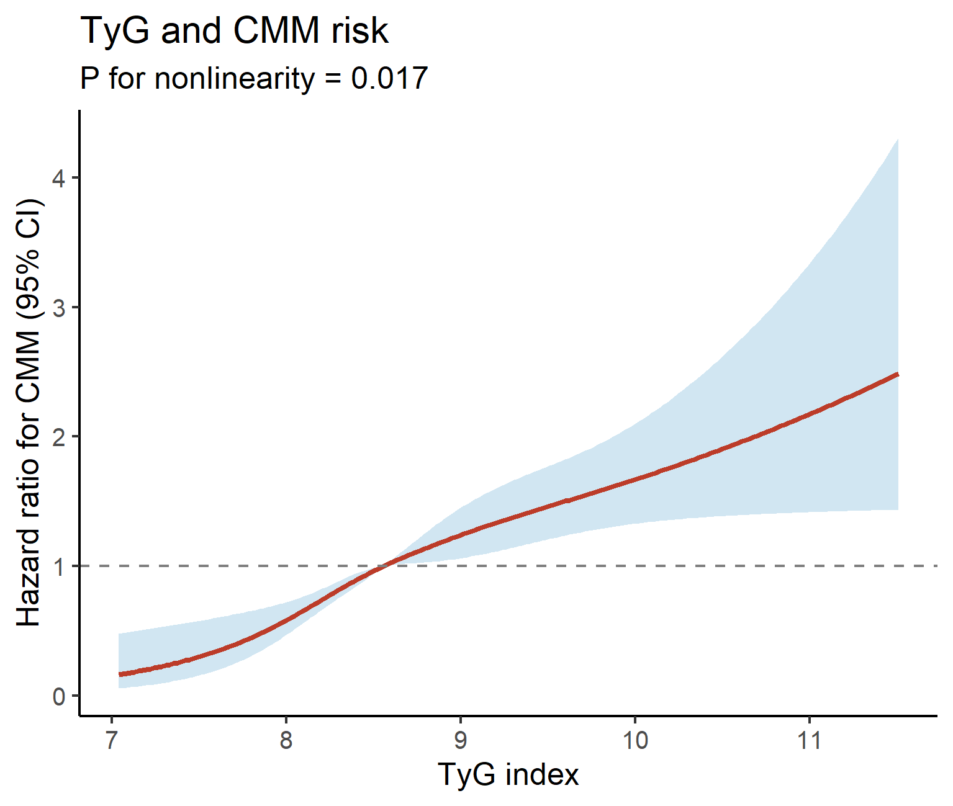
(A) TyG index (P for nonlinearity = 0.017). Basic model, age, sex, education, marital status, residence, smoking, alcohol, eGFR and hypertension. Hazard ratios are referenced to the median, and shaded areas denote 95% confidence intervals.
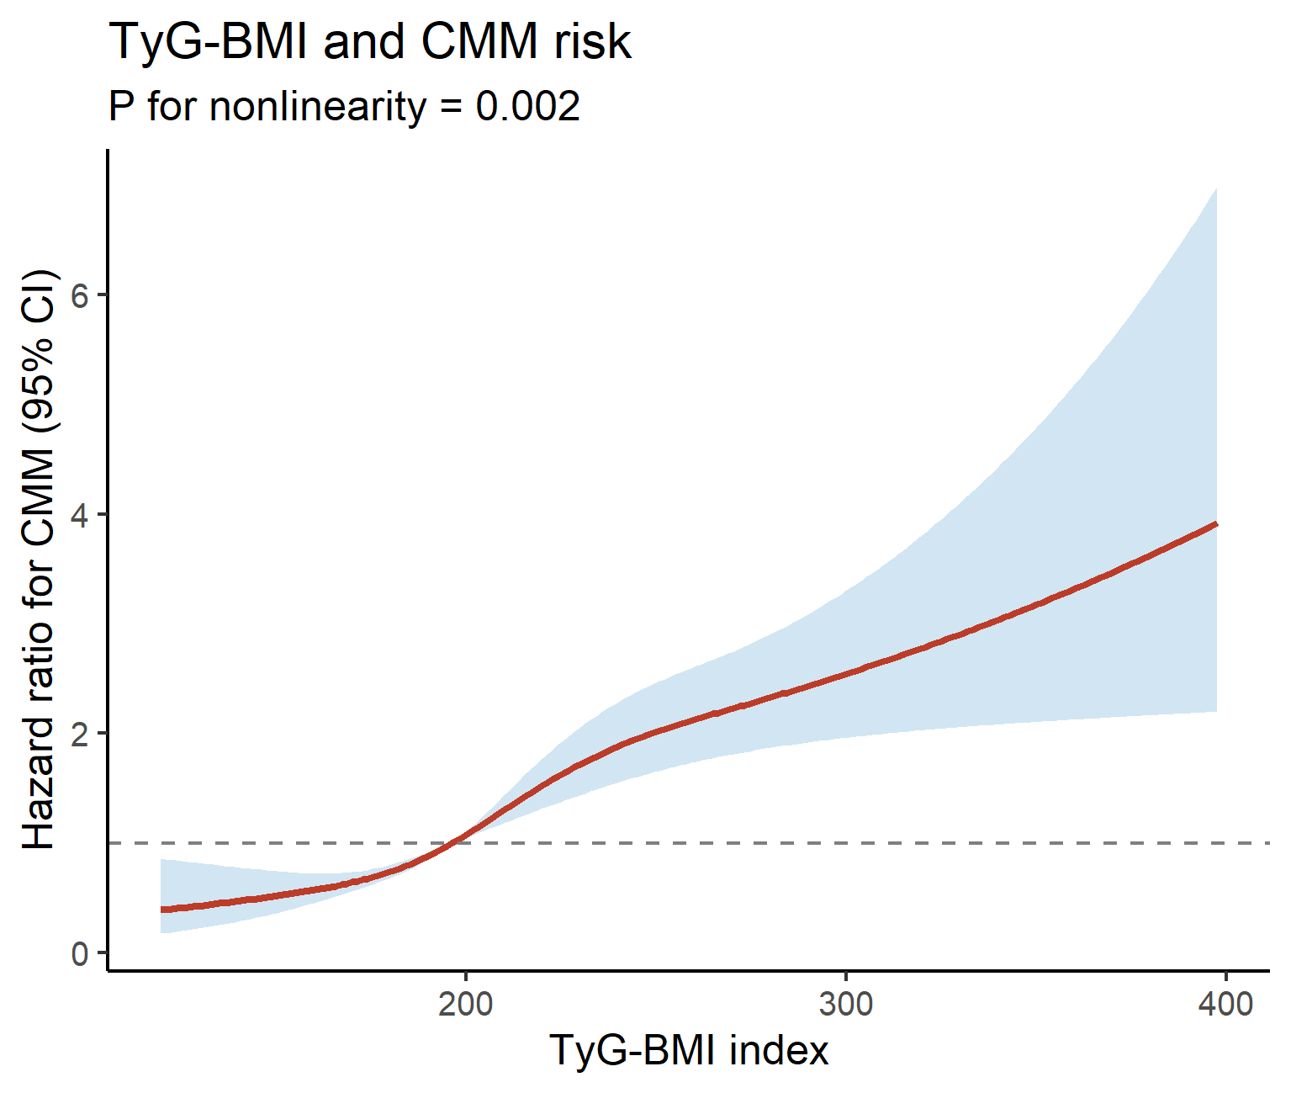
(B) TyG-BMI index (P for nonlinearity < 0.01). Basic model, age, sex, education, marital status, residence, smoking, alcohol, eGFR and hypertension. Hazard ratios are referenced to the median, and shaded areas denote 95% confidence intervals.

Supplementary Figure S2. Scaled Schoenfeld residuals for the proportional hazards assessment.
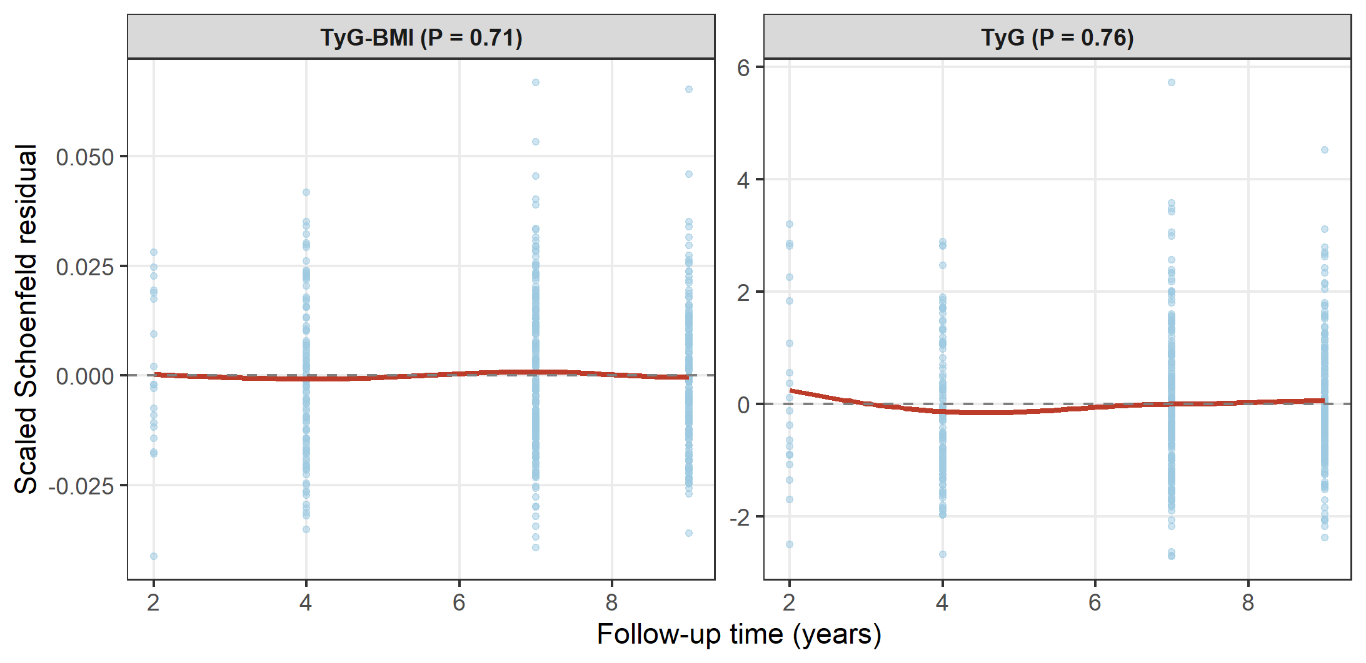
Scaled Schoenfeld residuals over follow-up time for TyG-BMI (left) and TyG (right) from the fully adjusted models. The red curve is a locally weighted smoother; an approximately flat curve around zero is consistent with proportional hazards (TyG-BMI, P = 0.71; TyG, P = 0.76). Events cluster at the biennial CHARLS assessment waves.

