Legend of Supplemental Materials
Supplemental Figure 1 Sample dendrogram and trait heatmap.
Supplemental Figure 2 Heat map for top 20 down-regulated and top 20 up-regulated genes.
Note: The gene symbols were listed in Y-axis and the datasets were listed in X-axis. Color-coded according to correlation coefficient (legend at right).
Supplemental Figure 3 Cluster dendrogram.
Note: Module identification is based on gene expression similarity. The genes with similar expression clustered according to a topological overlap metric into modules; assigned modules were colored and uncharacteristic genes assigned to gray module.
Supplemental Figure 4 The scatter diagram between the module membership in yellow module and gene significance for disease
Supplemental Figure 5A-D DNA methylation of 4 top hub genes based on colon adenocarcinoma (COAD).
Supplemental Figure 6A-D DNA methylation of 4 top hub genes based on rectum adenocarcinoma (READ).

Supplemental Figure 1 Sample dendrogram and trait heatmap.

Supplemental Figure 2 Heat map for top 20 down-regulated and top 20 up-regulated genes.
Note: The gene symbols were listed in Y-axis and the datasets were listed in X-axis. Color-coded according to correlation coefficient (legend at right).

Supplemental Figure 3 Cluster dendrogram.
Note: Module identification is based on gene expression similarity. The genes with similar expression clustered according to a topological overlap metric into modules; assigned modules were colored and uncharacteristic genes assigned to gray module.

Supplemental Figure 4 The scatter diagram between the module membership in yellow module and gene significance for disease

Supplemental Figure 5A-D DNA methylation of 4 top hub genes based on colon adenocarcinoma (COAD).
Supplemental Figure 5A: ABCC13
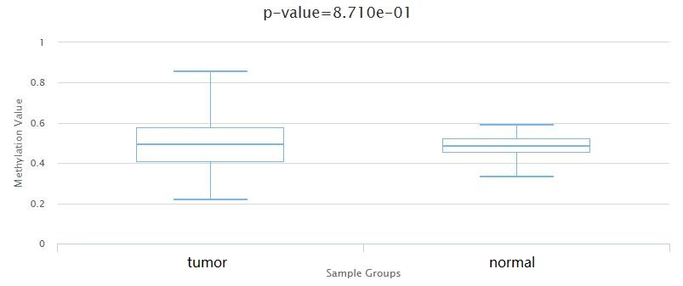
Supplemental Figure 5B: AMPD1
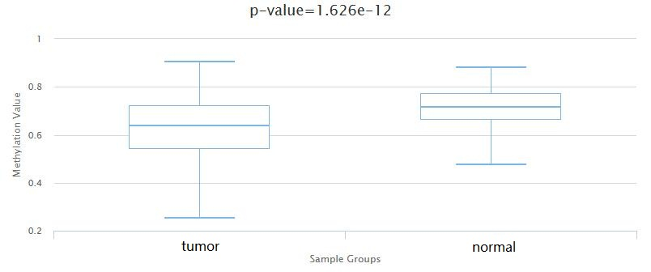

Supplemental Figure 5C: SCNN1B
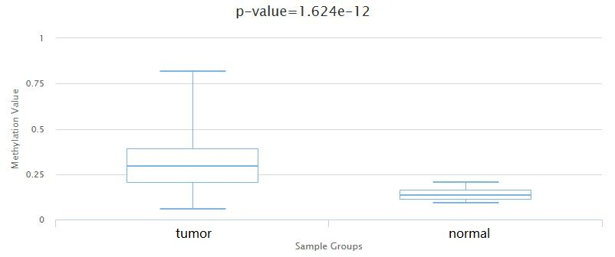

Supplemental Figure 5D: TMIGD1
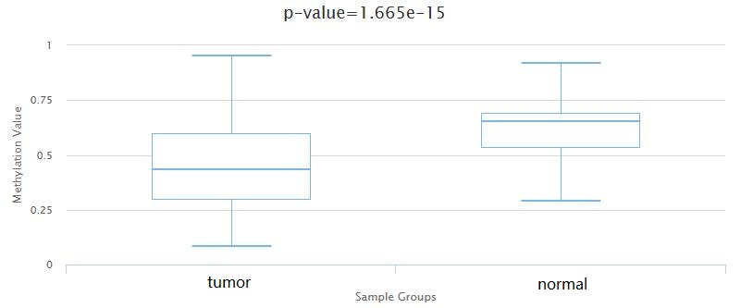

Supplemental Figure 6A-D DNA methylation of 4 top hub genes based on rectum adenocarcinoma (READ).
Supplemental Figure 6A: ABCC13
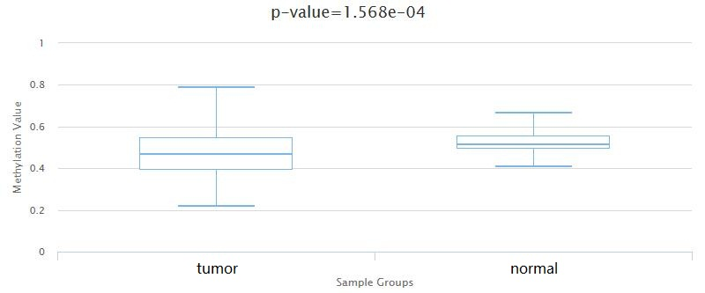

Supplemental Figure 6B: AMPD1
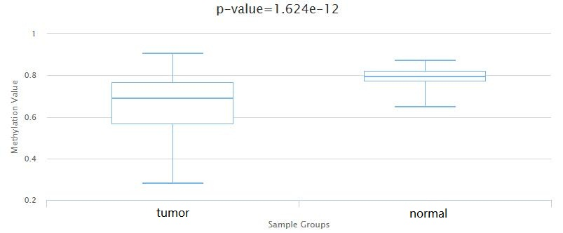

Supplemental Figure 6C: SCNN1B
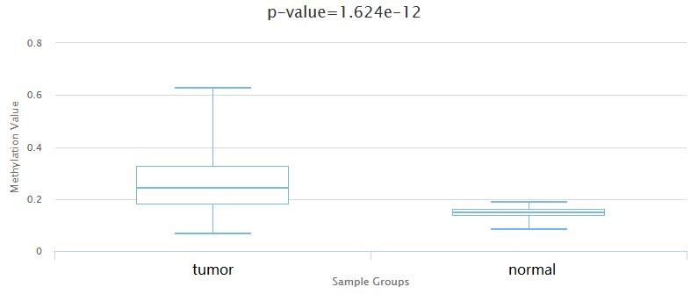

Supplemental Figure 6D: TMIGD1
