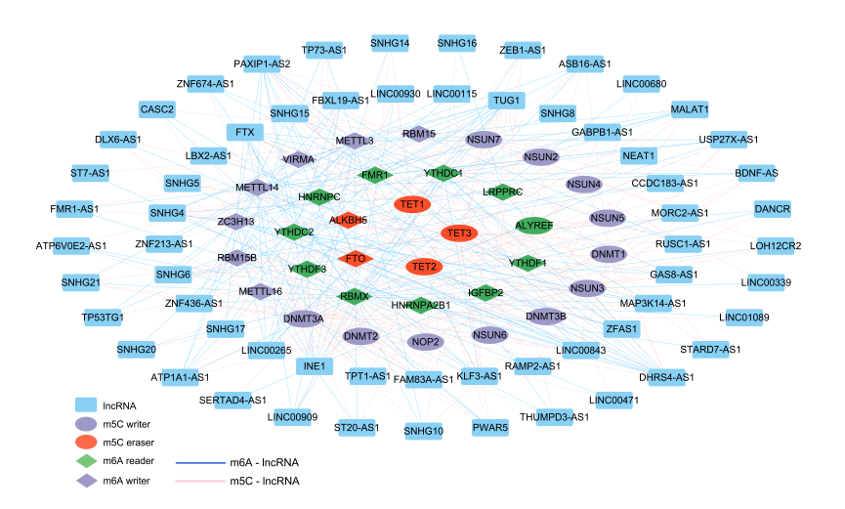
Figure S1 A co-expression network of m⁶A regulators, m⁵C regulators and lncRNAs.
The network is composed of 23 m⁶A regulators, 15 m⁵C regulators and 343 lncRNAs.

