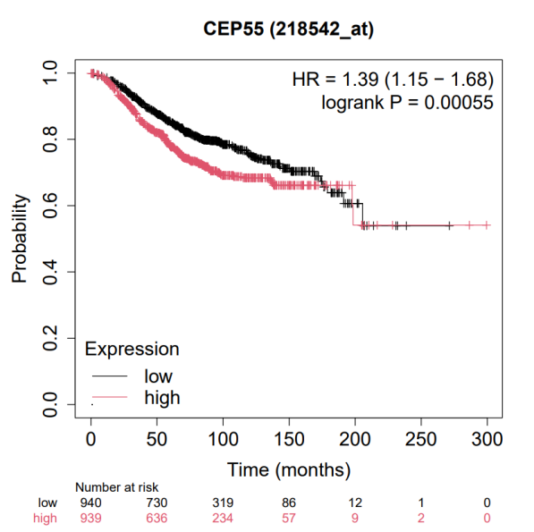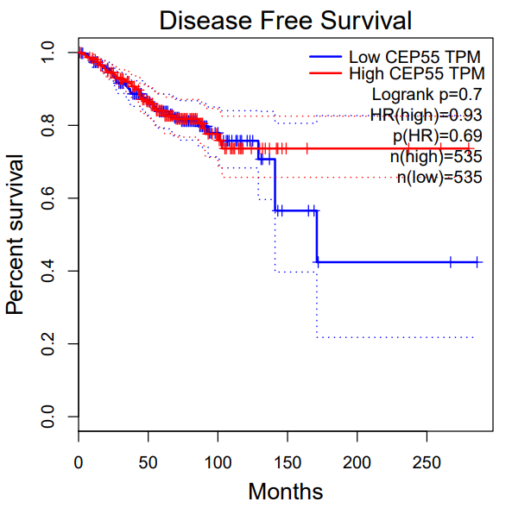
Supplementary Figure 1. Association between CEP55 expression and overall survival and disease-free survival curves of BC patients

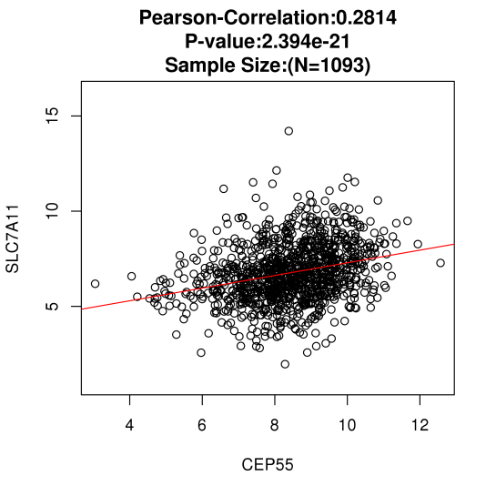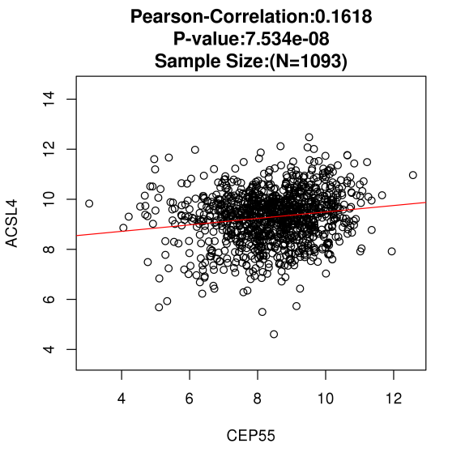
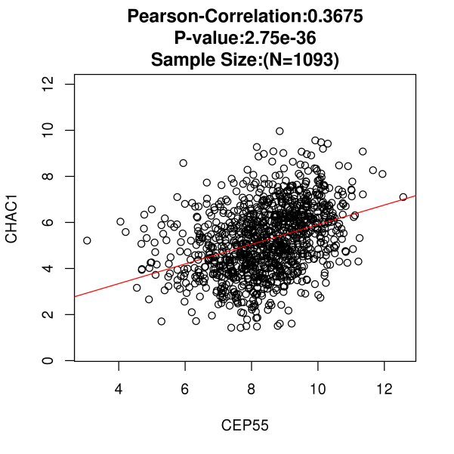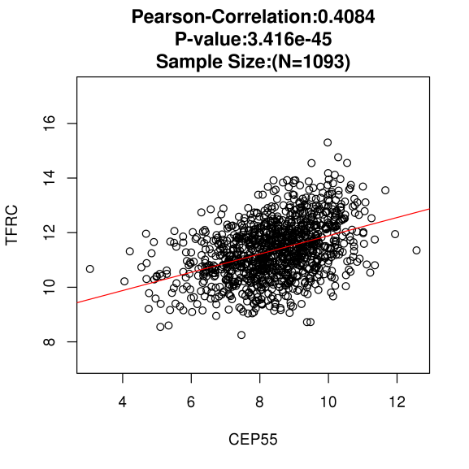
Supplementary Figure 2. Correlation between CEP55 expression and ferroptosis-related proteins (SLC7A11, ACSL4, CHAC1, TFRC) predicted using the LinkedOmics database.

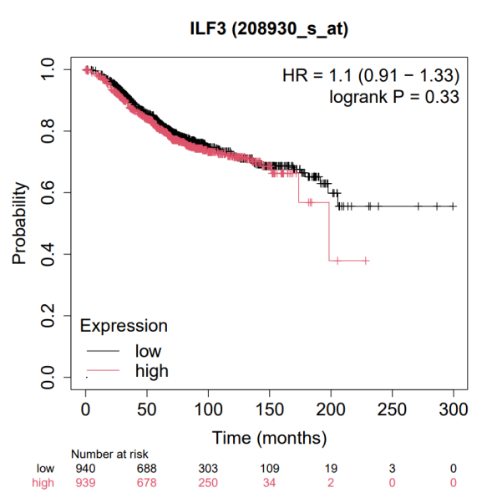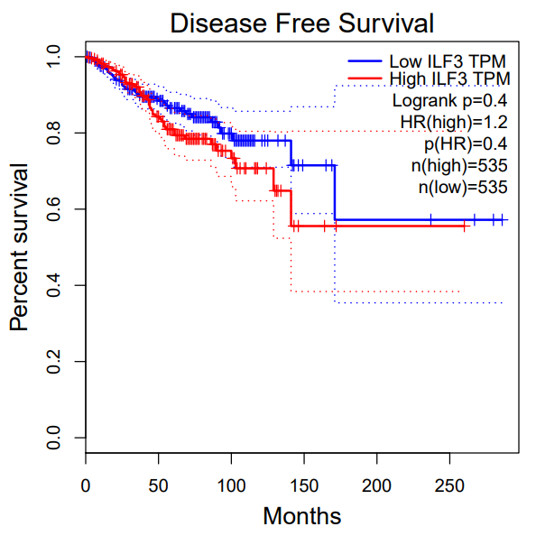
Supplementary Figure 3. Association between IL3 expression and overall survival and disease-free survival curves of BC patients

Supplementary Table 1. The clinicopathological parameters of BC patients (n=35)
Parameters | n=35
Age (years)
≤55 | 24
>55 | 11
Stage
I | 9
II-III | 26
Lymph node metastasis
Positive | 12
Negative | 23
Tumor size (cm)
<2 | 7
≥2 | 28
Histological type
luminal A | 19
luminal B | 6
HER-2 | 7
Basal-like cancer | 3

Supplementary Table 2. Primers sequences used for quantitative PCR
Name |  | Primers for qRT-PCR (5’-3’)
CEP55 | Forward | GGGAGGGCAGACCATTTCAG
CEP55 | Reverse | TACTAGGCTTCGATCCCCAC
ILF3 | Forward | CAGATGCCACTGCCGAGC
ILF3 | Reverse | TTCGACCTCCATGACGAAGC
GPX4 | Forward | TCACCAAGTTTGGACACCGT
GPX4 | Reverse | ATAGTGGGGCAGGTCCTTCT
SLC7A11 | Forward | TGGAACGAGGAGGTGGAGAA
SLC7A11 | Reverse | TGGTGGACACACAGGCTTT
β-actin | Forward | GGATTCCTATGTGGGCGACGA
β-actin | Reverse | GCGTACAGGGATAGCACAGC

