Supplementary Material 1. Plasmid information constructed in this experiment.
 | Primer sequence
NR2F1-WT-F | AAGGATGACGATGACAAGCTTATGGCAATGGTAGTTAGCAGCTG
NR2F1-WT-R | TGCTGGATATCTGCAGAATTCCTAGGAGCACTGGATGGACATGT
NR2F1-MUT-F | AAGGATGACGATGACAAGCTTATGGCAATGGTAGTTAGCAGCTG
NR2F1-MUT-R | TGCTGGATATCTGCAGAATTCCTAGGAGCACTGGATGGACATGT
NR2F1-MUT-T-R | CCTCtTGCCCACTTTGAGGCACTTCTTGAGGC
NR2F1-MUT-T-F | TCAAAGTGGGCAAGAGGCGGGAAGCGGTTCAG

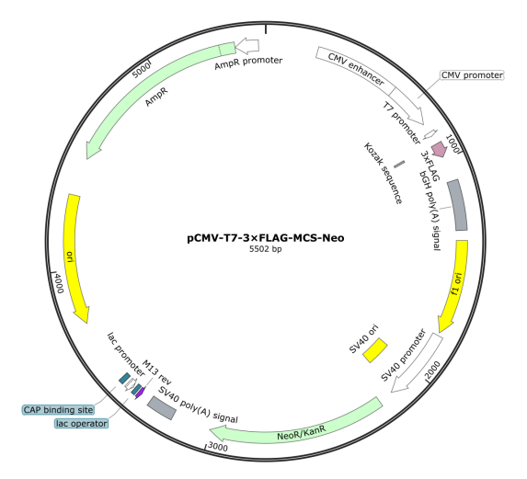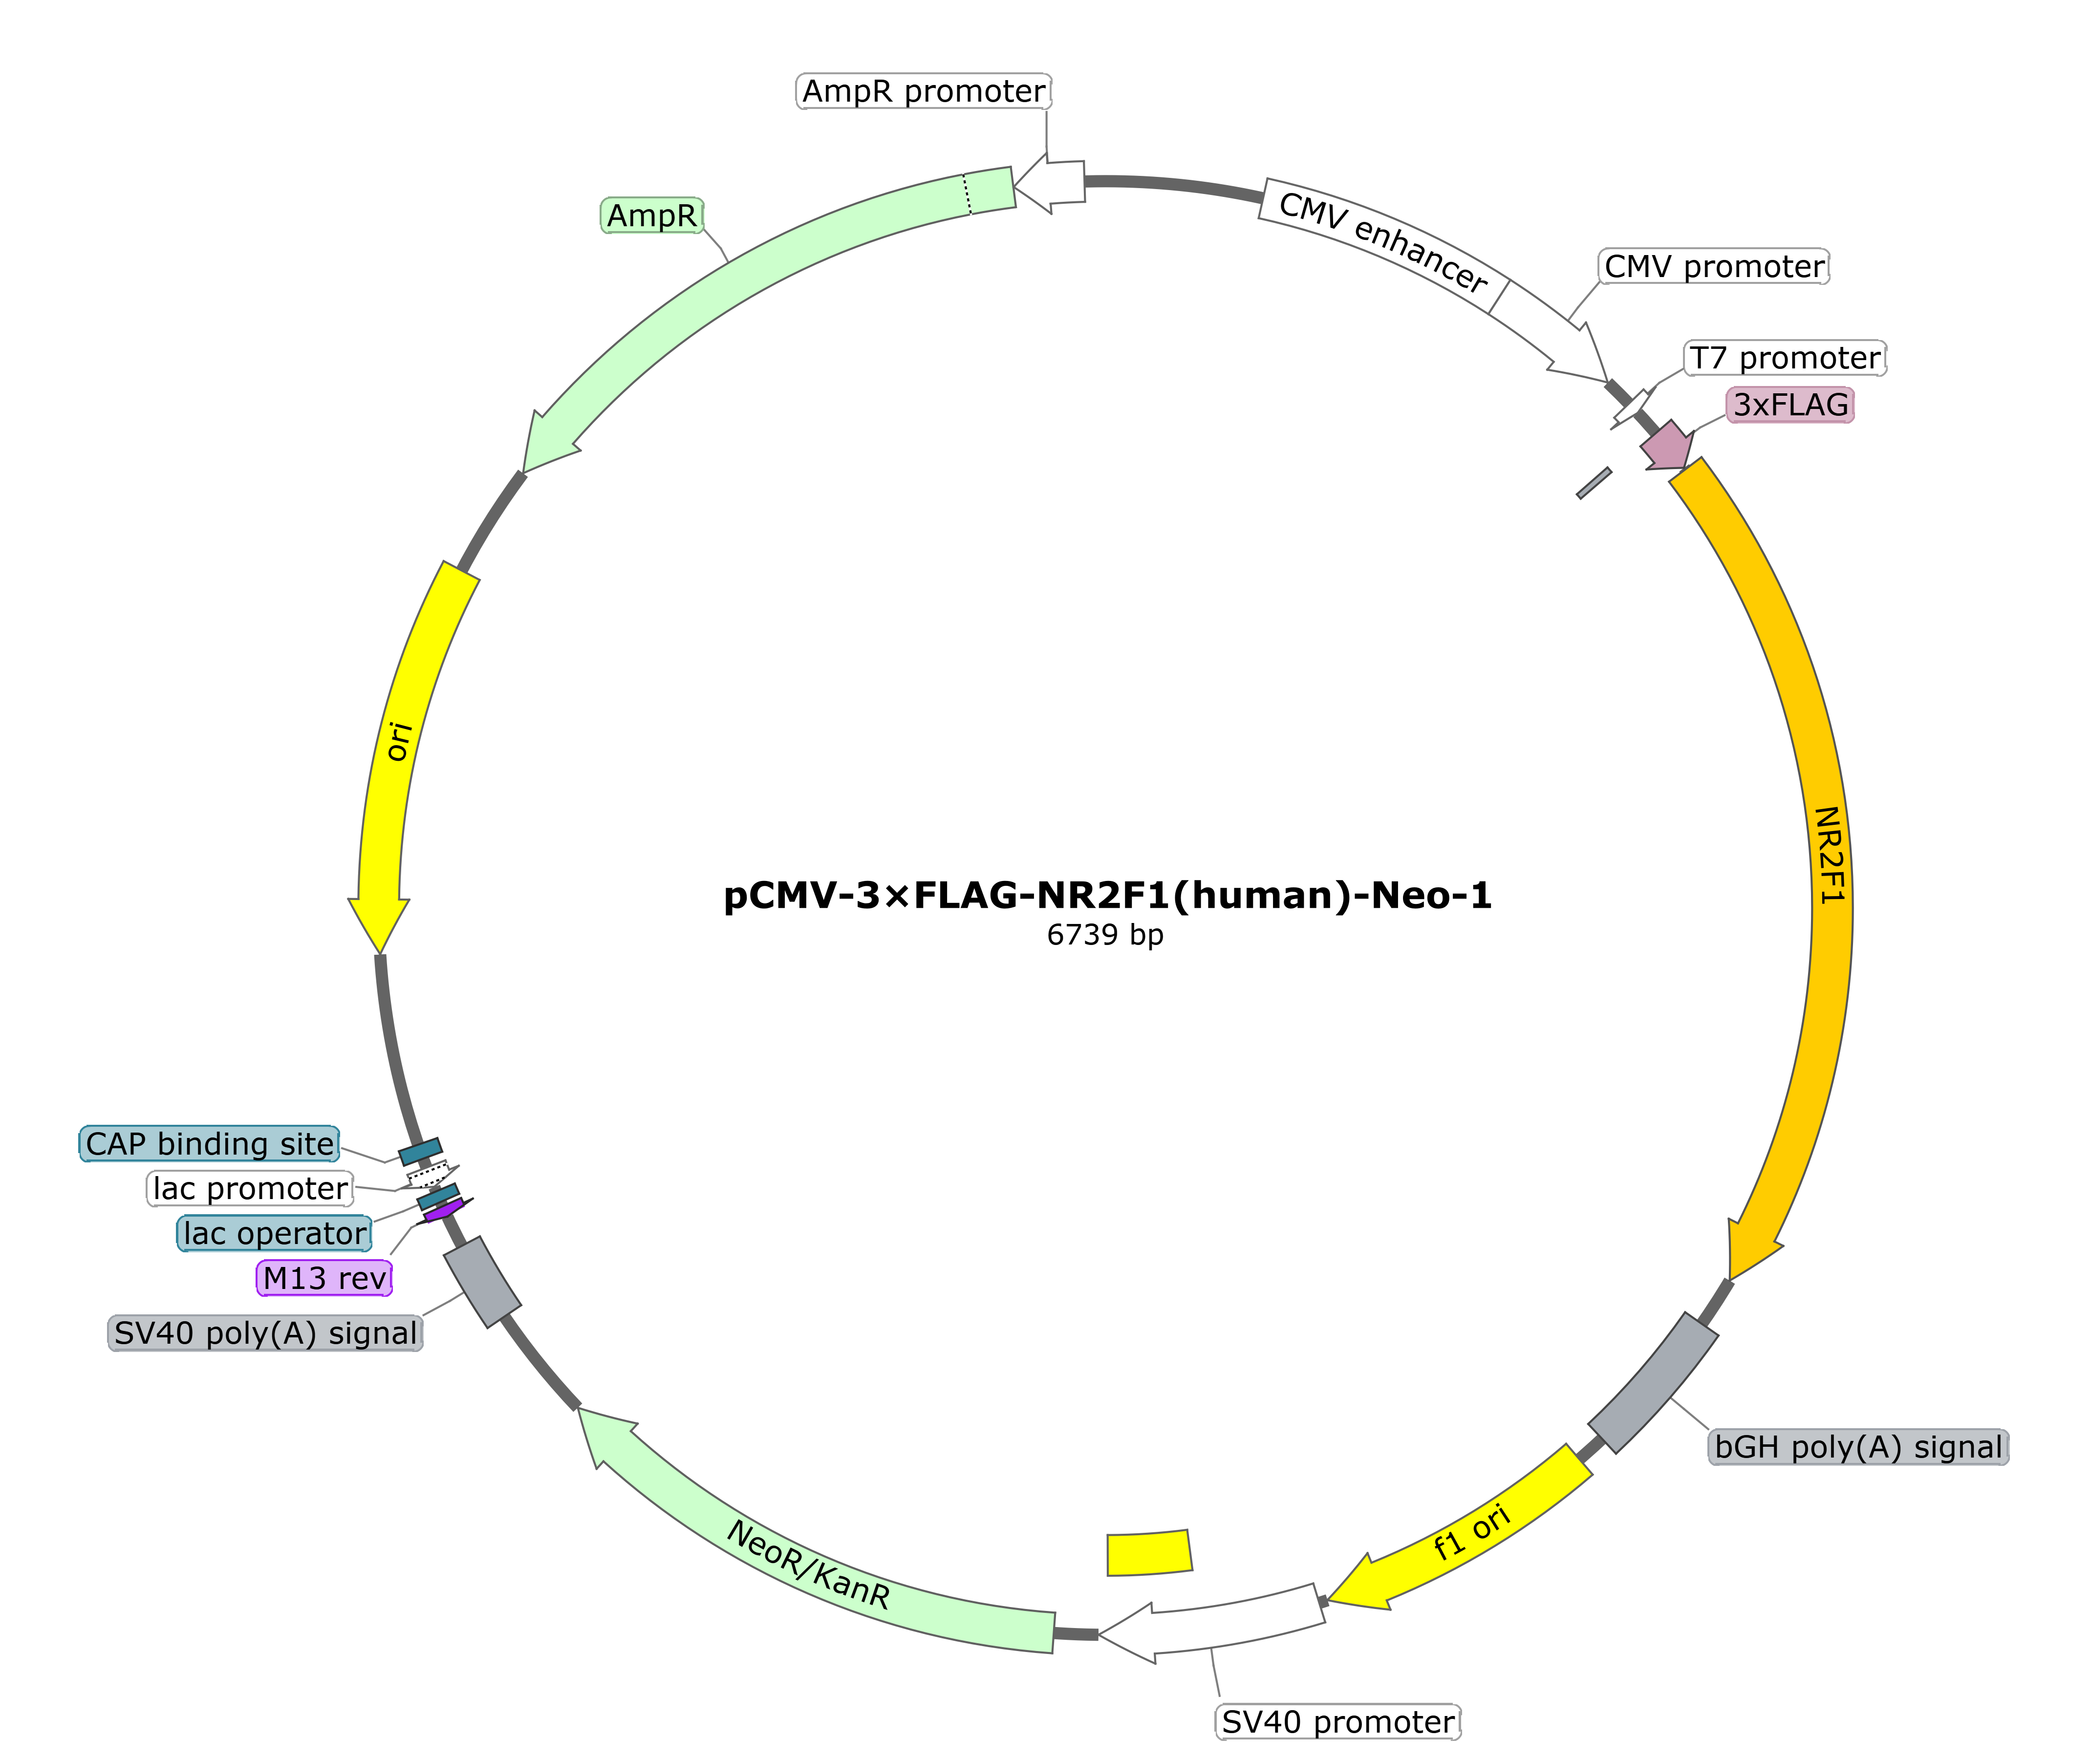
Figure. Cloning vector: pECMV-3×FLAG-N; Cloning sites: HindIII/EcoRI (On the left is an empty plasmid).

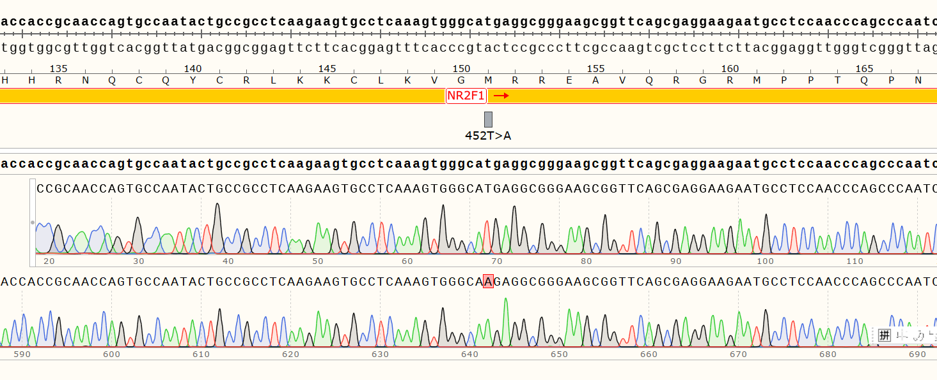
Figure. Result of the plasmid Sanger sequencing.

Supplementary Material 2. Sequencing data filtering strategy and related parameters in this study.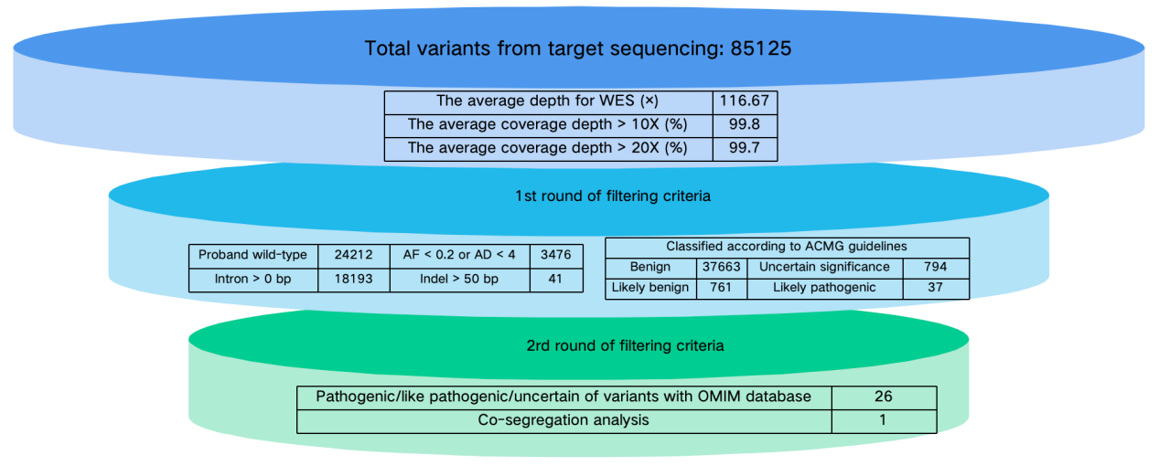Figure. Funnel diagram of variation data filtering strategy.

Supplementary Material 3. NR2F1 gene variants associated with BBSOAS as reported in the literatures.
Patient | DNA variant (NM_005654.4) | Amino acid variant | Domain | Inheritance | Ref
1 | c.339C>A | p.Ser113Arg | DBD | Germline | [1]
2 | c.344G>C | p.Arg115Pro | DBD | Germline | [1]
3 | c.755T>C | p.Leu252Pro | LBD | Germline | [1]
4 | c.335G>A | p.Arg112Lys | DBD | Germline | [1]
5 | c.2T>C | p.Met1? |  | Germline | [2]
6 | c.403C>A | p.Arg135Ser | DBD | Germline | [2]
7 | c.425G>T | p.Arg142Leu | DBD | Germline | [2]
8 | c.2T>G | p.Met1? |  | Germline | [2]
9 | c.328_330del | p.Phe110del | DBD | Germline | [2]
10 | c.382T>C | p.Cys128Arg | DBD | Germline | [2]
11 | c.2T>G | p.Met1? |  | Germline | [2]
12 | c.463G>A | p.Ala155* |  | Germline | [2]
13 | c.436T>C | p.Cys146Arg | DBD | Germline | [2]
14 | c.2T>C | p.Met1? |  | Germline | [2]
15 | c.413G>A | p.Cys138Tyr | DBD | Germline | [2]
16 | c.1103G>A | p.Gly368Asp | LBD | Germline | [2]
17 | c.291delC | p.His79Hisfs*22 |  | Germline | [2]
18 | c.103_113delinCGCCGCCGC | p.Gly35Argfs*361 |  | Germline | [2]
19 | c.2_4delinTGG | p.Met1? |  | Germline | [2]
20 | c.1115T>C | p.Leu372Pro | LBD | Germline | [3]
21 | c.257G>T | p.Cys86Phe | DBD | Germline | [3]
22 | c.403C>T | p.Arg135Cys | DBD | Germline | [4]
23 | c.286A>G | p.Lys96Glu | DBD | Germline | [5]
24 | c.513C>G | p.Tyr171* |  | Germline | [6]
25 | c.425G>A | p.Arg142His | DBD | Germline | [7]
26 | c.2T>C; p.M1? | p.Met1? |  | Germline | [7]
27 | c.729_730delinsCT | p.Gln244* | LBD | Germline | [7]
28 | c.115G>T | p.Glu39* |  | Germline | [7]
29 | c.292T>C | p.Tyr98His | DBD | Germline | [7]
30 | c.967_968delAA; p.Ly | p.Lys323Serfs*73 | LBD | Germline | [7]
31 | c.1080del | p.Asn362Thrfs*33 | LBD | Germline | [8]
32 | c.82C>T | p.Gln28* |  | Germline | [9]
33 | c.253G>T | p.Glu85* | DBD | Germline | [10]
34 | c.313G>A | p.Gly105Ser | DBD | Germline | [11]
35 | c.313G>A | p.Gly105Ser | DBD | Germline | [11]
36 | c.256T>C | p.Cys86Arg | DBD | Germline | [12]
37 | c.262 G>A | p.Val88Met | DBD | Germline | [12]
38 | c.284G>T | p.Gly95Val | DBD | Germline | [12]
39 | c.290A>C | p.His97Pro | DBD | Germline | [12]
40 | c.293A>G | p.Tyr98Cys | DBD | Germline | [12]
41 | c.311A>G | p.Glu104Gly | DBD | Germline | [12]
42 | c.323G>T | p.Ser108Ile | DBD | Germline | [12]
43 | c.365G>C | p.Cys122Ser | DBD | Germline | [12]
44 | c.417A>T | p.Gln139His | DBD | Germline | [12]
45 | c.1A>G | p.Met1? |  | Germline | [12]
46 | c.2T>C | p.Met1? |  | Germline | [12]
47 | c.380dupA | p.Asn127Lysfs*270 | DBD | Germline | [12]
48 | c.1117C>T | p.Arg373* | LBD | Germline | [12]
49 | c.931G>C | p.Ala311Pro | LBD | Germline | [12]
50 | c.954G>C | p.Glu318Asp | LBD | Germline | [12]
51 | c.1217T>C | p.Met406* |  | Germline | [12]
52 | c.602C > A | p.Ser201* |  | Germline | [13]
53 | c.2T>C | p.Met1? |  | Germline | [14]
54 | c.4delG | p.Ala2Glnfs*3 |  | Germline | [15]
55 | c.51_69dup | p.Asn24Glyfs*379 |  | Germline | [15]
56 | c.91_93dupCGC | p.Arg31dup |  | Germline | [15]
57 | c.115G>T | p.Glu39* |  | Germline | [15]
58 | c.290A>C | p.His97Pro | DBD | Germline | [15]
59 | c.353T>G | p.Leu118* | DBD | Germline | [15]
60 | c.359dupA | p.Tyr120* | DBD | Germline | [15]
61 | c.366C>G | p.Cys122Trp | DBD | Germline | [15]
62 | c.463G>A | p.Ala155Thr |  | Germline | [15]
63 | c.513G>C | p.Tyr171* |  | Germline | [15]
64 | c.599C>G | p.Thr200Arg |  | Germline | [15]
65 | c.698G>A | p.Trp233* | LBD | Germline | [15]
66 | c.1024G>A | p.Glu342Lys | LBD | Germline | [15]
67 | c.1036_1047del | p.Glu346_Gln349del | LBD | Germline | [15]
68 | c.1115T>C | p.Leu372Pro | LBD | Germline | [15]
69 | c.1118_1123del | p.Arg373_Leu374del | LBD | Germline | [15]
70 | c.1183G>A | p.Gly395Ser |  | Germline | [15]
71 | c.1198G>T | p.Glu400* |  | Germline | [15]
72 | c.437G>A | p.Cys146Tyr | DBD | Germline | [16]
73 | c.257-258delinsTT | p.Cys86Phe | DBD | Germline | [17]
74 | c.403C > G | p.Arg135Gly | DBD | Germline | [17]
75 | c.383G > A | p.Cys128Tyr | DBD | Germline | [17]
76 | c.1065C>G | p.Tyr355* | LBD | mosaicism | [18]
77 | c.169C>T | p.Gln57* |  | mosaicism | [19]
78 | ~2.85Mb deletion | / |  | Germline | [1]
79 | ~0.83Mb deletion | / |  | Germline | [1]
80 | ~0.9Mb deletion | / |  | Germline | [2]
81 | ~5.0Mb deletion | / |  | Germline | [2]
82 | ~0.2Mb deletion | / |  | Germline | [2]
83 | ~0.9Mb deletion | / |  | Germline | [2]
84 | ~1.2Mb deletion | / |  | Germline | [2]
85 | ~7.94Mb deletion | / |  | Germline | [3]
86 | ~2.33Mb deletion | / |  | Germline | [12]
87 | ~0.93Mb deletion | / |  | Germline | [12]
88 | ~599kb deletion | / |  | Germline | [15]
89 | ~0.582Mb deletion | / |  | Germline | [20]
Abbreviations: DBD, DNA-binding domain; LBD, ligand-binding domain.

References
- Bosch DG, Boonstra FN, Gonzaga-Jauregui C, et al. NR2F1 mutations cause optic atrophy with intellectual disability. Am J Hum Genet. 2014;94(2):303-9.
- Chen CA, Bosch DG, Cho MT, et al. The expanding clinical phenotype of Bosch-Boonstra-Schaaf optic atrophy syndrome: 20 new cases and possible genotype-phenotype correlations. Genet Med. 2016;18(11):1143-1150.
- Kaiwar C, Zimmermann MT, Ferber MJ, et al. Novel NR2F1 variants likely disrupt DNA binding: molecular modeling in two cases, review of published cases, genotype-phenotype correlation, and phenotypic expansion of the Bosch-Boonstra-Schaaf optic atrophy syndrome. Cold Spring Harb Mol Case Stud. 2017;3(6):a002162.
- Hino-Fukuyo N, Kikuchi A, Yokoyama H, et al. Long-term outcome of a 26-year-old woman with West syndrome and an nuclear receptor subfamily 2 group F member 1 gene (NR2F1) mutation. Seizure. 2017;50:144-146.
- Martín-Hernández E, Rodríguez-García ME, Chen CA, et al. Mitochondrial involvement in a Bosch-Boonstra-Schaaf optic atrophy syndrome patient with a novel de novo NR2F1 gene mutation. J Hum Genet. 2018;63(4):525-528.
- Park SE, Lee JS, Lee ST, et al. Targeted panel sequencing identifies a novel NR2F1 mutations in a patient with Bosch-Boonstra-Schaaf optic atrophy syndrome. Ophthalmic Genet. 2019;40(4):359-361.
- Bertacchi M, Romano AL, Loubat A, et al. NR2F1 regulates regional progenitor dynamics in the mouse neocortex and cortical gyrification in BBSOAS patients. EMBO J. 2020;39(13):e104163.
- Walsh S, Gösswein SS, Rump A, et al. Novel dominant-negative NR2F1 frameshift mutation and a phenotypic expansion of the Bosch-Boonstra-Schaaf optic atrophy syndrome. Eur J Med Genet. 2020;63(10):104019.
- Bojanek EK, Mosconi MW, Guter S, et al. Clinical and neurocognitive issues associated with Bosch-Boonstra-Schaaf optic atrophy syndrome: A case study. Am J Med Genet A. 2020;182(1):213-218.
- Hobbs MM, Wolters WC, Rayapati AO. Bosch-Boonstra-Schaaf Optic Atrophy Syndrome Presenting as New-Onset Psychosis in a 32-Year-Old Man: A Case Report and Literature Review. J Psychiatr Pract. 2020;26(1):58-62.
- Mio C, Fogolari F, Pezzoli L, et al. Missense NR2F1 variant in monozygotic twins affected with the Bosch-Boonstra-Schaaf optic atrophy syndrome. Mol Genet Genomic Med. 2020;8(7):e1278.
- Rech ME, McCarthy JM, Chen CA, et al. Phenotypic expansion of Bosch-Boonstra-Schaaf optic atrophy syndrome and further evidence for genotype-phenotype correlations. Am J Med Genet A. 2020;182(6):1426-1437.
- Zou W, Cheng L, Lu S, et al. A de novo nonsense mutation in the N-terminal of ligand-binding domain of NR2F1 gene provoked a milder phenotype of BBSOAS. Ophthalmic Genet. 2020;41(1):88-89.
- Gazdagh G, Mawby R, Self JE, et al. A severe case of Bosch-Boonstra-Schaaf optic atrophy syndrome with a novel description of coloboma and septo-optic dysplasia, owing to a start codon variant in the NR2F1 gene. Am J Med Genet A. 2022;188(3):900-906.
- Jurkute N, Bertacchi M, Arno G, et al. Pathogenic NR2F1 variants cause a developmental ocular phenotype recapitulated in a mutant mouse model. Brain Commun. 2021;3(3):fcab162.
- Kocaaga A, Yimenicioglu S, Gürsoy HH. Novel NR2F1 variant identified by whole-exome sequencing in a patient with Bosch-Boonstra-Schaaf optic atrophy syndrome. Indian J Ophthalmol. 2022;70(7):2762-2764.
- Liang Y, Wan L, Liu X, et al. Infantile epileptic spasm syndrome as a new NR2F1 gene phenotype. Int J Dev Neurosci. 2024;84(1):75-83.
- van Renterghem V, Vilain C, Devriendt K, et al. Two siblings with Bosch-Boonstra-Schaaf optic atrophy syndrome due to parental gonadal mosaicism. Eur J Med Genet. 2023;66(4):104729.
- Hrvatin N, Pereza N, Čaljkušić-Mance T, et al. Second Case of Gonadal Mosaicism and a Novel Nonsense NR2F1 Gene Variant as the Cause of Bosch-Boonstra-Schaaf Optic Atrophy Syndrome. Clin Genet. 2024;106(6):786-787.
- Al-Kateb H, Shimony JS, Vineyard M, et al. NR2F1 haploinsufficiency is associated with optic atrophy, dysmorphism and global developmental delay. Am J Med Genet A. 2013;161A(2):377-81.

