Table S1 Comprehensive details of GSE66360, GSE142008, and GSE179789 datasets
ID | source | platform | country | sample type | sample size | Organism
GSE66360 | GEO | GPL570 | USA | Expression profiling by array | AMI patients (n=49) vs healthy cohorts (n=50) | Homo sapiens
GSE142008 | GEO | GPL570 | China | Expression profiling by array | 8 CHD patients with paired pre- and post-treatment samples (n=16) | Homo sapiens
GSE179789 | GEO | GPL570 | China | Expression profiling by array | 8 CHD patients with paired pre- and post-treatment samples + 8 healthy individuals (n=24) | Homo sapiens

Table S2 Log2-fold change (logFC) and p.Value of the seven core genes on GSE66360 dataset

Gene.symbol | p.Value | logFC
IL1B | 1.81e-05 | 3.09
GLUL | 1.06e-05 | 1.63
SERPINA1 | 9.10e-05 | 2.6
ALDH2 | 5.57e-05 | 2.28
CD36 | 3.46e-04 | 2.68
TNF | 2.63e-03 | 1.61
PTGS2 | 1.72e-04 | 2.38

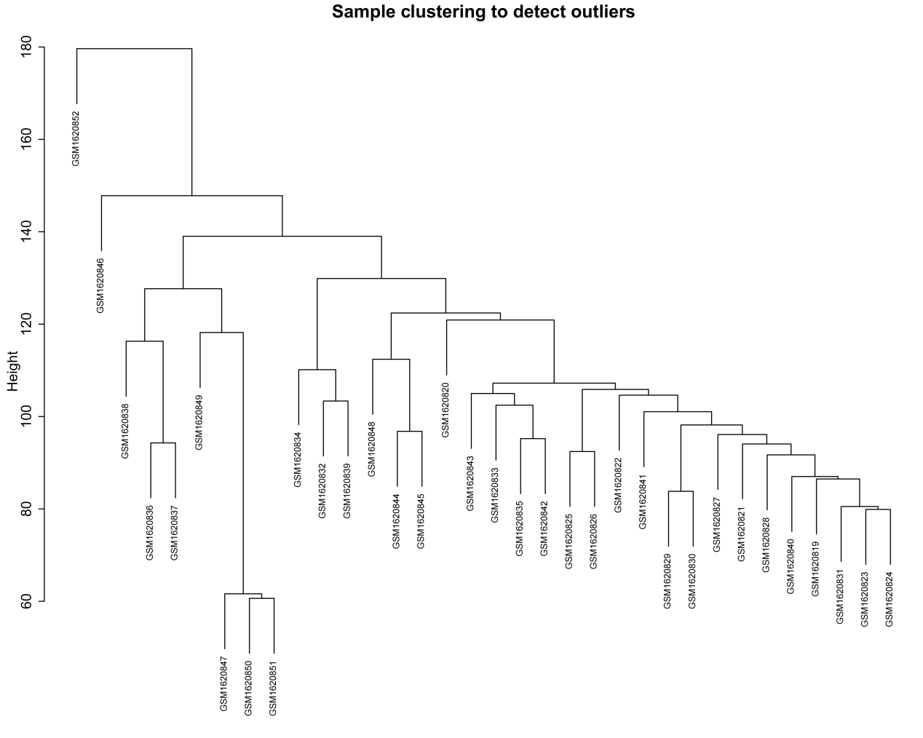
Fig S1 Sample Clustering Plot of GSE66360 (detect outliers). The vertical axis "Height" reflects differences in sample distances, with sample labels (e.g., GSM1123472) marked at the ends. Hierarchical clustering branches, formed by vertical/horizontal lines, display sample clustering relationships and aid in identifying anomalous samples with significant differences.

