Online Supplement

Table of contents
Web-appendix 1: clinicaltrial.gov refusal to register our study. 2
Web-appendix 2: TIDieR (Template for Intervention Description and Replication) checklist 3
Web Appendix 3: Results from the preliminary experimentation. 4
Web-appendix 4: summary of protocol changes with reasons 8
Web Appendix 5: Supporting material used during the event (in French) 9
Web Appendix 5: Population description 12
Web Appendix 6: inter-rater correlations for each pair and outcome (Pearson's r) [ Confidence interval]) 12
Web Appendix 7: Sensitivity Analyses for survival 13

Web-appendix 1: clinicaltrial.gov refusal to register our study.
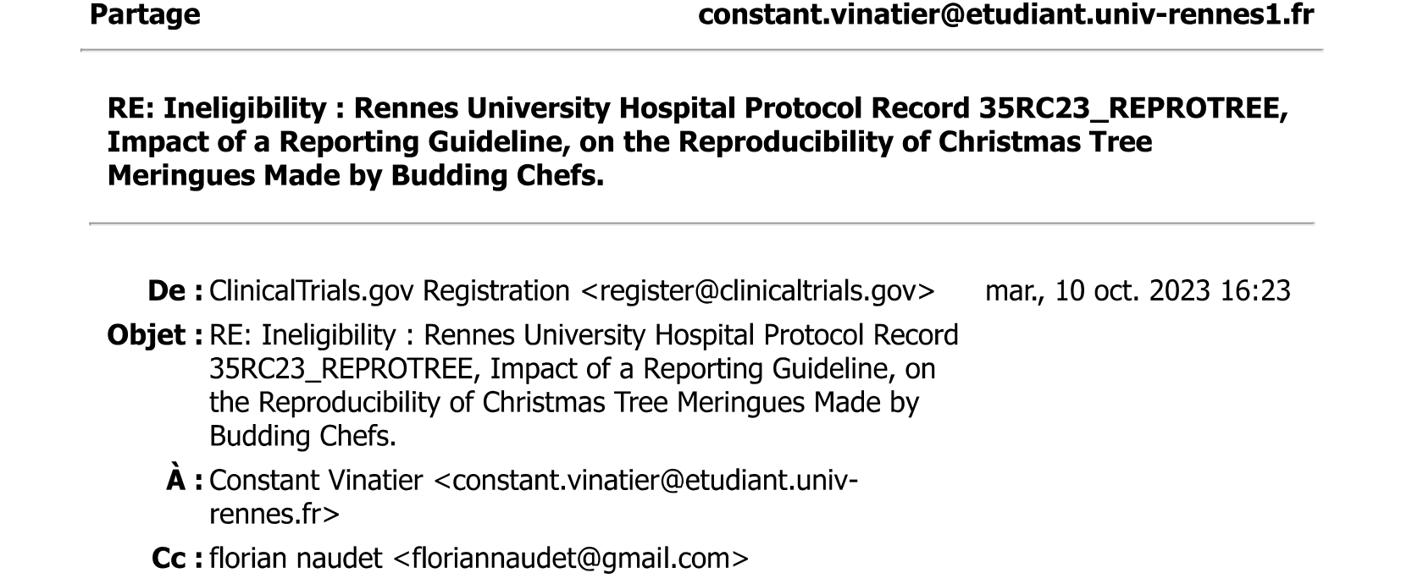

Web-appendix 2: TIDieR (Template for Intervention Description and Replication) checklist
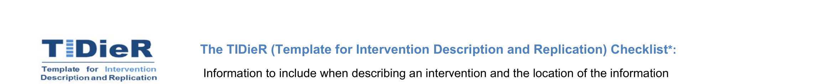

Item | Item | Where Located
 |  | Primary paper | explanation
1 | Bief Name :  Provide the name or a phrase that discribes the intervention | Line 1 of the receipe | Added a name to the receipe
2 | Why :  Describe any rationale, theory, or goal of the elements essential to the intervention | NA | NA
3 | What :  Materials describe any physical or informational material used in the intervention including those provided to participants or used in intervention delivery or in training of interventions providers. Provide information on where the materials can be accessed (e.g. online appendix, URL) . | From line 2 to 13 (recipe) | Added detail about kitchen utensils and the temperature of eggs
4 | Procedures describe each of the procedures, activities, and/or processes used in the intervention, including any enabling or support activites. | From line 16 to the end | - added comment about hygiene (L17)  - added detail about egg temperature  -added detail about the consistency of the preparation.  -added detail about the technique to use a piping bag  -changed the temperature of the oven from 110 to 100
5 | Who Provided :  For each category of intervention provider (e.g psychologit, nursing assistant), describe their expertise, background and any specific training given | NA | NA
6 | How :  Describe the modes of delivert (e.g.) face-to-face or by some other mechanism, such as internet or telephone) of the intervention and whether it was provided individyally or in a group | NA | NA
7 | Where :  Describe the type(s) of location(s) where the intervention occurred, including any necessary infrastructure or relevant features | From line 14 to 15 (recipe) | Added a description of the place of intervention
8 | When and How Much :  Describe the number of times the intervention was delivered and over what period of time inclusing the number of sessions, their schedule and their duration, intensity or dose. | Line 31 | Added a possibility to repeat the shaping of the meringues until the result is correct.
9 | Tailoring :  If the intevrention was planned to be personalised, tirated or adapted then describe what, why, when and how | NA | NA
10 | Modification :  If the intervention was modified during the course of the study, describe the changes (what, why, when and how) | NA | NA
11 | How well :  Planned : if intervention adherence or fidelity was assessed, describe how and by whom and if any strategies were used to maintain or improve fidelity, describe them | NA | NA
12 | Actual : If intervention adherence or fidelity was assessed, describe the extent to which the intervention was delivered as planned. | NA | NA

Authors use NA if an item is not applicable for the intervention being described.

Web Appendix 3: Results from the preliminary experimentation.
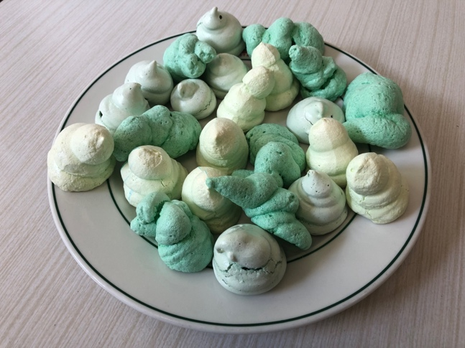

- design:

A preliminary search was completed, 3 different budding chefs were recruited in the research team and were asked to make Christmas tree meringues with the initial recipe. All meringues were then evaluated by 6 different judges to score general aspect, size and colour on a scale from 0 to 10. One meringue per cluster was tasted by each judge to score the taste on a scale from 0 to 10.

[FIGURE : COPY OF THE SCALE THAT WAS USED]

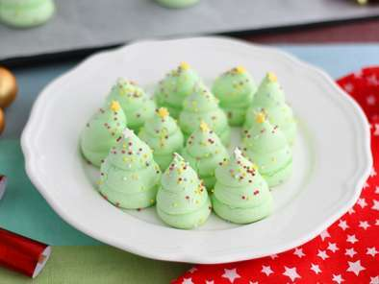
Visual reproducibility of the Christmas Tree meringues:
Please note the aspect of the meringues in comparison with the model (1 means the total absence of resemblance and 10 perfect reproducibility)

 | 1 | 2 | 3 | 4 | 5 | 6 | 7 | 8 | 9 | 10
General aspect
Colour
Height

- Descriptive results

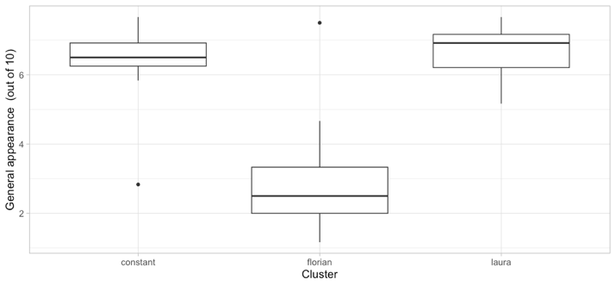 Figure 1: Results for general aspect according to the cluster (out of 10). | 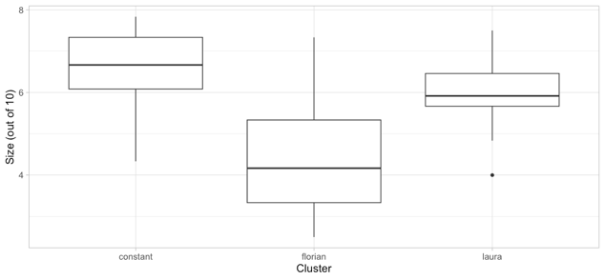  Figure 3: Results for size according to the cluster (out of 10).
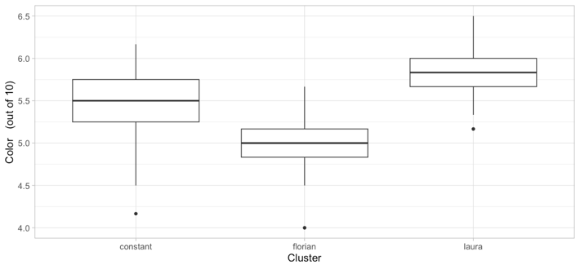 Figure 2: Results for colour according to the cluster (out of 10). | 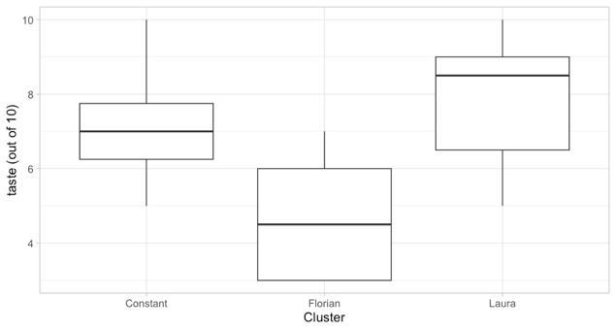  Figure 4: Results for taste according to the cluster (out of 10)

- Intracluster correlation

The intracluster correlation was determined with an ANOVA test:
summary_aov_aspg = summary(aov(asp_g_value ~ id_cluster,data=data_asp_mean))
summary_aov_aspg[[1]][1,2]/sum(summary_aov_aspg[[1]][,2])

For the primary endpoint, the intracluster correlation of this preliminary research was 0.75.
For the secondary endpoints, size gives an intracluster correlation of 0.46, and colour 0.5.

- Intraclass correlation for the 3 visual analogue scales
The ICC was determined by R with the function ICC (package: psych), the “average fixed rater ICC” was chosen for this study:

For general aspect:

 | Type | ICC | F | Df1 | Df2 | p | Lower bound | Upper bound
Single_raters_absolute | ICC1 | 0.69 | 14 | 61 | 310 | 3.1e-60 | 0.6 | 0.77
Single_random_raters | ICC2 | 0.69 | 14 | 61 | 305 | 3.9e-60 | 0.6 | 0.77
Single_fixed_raters | ICC3 | 0.69 | 14 | 61 | 305 | 3.9e-60 | 0.6 | 0.78
Average_raters_absolute | ICC1k | 0.93 | 14 | 61 | 310 | 3.1e-60 | 0.9 | 0.95
Average_random_raters | ICC2k | 0.93 | 14 | 61 | 305 | 3.9e-60 | 0.9 | 0.95
Average_fixed_rater | ICC3k | 0.93 | 14 | 61 | 305 | 3.9e-60 | 0.9 | 0.95

Number of subjects = 62 Number of Judges = 6
For size:
 | Type | ICC | F | Df1 | Df2 | p | Lower bound | Upper bound
Single_raters_absolute | ICC1 | 0.32 | 3.9 | 61 | 310 | 2.3e-15 | 0.22 | 0.45
Single_random_raters | ICC2 | 0.33 | 4.0 | 61 | 305 | 4.2e-16 | 0.22 | 0.45
Single_fixed_raters | ICC3 | 0.33 | 4.0 | 61 | 305 | 4.2e-16 | 0.23 | 0.46
Average_raters_absolute | ICC1k | 0.74 | 3.9 | 61 | 310 | 2.3e-15 | 0.63 | 0.83
Average_random_raters | ICC2k | 0.74 | 4.0 | 61 | 305 | 4.2e-16 | 0.63 | 0.83
Average_fixed_rater | ICC3k | 0.75 | 4.0 | 61 | 305 | 4.2e-16 | 0.64 | 0.84
Number of subjects = 62 Number of Judges = 6
See the help file for a discussion of the other 4 McGraw and Wong estimates,

For colour:
 | Type | ICC | F | Df1 | Df2 | p | Lower bound | Upper bound
Single_raters_absolute | ICC1 | -0.026 | 0.85 | 61 | 310 | 0.78 | -0.073 | 0.046
Single_random_raters | ICC2 | 0.000 | 1.0 | 61 | 305 | 0.48 | -0.045 | 0.068
Single_fixed_raters | ICC3 | 0.000 | 1.0 | 61 | 305 | 0.48 | -0.054 | 0.079
Average_raters_absolute | ICC1k | -0.177 | 0.85 | 61 | 310 | 0.78 | -0.695 | 0.225
Average_random_raters | ICC2k | 0.000 | 1.0 | 61 | 305 | 0.48 | -0.352 | 0.306
Average_fixed_rater | ICC3k | 0.000 | 1.0 | 61 | 305 | 0.48 | -0.442 | 0.341
Number of subjects = 62 Number of Judges = 6
See the help file for a discussion of the other 4 McGraw and Wong estimates,

Web-appendix 4: summary of protocol changes with reasons
Initial protocol | Change | Reason
Source population was enlarged to enable better recruitment
“To test the reproducibility of that cute cake, who better than students who choose to spend their free time helping others - heroes without capes – such as the medical students involved in the Rennes mentoring system. Students involved in the Rennes mentoring system will be invited to participate in the study…” | “An intensive screening of eligible budding chefs was run in December 2023 by CV, EF and FN) among medical students (2nd, 3rd, 4th, 5th and 6th years), hospital colleagues, friends and neighbours.” | After testing the logistics in a partner event in Leuven on 26 November 2023, we figured that recruiting a sufficient number of budding chefs on the same day was quite a challenge. Relying only on the students involved in the Rennes mentoring system would have been insufficient and would have compromised the feasibility of the study. We therefore widened selection criteria to all medical students as well as hospital colleagues, friends and neighbours.
The timeframe for data collection was enlarged for feasibility purposes
« At Day 0, the day before assessing the outcomes, at Rennes University (Faculty of Medicine), all participants were to collect the ingredients needed for the recipe and a sealed envelope containing their randomization allocation. » | Between 9th and 11th January 2024, all budding chefs collected a box containing all the ingredients needed for the recipe in larger quantities than necessary (3 eggs, 150 g of sugar, 3 pinches of green food dye [Scrapcooking intense color], 10 g of sugar pearls [Navarre]), a piping bag [De Buyer], a picture of gold standard meringues and the sealed envelope containing their recipe according to the randomisation allocation. | To ensure that we could collect all meringues, the timeframe for collection was extended from 1 day to 3 days.
Roles were changed to optimize study blinding
"The randomization list will be centralized, performed and prepared beforehand by the statistician (CV), according to randomization blocks (only the statistician will be aware of the block size).” | “On 22 December 2023, FN prepared a computer-generated randomisation list using permuted blocks of six or four (only FN was aware of the block size) and prepared sealed numbered envelopes with his 8-year-old daughter.” | As CV was in charge of inclusions and of the analysis, we though it better if he was fully blinded to the randomisation list until the final analysis of the data.
Constraints meant that changes had to be made to the jury procedure
“The jury will be composed of volunteers recruited during the public event before the sale.”  “The independent jury will be composed of 2 non-experts.” | The independent jury was composed of 4 non-expert judges, working in pairs and evaluating independently half of the meringues presented. The jury was composed of volunteers who were not involved in cooking the Christmas tree meringues. | For time constraints, the jury had 1/ to be quick and 2/ to start rating 1 hour before the opening of Les Champs Libres in order to have sufficient time for the sale. We decided to have 2*2 jury members rating respectively half of the meringues.
The independent jury will be given a Numerical scale of 1 to 10 to rate the reproducibility of each Christmas tree in line with the gold standard (i.e. Christmas trees cooked by the baker) in terms of visual aspect. | The jury was asked to rate key reproducibility features in comparison with the recipe photo that we considered as the “gold standard” to be reproduced. | The sale took place on 13th January 2024. Because January is a particularly busy month for pastry chefs in France (the "galette des rois" season), the pastry chef was unable to supply us with a batch of Christmas tree meringues. So we gave the photo of the recipe to the jury as a gold standard. This photo was the same as the one given to the participants.
“In addition, a tree from each given cluster will be randomly chosen to be tasted and evaluated by the jury.” | “In addition, a tree from each given cluster was tasted and evaluated by the jury. | We could not establish a randomization list here because we had to move fast before the sale. In fact, the jury member selected one meringue by looking at the second randomization list.
The data will be collected by a Google form then extracted to an excel document to be implemented in R for analysis. | The independent jury was given a numerical scale of 1 to 10 to rate each reproducibility feature of each Christmas tree in line with the gold standard. Scoring was on a paper case-report forms and subsequently entered by two investigators independently into a computerized database. | Using the Google form wasn't easy, and the jury's time constraints led us to choose a paper format for data collection. To limit the risk of error, we implemented double data entry.

Web Appendix 5: Supporting material used during the event (in French)

Definitions of reproducibility and how we incorporated it in our study.
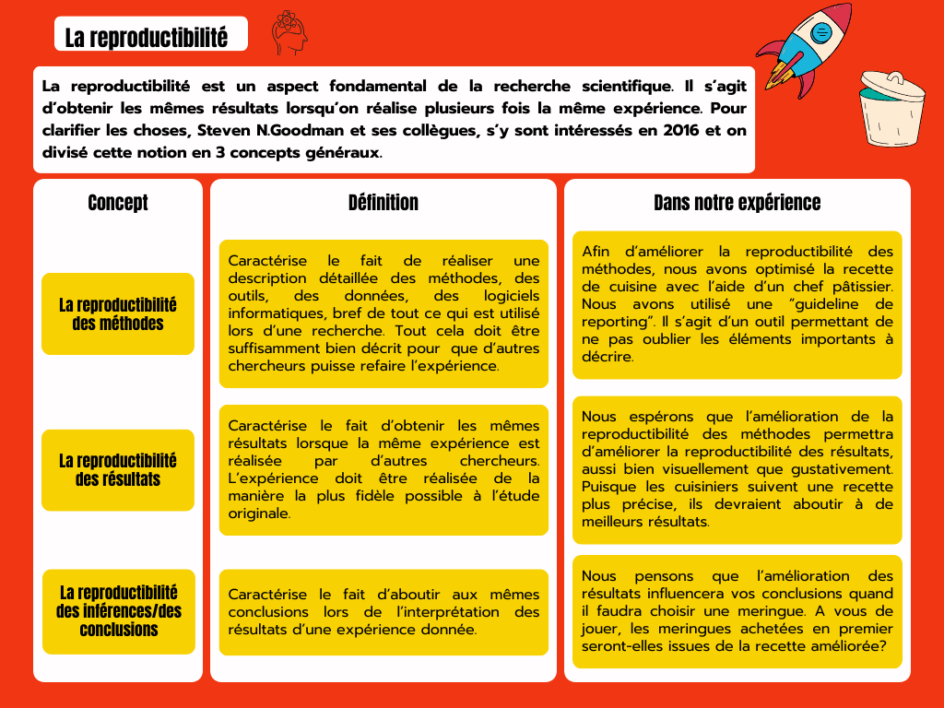

Explanation about how the science work. 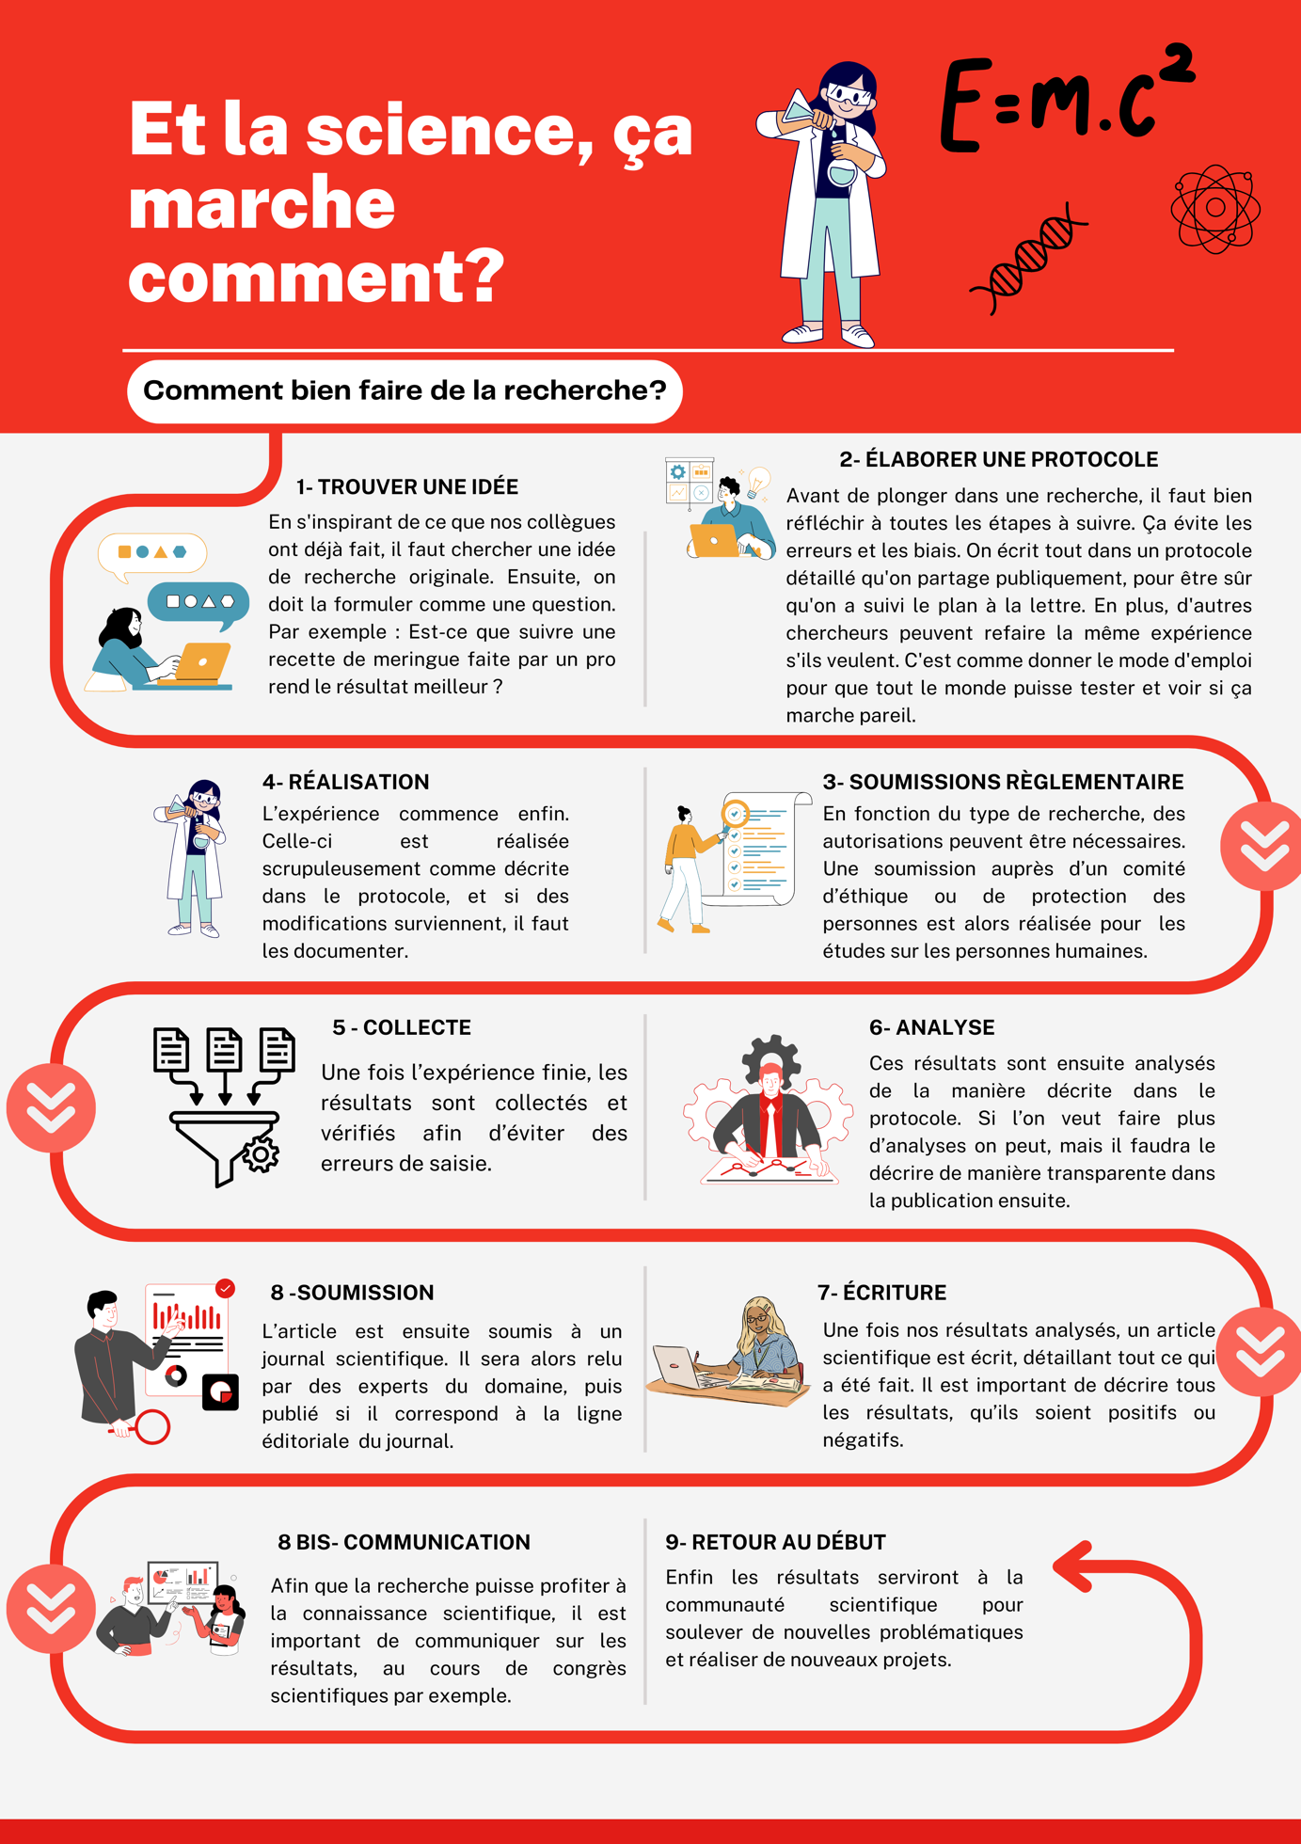
Description of 8 crucial steps to conduct a study. 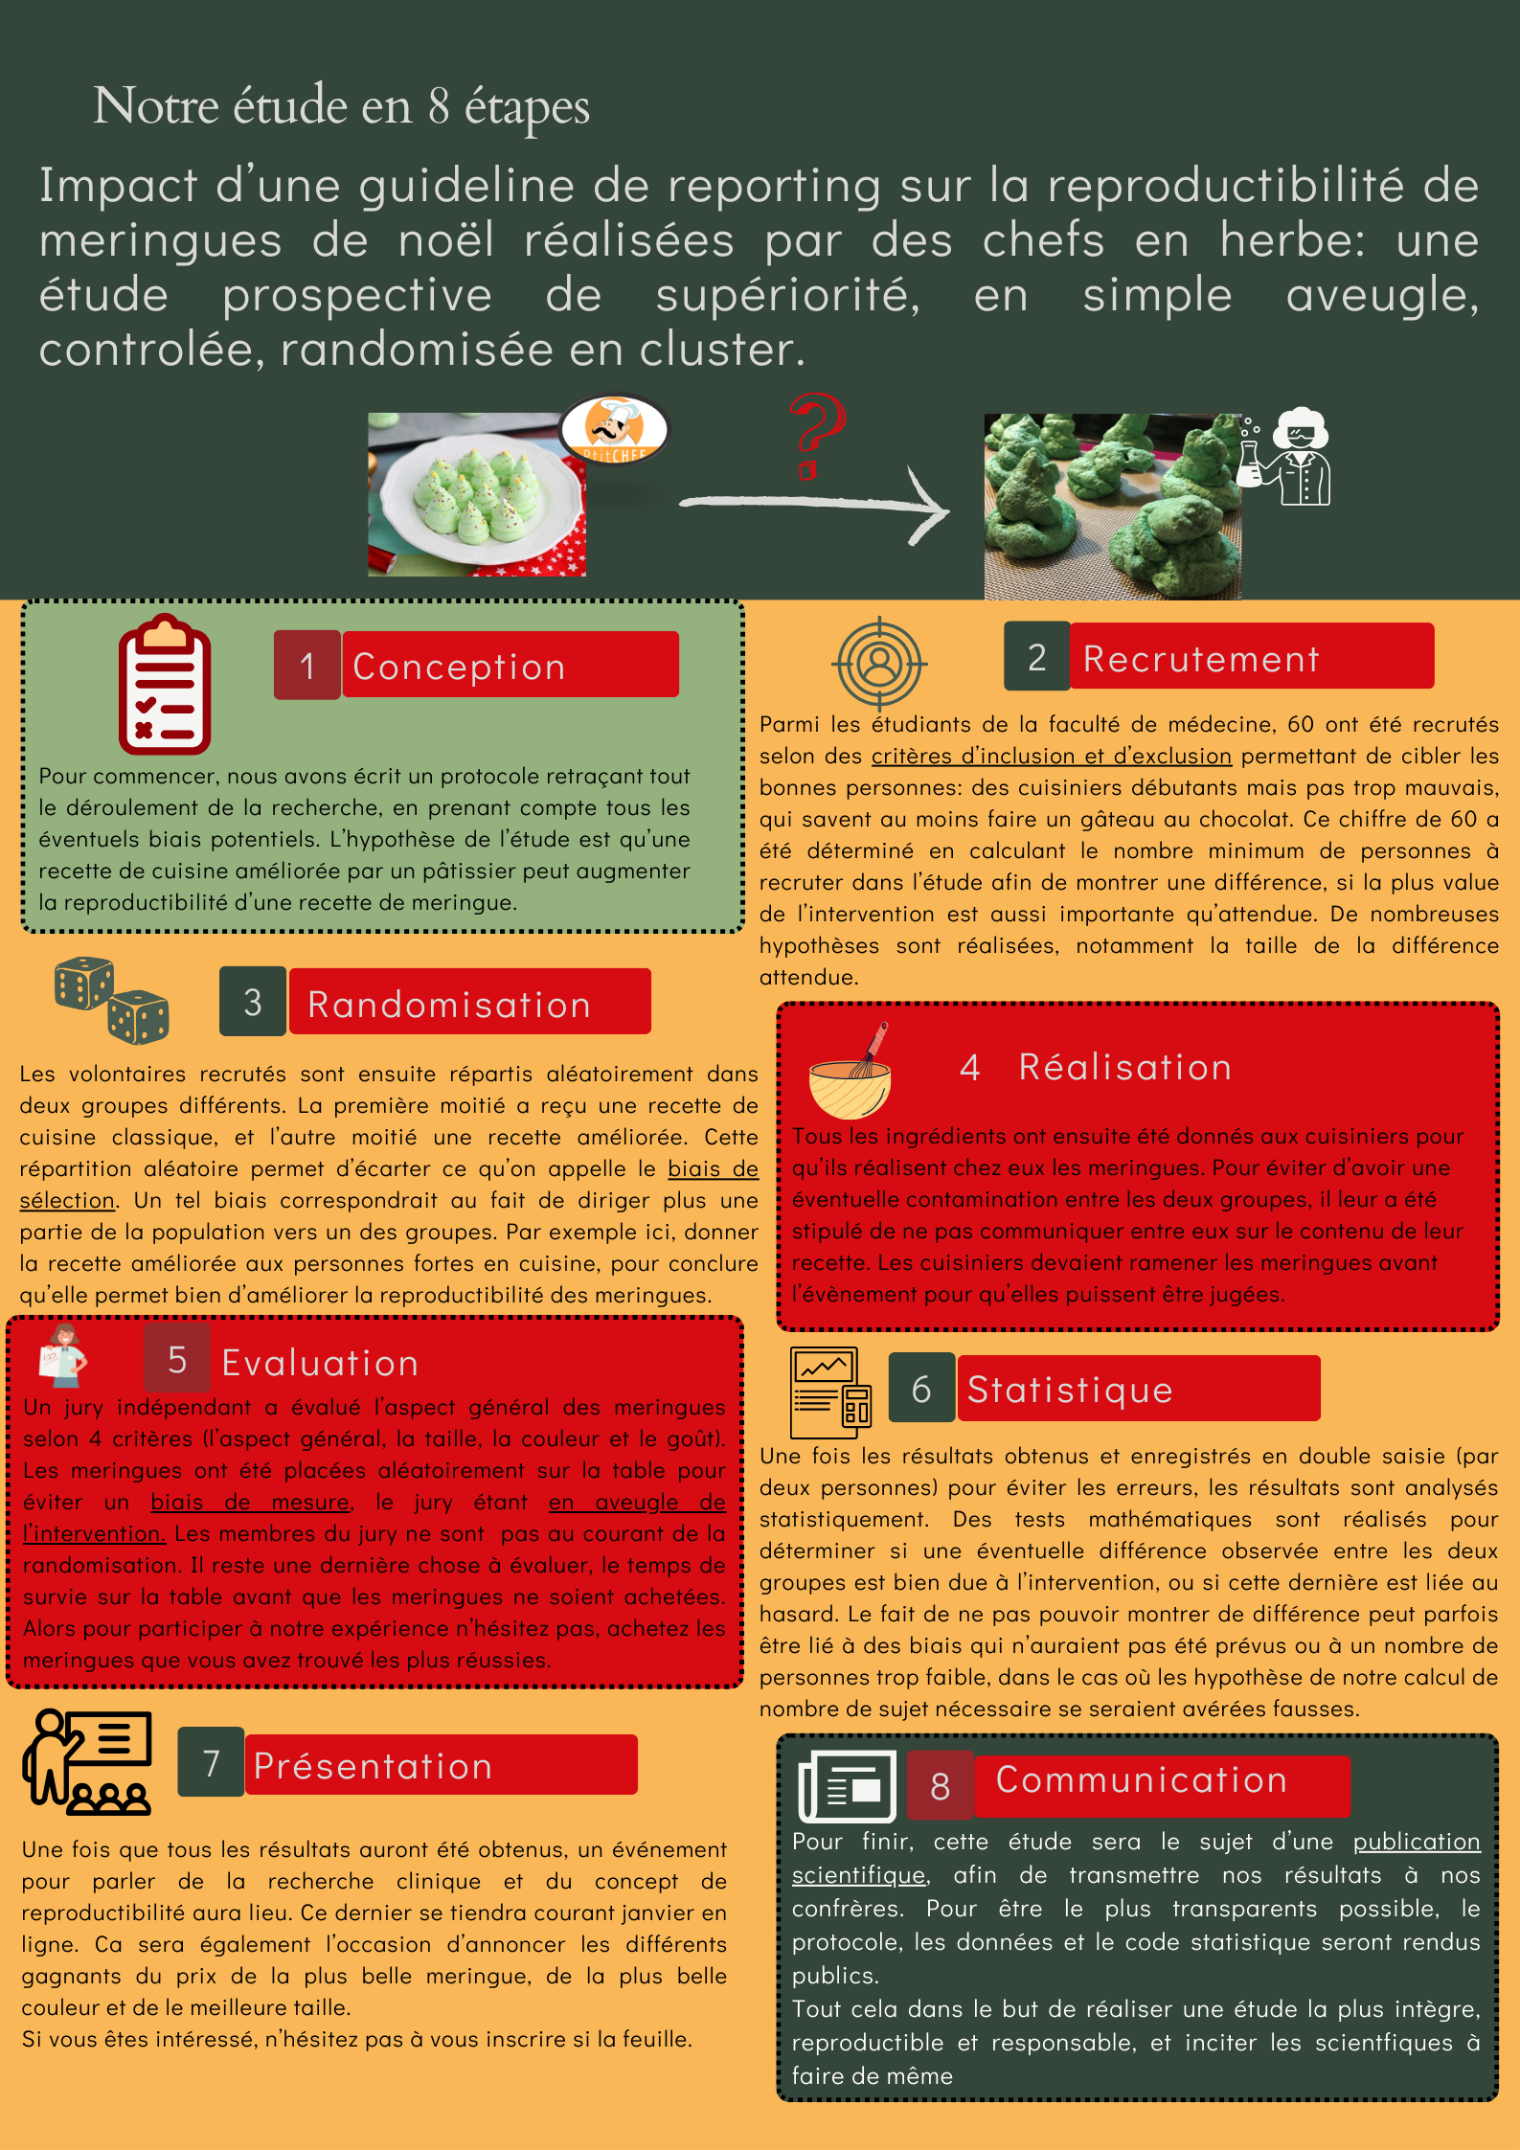

Web Appendix 5: Population description

Characteristic | Intervention, N = 301 | Control, N = 301
Mixer  Electric mixer  Food processor  Other | 21 (70%)  8 (27%)  1 (3.3%) | 24 (80%)  6 (20%)  0 (0%)
Oven  Built-in oven  Mini-oven | 25 (83%)  5 (17%) | 26 (87%)  4 (13%)
Cookery level  Beginner  Experienced  Professional | 10 (33%)  20 (67%)  0 (0%) | 9 (30%)  21 (70%)  0 (0%)
Age | 25 (23, 31) | 24 (22, 32)
¹ n (%); Median (IQR)

Web Appendix 6: inter-rater correlations for each pair and outcome (Pearson's r) [ Confidence interval])

 | Visual aspect | Colour | Size
Pair 1 | 0.69 [0.64;0.74] | 0.48 [0.41;0.55] | 0.67 [0.62;0.72]
Pair 2 | 0.72 [0.67;0.76] | 0.42 [0.34;0.50] | 0.71 [0.66;0.76]

Web Appendix 7: Sensitivity Analyses for survival

First: for the meringues that appeared to have been sold twice we selected the first one:

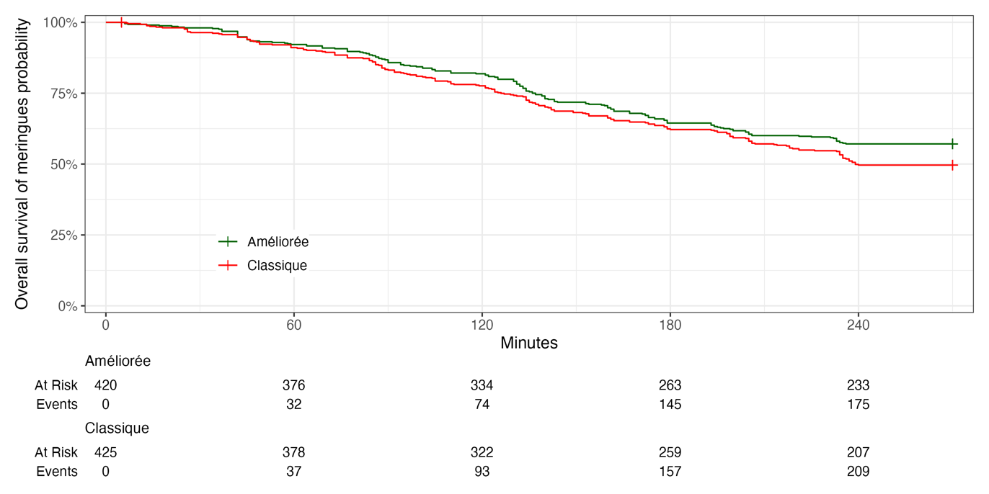

Call:
survival::coxph(formula = Surv(survival_time, event) ~ treatment +
frailty(id), data = survie_first_duplicate)

n= 845, number of events= 384

coef se(coef) se2 Chisq DF p
treatmentClassique 0.233 0.2632 0.08217 0.78 1.00 3.8e-01
frailty(id) 216.84 49.51 8.2e-23

exp(coef) exp(-coef) lower .95 upper .95
treatmentClassique 1.262 0.7921 0.7536 2.115

Iterations: 8 outer, 30 Newton-Raphson
Variance of random effect= 0.7474141 I-likelihood = -2402
Degrees of freedom for terms= 0.1 49.5
Concordance= 0.745 (se = 0.012 )
Likelihood ratio test= 290.4 on 49.61 df, p=<2e-16
Second: for the meringues that appeared to have been sold twice, we deleted them:

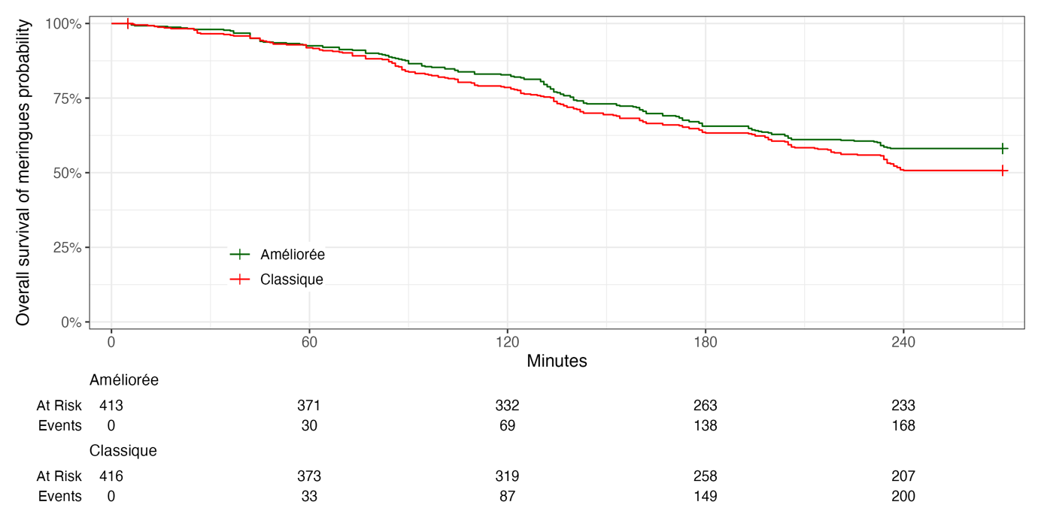
Call:
survival::coxph(formula = Surv(survival_time, event) ~ treatment +
frailty(id), data = survie_without_duplicate)

n= 829, number of events= 368

coef se(coef) se2 Chisq DF p
treatmentClassique 0.2193 0.2616 0.08931 0.7 1.00 4.0e-01
frailty(id) 204.4 48.92 6.5e-21

exp(coef) exp(-coef) lower .95 upper .95
treatmentClassique 1.245 0.8031 0.7457 2.079

Iterations: 8 outer, 30 Newton-Raphson
Variance of random effect= 0.7288512 I-likelihood = -2300.7
Degrees of freedom for terms= 0.1 48.9
Concordance= 0.744 (se = 0.013 )
Likelihood ratio test= 274.8 on 49.03 df, p=<2e-16

