Search
Databases: PubMed, Web of Science, Embase.
Grey literature: Google Scholar and the preprint servers BioRxiv and MedRxiv.
The Query string used in all included databases will simply be: “XXXXXXXXX”* to keep our search as broad as possible. We do not believe more advanced query strings to be necessary due to the search results only reaching the hundreds. We checked this number before writing the preregistration plan which means that, according to the NIRO guidelines, we are currently in the “scoping searches completed” stage (Topor et al., 2020). The relatively small number of hits will make it possible to select relevant RCTs by hand after the search is completed. In our search, no RCT or language filter was applied as these article characteristics were assessed in the screening phase. We chose to include studies that used any type of randomization and manuscripts written in English, Dutch, Farsi/Persian, French, German, Spanish, or Turkish. Final search date was 01/08/2024
* Here identifying information of the ‘key author’ is presented. In case you want to have the full information on the searchh, please email Marc Molendijk @ molendijkml@fsw.leidenuniv.nl
Topor, M., Pickering, J., Mendes, A. B., Bishop, D., Büttner, F. C., Elsherif, M., Evans, T. R., Henderson, E. L., Kalandadze, T., & Nitschke, F. (2020). Non-Interventional, Reproducible, and Open (NIRO) Systematic Review guidelines. OSF. https://doi.org/10.17605/osf.io/f3brw
Search validation procedure
We will validate our search through a match with the Google Scholar profile of “XXXXXXXXX”*
* Here identifying information of the ‘key author’ is presented. In case you want to have the full information on the searchh, please email Marc Molendijk @ molendijkml@fsw.leidenuniv.nl

1471 records identified through databases EMBASE (475), PUBMED (447), Web of Science (549), and in the grey literature (0). k = 729 after duplicates were removed.

Identification

459 records excluded (reasons: 2 language exclusion, 38 author criterion, 263 RCT criterion, 156 author AND RCT criterion)
729 records were screened after duplicates were removed

Screening

47 records excluded (reasons: 29 RCT criterion, 18 duplicates)

270 full-text articles assessed for eligibility

Eligibility

223 records included

Included

Figure S1. Flowchart on identification, screening and inclusion of eligible publications

Included RCTs
* This includes identifying information on the author team that we investigate. In case you want to have the full information, please email Marc Molendijk @ molendijkml@fsw.leidenuniv.nl

Bayes factor estimation
To test whether the empirical p-value distributions deviated from the expected uniform distribution, we relied on a combination of fitting a Beta distribution and subsequent Savage-Dickey ratio tests. The Beta distribution reduces to uniform when parameters a = b = 1. Deviations from uniformity were assessed via the a parameter: values less than 1 indicate p-value inflation, while values greater than 1 indicate p-value deflation. The b parameter was fixed to 1 in all subsequent analyses.
We used a Gamma(5,4) distribution as a prior, which ensures a mode of 1, while providing substantial flexibility in the implied plausible shapes of Beta distributions (see supplemental Figure 2 below). More informed priors centered at 1 would only increase the evidence against the null presented below. We estimated the a parameter with MCMC sampling using three chains of 50,000 iterations each. The first 2,000 iterations were discarded as burn-in. Visual inspection of the traces confirmed convergence (supplemental Figure 3A,4D). We ensured the effective sample size was at least 10000 in the tails (Vehtari et al., 2021). To quantify evidence for deviations from uniformity, we used the Savage-Dickey density ratio test to compute Bayes Factors comparing the null hypothesis (H₀: a=1, uniform distribution) against the alternative (H₁: a≠1, non-uniform distribution). Savage-Dickey tests (Wagenmakers et al., 2010) were performed separately for the p-values from the target group and the control RCT group. Note that the density of the posterior on the H₀ value was extremely low and therefore difficult to approximate. We estimated the density based on (a) fitting logsplines (Stone et al., 1997; see also Wagenmakers et al., 2010), as well as (b) using a normal approximation of the posterior distribution (Wetzels et al., 2009). We report the most conservative Bayes Factors; across methods, evidence was extremely strong.
In a second analysis, we tested for differences in the a parameter between groups. A single, two-group model was fitted to the p-values obtained from both groups simultaneously, estimating $a_{control}$ and the between-group difference $a_{difference}$, such that $a_{target}=a_{control}+a_{difference}$. The prior on $a_{control}$ was again Gamma(5,4), and the prior on $a_{difference}$ was N(0, 0.5). A Savage-Dickey ratio test was used to assess whether $a_{difference}=0$ (H₀: no difference between groups exists) versus $a_{difference}≠0$ (H₁: a difference between groups exists). Here, we added a fourth chain to ensure sufficient effective sample sizes in the tails.

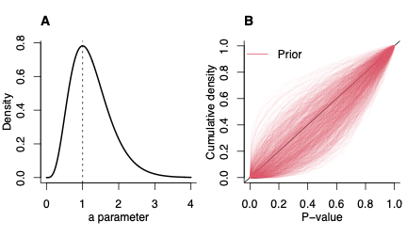
Figure S2
Panel A shows the prior distribution for parameter a, modeled as Gamma(5, 4). Panel B shows cumulative density functions of Beta(a, 1), using 1,000 draws of parameter a from the prior.

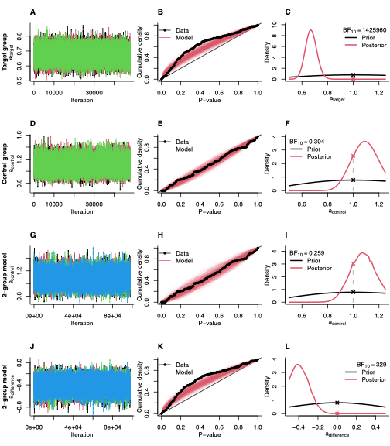
Figure S3
Bayes factor estimation with logspline approximators. A, D, G, J show trace plots of the MCMC chains for the a parameter of the fit Beta distribution. G and J correspond to the two-group model which estimated the a parameter for the control group (G) and the between-group difference (J; target-control) simultaneously. Colors mark the chains, with 48000 iterations each. B, E, H, K depict the quality of fit of the Beta distributions. Black lines are cumulative density functions of the observed p-values for the target group (B, K) and the control group (E, H). Red lines depict the cumulative densities of Beta(a, 1) distributions using 500 draws from the posteriors for parameter a (one line per draw). C, F, I, L show posterior and prior densities. Gray dotted lines indicate the parameter value corresponding with H₀.

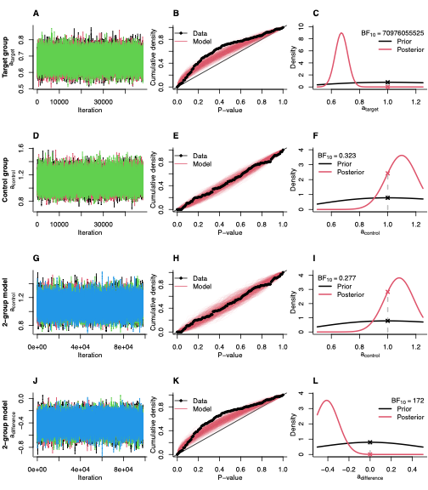
Figure S4
Bayes factor estimation with Gaussian approximators. A, D, G, J show trace plots of the MCMC chains for the a parameter of the fit Beta distribution. G and J correspond to the two-group model which estimated the a parameter for the control group (G) and the between-group difference (J; target-control) simultaneously. Colors mark the chains, with 48000 iterations each. B, E, H, K depict the quality of fit of the Beta distributions. Black lines are cumulative density functions of the observed p-values for the target group (B, K) and the control group (E, H). Red lines depict the cumulative densities of Beta(a, 1) distributions using 500 draws from the posteriors for parameter a (one line per draw). C, F, I, L show posterior and prior densities. Gray dotted lines indicate the parameter value corresponding with H₀.

Control RCTs

Control RCTs

RCTs of the key author

RCTs of the key author

Proportion of RCTs showing the characteristic

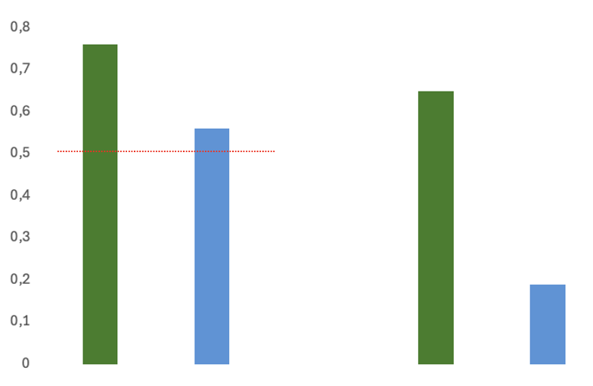
***
***
A. Even dropout B. Similar dropout
Figure S5
Panel A. shows the proportion of RCT’s with a total even dropout (dropout experimental group + dropout control group = an even number) in the RCT’s from the key author (in green) and the control RCT’s (in blue). The red line indicates the expected theoretical probability of 0,5. The comparisons with the theoretical value and that

Panel B. shows the proportion of RCT’s with a similar dropout (dropout experimental group = dropout control group) in the RCT’s from the key author (in green) and the control RCT’s (in blue).

*** P < .0001 for all comparisons [for even dropout, RCT’s of the key author vs. control RCT’s and vs. the expected value of 0,5; for similar dropout RCT’s of the key author vs. control RCT’s]

Table S1
Within column percentage of the event in the rows by authorship position of the key author.
 | Author position of the key author
 | First [k = 34] | Other [k = 22] | Final [k = 159]
Even dropout ^{A} | 44% | 63% | 84%
Uneven dropout | 56% | 37% | 16%
Similar dropout ^{B} | 40% | 26% | 76%
Disimilar dropout | 60% | 74% | 24%

^{A} Chi-square = 25.87, p < .001, BF₁₀ = 4489.07
^{B} Chi-square = 33.07, p < .001, BF₁₀ = 230359.60

References
Stone, C. J., Hansen, M. H., Kooperberg, C., & Truong, Y. K. (1997). Polynomial splines and their
tensor products in extended linear modeling: 1994 Wald memorial lecture. The Annals of
Statistics, 25(4), 1371-1470. https://doi.org/10.1214/aos/1031594728

Vehtari, A., Gelman, A., Simpson, D., Carpenter, B., & Bürkner, P. C. (2021). Rank-normalization,
folding, and localization: An improved R ̂ for assessing convergence of MCMC (with discussion).
Bayesian Analysis, 16(2), 667-718. https://doi.org/10.1214/20-BA1221

Wagenmakers, E. J., Lodewyckx, T., Kuriyal, H., & Grasman, R. (2010). Bayesian hypothesis
testing for psychologists: A tutorial on the Savage-Dickey method. Cognitive Psychology, 60(3),
158–189. https://doi.org/10.1016/j.cogpsych.2009.12.001

Wetzels, R., Raaijmakers, J. G., Jakab, E., & Wagenmakers, E. J. (2009). How to quantify support for and against the null hypothesis: A flexible WinBUGS implementation of a default Bayesian t test. Psychonomic Bulletin & Review, 16(4), 752-760. https://doi.org/doi:10.3758/PBR.16.4.752

