Online supplement 2, Iterative TRAC design over time
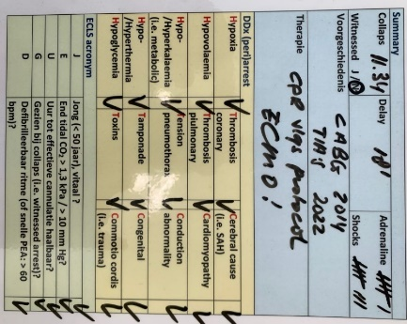  A | 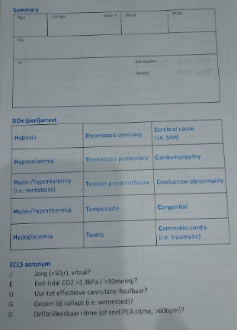  B
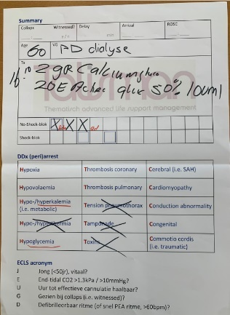  C | 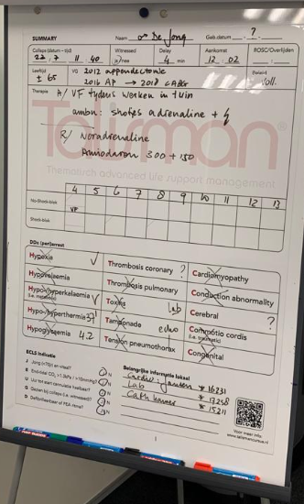  D
Legenda: Iterative modifications over time: (a) initial design in phase 2, (b-c-d) iterative modifications resulting from phase 3

