APPENDIX

Figure 1A - Tree plot for the normalised Time-to-degree (Total population)

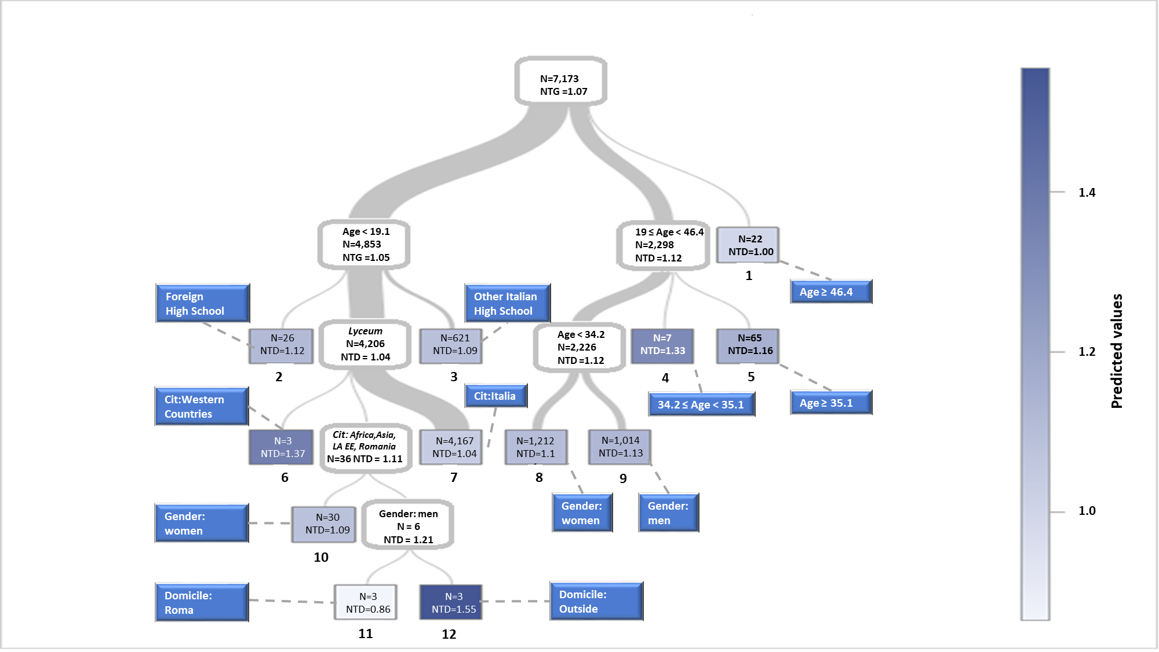 Note - N: absolute number of BAs; NTG: average normalised time-to-degree; Cit: Citizenship; EE: Eastern Europe; LA: Latin America; HS: High School.

