Appendix
Table A1. Model 2
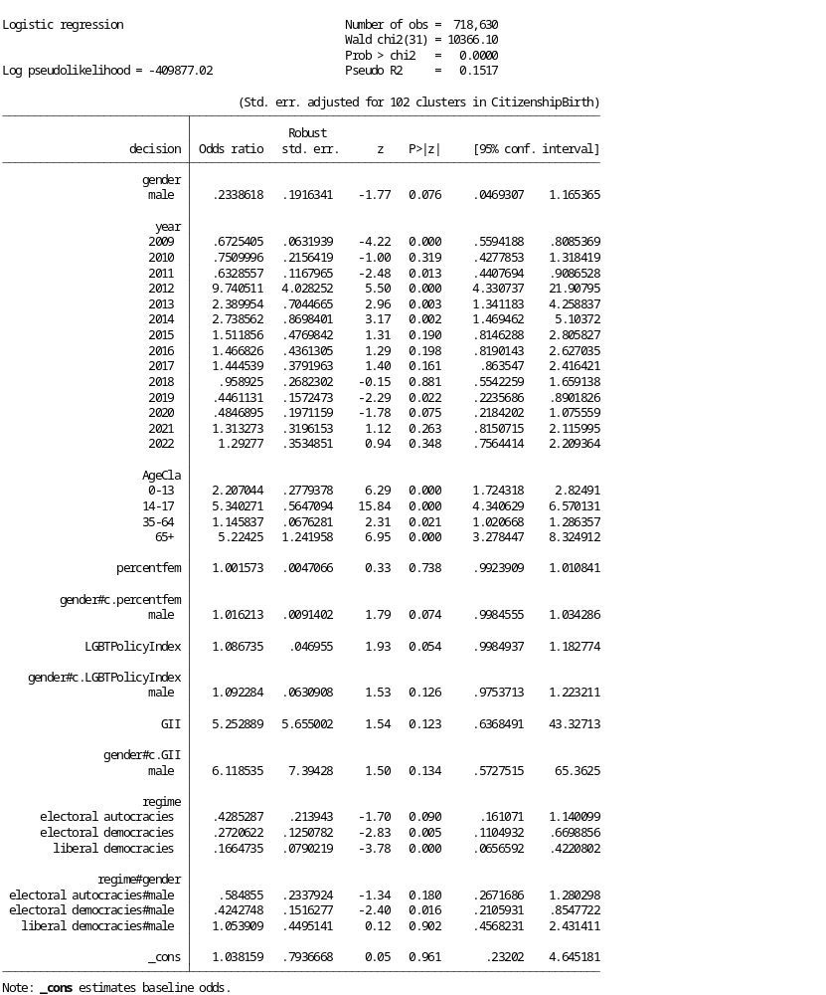
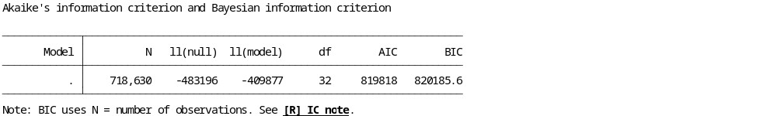
Table A2. Model 3
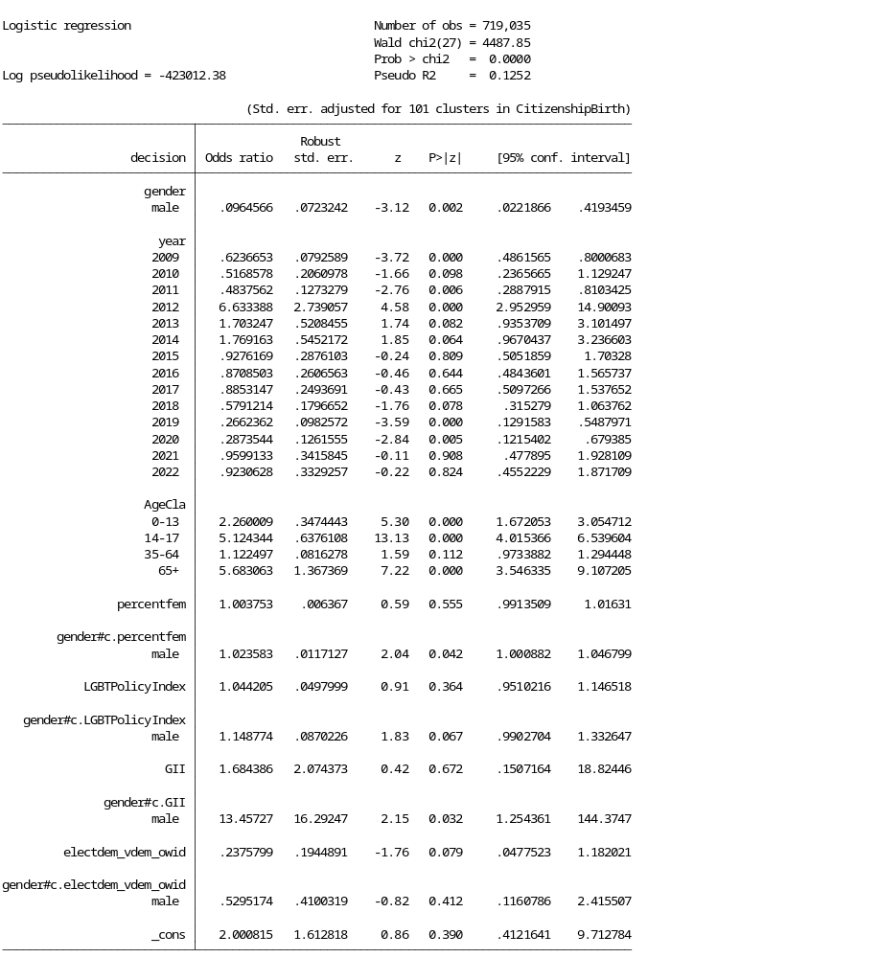
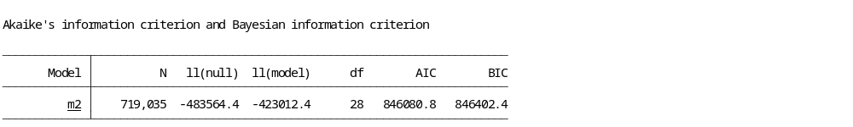

Table A3. Model 4
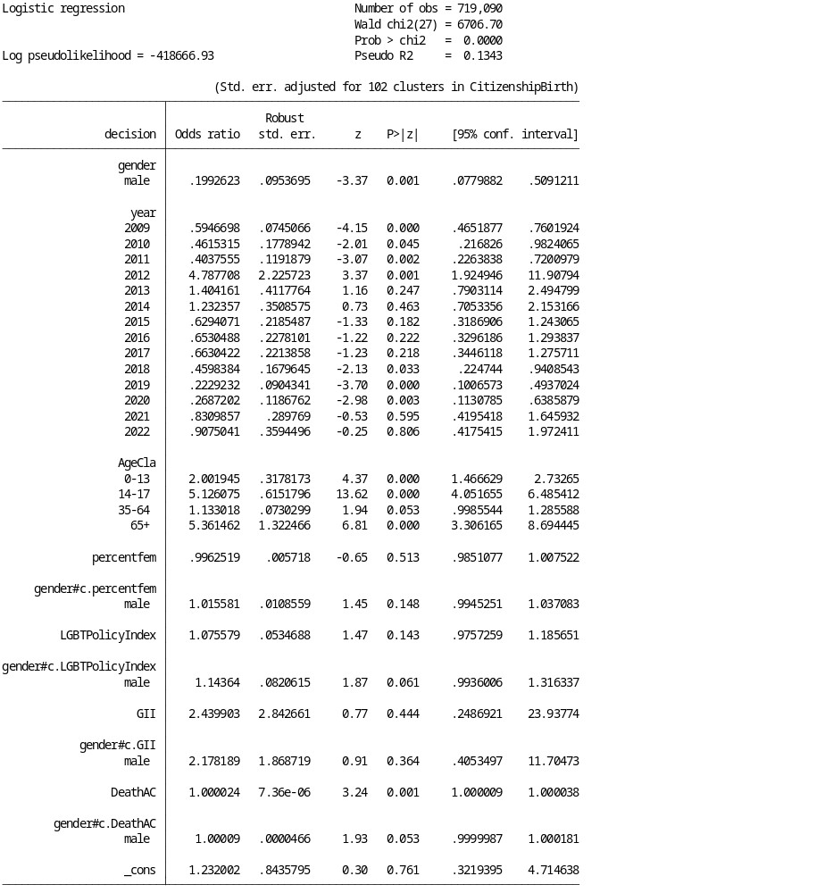
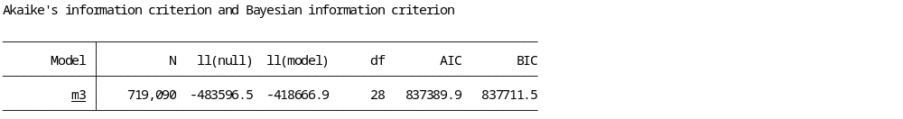

Table A4. Model 5 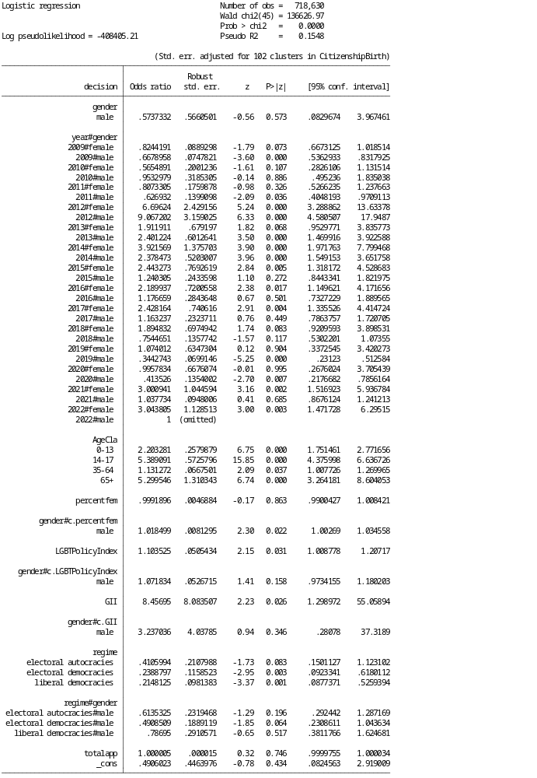
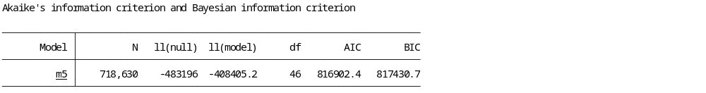

Figure A1 Predicted probabilities of being recognised a form of protection by gender and number of victims in armed conflicts in the year of the decision
