Appendix
- Tables
Factor analysis on the items of traditional attitudes towards family and gender roles
Table 1A reports the first outcome of the factor analysis, providing evidence of the existence of two underling factors. Factor loadings are reported in Table 2A. To be noticed that item n.4 has been removed. It provides a very low factor loading (about 1.6) in factor 2, while its interpretation in the factor is ambiguous.
Table 1A. Results from the factor analysis (maximum likelihood estimation applied): eigenvalues and factor loadings
Factors | Eigenvalue | Proportion of explained variance
Factor1 | 1.58 | 0.83
Factor2 | 1 | 0.51

 | Factor 1: Traditionalism in family values | Factor 2: Traditionalism in gender roles
- Marriage is an outdated institution (reversed) | 0.261 | -0.395
- A couple can live together even without planning to get married (reversed) | 0.683 | -0.173
- A woman can have a child alone even if she doesn't want to have a stable relationship with a man (reversed) | 0.513 | -0.295
- It is right that a couple with an unhappy marriage, divorces even if they have children (reversed) | 0.649 | -0.172
- If the parents separate / divorce it is better that the children stay with the mother rather than with the father | 0.332 | 0.493
- When parents need care, it is natural that daughters more than sons take care of them | 0.462 | 0.513
- Being a housewife allows a woman to feel self-fulfilled as holding a paid job | 0.207 | 0.402

Table 2A. Results from the factor analysis after a Promax rotation
Factors | Eigenvalue | Proportion
Factor1 | 1.47 | 0.77
Factor2 | 1.13 | 0.59

 | Factor 1: Traditionalism in family values | Factor 2: Traditionalism in gender roles
- Marriage is an outdated institution (reversed) | 0.427 | -0.246
- A couple can live together even without planning to get married (reversed) | 0.678 | 0.135
- A woman can have a child alone even if she doesn't want to have a stable relationship with a man (reversed) | 0.593 | -0.047
- It is right that a couple with an unhappy marriage, divorces even if they have children (reversed) | 0.649 | 0.121
- If the parents separate / divorce it is better that the children stay with the mother rather than with the father | 0.036 | 0.589
- When parents need care, it is natural that daughters more than sons take care of them | 0.138 | 0.663
- Being a housewife allows a woman to feel self-fulfilled as holding a paid job | -0.02 | 0.453

Table 3A – Distribution of the covariates and control variables by gender
 | Men | Women | Total
Age class
25-29 | 51.54 | 53.76 | 52.62
30-34 | 48.46 | 46.24 | 47.38
Education
tertiary degree | 24.72 | 29.13 | 26.86
Partnership condition
in stable partnership | 44.61 | 51.55 | 47.98
Employment condition
unemployed | 17.17 | 21.93 | 19.48
inactive | 17.98 | 22.51 | 20.18
employed - fixed contract | 57.64 | 47.53 | 52.73
employed - termporary contract | 7.21 | 8.03 | 7.61
Income level
0-500 euros | 45.21 | 56.72 | 50.8
501-1299 euros | 30.25 | 29.83 | 30.05
>1300 | 24.54 | 13.45 | 19.15
TOTAL | 1765 | 1667 | 3432

 | Mean | Std. err. | [95% confidence  interval] |  | TOTAL
Factor 1: traditionalism in family values
Men | 0.117 | 0.022 | 0.075 | 0.160 | 1765
Women | -0.150 | 0.018 | -0.186 | -0.114 | 1667
Factor 2: traditionalism in gender roles
Men | 0.049 | 0.020 | 0.010 | 0.089 | 1765
Women | -0.178 | 0.016 | -0.210 | -0.146 | 1667

Table 4A. Logit regression models on not being motivated to have children in life, including socio-economic characteristics, interacted with gender (c.i. at 5%)
 | Education |  |  | Income |  |  | Employment |  |  | Partnership
 | Coeff. | Std. Err. | p-value | Coeff. | Std. Err. | p-value | Coeff. | Std. Err. | p-value | Coeff. | Std. Err. | p-value
Woman | 0.362 | 0.131 | 0.006 | 0.185 | 0.151 | 0.221 | 0.087 | 0.273 | 0.750 | 0.372 | 0.137 | 0.007
Age (ref: 25-29)
30-34 | 0.255 | 0.103 | 0.014 | 0.257 | 0.103 | 0.013 | 0.247 | 0.103 | 0.017 | 0.257 | 0.103 | 0.013
In partnership | -0.498 | 0.098 | 0.000 | -0.494 | 0.098 | 0.000 | -0.490 | 0.099 | 0.000 | -0.415 | 0.151 | 0.006
partnership*woman |  |  |  |  |  |  |  |  |  | -0.157 | 0.197 | 0.426
Education (ref: no tertiary degree)
tertiary degree | 0.255 | 0.125 | 0.042 | 0.136 | 0.083 | 0.100 | 0.133 | 0.083 | 0.109 | 0.134 | 0.083 | 0.106
tertiary degree*woman | -0.225 | 0.164 | 0.171
Income (ref: 0-500 euros/month)
501-1300 euros/month | -0.464 | 0.163 | 0.004 | -0.669 | 0.216 | 0.002 | -0.458 | 0.163 | 0.005 | -0.462 | 0.163 | 0.005
>1300 euros/month | -0.454 | 0.177 | 0.010 | -0.454 | 0.213 | 0.033 | -0.433 | 0.178 | 0.015 | -0.451 | 0.177 | 0.011
501-1300 euros/month*woman |  |  |  | 0.409 | 0.233 | 0.079
>1300 euros/month*woman |  |  |  | -0.030 | 0.233 | 0.899
Employment condition (ref: unemployed)
inactive | 0.095 | 0.170 | 0.574 | 0.101 | 0.169 | 0.551 | -0.028 | 0.273 | 0.919 | 0.098 | 0.170 | 0.565
employed stable | 0.298 | 0.204 | 0.144 | 0.287 | 0.203 | 0.157 | 0.141 | 0.284 | 0.620 | 0.291 | 0.204 | 0.154
employed unstable | 0.089 | 0.214 | 0.678 | 0.085 | 0.214 | 0.693 | -0.080 | 0.332 | 0.810 | 0.085 | 0.214 | 0.691
inactive*woman |  |  |  |  |  |  | 0.229 | 0.339 | 0.499
employed stable*woman |  |  |  |  |  |  | 0.279 | 0.302 | 0.357
employed unstable*woman |  |  |  |  |  |  | 0.298 | 0.416 | 0.474
Constant | -0.407 | 0.170 | 0.016 | -0.317 | 0.178 | 0.075 | -0.259 | 0.227 | 0.255 | -0.410 | 0.168 | 0.015
Note - Sample size in each model: 3432 observations

Table 5A. Logit regression models on not being motivated to have children in life, including the index for traditionalism in family values, interacted with gender (c.i. at 5%)
 | Coeff. | Std. Err. | p-value
Woman | 0.182 | 0.090 | 0.045
Age (ref: 25-29)
30-34 | 0.267 | 0.075 | 0.000
In partnership | -0.456 | 0.071 | 0.000
Education (ref: no tertiary degree)
tertiary degree | 0.158 | 0.060 | 0.009
Income (ref: 0-500 euros/month)
501-1300 euros/month | -0.519 | 0.120 | 0.000
>1300 euros/month | -0.508 | 0.132 | 0.000
Employment condition (ref: unemployed)
inactive | 0.087 | 0.122 | 0.478
employed stable | 0.339 | 0.152 | 0.025
employed unstable | 0.103 | 0.160 | 0.518
Family traditionalism | -0.708 | 0.077 | 0.000
Family traditionalism (quadratic term) | 0.343 | 0.056 | 0.000
Family traditionalism*woman | 0.085 | 0.100 | 0.398
Family traditionalism (quadratic term)*woman | -0.048 | 0.075 | 0.523
Constant | -0.587 | 0.123 | 0.000
Note - sample size: 1667 observations

Table 6A. Logit regression models on not being motivated to have children in life, including the index for traditionalism in family values interacted with socio-economic characteristics, for men only (c.i. at 5%)
Men | Income |  |  | Partnership
 | Coeff. | Std. Err. | p-value | Coeff. | Std. Err. | p-value
Age (ref: 25-29)
30-34 | 0.152 | 0.164 | 0.352 | 0.123 | 0.163 | 0.448
In partnership | -0.350 | 0.157 | 0.025 | -0.433 | 0.189 | 0.022
Education (ref: no tertiary degree)
tertiary degree | 0.300 | 0.134 | 0.025 | 0.302 | 0.131 | 0.022
Income (ref: 0-500 euros/month)
501-1300 euros/month | -0.927 | 0.295 | 0.002 | -0.779 | 0.268 | 0.004
>1300 euros/month | -0.896 | 0.310 | 0.004 | -0.615 | 0.281 | 0.029
Employment condition (ref: unemployed)
inactive | -0.091 | 0.280 | 0.744 | -0.109 | 0.285 | 0.703
employed stable | 0.298 | 0.335 | 0.374 | 0.320 | 0.343 | 0.351
employed unstable | 0.017 | 0.345 | 0.959 | 0.030 | 0.348 | 0.932
Family traditionalism | -0.480 | 0.166 | 0.004 | -0.619 | 0.145 | 0.000
Family traditionalism (quadratic term) | 0.180 | 0.122 | 0.139 | 0.305 | 0.127 | 0.015
Family traditionalism & income
501-1300 euros/month*traditionalism | -0.487 | 0.267 | 0.069
>1300 euros/month*traditionalism | -0.376 | 0.240 | 0.119
501-1300 euros/month*traditionalism (quadratic term) | 0.244 | 0.187 | 0.192
>1300 euros/month*traditionalism (quadratic term) | 0.480 | 0.176 | 0.006
Family traditionalism & partnership
partner*traditionalism |  |  |  | -0.253 | 0.213 | 0.235
partner*traditionalism (quadratic term) |  |  |  | 0.118 | 0.162 | 0.467
Constant | -0.361 | 0.257 | 0.160 | -0.416 | 0.257 | 0.105
Note - sample size: 1765 observations

Table 7A. Logit regression models on not being motivated to have children in life, including the index for traditionalism in family values interacted with socio-economic characteristics, for women only (c.i. at 5%)
Women | Partnership
 | Coeff. | Std. Err. | p-value
Age (ref: 25-29)
30-34 | 0.403 | 0.135 | 0.003
In partnership | -0.476 | 0.168 | 0.005
Education (ref: no tertiary degree)
tertiary degree | 0.035 | 0.112 | 0.753
Income (ref: 0-500 euros/month)
501-1300 euros/month | -0.231 | 0.204 | 0.252
>1300 euros/month | -0.412 | 0.234 | 0.078
Employment condition (ref: unemployed)
inactive | 0.181 | 0.207 | 0.384
employed stable | 0.283 | 0.249 | 0.257
employed unstable | 0.156 | 0.287 | 0.588
Family traditionalism | -0.769 | 0.139 | 0.000
Family traditionalism (quadratic term) | 0.314 | 0.104 | 0.003
Family traditionalism & partnership
partner*traditionalism | 0.281 | 0.181 | 0.120
partner*traditionalism (quadratic term) | -0.053 | 0.141 | 0.704
Constant | -0.519 | 0.213 | 0.015
Note - sample size: 1667 observations

Table 8A. Logit regression models on not being motivated to have children in life, including the index for traditionalism in gender roles, interacted with gender (c.i. at 5%)
 | Coeff. | Std. Err. | p-value
Woman | 0.266 | 0.075 | 0.000
Age (ref: 25-29)
30-34 | 0.261 | 0.075 | 0.004
In partnership | -0.502 | 0.070 | 0.000
Education (ref: no tertiary degree)
tertiary degree | 0.133 | 0.059 | 0.024
Income (ref: 0-500 euros/month)
501-1300 euros/month | -0.457 | 0.115 | 0.000
>1300 euros/month | -0.461 | 0.126 | 0.001
Employment condition (ref: unemployed)
inactive | 0.092 | 0.121 | 0.451
employed stable | 0.301 | 0.145 | 0.038
employed unstable | 0.096 | 0.150 | 0.521
Gender role traditionalism | -0.211 | 0.077 | 0.006
Gender role traditionalism (quadratic term) | 0.206 | 0.076 | 0.007
Gender role traditionalism*woman | 0.125 | 0.100 | 0.211
Gender role traditionalism (quadratic term)*woman | 0.001 | 0.106 | 0.211
Constant | -0.489 | 0.124 | 0.000
Note - sample size: 3432 observations

Table 9A. Logit regression models on not being motivated to have children in life, including the index for traditionalism in gender roles interacted with socio-economic characteristics, by gender (c.i. at 5%)
 | Income  (men) |  |  | Income  (women) |  |  | Employment  (men) |  |  | Employment  (women)
 | Coeff. | Std. Err. | p-value | Coeff. | Std. Err. | p-value | Coeff. | Std. Err. | p-value | Coeff. | Std. Err. | p-value
Age (ref: 25-29)
30-34 | 0.130 | 0.112 | 0.245 | 0.390 | 0.092 | 0.000 | 0.122936 | 0.112 | 0.275 | 0.376 | 0.092 | 0.000
In partnership | -0.435 | 0.107 | 0.000 | -0.626 | 0.088 | 0.000 | -0.428 | 0.108 | 0 | -0.596 | 0.088 | 0.000
Education (ref: no tertiary degree)
tertiary degree | 0.261 | 0.091 | 0.004 | 0.020 | 0.077 | 0.792 | 0.204 | 0.089 | 0.022 | 0.017 | 0.078 | 0.821
Income (ref: 0-500 euros/month)
501-1300 euros/month | -0.983 | 0.215 | 0.000 | -0.671 | 0.171 | 0.000 | -0.667 | 0.182 | 0.000 | -0.256 | 0.142 | 0.072
>1300 euros/month | -0.673 | 0.212 | 0.001 | -0.623 | 0.198 | 0.002 | -0.530 | 0.189 | 0.005 | -0.463 | 0.165 | 0.005
Employment condition (ref: unemployed)
inactive | -0.085 | 0.198 | 0.667 | 0.198 | 0.146 | 0.176 | 0.200 | 0.249 | 0.420 | -0.078 | 0.200 | 0.694
employed stable | 0.273 | 0.233 | 0.241 | 0.339 | 0.171 | 0.048 | 0.147 | 0.266 | 0.579 | -0.124 | 0.212 | 0.557
employed unstable | 0.003 | 0.237 | 0.989 | 0.236 | 0.190 | 0.215 | 0.368 | 0.306 | 0.228 | -0.376 | 0.255 | 0.141
Gender role traditionalism | -0.150 | 0.125 | 0.232 | -0.082 | 0.090 | 0.364 | -0.042 | 0.229 | 0.855 | 0.206 | 0.152 | 0.176
Gender role traditionalism (quadratic term) | -0.011 | 0.136 | 0.932 | -0.085 | 0.104 | 0.409 | 0.207 | 0.204 | 0.311 | -0.302 | 0.160 | 0.059
Gender role traditionalism & income | -0.080 | 0.183 | 0.661 | -0.113 | 0.147 | 0.443
501-1300 euros/month*traditionalism | -0.093 | 0.175 | 0.592 | -0.034 | 0.159 | 0.827
>1300 euros/month*traditionalism
501-1300 euros/month*traditionalism_quadratic | 0.545 | 0.195 | 0.005 | 0.688 | 0.151 | 0.000
>1300 euros/month*traditionalism_quadratic | 0.254 | 0.173 | 0.142 | 0.258 | 0.181 | 0.155
Gender role traditionalism & employment
inactive |  |  |  |  |  |  | -0.253 | 0.276 | 0.360 | -0.157 | 0.201 | 0.433
employed stable |  |  |  |  |  |  | -0.179 | 0.248 | 0.471 | -0.424 | 0.176 | 0.016
employed unstable |  |  |  |  |  |  | -0.178 | 0.333 | 0.593 | -0.894 | 0.248 | 0.000
Gender role traditionalism (quadratic) & employment
inactive |  |  |  |  |  |  | -0.559 | 0.292 | 0.56 | 0.548 | 0.214 | 0.011
employed stable |  |  |  |  |  |  | 0.157 | 0.223 | 0.480 | 0.707 | 0.183 | 0.000
employed unstable |  |  |  |  |  |  | -0.768 | 0.412 | 0.063 | 0.889 | 0.264 | 0.001
Constant | -0.226 | 0.183 | 0.219 | -0.122 | 0.151 | 0.417 | -0.344 | 0.204 | 0.092 | 0.025 | 0.171 | 0.880
Note – women’s sample size: 1667 observations; men’s sample size: 1765 observations

Table 10A. Logit regression models on not intending to have a child in the next two years, including some socio-economic characteristics and the cultural covariates interacted with gender (c.i. at 5%)
 | Education |  |  | Employment |  |  | Income |  |  | Partnership
 | Coeff. | Std. Err. | p-value | Coeff. | Std. Err. | p-value | Coeff. | Std. Err. | p-value | Coeff. | Std. Err. | p-value
Woman | -0.775 | 0.135 | 0.000 | -1.035 | 0.332 | 0.002 | -0.800 | 0.187 | 0.000 | -0.758 | 0.169 | 0.000
Age (ref: 25-29)
30-34 | -0.429 | 0.105 | 0.000 | -0.431 | 0.107 | 0.000 | -0.427 | 0.106 | 0.000 | -0.428 | 0.105 | 0.000
In partnership | -0.567 | 0.105 | 0.000 | -0.562 | 0.106 | 0.000 | -0.563 | 0.105 | 0.000 | -0.606 | 0.170 | 0.000
In partnership*woman |  |  |  |  |  |  |  |  |  | 0.064 | 0.212 | 0.763
Education (ref: no tertiary degree)
tertiary degree | 0.050 | 0.133 | 0.704 | 0.165 | 0.085 | 0.053 | 0.159 | 0.084 | 0.059 | 0.168 | 0.085 | 0.049
tertiary degree*woman | 0.210 | 0.165 | 0.205
Income (ref: 0-500 euros/month)
501-1300 euros/month | -0.298 | 0.165 | 0.071 | -0.288 | 0.163 | 0.078 | -0.315 | 0.243 | 0.195 | -0.297 | 0.165 | 0.071
>1300 euros/month | -0.479 | 0.182 | 0.008 | -0.468 | 0.180 | 0.009 | -0.609 | 0.239 | 0.011 | -0.481 | 0.181 | 0.008
501-1300 euros/month*woman | 0.022 | 0.205 | 0.916
>1300 euros/month*woman | 0.007 | 0.198 | 0.993
Employment condition (ref: unemployed)
inactive | 0.471 | 0.196 | 0.016 | 0.203 | 0.386 | 0.599 |  |  |  | 0.469 | 0.196 | 0.017
employed stable | -0.137 | 0.211 | 0.517 | -0.374 | 0.337 | 0.267 |  |  |  | -0.130 | 0.210 | 0.536
employed unstable | 0.233 | 0.236 | 0.323 | -0.136 | 0.406 | 0.739 |  |  |  | 0.240 | 0.236 | 0.308
inactive*woman |  |  |  | 0.382 | 0.436 | 0.381
employed stable*woman |  |  |  | 0.350 | 0.355 | 0.324
employed unstable*woman |  |  |  | 0.577 | 0.484 | 0.233
Family traditionalism
Family traditionalism (quadratic term)
Family traditionalism*woman
Family traditionalism (quadratic term)*woman
Gender role traditionalism
Gender role traditionalism (quadratic term)
Gender role traditionalism*woman
Gender role traditionalism (quadratic term)*woman
Constant | 1.913 | 0.185 | 0.000 | 2.096 | 0.295 | 0.000 | 1.932 | 0.204 | 0.000 | 1.901 | 0.191 | 0.000

 | Family traditionalism |  |  | Gender role traditionalism
 | Coeff. | Std. Err. | p-value | Coeff. | Std. Err. | p-value
Woman | -0.763 | 0.141 | 0.000 | -0.820 | 0.115 | 0.000
Age (ref: 25-29)
30-34 | -0.412 | 0.106 | 0.000 | -0.420 | 0.105 | 0.000
In partnership | -0.539 | 0.106 | 0.000 | -0.563 | 0.106 | 0.000
In partneship*woman
Education (ref: no tertiary degree)
tertiary degree | 0.147 | 0.085 | 0.086 | 0.156 | 0.086 | 0.068
tertiary degree*woman
Income (ref: 0-500 euros/month)
501-1300 euros/month | -0.282 | 0.163 | 0.084 | -0.307 | 0.163 | 0.060
>1300 euros/month | -0.469 | 0.180 | 0.009 | -0.504 | 0.179 | 0.005
501-1300 euros/month*woman
>1300 euros/month*woman
Employment condition (ref: unemployed)
inactive | 0.475 | 0.196 | 0.015 | 0.485 | 0.196 | 0.013
employed stable | -0.106 | 0.209 | 0.614 | -0.107 | 0.208 | 0.606
employed unstable | 0.294 | 0.237 | 0.215 | 0.272 | 0.236 | 0.250
inactive*woman
employed stable*woman
employed unstable*woman
Family traditionalism | -0.399 | 0.098 | 0.000
Family traditionalism (quadratic term) | 0.405 | 0.072 | 0.000
Family traditionalism*woman | 0.160 | 0.122 | 0.188
Family traditionalism (quadratic term)*woman | -0.200 | 0.088 | 0.023
Gender role traditionalism |  |  |  | -0.183 | 0.083 | 0.027
Gender role traditionalism (quadratic term) |  |  |  | -0.205 | 0.074 | 0.006
Gender role traditionalism*woman |  |  |  | 0.199 | 0.104 | 0.056
Gender role traditionalism (quadratic term)*woman |  |  |  | 0.256 | 0.101 | 0.012
Constant | 1.795 | 0.142 | 0.000 | 2.016 | 0.135 | 0.000
Note –sample size: 3432 observations

Table 11A. Logit regression models on not desiring children in life, including some socio-economic characteristics and the cultural covariates interacted with gender (c.i. at 5%)
 | Education |  |  | Employment |  |  | Income |  |  | Partnership
 | Coeff. | Std. Err. | p-value | Coeff. | Std. Err. | p-value | Coeff. | Std. Err. | p-value | Coeff. | Std. Err. | p-value
Woman | 0.028 | 0.180 | 0.875 | 0.012 | 0.363 | 0.974 | -0.099 | 0.194 | 0.611 | 0.110 | 0.183 | 0.548
Age (ref: 25-29)
30-34 | 0.358 | 0.141 | 0.011 | 0.359 | 0.139 | 0.010 | 0.363 | 0.141 | 0.010 | 0.364 | 0.141 | 0.010
In partnership | -0.720 | 0.134 | 0.000 | -0.717 | 0.137 | 0.000 | -0.713 | 0.135 | 0.000 | -0.598 | 0.208 | 0.004
In partneshipr*woman |  |  |  |  |  |  |  |  |  | -0.234 | 0.272 | 0.388
Education (ref: no tertiary degree)
tertiary degree | 0.165 | 0.164 | 0.316 | 0.134 | 0.110 | 0.224 | 0.132 | 0.111 | 0.232 | 0.133 | 0.110 | 0.227
tertiary degree*woman | -0.054 | 0.219 | 0.805
Income (ref: 0-500 euros/month)
501-1300 euros/month | -0.508 | 0.224 | 0.023 | -0.512 | 0.222 | 0.021 | -0.678 | 0.306 | 0.027 | -0.511 | 0.224 | 0.023
>1300 euros/month | -0.668 | 0.233 | 0.004 | -0.662 | 0.233 | 0.005 | -0.733 | 0.262 | 0.005 | -0.677 | 0.232 | 0.003
501-1300 euros/month*woman |  |  |  |  |  |  | 0.333 | 0.333 | 0.318
>1300 euros/month*woman |  |  |  |  |  |  | 0.136 | 0.325 | 0.677
Employment condition (ref: unemployed)
inactive | -0.044 | 0.220 | 0.840 | -0.005 | 0.371 | 0.990 | -0.037 | 0.221 | 0.866 | -0.046 | 0.221 | 0.836
employed stable | 0.113 | 0.266 | 0.670 | 0.087 | 0.379 | 0.818 | 0.109 | 0.266 | 0.683 | 0.108 | 0.267 | 0.687
employed unstable | 0.608 | 0.264 | 0.021 | 0.672 | 0.432 | 0.119 | 0.611 | 0.264 | 0.021 | 0.604 | 0.264 | 0.022
inactive*woman |  |  |  | -0.065 | 0.456 | 0.886
employed stable*woman |  |  |  | 0.056 | 0.408 | 0.891
employed unstable*woman |  |  |  | -0.124 | 0.527 | 0.814
Family traditionalism
Family traditionalism (quadratic term)
Family traditionalism*woman
Family traditionalism (quadratic term)*woman
Gender role traditionalism
Gender role traditionalism (quadratic term)
Gender role traditionalism*woman
Gender role traditionalism (quadratic term)*woman
Constant | -1.614 | 0.220 | 0.000 | -1.607 | 0.292 | 0.000 | -1.550 | 0.223 | 0.000 | -1.650 | 0.212 | 0.000

 | Family traditionalism |  |  | Gender role traditionalism
 | Coeff. | Std. Err. | p-value | Coeff. | Std. Err. | p-value
Woman | -0.040 | 0.191 | 0.836 | -0.078 | 0.161 | 0.626
Age (ref: 25-29)
30-34 | 0.390 | 0.143 | 0.006 | 0.335 | 0.140 | 0.017
In partnership | -0.689 | 0.138 | 0.000 | -0.733 | 0.136 | 0.000
In partnership*woman
Education (ref: no tertiary degree)
tertiary degree | 0.113 | 0.112 | 0.315 | 0.157 | 0.110 | 0.154
tertiary degree*woman
Income (ref: 0-500 euros/month)
501-1300 euros/month | -0.482 | 0.223 | 0.031 | -0.501 | 0.216 | 0.020
>1300 euros/month | -0.632 | 0.233 | 0.007 | -0.661 | 0.227 | 0.004
501-1300 euros/month*woman
>1300 euros/month*woman
Employment condition (ref: unemployed)
inactive | -0.038 | 0.228 | 0.868 | -0.044 | 0.222 | 0.841
employed stable | 0.141 | 0.267 | 0.599 | 0.110 | 0.261 | 0.674
employed unstable | 0.693 | 0.271 | 0.011 | 0.597 | 0.265 | 0.024
inactive*woman
employed stable*woman
employed unstable*woman
Family traditionalism | -0.354 | 0.107 | 0.001
Family traditionalism (quadratic term) | 0.420 | 0.064 | 0.000
Family traditionalism*woman | -0.136 | 0.136 | 0.315
Family traditionalism (quadratic term)*woman | -0.046 | 0.087 | 0.601
Gender role traditionalism |  |  |  | -0.215 | 0.103 | 0.037
Gender role traditionalism (quadratic term) |  |  |  | 0.047 | 0.116 | 0.684
Gender role traditionalism*woman |  |  |  | 0.083 | 0.129 | 0.518
Gender role traditionalism (quadratic term)*woman |  |  |  | 0.227 | 0.149 | 0.128
Constant | -1.977 | 0.154 | 0.000 | -1.693 | 0.161 | 0.000
Note –sample size: 3432 observations

- Figures
Figure 1A. Predicted probabilities of not reporting self-fulfilment motivation to have children in life for childless men (25-34 years old) by level of traditionalism in family values and level of income. Weights applied.
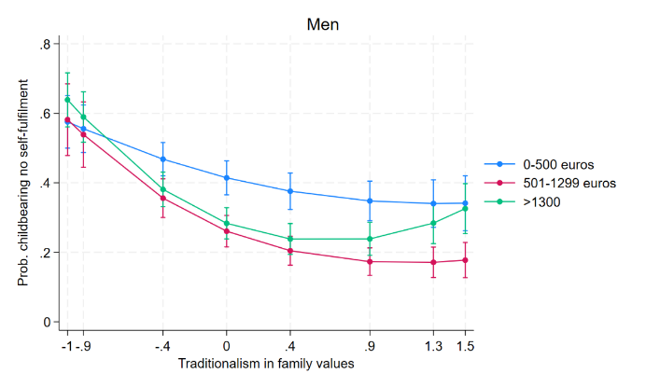
Note: results are from logit model including individual’s level of education, income, employment condition and being in a partnership by gender (Confidence intervals for pair-wise comparisons at the 95% significance level).

Figure 2A. Predicted probabilities of not reporting self-fulfilment motivation to have children in life for childless men and women (25-34 years old) by level of traditionalism in family values and partnership status. Weights applied.
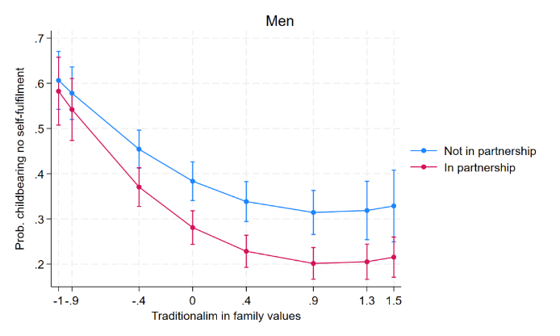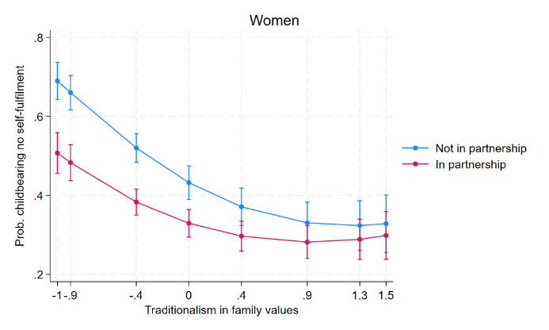
Note: results are from logit model including individual’s level of education, income, employment condition and being in a partnership by gender (Confidence intervals for pair-wise comparisons at the 95% significance level)

Figure 3A. Predicted probabilities of not reporting self-fulfilment motivation to have children in life for childless men and women (25-34 years old) by level of traditionalism in gender roles and employment condition. Weights applied.
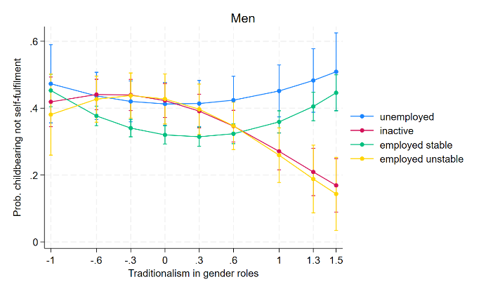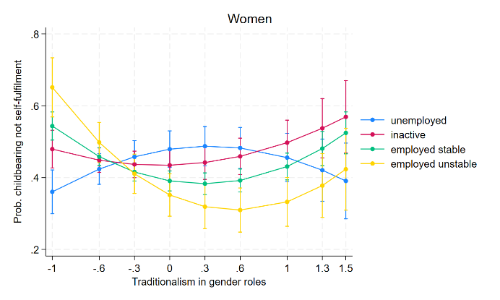
Note: results are from logit model including individual’s level of education, income, employment condition and being in a partnership by gender (Confidence intervals for pair-wise comparisons at the 95% significance level)
Figure 4A. Predicted probabilities of not reporting self-fulfilment motivation to have children in life for childless men and women (25-34 years old) by level of traditionalism in gender roles and income level. Weights applied.
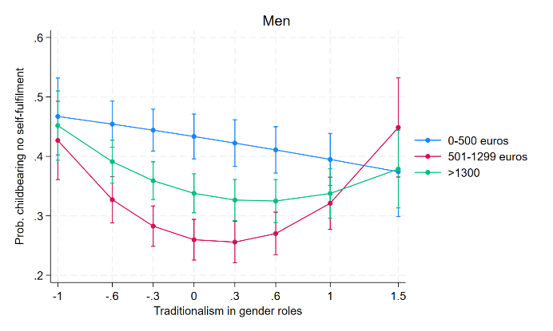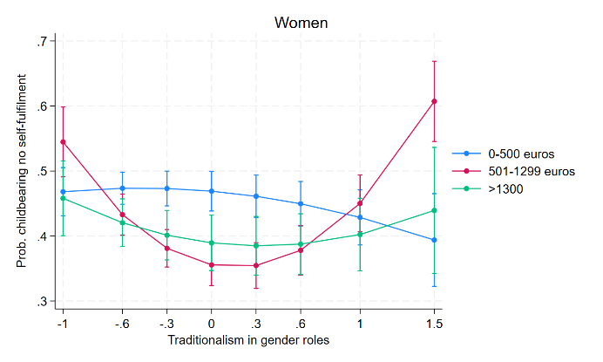

Note: results are from logit model including individual’s level of education, income, employment condition and being in a partnership by gender (Confidence intervals for pair-wise comparisons at the 95% significance level)

