EXPERIMENTAL SECTION
All samples were stored properly until analyzed. Deuterated solvents, DMSO-d₆ (99.9 atom % D), methanol-d₄ (99.9 atom % D), chloroform-d (99.9 atom % D), and D₂O (99.8 atom % D) were obtained from Cambridge Isotope Laboratories Inc. (Andover, MA, USA). The analytes were prepared at temperatures between 15°C and 30°C and at 20% to 60% relative humidity. The weighed amounts of sample were at least twice the minimum weight of the ultra-micro balance (Mettler Toledo, Columbus, OH, USA) used (not less than 4 mg). Analytes were weighed directly into a tared vial, diluted with the appropriate solvent, capped, and vortexed until full dissolution could be visually confirmed. All NMR measurements were acquired on a Bruker Ascend-400 (Bruker Corporation, Billerica, MA), JEOL Eclipse+300 (Tokyo, Japan), Magritek Spinsolve 80 (Malvern, PA, USA), and/or Magritek Spinsolve 60 (Malvern, PA, USA) spectrometers in 5 mm NMR tubes (Norell, Landisville, NJ, USA), using standard pulse sequences. The samples were dissolved in 600 μL of neat NMR solvent or NMR solvent mixture dispensed by an analytical syringe (Valco Instruments, Baton Rouge, LA, USA). The acquired spectra were processed using Mestrenova (Ver 12.0.3 and 14.3.0).
Acquisition of ¹H NMR spectra was as follows: 8 scans (NS), 5.45 s acquisition time (AQ), collecting 64k of time domain (TD) data, 90° excitation pulse (zg), and a relaxation time (D1) of 60 s or 90 s. For data processing, line resolution was improved by applying a Lorentzian window function (LB, 0.3) and four times zero-filling prior to Fourier transformation of the free induction decay (FID). Baseline correction using a fifth-order polynomial function and phase correction was performed manually.

SI-1 Case Study of Ibuprofen – Digital Reference Spectrum Generation
The ¹H NMR raw data used in the generation of ibuprofen’s digital Reference Spectrum was obtained in HMDB database. Ibuprofen tablet (First Aid Only, MFR# 90015) was grinded and extracted by chloroform-d. The resulted solutions were measured using different NMR spectrometers (¹H, 60 MHz, 80 MHz and 300 MHz). Calculated and experimental results can be found in Fig. 3. The experimental spectra were acquired using D1 60 s.
All ¹H NMR parameters (chemical shifts and J-coupling values) were manually measured using MestReNova software (Ver 12.0.3, Mestrelab, Spain). Predicted NMR parameters (SI Fig. 1.1 and SI Table 1.1) were calibrated using experimental spectrum (SI Fig. 1.2) and all computed values of ibuprofen’s digital Reference Spectrum were presented in SI Table 1.2.
To investigate the similarity of calculated and experimental spectra, the ibuprofen digital Reference Spectrum and a USP reference standard were used for ¹H, 400 MHz qNMR test. The similarity was measured by ChemAdder software and R² value was 99.99% and RMSE value equaled to 0.024, as shown in the SI Fig. 1.3. The difference between experimental and calculated spectra was presented as a residual spectrum. For example, the solvent signal pattern was clearly presented in the residual spectrum.
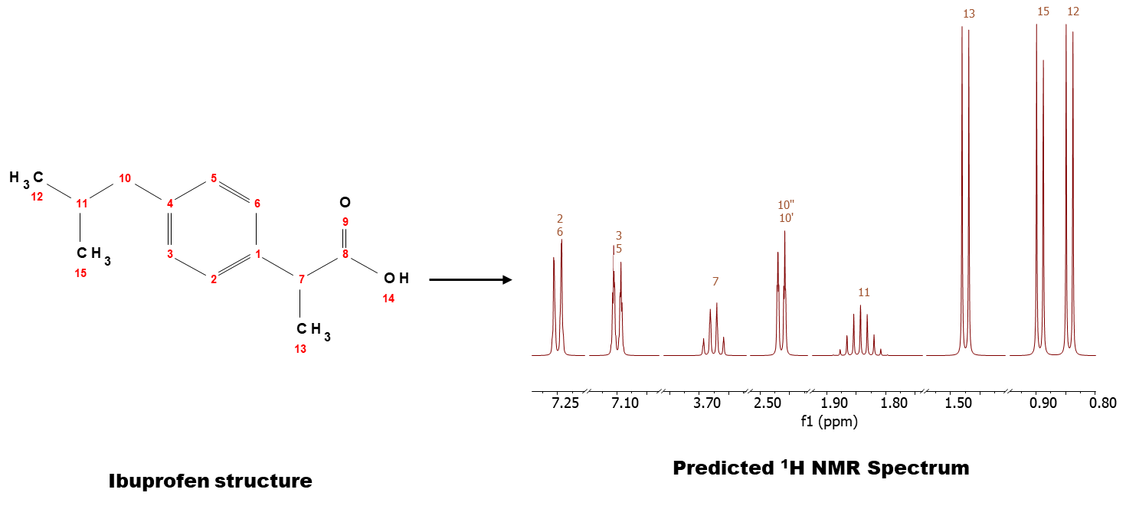
SI Fig. 1.1 ¹H NMR predicted spectrum, using structure information and simulation feature in MestReNova software.

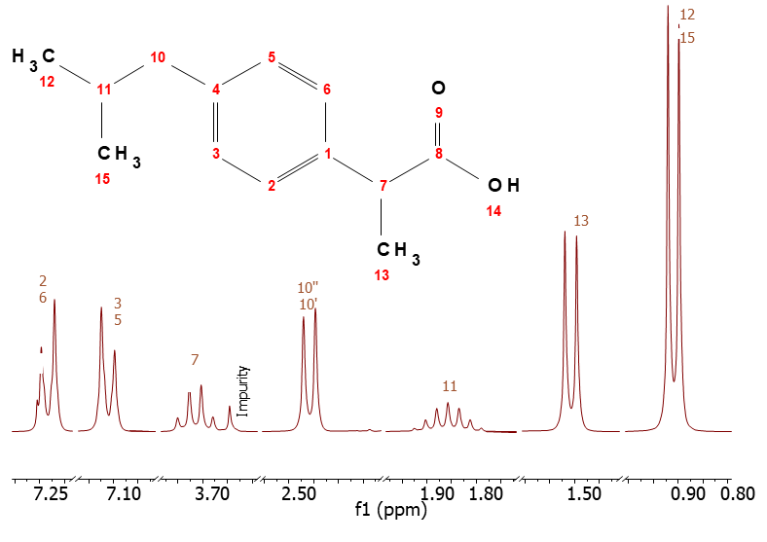
SI Fig. 1.2 ¹H NMR spectrum (CDCl₃, 300 MHz) of the ibuprofen with signal assignment, referring to the article, Mizrahi, B., Domb, A.J. Anhydride Prodrug of Ibuprofen and Acrylic Polymers. AAPS PharmSciTech 10, 453–458 (2009).

SI Fig. 1.3 Stack of ibuprofen ¹H NMR spectrum (CDCl₃, 400 MHz). Calculated spectrum was in red; experimental spectrum presented in blue, and residual spectrum (i.e., the difference between calculated and experimental spectra) exhibited in green.

SI Table 1.1. ¹H NMR Predicted NMR Parameters of Ibuprofen
Atom assignment | Chemical shift (ppm) | J –coupling (Hz)
2 CH | 7.25 | J(2-3) | 7.50
2 CH | 7.25 | J(2-6) | 1.50
2 CH | 7.25 | J(2-5) | 0.10
2 CH | 7.25 | J(2-7) | 0.62
3 CH | 7.1 | J(3-10') | 1.00
3 CH | 7.1 | J(3-10'') | 1.00
3 CH | 7.1 | J(3-2) | 7.50
3 CH | 7.1 | J(3-6) | 0.10
3 CH | 7.1 | J(3-5) | 1.50
5 CH | 7.1 | J(5-10') | 1.00
5 CH | 7.1 | J(5-10'') | 1.00
5 CH | 7.1 | J(5-3) | 1.50
5 CH | 7.1 | J(5-2) | 0.10
5 CH | 7.1 | J(5-6) | 7.50
6 CH | 7.25 | J(6-3) | 0.10
6 CH | 7.25 | J(6-2) | 1.50
6 CH | 7.25 | J(6-5) | 7.50
6 CH | 7.25 | J(6-7) | 0.62
7 CH | 3.68 | J(7-2) | 0.62
7 CH | 3.68 | J(7-6) | 0.62
7 CH | 3.68 | J(7-13) | 6.80
10a CH2 | 2.46 | J(10a-11) | 7.00
10a CH2 | 2.46 | J(10a-10b) | 13.14
10a CH2 | 2.46 | J(10a-3) | 1.00
10a CH2 | 2.46 | J(10a-5) | 1.00
10b CH2 | 2.46 | J(10b-11) | 7.00
10b CH2 | 2.46 | J(10b-10') | 13.14
10b CH2 | 2.46 | J(10b-3) | 1.00
10b CH2 | 2.46 | J(1b'-5) | 1.00
11 CH | 1.84 | J(11-12) | 6.80
11 CH | 1.84 | J(11-15) | 6.80
11 CH | 1.84 | J(11-10a) | 7.00
11 CH | 1.84 | J(11-10b) | 7.00
12 CH3 | 0.84 | J(12) | 6.98
12 CH3 | 0.84 | J(12-11) | 6.80
13 CH3 | 1.47 | J(13-7) | 6.80
13 CH3 | 1.47 | J(13) | 7.70
15 CH3 | 0.89 | J(15-11) | 6.80
15 CH3 | 0.89 | J(15) | 6.98

SI Table 1.2. ¹H NMR Computed NMR Parameters in Ibuprofen digital Reference Spectrum
Atom assignment | Chemical shift (ppm) | J –coupling (Hz)
2 CH | 7.25 | J(2-3) | 7.50
2 CH | 7.25 | J(2-6) | 0.50
2 CH | 7.25 | J(2-5) | 1.50
2 CH | 7.25 | J(2-7) | 0.62
3 CH | 7.19 | J(3-5) | 1.50
3 CH | 7.19 | J(3-2) | 7.50
3 CH | 7.19 | J(3-6) | 0.50
5 CH | 7.19 | J(5-3) | 1.50
5 CH | 7.19 | J(5-2) | 0.50
5 CH | 7.19 | J(5-6) | 7.50
6 CH | 7.25 | J(6-3) | 0.50
6 CH | 7.25 | J(6-5) | 7.50
6 CH | 7.25 | J(6-2) | 1.50
6 CH | 7.25 | J(6-7) | 0.62
7 CH | 3.68 | J(7-13) | 6.80
7 CH | 3.68 | J(7-2) | 0.62
7 CH | 3.68 | J(7-6) | 0.62
10a CH₂ | 2.49 | J(10a-10b) | -12.40
10a CH₂ | 2.49 | J(10a-11) | 7.00
10b CH₂ | 2.44 | J(10b-10a) | -12.40
10b CH₂ | 2.44 | J(10b-11) | 7.00
11 CH | 1.84 | J(11-12) | 6.80
11 CH | 1.84 | J(11-15) | 6.80
11 CH | 1.84 | J(11-10a) | 7.00
11 CH | 1.84 | J(11-10b) | 7.00
12 CH₃ | 0.87 | J(12) | 6.98
12 CH₃ | 0.87 | J(12-11) | 6.80
13 CH₃ | 1.42 | J(13-7) | 6.80
13 CH₃ | 1.42 | J(13) | 7.70
15 CH₃ | 0.87 | J(15-11) | 6.80
15 CH₃ | 0.87 | J(15) | 6.98
Note: These data can be saved in XML format file, as ibuprofen digital Reference Spectrum.

SI-2 Quantitative Analysis of Amino Acid Mixture
L-serine (Lot No. PHR1103), leucine (Lot No. PHR1105), and isoleucine (Lot No. PHR1099) were obtained from Sigma-Aldrich (St. Louis, MI, USA). The amino acid solution was prepared by mass ratio of serine: leucine: isoleucine, as 20.0 mg: 19.8 mg: 16.1 mg, and then measured using an NMR spectrometer (¹H, 400 MHz). The D1 of 60 s was used to acquire the experimental spectra.
Using USP-ID, the components in the amino acids were identified. Both experimental and calculated spectra are presented in SI Fig. 2.1. The match scores (%)/R² values (%) for serine, leucine, and isoleucine were 99.71/0.03, 99.83/0.16, 99.58/0.119, respectively. The molar ratio of serine: leucine: isoleucine was 41.2:32.3: 26.5, aligning with the measured mass ratio, mentioned above. Accordingly, this study demonstrated that independent calculation of each digital Reference Spectrum allows for calculated spectra to be additive and to achieve both qualitative and quantitative analysis.

SI Fig. 2.1 Comparison of the calculated ¹H spectrum (A) of amino acid mixture, including serine (B), leucine (C), and isoleucine (D), and experimental ¹H spectrum (E) at 400 MHz. The amino acid mixture was dissolved in D₂O.

SI-3 Robustness Study on Quantitative Analysis of Histidine
Histidine (Lot No. SLCP9576) was obtained from Sigma-Aldrich (St. Louis, MI, USA). A modified solution stability test using histidine was adopted in this study to validate the reliability of the developed method under normal usage conditions. The test involved preparing and analyzing one standard histidine solution each day over an 8-day period. The experimental spectra were acquired using D1 90 s. The criterion for passing the test was that the normalized integral value of the available histidine signals (H_{α}, H_{β}, H_{δ}, and H_{ε} in SI Fig. 3.1) measured under the defined standard conditions must not deviate by more than 2% from the normalized integral values recorded under the standard conditions. This demonstrated the method's ability to produce consistent results over time, accounting for typical variations in sample preparation.
Using the quantitation strategy of the proposed model, the variation across the 8 dataset groups was >2%. To investigate the source of this uncertainty, the integral values for each histidine signal (SI Table 3.1) were examined. This revealed that the normalized integrals for the H_{ε} signal varied from 1.00 to 0.83 over the 8-day period, an approximately 17% change. This variation may be due to exchange occurring between the H_{ε} on histidine and deuterium (D) from the D₂O solvent. This has been confirmed by dissolving histidine in H₂O, where qNMR data acquired under the same standard conditions every day for 8 days. The results have been presented in SI Table 5.2. The integrals for the H_{ε} signal were against the normalized integrals (1.00) of H_{δ} signal, over the 7-day period.

SI Fig. 3.1 ¹H qNMR spectrum of histidine, under 80 MHz. The signal labels align with the International Union of Pure and Applied Chemistry (IUPAC) assignments.

SI Table 3.1. Integrals of Histidine Signals (H_{α}, H_{β}, H_{δ}, and H_{ε}) on Each Day Over 8-Day Period, Where Sample Was Dissolved in D₂O
 | H_{ε} | H_{δ} | H_{α} | H_{β}
ppm | 7.75 | 7.05 | 3.99 | 3.21
Day-0 | 1.00 | 1.00 | 1.01 | 2.00
Day-1 | 0.96 | 1.00 | 0.99 | 1.97
Day-2 | 0.93 | 1.00 | 1.01 | 1.98
Day-3 | 0.92 | 1.00 | 1.00 | 1.98
Day-4 | 0.90 | 1.00 | 1.00 | 1.99
Day-5 | 0.87 | 1.00 | 1.01 | 1.99
Day-6 | 0.85 | 1.00 | 1.00 | 1.99
Day-7 | 0.83 | 1.00 | 1.00 | 1.99

SI Table 3.2 Integrals of Histidine Signals (H_{α}, H_{β}, H_{δ}, and H_{ε}) on Each Day Over 7-Day Period, Where Sample Was Dissolved in H₂O
 | H_{ε} | H_{δ} | H_{α} | H_{β}
ppm | 7.75 | 7.05 | 3.99 | 3.21
Day-0 | 0.99 | 1.00 | - | -
Day-1 | 0.99 | 1.00 | - | -
Day-2 | 0.99 | 1.00 | - | -
Day-3 | 0.98 | 1.00 | - | -
Day-4 | 0.99 | 1.00 | - | -
Day-5 | 1.00 | 1.00 | - | -
Day-6 | 1.00 | 1.00 | - | -
Note: - indicates that H₂O signal covered with H_{α} and H_{β}, so accurate integral cannot be obtained manually.

SI-4 Case Study of Cough Syrup Spiked with Diethylene Glycol
The known kid’s cough syrup (Lot 3009171911, P&G.) was used for performing the experiment. Small amount of standard diethylene glycol (Lot R147W0, USP.) was used to spike in cough syrup. The ¹H signals from diethylene glycol were underneath the major signal patterns from glycerin and sorbitol, as shown in SI Fig. 4.1. Even though the signals from diethylene glycol was not identified visually, the proposed digital platform successfully identify all the components including diethylene glycol present in syrup sample. The experimental spectra were obtained using D1 of 60 s.

SI Fig. 4.1 ¹H-NMR analysis using Digital Platform interface (USP-ID) for the identification of spiked diethylene glycol in Kid’s cough syrup (Glycerin – Gly, Propylene glycol- Pro, Sorbitol- Sor, Dimethyl sulfone – Dim, Diethylene glycol-Die. (A) Experimental spectrum; (B) Calculated spectrum showing all signal patterns of Gly, Pro, Sor, Dim and Die; (C) Calculated spectrum showing signal patterns of Die.

SI-5 Case Study of Ascorbic acid – Repeatability Test and Linear Test
Ascorbic acid (Lot No. LRAC2886) and dimethyl sulfone (DMSO₂, Lot No. PHR1309) were obtained from Sigma-Aldrich (St. Louis, MI, USA).
In a repeatability test, six solutions of the test item will be prepared and measured in quick succession. Approx. 30 mg of ascorbic acid and 10 mg of the internal standard DMSO₂ were dissolved in 0.8 mL D₂O. The experimental spectra acquisition was performed with D1 for 90 s. The results, in terms of mass fraction (content, %), are provided in SI Table 5.1. To assess the data analyzed by two different software, i.e., Topspin and digital platform, both a t-test and an F-test were conducted, the outcomes of which are detailed in SI Table 5.2. The Topspin represents traditional integral methodology; and the digital product demonstrates automatic QMSA approach.

SI Table 5.1. A Comparative Analysis with Topspin and the Digital Platform
Test item | content (%)/Topspin | content (%)/Digital platform
A | 99.15 | 99.11
B | 99.62 | 99.73
C | 99.60 | 100.07
D | 99.56 | 100.12
E | 99.50 | 99.59
F | 99.26 | 99.39

SI Table 5.2. A Variability Analysis of Topspin and Digital Platform Using t-Test and F-Test
 | Topspin | Digital platform
Mean | 99.45 | 99.67
Variance | 0.038 | 0.153
Observations | 6 | 6
t-Test Results
Statistic | -1.2320
p-value | 0.2461
F-Test Results
Statistic | 0.2513
p-value | 0.0779

Linearity has been validated across the method's specified range. This was demonstrated by preparing 6 solutions of the test item, each with varying test item weights, and subsequently measuring them. The test samples (refer to SI Table 5.3 for approximate weights) were dissolved in 0.8 mL of D₂O, along with 10 mg of the internal standard (DMSO₂). To assess linearity, linear regression on the calibration curve was conducted (SI Figure 5.1), determining both the intercept and the slope, as well as calculating the correlation coefficient (R) or coefficient of determination (R²). The data analyzed using the digital platform yielded a linear equation of y = 0.9995x (R² = 1).

SI Table 5.3. Test Item Weights for Linearity Solution Preparations and its Linearity Results Obtained via TopSpin and the Digital Platform
No. | Test item weight (mg) | Topspin  (mg) | Digital platform (mg)
1 | 0 | 0 | 0
2 | 21.02 | 20.73 | 20.96
3 | 24.03 | 24.02 | 24.29
4 | 30.01 | 29.99 | 30.13
5 | 36.10 | 35.69 | 35.90
6 | 39.13 | 39.06 | 38.92

SI Fig. 5.1 Linearity results obtained through TopSpin software and digital platform.

