FDA's Implementation of Knowledge-Aided Assessment and Structured Application for Manufacturing Assessment of Non-Sterile Solid Oral Dosage Form Drug Products
Zhouxi Wang, Jingbo Xiao, Daniel Obrzut, Stelios Tsinontides and Rakhi Shah
Office of Pharmaceutical Quality, Center for Drug Evaluation and Research, U.S. Food and Drug Administration, 10903 New Hampshire Ave, Silver Spring, MD, 20993, USA

Abstract
The Knowledge-Aided Assessment and Structured Application (KASA) is an initiative led by the FDA’s Center for Drug Evaluation and Research (CDER) which is launched within CDER’s Office of Pharmaceutical Quality (OPQ). It is a platform designed to conduct the quality assessment of drug product applications more efficiently, effectively, and consistently, promoting OPQ’s “One Quality Voice”. KASA is part of CDER’s broader efforts to support the digital transformation of application submission, assessment, and lifecycle knowledge management for Chemistry, Manufacturing, and Controls (CMC) data. KASA supports CDER’s Office of Pharmaceutical Manufacturing Assessment (OPMA)’s mission which is to assure that quality pharmaceuticals are consistently manufactured over the product lifecycle. This paper provides insights into the OPMA’s implementation of manufacturing section for non-sterile solid oral dosage form (SODF) drug products, covering both manufacturing process and facility aspects, within the KASA platform for Abbreviated New Drug Applications (ANDAs). We provide details how key features of KASA, such as structured applications and knowledge-aided tools, enable manufacturing assessors to perform assessment using scientific and risk-based approaches, and promote lifecycle knowledge management. Additionally, we highlight the quantitative risk models embedded in the KASA manufacturing section for non-sterile SODF drug products, which generate initial risks related to manufacturing process and facility in terms of drug product quality. The paper also describes the risk control strategies implemented within the KASA framework. As of September 2024, over 1,130 manufacturing assessments of original ANDAs for non-sterile SODF drug products have been completed with at least the first review cycle, using the KASA platform since its launch in February 2021. This demonstrates the success of implementation of KASA in OPMA’s manufacturing assessment in support of OPQ’s regulatory assessments.

Keywords
KASA, Manufacturing, Quality Assessment, Non-Sterile Solid Oral Dosage Form, Lifecycle Knowledge Management, Risk Assessment

Introduction
Knowledge-Aided Assessment and Structured Application (KASA) is an FDA wide initiative led by the FDA’s Center for Drug Evaluation and Research (CDER), which was launched in OPQ in February 2021 for SODF drug products for ANDAs. KASA platform is a system designed to help FDA assessors to conduct quality assessment for drug applications. KASA improves regulatory assessment by incorporating structured data, lifecycle knowledge management, and advanced data analytical tools.
The need for the KASA platform stems from both external and internal challenges faced by OPQ (Yu, et al, 2019). Externally, there is an increasing volume of submissions and higher expectations of review process efficiency under the user fee programs. OPQ reviews approximately 1,000 original applications which include New Drug Applications (NDAs), Abbreviated New Drug Applications (ANDAs), and Biologics License Applications (BLAs) each year (Tran, et al, 2024). The growing complexity and volume of applications, along with thousands of Investigational New Drug (IND) applications and post-approval submissions per year, present significant challenges to the review process (Tran, et al, 2024). Additionally, the widespread use of unstructured data, such as narrative-based submissions, hampers data analysis and management and limits efficiency and improvements. Without the use of KASA, the quality assessment process is dependent on the reliance on freestyle narratives, unguided risk assessments, unstructured text and application assessment summaries. This reduces efficiency and consistency in assessment and decision-making, while also complicating lifecycle knowledge management (Rosencrance, et al, 2019, Raw, 2022, Chia, 2021, Welch, 2021).
The FDA has initiated several internal and external projects to streamline pharmaceutical quality information submissions, reviews, and lifecycle knowledge management (Tran, et al, 2024). These initiatives include but are not limited to the ICH M4Q(R2) Common Technical Document for Quality Guideline (ICH, 2021a, ICH, 2021b), ICH Q12 Lifecycle Management, the Knowledge-aided Assessment and Structured Application (KASA), the Quality Surveillance Dashboard (QSD), and the Pharmaceutical Quality/Chemistry, Manufacturing, and Controls (PQ/CMC) for CMC data element submissions and data exchange standards (FDA, 2024a). Notably, KASA has already been successfully implemented and is being routinely used as OPQ’s review platform for non-sterile solid oral dosage form (SODF) ANDAs. This includes assessment from multiple quality disciplines such as drug substance, drug product, manufacturing, and biopharmaceuticals.
The Office of Pharmaceutical Manufacturing Assessment (OPMA), part of CDER’s Office of Pharmaceutical Quality (OPQ), assures that quality pharmaceuticals are consistently manufactured over the product lifecycle. It provides the assessment of the proposed manufacturing process and facilities at commercial scale for CDER regulated products. The first KASA prototype of the manufacturing section was developed in-house in 2019 for non-sterile SODF ANDA’s for OPMA office. Multiple versions and improvements were made for the manufacturing section, and pilot tested throughout 2019-2020. In 2021, the FDA transferred the KASA manufacturing section for non-sterile SODF ANDAs to the cloud where the data are stored on FDA servers within a Federal Information Security Management Act (FISMA) high security environment, ensuring the strictest level of protection. The KASA manufacturing section was officially launched for routine assessment of non-sterile SODF ANDAs in February 2021.
Since the publication of the KASA white paper in 2019 (Yu, et al, 2019), which provided the vision of the concept of the KASA platform, there has been limited detailed exploration in the literature regarding its implementation, particularly in the manufacturing section of the KASA platform. This paper presents our perspective on the FDA’s implementation of the KASA manufacturing section for non-sterile SODF ANDAs as well as an up-to-date status of its use in the OPMA's review workflow. We provide detailed insights into the implementation of KASA manufacturing section in the OPMA office, specifically applied to non-sterile SODF ANDAs. Additionally, we summarize KASA’s features as a platform for conducting structured application assessment for manufacturing. We present the models used for facility and manufacturing initial risk assessments, discuss the practical risk control workflow, and provide case studies.

2. Current implementation

2.1. Features as a structured application assessment tool

KASA is a structured application assessment tool organized into hierarchical modules and sub-modules. Structured descriptors are extensively used in KASA to document required information concisely and minimize extensive narrative details. Both submission information and assessment information then are organized into structured data for further data management, including but not limited to data storage and tracking, data analysis, and data visualization.

2.1.1 Modules and sub-modules
KASA is aligned with the current Integrated Quality Assessment (IQA) assessment practices. For a typical SODF ANDA, a multidisciplinary assessment team within the OPQ works across multiple quality disciplines, such as drug substance, drug product, biopharmaceutics, and drug product manufacturing, based on the expertise of each OPQ sub-office. A similar methodology is followed for assessment of CMC information of NDAs, ANDAs or BLAs for original or supplemental applications. For ANDAs, each quality discipline has a separate assessment template within KASA platform.
The structure of the OPMA’s manufacturing section in KASA for non-sterile SODF ANDAs follows a top-down hierarchy, consisting of modules and sub-modules as shown in Figure 1. Seven main modules are included: Overview, Facilities Assessment, Manufacturing Risk Assessment, Unit Operations, Microbial Assessment, Other Considerations, and Assessment Summary. The Overview, Facilities Assessment, Manufacturing Risk Assessment, and Unit Operations modules contain additional sub-modules. Each module and sub-module are used to document and assess specific portions of the ANDA submission.

2.1.1.1. Overview module
The Overview module consists of two sub-modules. The Overview sub-module captures basic information such as the ANDA number, drug substance name, strength, drug product, and a list of facilities with their respective responsibilities. The Consults sub-module documents any consultations with other disciplines, when applicable.

2.1.1.2. Facilities Assessment module
The Facilities Assessment module is categorized into four sub-modules according to each facility’s commercial responsibilities: drug product manufacturer, drug substance manufacturer, commercial testing, and primary packaging. Drug substance intermediate manufacturers are grouped with drug substance manufacturers, while drug product intermediate manufacturers are categorized with drug product manufacturers. Facilities are automatically sorted into these sub-modules according to Profile Class Codes (FDA, 2024b) which are based on the assessor’s screening of facility responsibilities.
For each facility grouped into a sub-module, the preloaded information includes general details from the submission, along with multiple links for retrieving real-time facility status data, as the status of each facility is subject to changes from activities across FDA’s different centers. This data includes supply chain information, facility compliance status, scheduled and ongoing inspections, recalls, compliance alerts, partner agency inspections, and internal cross-center comments.
After reviewing the information provided through KASA sub-module pages, the assessor conducts the initial risk assessment by selecting structured descriptors in drop-down menus. The system then automatically calculates the initial risk score based on the drop-down selections, which cover facility history and information from the submission. Based on the facility’s responsibilities and the initial risk assessment, along with the auto-calculated risk score, the assessor provides an initial recommendation for the facility, such as whether a pre-approval inspection (PAI) (FDA, 2022) or remote regulatory assessment (RRA) (FDA, 2024c) is needed. The KASA platform then automatically inserts the necessary documentation sections based on this recommendation, such as PAI or RRA assessment sections if applicable. All information requests and responses throughout the assessment cycles are documented in KASA. This allows assessor to view all historical data on the information requests, responses and then makes a final recommendation on each facility based on a holistic assessment. If a PAI or RRA is determined to be unnecessary, a facility recommendation of either approve or withhold is made based on existing inspection history and other available facility information.

2.1.1.3. Manufacturing Risk Assessment module
The Manufacturing Risk Assessment module includes five sub-modules and covers drug product design, drug substance attributes, batch formula, manufacturing process, and initial risk assessment. These five sub-modules work together comprehensively to bridge the risks and risk mitigations for drug product manufacturing by addressing critical aspects of the manufacturing process and facilities.
- Drug product design sub-module
In the drug product design sub-module, the assessor primarily uses drop-down menus to input drug design information, such as configuration and release mechanism, handling of special drug products, and flagging unique situations for further assessment. The release mechanism, particularly for modified-release formulations, can also be selected. Special drug product designs such as chewable or orally disintegrating tablets are captured within this section. Unique situations, such as continuous manufacturing, atypical manufacturing, established conditions, and process analytical technologies used during manufacturing can also be covered as part of ANDA manufacturing assessment.
- Drug substance attributes sub-module
This sub-module is used to gather information of the drug loads for each active pharmaceutical ingredient (API) in every strength, solubility of API, and overall drug product release types. Additionally, the assessor documents and assesses drug substance (DS) properties impacting manufacturability of drug product, such as hygroscopicity, pH sensitivity, thermal stability, and polymorphism, etc. Each DS is documented distinctly within the sub-module.

- Batch formula sub-module
The assessor documents and evaluates the various batch formulas and batch sizes, including exhibit batches and the proposed future commercial batches. The scale-up factor from the exhibit or executed batches to the commercial batches for each drug product strength is automatically calculated. This will ensure that relevant information is properly linked in the submission to avoid unnecessary repetition.

- Manufacturing process sub-module
In this sub-module, the assessor documents and assesses the manufacturing flow diagram at a high level. The assessor reviews the manufacturing flow diagram to ensure that major unit operations align with the process described in the submission and that the diagram accurately reflects input materials and in-process controls (IPCs) for each unit operation. The high-level description orients assessors before the in-depth assessment documented in unit operation sub-modules.

- Initial risk assessment sub-module
An initial risk assessment of each step in the manufacturing process is performed in this sub-module. The assessor constructs the unit operation chain according to the submission information and assesses the initial risk for each unit operation. Each Critical Quality Attribute (CQA) that may be affected by a unit operation is assessed individually. A quantitative Failure Mode and Effect Analysis (FMEA) is performed for each unit operation, considering product properties, manufacturing process, and facility risks. Additionally, this sub-module includes an initial risk-based assessment of microbial risks.

2.1.1.4. Unit Operations module
The sub-modules under Unit Operation module are tailored to allow a thorough assessment of specific unit operations for each individual ANDA. This sub-module includes assessment of in-process controls (IPCs), process parameters, development data, and scale up for individual unit operations. The unit operations will automatically be generated based on the selection of unit operations in the initial risk assessment sub-module under the Manufacturing Risk Assessment module described above in section 2.1.1.3 e. The sub-modules for selected unit operations are named according to the corresponding unit operation and organized in the same order as the initial risk assessment for unit operations.

2.1.1.5. Microbial Assessment module
Microbiological evaluation of non-sterile SODF drug products follows an efficient, risk-based approach. The depth of evaluation is guided by the risk score obtained from initial risk assessment sub-module described above in section 2.1.1.3 e. The assessor uses a smart template where a decision tree function is built based on internal assessment practices to perform a structured assessment commensurate with the drug product risk.

2.1.1.6. Other Considerations module
In this module, an assessor documents and assesses holistic aspects that may not be fully addressed when assessing individual unit operations modules, providing an opportunity to assess topics from another perspective that considers their impact across the entire unit operation chain. Some examples may include batch yield and reconciliation, hold times, and any executed batch records or master batch records issues, etc.

2.1.1.7. Assessment Summary module
This module is used to document assessment recommendations, discipline executive summary, key issues from the last review cycle and resolution, and a concise description of any outstanding issues. Additionally, updated risks for each unit operation including any residual risk with relevant justification is auto populated in this module from all the prior modules to give assessors an overview of the overall risk mitigation strategies proposed in the submission.

2.1.2 Structured descriptor
Within the KASA modules and sub-modules, structured descriptors are widely used to document submission information from drug product applications. Figure 2 illustrates examples of structured descriptors in a lubrication unit operation. The unit operation information is systematically organized using structured descriptors, categorizing data by the type of unit operation (e.g., lubrication) and equipment type (e.g., diffusion mixer). Proposed process parameters, in-process controls (IPCs), sampling plans, and acceptance criteria are detailed as structured data, accompanied by relevant comments and links to source information from applications.
To streamline and eliminate the narrative style traditionally used in assessment practices, the KASA platform now requires assessors to input key information using controlled vocabularies from structured descriptor through the drop-down options where applicable. For instance, specific unit operations may have predefined IPCs and process parameters available. Table 1 shows two commonly used unit operations, i.e., blending and compression, along with the corresponding controlled vocabularies used for IPCs. For blending unit operation, commonly assessed IPCs include assay, blend uniformity, etc. For compression unit operation, the IPCs may include tablet appearance, individual and group/average tablet weight, tablet hardness, friability, etc. Also, in each of these structured vocabularies, there is an option of manual entry by assessors where the assessor can select “other” and use this option to enter the information which doesn’t appear in the drop-down menu selections. This gives flexibility where some unique information is available in applications and for which no drop-down selections are available. This approach ensures consistent terminology and a standardized level of granularity when documenting key information, which helps to harmonize assessments. It is anticipated that a significant portion of descriptors capturing information from submissions could potentially be preloaded in the future by connecting initiatives, such as PQ/CMC that will be with the required submission information and data elements (FDA, 2024a, FDA, 2023a) and the Structured Product Quality Submission (SPQS) effort undertaken in ICH.
To ensure a thorough and comprehensive assessment, evaluations on the KASA platform have been validated to confirm the completeness of information within the modules, sub-modules, and required structure descriptors. This approach helps maintain consistency in terminology, content, and granularity in assessment practices among different assessors and enhance transparency and communication.

2.2 Key features as the knowledge-aided assessment
The current manufacturing section of KASA platform for non-sterile SODF ANDAs includes numerous knowledge-aided features. In the following section, we provide the detailed descriptions of some key features, such as (1) drop-down menus to assist assessors in conducting assessments, (2) a built-in decision tree to guide the assessment process and generate template language for information requests (IRs), (3) links to multiple databases, (4) an integrated initial risk model for manufacturing process and facilities, and (5) automatic validation.

2.2.1 Drop-down menus

Drop-down menus in KASA have been developed to provide knowledge-aided information that guides assessors during the evaluation process. These drop-down options serve multiple knowledge-aided functions, including but not limited to:

Incorporating controlled vocabulary for input submission information

Assisting with risk assessment and risk control strategies

Categorizing deficiencies

In the current manufacturing section of KASA platform for non-sterile SODF ANDAs, drop-down options are used to control the vocabulary for inputting submission information into the structured data, as mentioned in section 2.1.2. The drop-down options also provide suggestions for analyzing the factors that impact manufacturing. For example, in the drug substance attributes sub-module, a list of drop-down options helps assessors conduct a thorough analysis of drug substance properties that may impact the manufacturing of the drug product. These properties include hygroscopicity, pH sensitivity, thermal stability, polymorphism, particle size distribution, flowability, dissolution rate, and oxidation sensitivity, etc. In addition to evaluating the potential impact of drug substance attributes and drug product design on manufacturing, drop-down options suggest risk control strategies for batch formulas, manufacturing processes, and specific unit operations. When recommending risk control strategies for unit operations, these drop-down options are automatically tailored to each unit operation. Table 2 provides examples of drop-down menus used to assess unit operations, i.e., blending and compression, which document risk mitigation strategies based on specific considerations of the unit operation, development studies, and potential scale-up proposals. Furthermore, the drop-down options help categorize deficiencies identified and assist in analyzing issues related to specific drug products or manufacturing processes over multiple assessment cycles.

2.2.2 Built-in decision tree
One of the knowledge-aided features includes built-in decision trees to support assessment processes. For instance, embedded decision trees guide assessors through the necessary steps to assess the adequacy of microbial controls during manufacturing and in the finished non-sterile SODF drug products. These microbial control decision trees follow a risk-based approach. For microbial risk assessment, a decision tree is used with an overarching question regarding microbial specifications for drug product at release and on stability and then dwells into other detailed assessment based on risk factors such as formulation details, raw material specifications for drug substance and excipients, and stability results. Each step is automatically recorded. The system flags concerns and automatically generates boilerplate language developed internally by microbial subject experts for an information request, which is subsequently reviewed and modified as necessary by the assessors, minimizing the need for extensive editing.

2.2.3 Links for integrated databases
KASA provides real-time access to multiple databases, enabling assessors to quickly retrieve up-to-date information with just a few clicks. During facility assessments, assessors can access comprehensive data from various FDA centered databases, including supply chain details, current Good Manufacturing Practice (cGMP) compliance history of facilities, and inspection results.

2.2.4 Quantitative models for initial risk assessment

A key pillar of KASA is applying predefined rules and algorithms to estimate initial risks for drug product quality (Yu, et al, 2019). The current manufacturing section of KASA platform for non-sterile SODF ANDAs has embedded two quantitative risk models: facility model and manufacturing model as described in sections 2.1.1.2 and 2.1.1.3. Both risk models are based on Failure Modes and Effects Analysis (FMEA) approach, which evaluates potential failure modes, their causes, and the effects on the system. The FMEA approach starts by identifying failure modes and quantifying the associated risks using the Risk Priority Number (RPN), which is calculated by multiplying the severity, occurrence, and detection ratings. The quantitative ratings for severity, occurrence, and detection, along with any quantitative modifications to these ratings, are determined based on available system data and inputs from OPMA’s subject matter experts.

2.2.5 Automatic validation
KASA includes automated validation features designed to ensure that all internally required sections within each module and sub-module are completed before the primary assessor can submit the assessment to the secondary assessor. These features also verify that all communications between assessors are fully addressed and resolved before assessment finalization. These features promote completeness and thoroughness in the assessment process.

3. Risk model discussion

3.1 Facility initial risk assessment model
For a facility risk model, the risk scoring system is implemented to reflect each facility's responsibilities and associated risk categories and factors. A typical commercial drug product manufacturing facility, given its more complex operations compared to a physical chemistry testing lab, is evaluated using a broader range of factors. These may include process experience, quality oversight, quality defect signals, data integrity concerns, and other potential risk contributors.
Process experience refers to the facility's experience with the type of manufacturing, as informed from inspections. This factor includes whether the facility is engaged in similar unit operations or changing to a more complex or novel process. Facilities with no prior inspection history or undergoing significant process changes may likely have a higher risk and need additional scrutiny.
Quality oversight takes into account the facility's compliance history, including whether the facility has received Form FDA 483 observations, whether the relevant 483 observations could impact manufacturing of the proposed drug product, and whether the responses and Corrective Actions and Preventive Actions (CAPAs) have been adequate to address the relevant 483 observations.
Quality defect signal refers to recent Field Alert Reports (FARs) or product recalls from the facility, which is covered under cGMP. This factor assesses the relevance of these signals to the proposed drug product and whether sufficient CAPAs have been implemented to adequately address the risk from the FARs or recalls.
Data integrity concerns involve assessing the accuracy, completeness, and consistency of data related to a facility. Data integrity is a key aspect of cGMP (FDA, 2016).
Other potential risk factors may include unique risks such as facilities resuming operations, those with special environmental concerns, or those involved in particularly complex processing steps. Facilities with potential cross-contamination risks are also considered in the risk assessment model.
Based on a matrix developed internally for these factors, evaluating the probability of occurrence, severity, and detectability, the overall risk score for a facility is calculated.

3.2 Facility risk control
We demonstrate the strategy for using the risk model to assess a facility’s initial risk, as shown in Figure 3. The assessor evaluates the ability of the proposed facility to execute the proposed manufacturing process in the pending applications using a wide range of factors, including prior experience and capabilities across various dosage forms, cGMP compliance history (e.g., inspection classifications, 483 observations, CAPAs, defect signals, data integrity), and control strategies for previously approved drug products.
For some facilities, a pre-approval inspection (PAI) may be required to address a knowledge gap in the information available at the agency. The inspection serves multiple objectives: confirming the facility's readiness for commercial manufacturing, ensuring compliance with the application, conducting data integrity audits, and verifying the facility's commitment to quality in pharmaceutical development (FDA, 2022).
The FDA also uses other tools to mitigate facility risks. Mutual Recognition Agreements (MRAs) with foreign regulatory authorities allow assessors to utilize inspection data/reports from other international regulatory authorities to mitigate risk. Additionally, Remote Regulatory Assessments (RRAs) enable the FDA to remotely evaluate compliance and overall facility readiness of establishments which manufacture FDA regulated products when appropriate (FDA, 2024c).
FDA may utilize post-approval inspections (PoAIs) to mitigate residual risks associated with the facility after approval of an application. Facilities having residual facility risks without application specific concerns may be deferred to routine surveillance inspections.

3.3 Manufacturing initial risk assessment for a unit operation
The initial manufacturing risk score for a unit operation is determined by factors derived from the product, process, and facility. Due to the complexities of manufacturing supply chains, the variety of drug product strengths, and the numerous unit operations involved in drug production, it is crucial to incorporate flexibility into the model to address these variables. To ensure that all relevant factors are considered without unnecessarily enumerating every possible combination in drug manufacturing lines, the manufacturing risk model was developed with (1) general questions based on a manufacturing strategy, and (2) specific questions for each unit operation (see Figure 4).
At the beginning of the initial manufacturing risk assessment, a variable is created to represent scenarios of facilities, drug substance(s), strength(s), and a drug component release mechanism. Depending on the complexity, either a single variable or multiple variables may be needed to represent the manufacturing process. A general risk score is calculated for each variable.
Once a variable is set and a general risk score is calculated, all relevant unit operations for each scenario should be selected. Assessors are presented with a series of specific questions related to each unit operation. The answers to these questions are used to calculate the initial manufacturing risk score for each impacted CQA of the drug product in every selected unit operation, using the FMEA approach. The risk scores are determined based on the severity, occurrence, and detectability of the scenario and the specific factors of each unit operation. For each unit operation, multiple CQAs risks may be calculated. The overall initial manufacturing risk score for a unit operation is determined using all of the CQA risk scores.
Figure 5 shows the manufacturing initial risk score calculation for the potential impact of the functional spray coating operation on dissolution, a CQA of the drug product. Various factors, such as the type of coating, attributes of the drug substance, and information related to manufacturing scale-up or the facility, can contribute to calculating the risk to the dissolution CQA of the drug product. The dissolution risk score for the functional spray coating is determined by both the general risk by a given scenario and the spray coating specific risk.

3.4 Manufacturing risk control
The current SODF manufacturing section in KASA is aligned with the principle of ICH Q9 (FDA, 2023b) quality risk management. Using the information from drug applications related to drug design, development, processes, and facilities, KASA's embedded algorithm generates an initial manufacturing risk scores as described in the earlier section.
Once the initial overall manufacturing risk score is generated for a unit operation. The initial overall manufacturing risk score will determine the level of effort required for the assessor to evaluate the different unit operations. For unit operations considered to have medium or high risk, a full assessment sub-module will be loaded for the assessor to conduct an assessment with substantial effort. For unit operation considered to have low risk, an abbreviated unit operation sub-module would be recommended for the assessor to conduct a unit operation assessment with limited effort.
In a typical full assessment sub-module for a unit operation, assessors will evaluate whether the risks identified in the Manufacturing Initial Risk Assessment have been mitigated to an acceptable level. The assessment will involve bridging all necessary information the applicant provided from development studies and exhibit or executed batches data to the final commercial manufacturing proposal and corresponding risk mitigation strategies for each unit operation.
The commercial manufacturing conditions sub-section in the unit operation covers details such as equipment types, proposed IPCs, and critical process parameters (CPPs) (as shown in Figure 2). The design and development sub-section addresses special considerations, process development, and scale-up proposals. KASA will automatically present common strategies to the assessor based on established knowledge and the specific unit operation under review. The assessor evaluates whether the proposed processes and control strategies are appropriate for their intended purpose and scalable.
KASA gives information in easily accessible and readable format that assessors can readily document and evaluate the applicant's proposed risk management strategies to confirm that the unit operation is adequately controlled and that risks are effectively mitigated. The risk score will be updated and will lead to a final manufacturing risk for each unit operation, based on a holistic assessment that considers all relevant factors to ensure comprehensive risk control. The residual risk may be controlled beyond the review cycle and be incorporated into lifecycle management consideration section in the KASA platform. These tasks could include fulfilling post-marketing change agreements, addressing scale-up challenges, considering process validation, managing changes to critical established conditions, overseeing novel or complex unit operations or control strategies, handling facility implementation issues, and responding to post-approval inspection recommendations.

3.5 Case studies
This section presents constructed case studies to illustrate how initial manufacturing risk assessment and control strategies are applied to manage blend uniformity (BU) and content uniformity (CU) risk scores during the blending and compression unit operations as shown in Figure 6.
In application A, an immediate-release (IR) tablet with a low drug load (e.g., < 5%) was manufactured using direct compression. Initially, the initial risk for CU in the compression process was calculated as high. Several process and facility controls were proposed to mitigate the risk. On the process perspective, the firm employed online monitoring of active concentration and provided developmental studies to demonstrate an enhanced process understanding. On the facility perspective, the manufacturing site was cGMP compliant. The site also had substantial tablet manufacturing experience, and no documented issues with BU or CU. With these controls in place, the updated CU risk score can be changed to a lower risk level.
In application B, a similar IR tablet with a low API load was manufactured using direct compression, but with an additional risk factor, i.e., the site lacked documented tablet manufacturing experience from previous inspections. To mitigate the high risk of CU from the process factor, the firm presented sufficient data from development studies and provided well-supported scale-up plans for commercial manufacturing. They also planned to implement an enhanced in-process sampling plan, combined with a statistically validated method, to demonstrate product uniformity using in-process CU testing at the commercial scale. Regarding the facility factor, a pre-approval inspection was conducted to verify the site's capability for the proposed drug product manufacturing. With these strategies in place, the updated CU risk was considered low.
In application C, the drug product was an IR tablet with a medium drug load (e.g., ~ 10%) manufactured using direct compression. While the site was cGMP compliant, there were documented issues with BU and CU in the inspection reports. Therefore, the initial risk was considered medium for the CU on the compression operation. The firm provided control strategies, including acceptable development data such as hardness challenge studies for compression forces and studies on press speed effects on tablet CQAs to determine compression speed ranges. The proposed IPCs (e.g., hardness, thickness, tablet weights, dissolution, and uniformity) for commercial batches were justified by developmental and executed batch data. From the facility perspective, the firm addressed previous BU/CU issues from responses to FDA's 483 observations, and the facility's CAPAs were deemed adequate upon review. Considering all factors, the overall risk for CU for the unit operation was also deemed low.
In application D, the drug product was an IR tablet with a low drug load, manufactured using a blending unit operation. The API exhibited poor to marginal flowability, resulting in a higher initial risk of segregation and, consequently, an elevated risk to BU in the unit operation. To mitigate this risk, the firm conducted development studies demonstrating that optimization of blending speed and time for the API–excipient mixture effectively minimized segregation, as supported by BU and downstream CU data. IPCs, including BU testing, were established based on development data and implemented for commercial production. From a facility perspective, the manufacturing site demonstrated extensive experience with similar operations. Considering these controls and mitigation strategies, the overall risk to uniformity for the blending unit operation was deemed low.
These case studies illustrate how the SODF manufacturing KASA platform supports a systematic approach for assessors to conduct risk-based evaluations consistently across applications. Assessors use drop-downs and structured descriptors to document their reviews in alignment with the risk management principles of ICH Q9 Guideline. Additionally, by incorporating real-time information through multiple database links, assessors can make data-driven decisions to support the application’s regulatory final outcome.

4. Conclusion
In this paper, we provide industry a clear picture on how the manufacturing section of KASA has been implemented within OPMA and offer an in-depth description of KASA manufacturing section for non-sterile SODF drug products. We summarize the key features of KASA as a structured application, highlighting its knowledge-aided tools that assist assessors in conducting ANDA assessments. We also describe the quantitative risk models applied to both facilities and manufacturing processes to ensure effective and consistent initial risk assessment and discuss the knowledge-based drop-downs that support the evaluation of risk control strategies. Additionally, we present case studies to demonstrate how risk assessments and control strategies have been conducted within the KASA interface.
The implementation of the KASA manufacturing section for non-sterile SODF drug products embraces the principles of the three pillars outlined in the original KASA white paper (Yu, et al, 2019). It supports risk assessment through predefined rules, algorithms, and structured frameworks that systematically identify and evaluate product and process risks. It facilitates risk evaluation by integrating product design, process understanding, and quality standards to determine the adequacy of control strategies. Finally, it improves risk control by linking evaluation outcomes to process design, facility capability assessment, and inspection or pre-approval activities, ensuring effective management of residual risks. The KASA manufacturing section has been instrumental for OPMA assessors in facilitating risk evaluation, as well as process and facility assessments. The implementation of the KASA manufacturing section has empowered OPMA assessors to establish an efficient, consistent, science- and risk-based assessment framework for pharmaceutical manufacturing processes and facilities. This accomplishment advances the FDA's priority of modernizing the assessment frameworks for regulated products. Since the KASA platform was implemented for routine assessments of SODF ANDAs in February 2021, OPMA assessors have successfully used KASA to complete the first review cycle of more than 1,130 original ANDA applications, demonstrating its practical reliability and the success of its implementation in OPQ's regulatory assessments.
The expected new release of KASA future versions aim to expand KASA application to other dosage forms, such as liquid dosage forms, and will include multiple-component drug products, such as combination drug products. KASA will also be applicable to NDAs and BLAs assessments. By integrating other initiatives and innovations within the CDER, such as PQ/CMC and ICH Q4M (R2), ICH Q12, QSD etc. KASA will enhance CDER's capability to manage the increasing volume and complexity of regulatory submissions, review processes, and lifecycle management. Overall, KASA and other OPQ ongoing innovation efforts will ensure consistency and align with the evolving landscape of the pharmaceutical industry and regulatory agencies, which are increasingly applying digital tools and moving towards digital transformation and innovations.

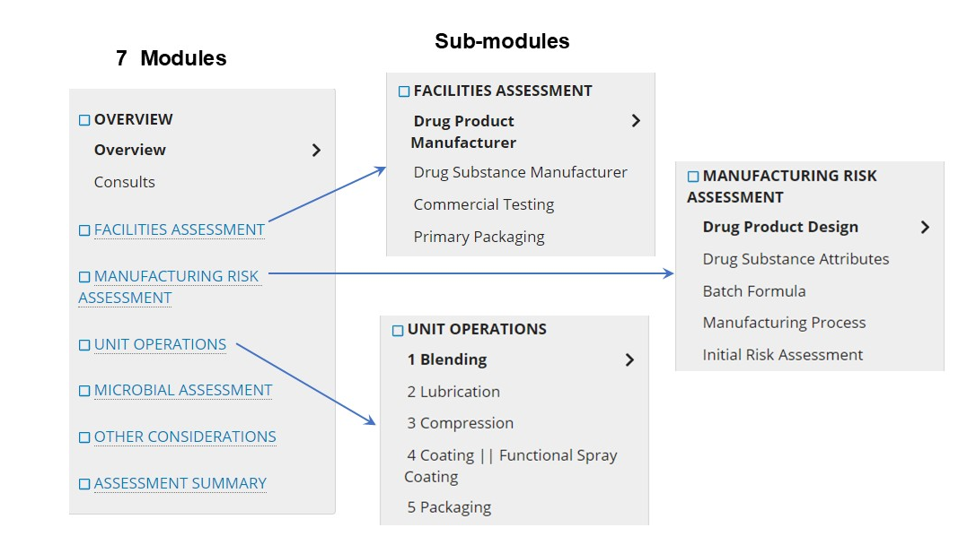
Figure 1. The structure of the KASA manufacturing section for non-sterile Solid Oral Dosage Form (SODF) ANDAs is organized into a hierarchy of modules and sub-modules. The Unit Operation sub-modules may vary depending on individual processes. The figure provides an illustrative example, showing a sample of unit operations used in manufacturing, which could include blending, lubrication, compression, coating/functional spray coating, and packaging.
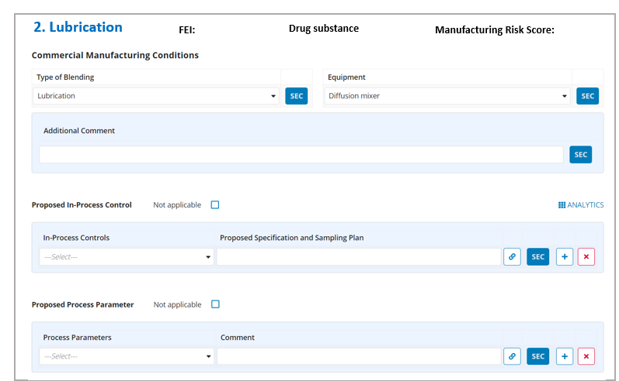
Figure 2. An illustrative example of structured descriptors captured for commercial manufacturing conditions in a unit operation, such as lubrication.

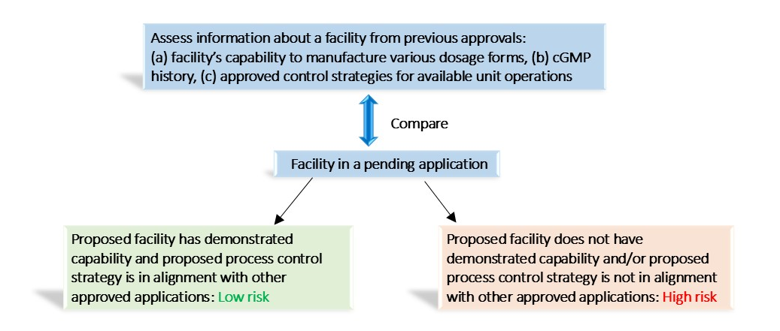
Figure 3. General strategies for knowledge-aided assessment of a facility. Typically, the site conducts a risk assessment for the proposed responsibility, considering previous process experience, quality oversight, defect signals, data integration, and other relevant factors impacting the pending application.

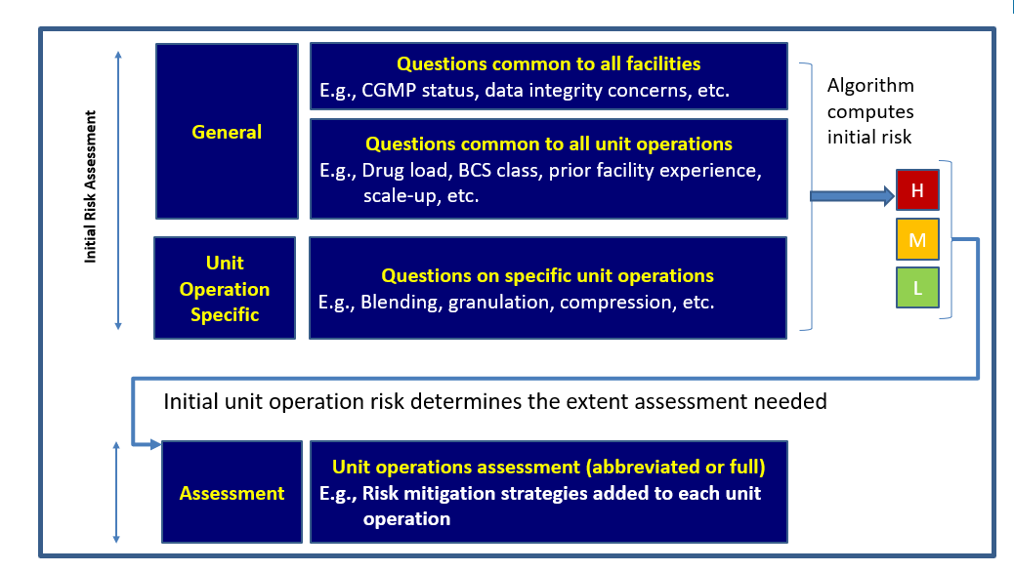
Figure 4. Mechanism for calculating the initial manufacturing risk score for a unit operation: The initial manufacturing risk score for a unit operation is determined by combining the general risk of a given scenario (as described in section 3.3), based on general risk questions, with the manufacturing initial risk scores of a unit operation derived from unit operation specification questions.

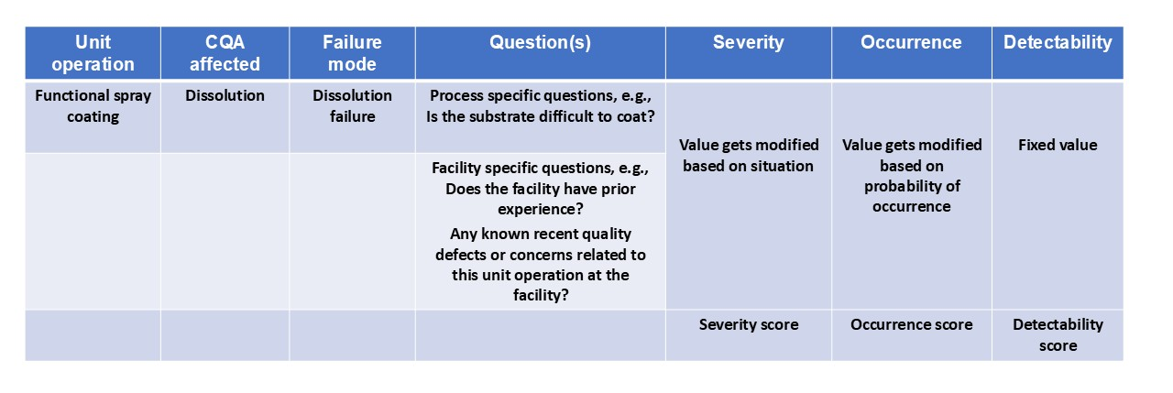
Risk Priority Number (RPN) = Severity score X Occurrence score X Detectability score

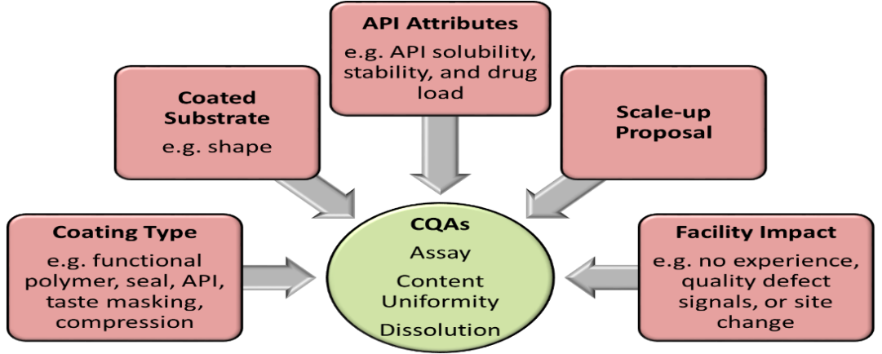

Figure 5. FMEA risk score calculation for a Critical Quality Attribute (CQA) in functional spray coating. Factors such as facility characteristics, scale-up considerations, API attributes, and specific unit operations influence the severity and occurrence scores, which in turn affect the initial risk scores for each individual CQA in the coating operation. The overall initial manufacturing risk score for a unit operation is then determined by the weighted scores of all individual CQA risks.

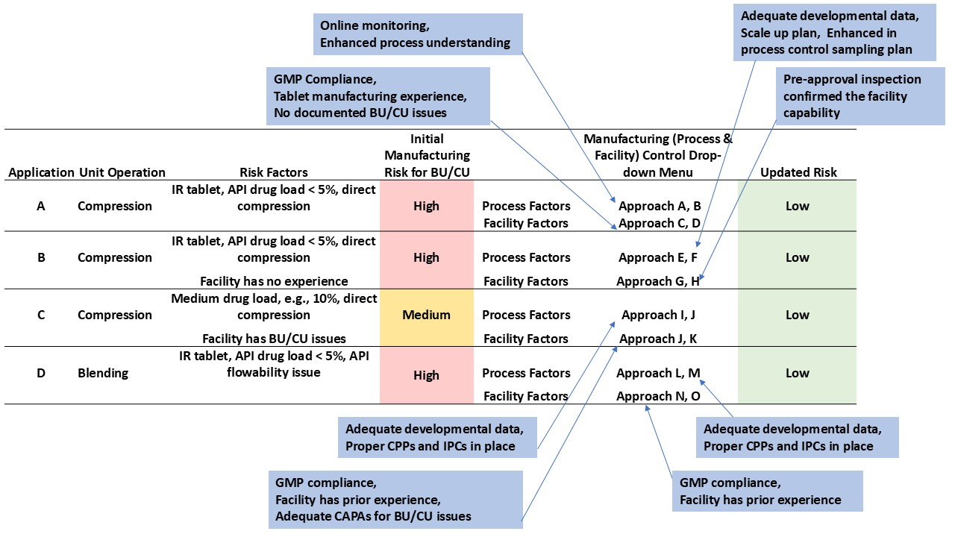
Figure 6. Constructed case studies of manufacturing risk control for unit operations, such as compression and blending in various applications, showing how risk factors influence blend uniformity and content uniformity risk scores. Different control strategies were applied, leading to updates in the final risk assessment.

Table 1. Controlled vocabularies for in-process controls (IPCs) in two representative unit operations, i.e., blending and compression.
Unit Operation | IPC Controlled Vocabularies
Blending | Assay
 | Blend uniformity
 | Water content
 | Particle size distribution
 | Bulk/tapped densities
 | Assay alarm
 | Mass balance model alarm
 | etc.
Compression | Appearance
 | Tablet individual weight
 | Tablet group or average weight
 | Hardness
 | Friability
 | Thickness
 | Disintegration time
 | Stratified content uniformity or uniformity of dosage units
Metal detection
etc.

Table 2. The drop-down representative options for design and development for representative blending and compression unit operations.
Blending
Risk Control Strategies - Design and Development
Special Considerations | Geometric or serial dilution
 | Addition order of components
 | etc.
Process Development - Consideration | Blend uniformity from exhibit batches
 | Development data to support proposed process parameters
 | etc.
Scale-up Proposal - Consideration | No scale up proposed
 | Scale up factor of unit operation
 | Change of equipment principle
 | Sublots
 | etc.
Compression
Risk Control Strategies - Design and Development
Special Considerations | This is a unique design tablet (e.g., multi-layer tablet, scored tablet)
 | Disintegration proposed as a surrogate for dissolution
 | Special consideration for in-coming material attributes
 | etc.
Process Development - Consideration | Hardness challenge
 | Machine speed study
 | Development data to support proposed process parameters
 | etc.
Scale-up Proposal - Consideration | No scale up proposed
Scale-up Proposal - Consideration | Scale up within 10 folds  Change of equipment principle  etc.

Abbreviations

- API: Active Pharmaceutical Ingredient
- ANDA: Abbreviated New Drug Application
- BCS: Biopharmaceutical Classification System
- BLA: Biologics License Application
- BU: Blend Uniformity
- CAPA: Corrective and Preventive Action
- CDER: Center for Drug Evaluation and Research
- cGMP: current Good Manufacturing Practice
- CMC: Chemistry, Manufacturing, and Controls
- CQA: Critical Quality Attribute
- CPP: Critical Process Parameter
- CU: Content Uniformity
- DR: Delayed Release
- DS: Drug substance
- ER: Extended Release
- FMEA: Failure Modes and Effects Analysis
- ICH: International Council for Harmonisation of Technical Requirements for Pharmaceuticals for Human Use
- IND: Investigational New Drug
- IPC: In-Process Control
- IQA: Integrated Quality Assessment
- IR: Immediate Release
- KASA: Knowledge-Aided Assessment & Structured Application
- NDA: New Drug Application
- OPMA: Office of Pharmaceutical Manufacturing Assessment
- OPQ: Office of Pharmaceutical Quality
- PAI: Pre-approval inspection
- PoAI: Post-approval inspection
- PQ/CMC: Pharmaceutical Quality/Chemistry, Manufacturing, and Controls
- QSD: Quality Surveillance Dashboard
- RPN: Risk Priority Number
- RRA: Remote Regulatory Assessment
- SODF: Solid Oral Dosage Form
- SPQS: Structured Product Quality Submission

Reference

1. Yu LX, Raw A, Wu L, Capacci-Daniel C, Zhang Y, Rosencrance S. FDA’s new pharmaceutical quality initiative: Knowledge-aided assessment & structured applications. International Journal of Pharmaceutics: X. 2019;1:100010. doi: https://doi.org/10.1016/j.ijpx.2019.100010.
2. Tran R, Fraser G, Fisher AC, Lee SL, Boam A, Tsinontides S, et al. A network of regulatory innovations to improve FDA quality assessments of human drug applications. International Journal of Pharmaceutics: X. 2024;7:100239. doi: https://doi.org/10.1016/j.ijpx.2024.100239.
3. Rosencrance S, Raw A, Smith D, Slack M. FDA’s new initiative: KASA. 4thFDA/PQRI Conference, April 11, 2019.
4. Raw A. The Future of FDA Quality AssessmentKnowledge-Aided Assessment & Structured Application -KASA. DMF Workshop: GDUFA III Enhancements and Structured Submissions, November 30, 2022.
5. Chia E-SJ. Knowledge-Aided Assessment and Structured Application (KASA): Part 1 Modernizing FDA’s Regulatory Assessment. Pharmaceutical Quality Symposium, October 26, 2021.
6. Welch J. Knowledge-Aided Assessment and Structured Application (KASA): Part 2 Biological Products. Pharmaceutical Quality Symposium 2021, October 26-27, 2021.
7. ICH. Concept Paper: M4Q(R2) Common Technical Document on Quality Guideline. ICH; 2021a.
8. ICH. Business Plan: M4Q(R2) Common Technical Document on Quality Guideline. ICH; 2021b.
9. FDA. Pharmaceutical Quality - Chemistry, Manufacturing & Controls | PQ/CMC. https://www.fda.gov/industry/fda-data-standards-advisory-board/pharmaceutical-quality-chemistry-manufacturing-controls-pqcmc2024a.
10. FDA. 2024 Investigations Operations Manual (IOM). U.S. Food and Drug Administration; 2024b.
11. FDA. Compliance program 7346.832--Preapproval Inspections. U.S. Food and Drug Administration; 2022.
12. FDA. Conducting Remote Regulatory Assessments Questions and Answers--Draft Guidance for Industry. Food and Drug Administration; 2024c.
13. FDA. Draft Pharmaceutical Quality Chemistry Manufacturing and Controls (PQ/CMC) Data Exchange. Food and Drug Administration, 2023a.
14. FDA. Data Integrity and Compliance With CGMP -- Guidance for Industry. 2016.
15. FDA. Q9(R1) Quality Risk Management--Guidance for Industry. U.S. Food and Drug Administration; 2023b.

Ethics Declarations
Ethics approval
Not applicable

Availability of data and materials
Not appliable

Competing interests
The authors declare that they have no competing interests.

Funding
This research did not receive external funding.

Acknowledgements
The authors would like to thank the KASA Working Group members and all assessors who served as KASA beta testers

Consent for publication.
Not applicable

Authors' information
Authors' contributions
Zhouxi Wang: Conceptualization, Visualization, Writing - original draft, Writing - review & editing. Jingbo Xiao: Conceptualization, Writing - review & editing. Daniel Obrzut: Writing - review & editing. Stelios Tsinontides: Writing - review & editing. Rakhi Shah: Supervision, Writing - review & editing.
All authors read and approved the final manuscript

Authors and Affiliations
Office of Pharmaceutical Manufacturing Assessment, Office of Pharmaceutical Quality, Center for Drug Evaluation and Research, Food and Drug Administration, 10903 New Hampshire Ave, Silver Spring, MD, 20993, USA
Zhouxi Wang, Jingbo Xiao, Daniel Obrzut, Stelios Tsinontides and Rakhi Shah

Corresponding author
Correspondence to Zhouxi Wang

Disclaimer
Springer Nature remains neutral with regard to jurisdictional claims in published maps and institutional affiliations.
This publication reflects the views of the authors and should not be construed to represent FDA’s views or policies.

