Supporting Information

Integrated Computational-Experimental Workflow for Feasibility Assessment of Amorphous Solid Dispersion Preparation by Hot Melt Extrusion Using <1 g API

Emily G. Benson^{1,2}, Julie M. Ortiz,¹ Erika L. Buckle¹, Abu Zayed Md Badruddoza¹,
Christian Luebbert,³ Lynne S. Taylor,² Dana E. Moseson-Tarrh^{1,*,#}

- Research and Development Pfizer, Inc., Groton, Connecticut 06340, United States.
- Department of Industrial and Molecular Pharmaceutics, College of Pharmacy, Purdue University, West Lafayette, Indiana 47907, United States.
- amofor GmbH, Otto-Hahn-Straße 15, 44227 Dortmund, Germany.
* Corresponding author: danamosesontarrh@outlook.com
# Current address: Eli Lilly and Company, Indianapolis, Indiana 46285, United States.

PC-SAFT Modeling
Solubility data and melting data of encorafenib were provided as the inputs for the PC-SAFT model development (Table S1, Table S2). The comparison of experimental solubility vs. solubility predicted by PC-SAFT is shown in Figure S1 to demonstrate the model fit. Model parameters for encorafenib and other materials used in this study are found in Table S3.

Table S1. Solubility of encorafenib in different solvents at 25°C and 37°C.
Solvent | Temperature (°C) | Experimental Value (g/L)
water | 25 | 0.008
water | 37 | 0.027
methanol | 25 | 43
ethanol | 25 | 10
2-propanol | 25 | 1.9
acetonitrile | 25 | 19
1-octanol | 25 | 0.99
1-octanol | 37 | 1.70

Table S2. Melting parameters of encorafenib used for PC-SAFT model fitting.
Parameter | Result
Melting temperature T^{SL} (°C) | 189
Melting enthalpy h^{SL} (J/mol) | 45030
Heat capacity difference solid and liquid API Δc_{p}^{API} (J/molK) | 97.5

Table S3. PC-SAFT pure component parameters of encorafenib and other materials investigated in this study.
Name | Mw (g/mol) | Segment no. (-) | Segment diameter (A°) | Disp. Energy / kB (K) | Asso. Energy / kB (K) | Asso. Volume | No. Asso. Donors | No. Asso. Accept.
Encorafenib¹ | 540 | 4.463 | 3.444 | 233.4 | 1506.2 | 0.011 | 0.99 | 1.63
HPMCAS-L² | 114700 | 5608.8 | 2.889 | 298.05 | 1602 | 0.02 | 712 | 712
PVPVA64³ | 65000 | 2421.0 | 2.947 | 205.27 | 1200 | 0.02 | 653 | 653
Soluplus³ | 118000 | 6372.0 | 2.809 | 225.00 | 0 | 0.02 | 2486 | 2486
Affinisol HPMC 100LV⁴ | 177500 | 4968.4 | 3.629 | 348.37 | 2338 | 0.02 | 2407 | 4081
¹Calculated parameters were determined from this work.
² Parameters were recalculated for this grade based on literature [1]
³ Parameters were input straight from literature for PVPVA [2] and Soluplus [3].
⁴ Parameters were recalculated for this grade.

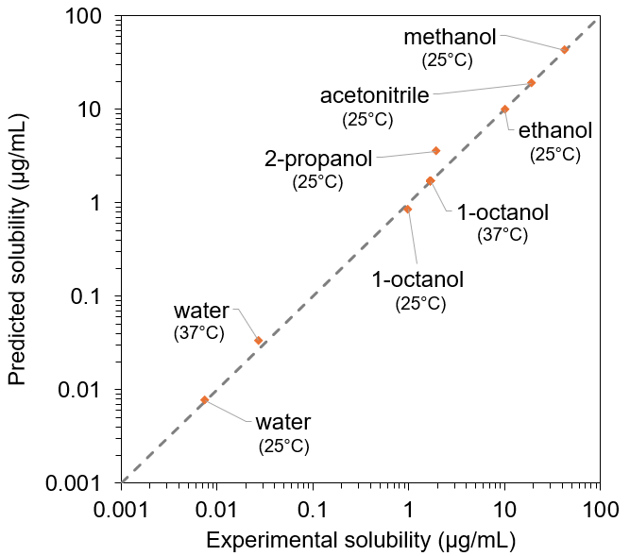
Figure S1. Predicted vs. experimental solubility of encorafenib in different solvents at 25°C and 37°C.
Sample Characterization

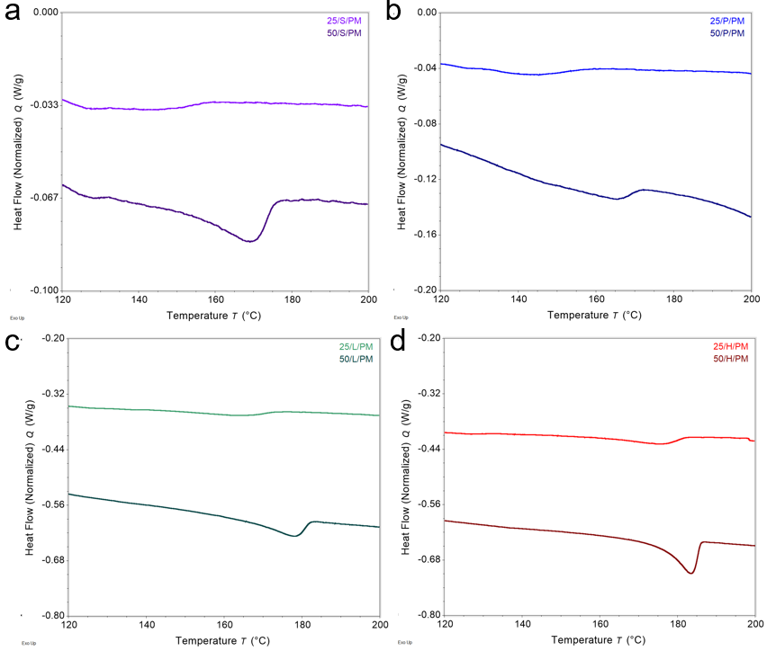
Figure S2. Differential scanning calorimetry (DSC) thermograms of 25% and 50% DL ENC physical mixtures (PM) (1°C/min heating rate) for SP- (a), PVPVA- (b), HPMCAS- (c), and HPMC- (d) drug mixtures.

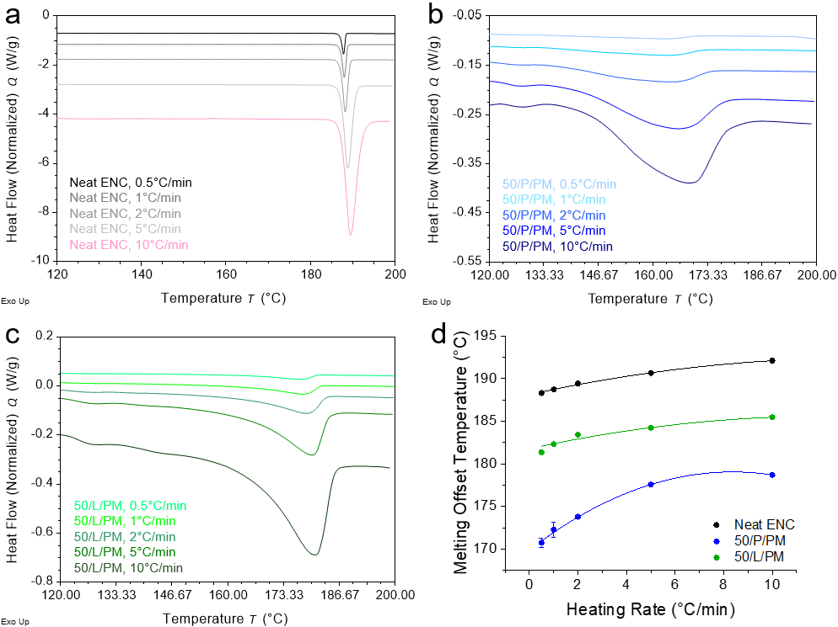
Figure S3. Representative differential scanning calorimetry (DSC) traces of melting endotherms for (a) neat encorafenib (ENC), (b) 50% DL ENC/PVPVA physical mixtures, and (c) 50% DL ENC/HPMCAS physical mixtures at heating rates of 0.5, 1, 3, 5, and 10°C/min. Melting point offset temperatures for each sample and heating condition were plotted (d) to extrapolate melting offset temperatures at a theoretical 0°C/min heating rate. Error bars represent standard deviations of n=3 scans and are too small to be observed for most conditions.

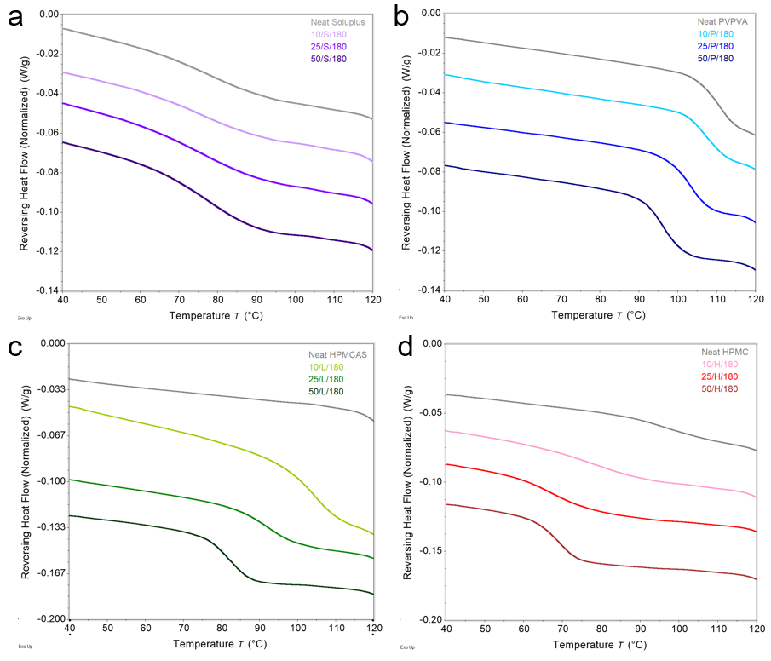
Figure S4. Differential scanning calorimetry (DSC) thermograms of 10%, 25%, and 50% DL ENC vacuum compression molding (VCM) disks after cryomilling showing glass transitions for SP- (a), PVPVA- (b), HPMCAS- (c), and HPMC- (d) based ASDs.

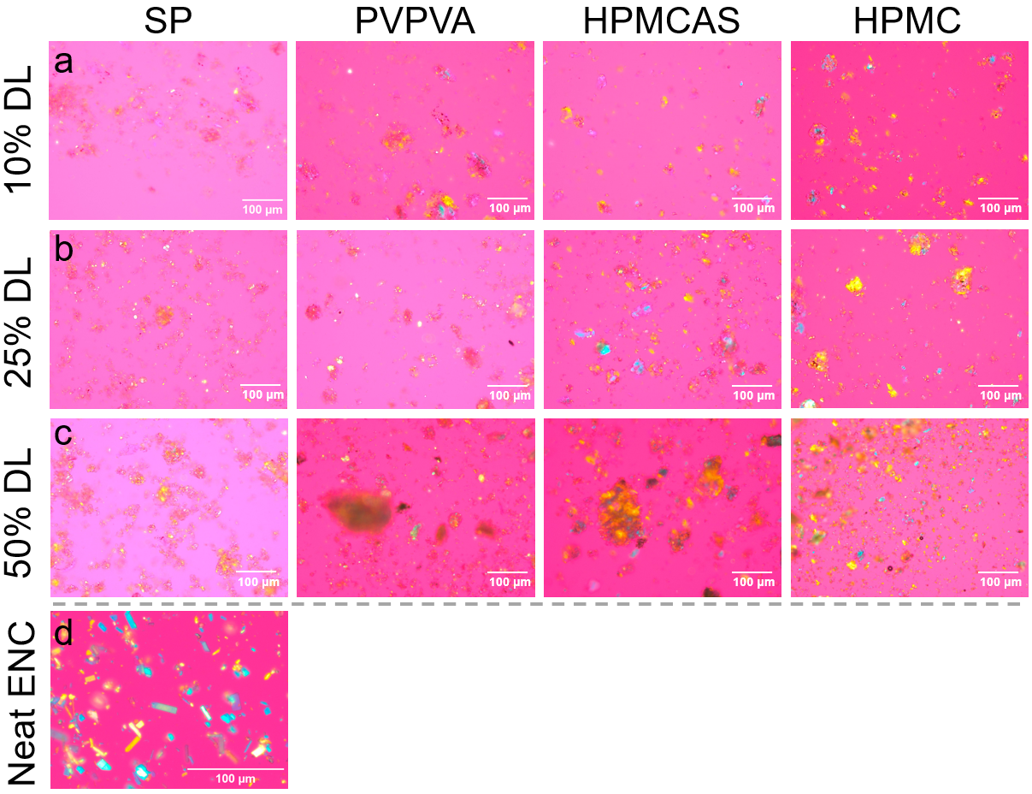
Figure S5. Polarized light microscopy (PLM) images of 10% (a), 25% (b), and 50% (c) DL encorafenib physical mixtures in SP, PVPVA, HPMCAS, and HPMC (left to right) as well as neat crystalline encorafenib (d).

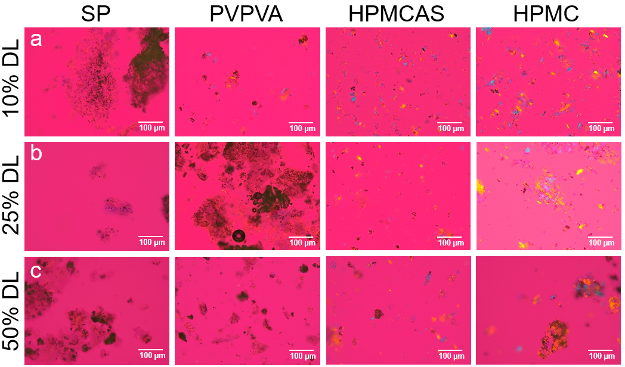
Figure S6. Polarized light microscopy (PLM) images of powder from cryo-milled vacuum compression molding (VCM) disks with a 10% (a), 25% (b), and 50% DL (c) of encorafenib in SP, PVPVA, HPMCAS, and HPMC (left to right) processed at 180°C for 10 min. Softer blue and yellow coloration likely corresponds to strain birefringence rather than crystalline character.

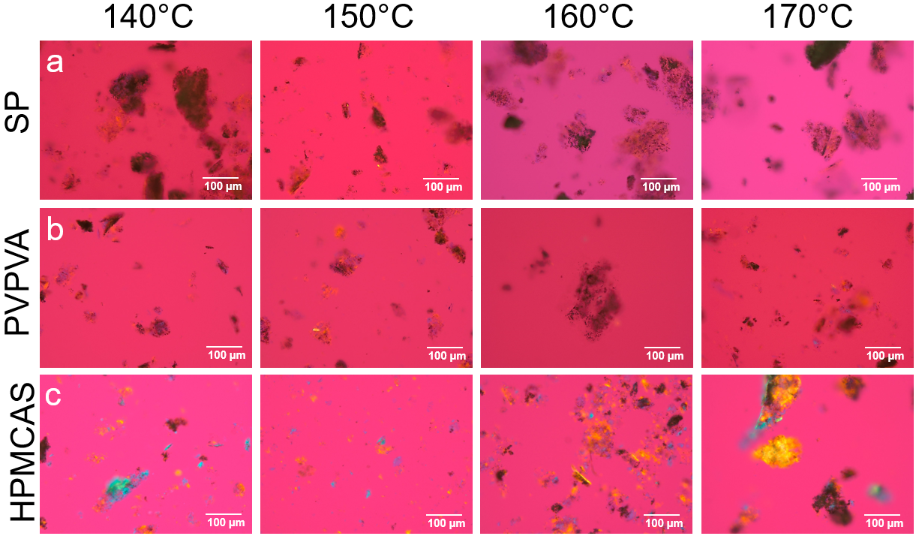
Figure S7. Polarized light microscopy (PLM) images of powder from cryo-milled vacuum compression molding (VCM) disks with a 25% DL of encorafenib in SP (a), PVPVA (b), and HPMCAS (c) processed at 140°C, 150°C, 160°C, and 170°C (left to right) to determine the temperature at which crystalline encorafenib is not fully amorphous. Softer blue and yellow coloration likely represents strain birefringence rather than crystalline character.

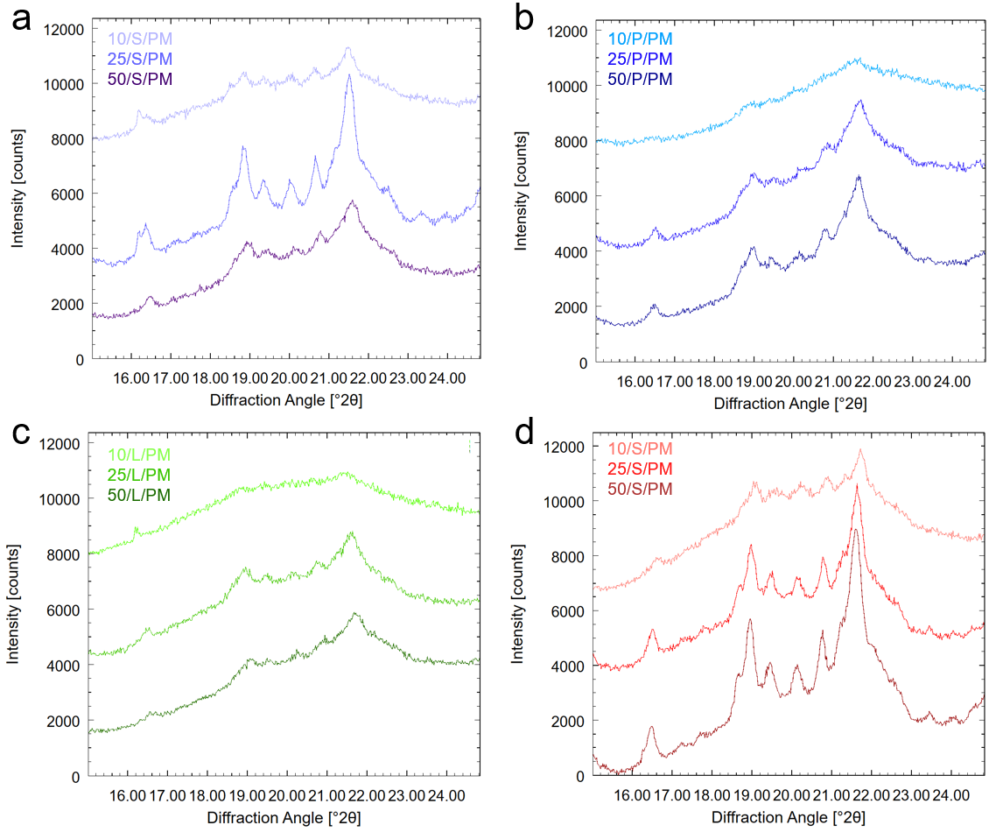
Figure S8. X-ray powder diffractograms of cryomilled physical mixtures of 10%, 25%, and 50% DL ENC in SP (a), PVPVA (b), HPMCAS (c), and HPMC (d). Broader peaks in cryo-milled samples indicate the process converted some ENC to the amorphous form—more notable in PVPVA- and HPMCAS-based physical mixtures.

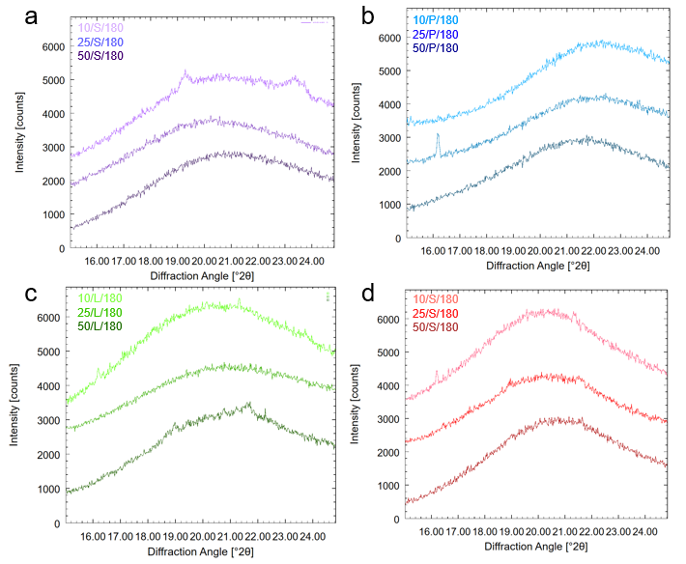
Figure S9. X-ray powder diffractograms of cryomilled VCM disks of 10%, 25%, and 50% DL ENC in SP (a), PVPVA (b), HPMCAS (c), and HPMC (d) processed at 180°C. The peak occurring at 16° cannot alone conclusively determine residual crystalline ENC content. Peaks in the 10/S/180°C sample do not all align with the starting ENC peaks.

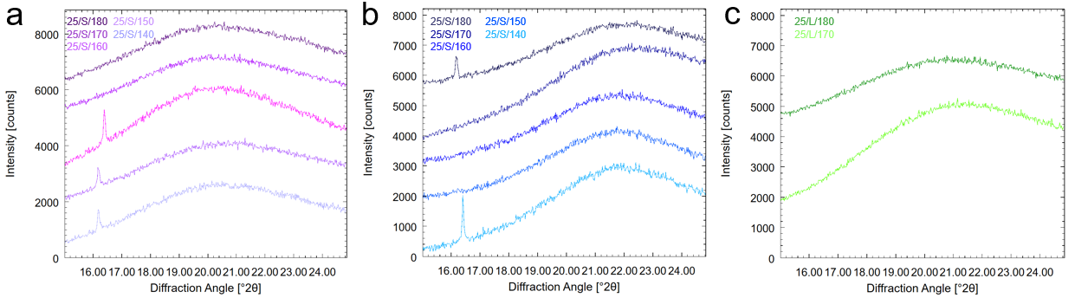Figure S10. X-ray powder diffractograms of cryomilled VCM disks processed from 140-180°C of 25% DL ENC in SP (a), PVPVA (b), and HPMCAS (c). The peak occurring at 16° cannot alone conclusively determine residual crystalline ENC content.

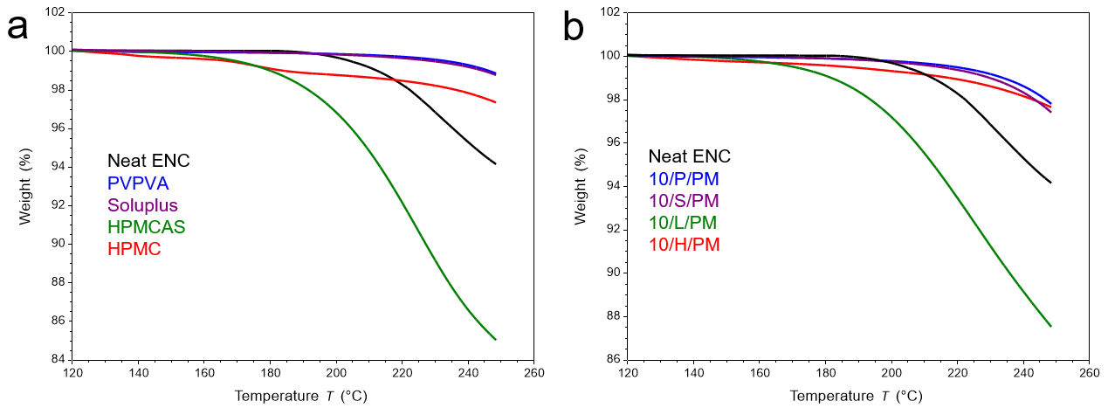
Figure S11. Thermogravimetric analysis (TGA) traces of neat materials (a) and 10% DL physical mixtures of ENC with PVPVA, SP, HPMCAS, and HPMC (b). Samples were heated at 1°C/min. 100% weight was assigned after moisture loss.

Table S4. Onset degradation temperatures of neat materials and 10% DL physical mixtures of encorafenib (ENC) with PVPVA, Soluplus, HPMCAS, and HPMC. Onset temperatures were calculated from the intersection of the tangent lines before and after mass loss and at 0.1%, 0.5% and 1% mass loss after normalization from thermogravimetric analysis (TGA) traces heated at 1°C/min performed in singlicate.
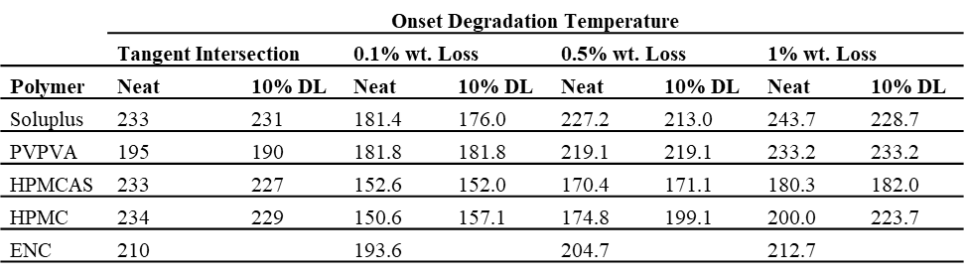

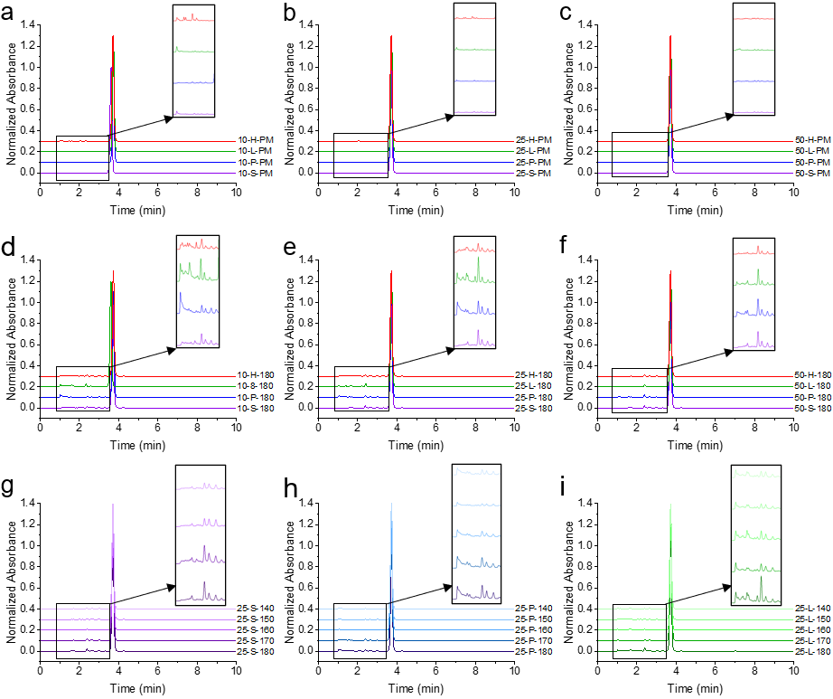
Figure S12. High performance liquid chromatography (HPLC) chromatograms of 10% (a), 25% (b), and 50% (c) DL physical mixtures (PM); 10% (d), 25% (e), and 50% (f) DL ASDs processed at 180°C; and 25% DL ASDs of SP (g), PVPVA (h), and HPMCAS (i) processed from 140-180°C. Inlays of 1.5 s before the ENC peak are shown on each plot as the majority of degradation products eluted in this range.

References
1. Lehmkemper K, Kyeremateng SO, Heinzerling O, Degenhardt M, Sadowski G (2017) Impact of Polymer Type and Relative Humidity on the Long-Term Physical Stability of Amorphous Solid Dispersions. Mol Pharm 14:4374–4386. https://doi.org/10.1021/acs.molpharmaceut.7b00492
2. Lehmkemper K, Kyeremateng SO, Heinzerling O, Degenhardt M, Sadowski G (2017) Long-Term Physical Stability of PVP- and PVPVA-Amorphous Solid Dispersions. Mol Pharm 14:157–171. https://doi.org/10.1021/acs.molpharmaceut.6b00763
3. Wolbert F, Fahrig IK, Gottschalk T, Luebbert C, Thommes M, Sadowski G (2022) Factors Influencing the Crystallization-Onset Time of Metastable ASDs. Pharmaceutics 14:. https://doi.org/10.3390/pharmaceutics14020269

