Supplementary material
Production and separation of ⁴³Sc for radiopharmaceutical purposes
Katharina A. Domnanich^{1,2}, Robert Eichler^{1,2}, Cristina Müller^{3,4}, Sara Jordi^{1,2}, Vera Yakusheva⁵, Saverio Braccini⁶, Martin Behe^{1,3}, Roger Schibli^{3,4}, Andreas Türler², Nicholas P. van der Meulen^{1,3*}

¹Laboratory of Radiochemistry, Paul Scherrer Institute, 5232 Villigen PSI, Switzerland
²Department of Chemistry and Biochemistry University of Bern, 3012 Bern, Switzerland
³Center for Radiopharmaceutical Sciences ETH-PSI-USZ, Paul Scherrer Institute, 5232 Villigen PSI, Switzerland
⁴Department of Chemistry and Applied Biosciences, ETH Zurich, 8093 Zurich, Switzerland
⁵GSI Helmholtzzentrum für Schwerionenforschung GmbH, 64291 Darmstadt, Germany
⁶Albert Einstein Center for Fundamental Physics (AEC), Laboratory for High Energy Physics (LHEP), University of Bern, Sidlerstrasse 5, 3012 Bern, Switzerland

E-mail addresses:
katharina.domnanich@psi.ch; robert.eichler@psi.ch, cristina.mueller@psi.ch; sara.jordi@psi.ch; v.yakusheva@gsi.de; saverio.braccini@lhep.unibe.ch; martin.behe@psi.ch; roger.schibli@psi.ch; andreas.tuerler@dcb.unibe.ch; nick.vandermeulen@psi.ch

* Corresponding author:
Dr. Nicholas P. van der Meulen
Laboratory of Radiochemistry
Paul Scherrer Institute
5232 Villigen-PSI
Switzerland
e-mail: nick.vandermeulen@psi.ch
phone: +41-56-310 50 87
fax: +41-56-310 28 49
$${A\left({}_{}^{43}{Sc}\right)}_{calc}=σ*ϕ*N_{T}*(1-e^{-λ*t_{irr}})$$
Supplementary Fig. S1a Formula for the calculation of the ⁴³Sc activity in Bq (s⁻¹), accessible under the applied irradiation conditions. σ = nuclear cross section of the ⁴⁶Ti(p,α)⁴³Sc and ⁴³Ca(p,n)⁴³Sc reaction in cm⁻², N_{T} = number of ⁴⁶Ti or ⁴³Ca atoms, Φ = proton flux in protons*s⁻¹, λ = decay constant of ⁴³Sc in s⁻¹, t_{irr} = irradiation time in s

$$f({}_{}^{43}{Sc)}=\frac{{A({}_{}^{43}{Sc)}}_{calc}}{{A({}_{}^{43}{Sc)}}_{exp}}$$
Supplementary Fig. S1b Formula for the discrepancy $f$ between the theoretically achievable and the experimentally obtained ⁴³Sc activity (dimensionless).

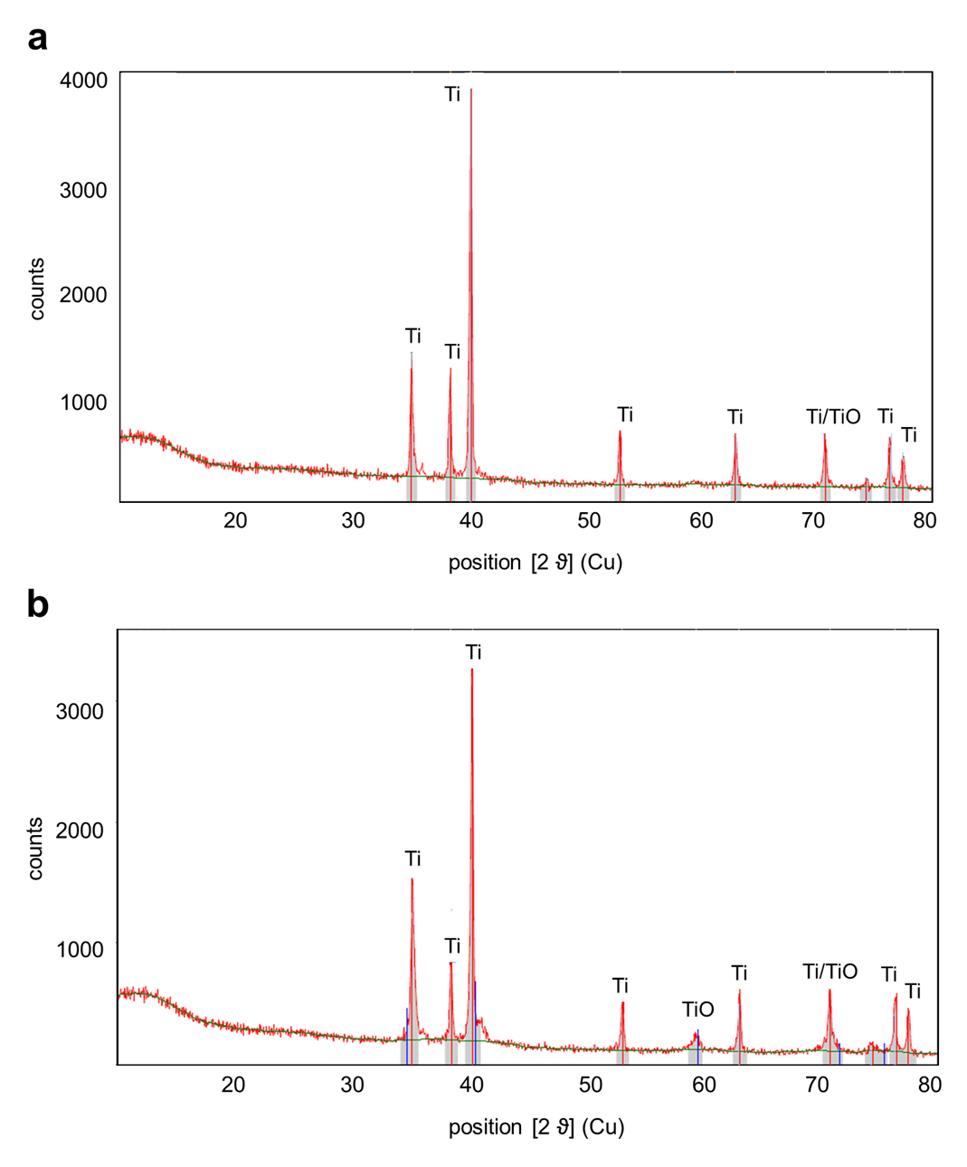
Supplementary Fig. S2 XRD Spectra of reduced ⁴⁶Ti metal of a sample with a determined reduction yield of 99% (a) and 96% (b). The remaining species, insoluble by the HCl dissolution, were identified as TiO in both cases.

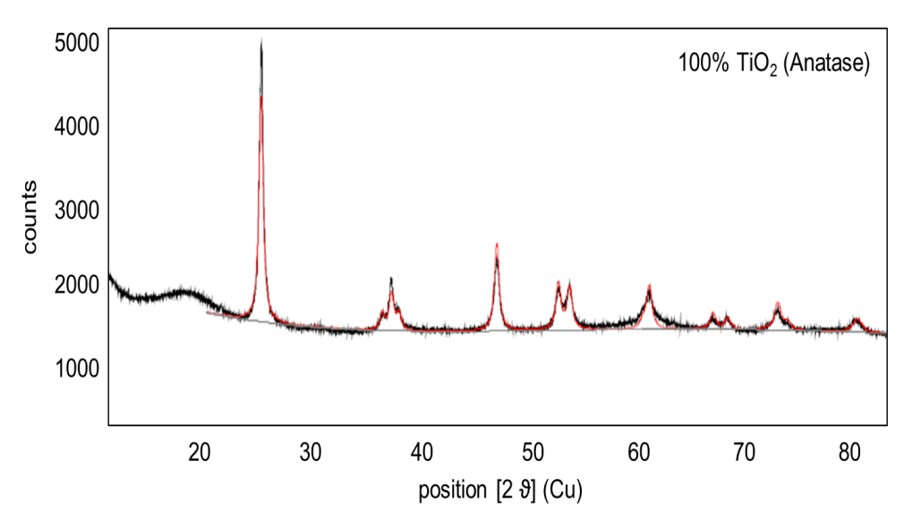
Supplementary Fig. S3 XRD Spectrum of precipitated, natural TiO₂ after drying at 400 °C for 1 h.

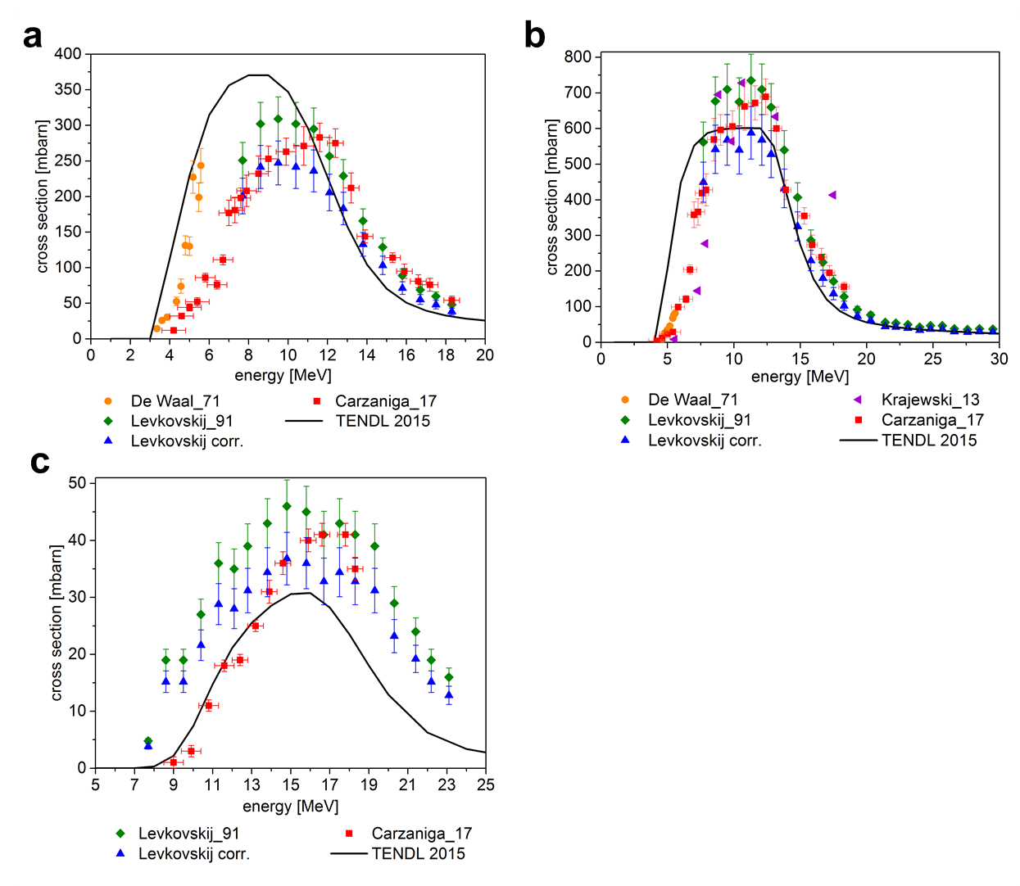
Supplementary Fig. S4 Measured cross section values (squares, triangles and dots, retrieved from the EXFOR database and Carzaniga et al.) (Carzaniga, Auger et al. 2017, International Atomic Energy Agency 2017) as well as the theoretical calculations from the TENDL-2015 library (Koning, Rochman et al. 2015) for the ⁴³Ca(p,n)⁴³Sc (a), ⁴⁴Ca(p,n)⁴⁴Sc (b) and the ⁴⁶Ti(p,α)⁴³Sc (c) nuclear reaction

Supplementary Table S5 Trace metal analysis of the purchased ⁴⁶TiO₂ and reduced ⁴⁶Ti metal by ICP-OES. Only the elements determined at a concentration higher than the detection limit are listed below
Element | Ratio of element per mg of Ti
 | purchased ⁴⁶TiO₂ | reduced to ⁴⁶Ti metal
Ca | 3.7*10⁻⁵ | 4.9*10⁻³
Mg | 5.2*10⁻⁶ | 1.8*10⁻⁴
Sr | 2.4*10⁻⁷ | 1.1*10⁻³
Ti | 1 | 1
Zr | 3.4*10⁻⁵ | 6.6*10⁻⁴

References
Carzaniga, T. S., M. Auger, S. Braccini, M. Bunka, A. Ereditato, K. P. Nesteruk, P. Scampoli, A. Türler and N. Van der Meulen (2017). "Measurement of ⁴³Sc and ⁴⁴Sc production cross-section with an 18 MeV medical PET cyclotron." Appl Radiat Isot.
International Atomic Energy Agency. (2017). "Experimental Nuclear Reaction Data (EXFOR)." Retrieved 04.09.2017, from https://www-nds.iaea.org/exfor/exfor.htm.
Koning, A. J., D. Rochman, J. Kopecky, C. Sublet, E. Bauge, S. Hilaire, P. Romain, B. Morillon, H. Duarte, S. van der Marck, S. Pomp, H. Sjostrand, R. Forrest, H. Henriksson, O. Cabellos, S. Goriely, J. Leppanen, H. Leeb, A. Plompen and R. Mills. (2015). "TENDL-2015: TALYS-based evaluated nuclear data library." Retrieved 05.03.2017, from https://tendl.web.psi.ch/tendl_2015/tendl2015.html.

