Supplementary Material
Production and characterization of no-carrier-added ¹⁶¹Tb as an alternative to the clinically-applied ¹⁷⁷Lu for radionuclide therapy
Nadezda Gracheva¹, Cristina Müller¹, Zeynep Talip¹, Stephan Heinitz², Ulli Köster³, Jan Rijn Zeevaart⁴, Alexander Vögele², Roger Schibli^{1,5}, Nicholas P. van der Meulen^{1,2*}

¹ Center for Radiopharmaceutical Sciences ETH-PSI-USZ, Paul Scherrer Institut, 5232 Villigen-PSI, Switzerland
² Laboratory of Radiochemistry, Paul Scherrer Institut, 5232 Villigen-PSI, Switzerland
³ Institut Laue-Langevin, 38042 Grenoble, France
⁴ Radiochemistry, South African Nuclear Energy Corporation (Necsa), 0242 Brits, South Africa
⁵ Department of Chemistry and Applied Biosciences, ETH Zurich, 8093 Zurich, Switzerland

E-mail addresses:
nadezda.gracheva@psi.ch; cristina.mueller@psi.ch; zeynep.talip@psi.ch; stephan.heinitz@sckcen.be; koester@ill.fr; janrijn.zeevaart@necsa.co.za; alexander.voegele@psi.ch; roger.schibli@psi.ch; nick.vandermeulen@psi.ch
*Corresponding author:
Dr. Nicholas P. van der Meulen
Laboratory of Radiochemistry/Center for Radiopharmaceutical Sciences ETH/PSI/USZ
Paul Scherrer Institut
5232 Villigen-PSI
Switzerland
e-mail: nick.vandermeulen@psi.ch
phone: +41-56-310 50 87
fax: +41-56-310 28 49
Development of the ¹⁶¹Tb purification process on the bench
Purpose: After irradiation of ¹⁶⁰Gd targets, a purification process of the radionuclide of interest is required. This step is critical towards obtaining radionuclidically, radiochemically and chemically pure ¹⁶¹Tb, relevant for further preclinical or clinical application. The purification method should be reproducible and suitable for the separation of µg amounts of the radionuclide (e.g. the mass of 20 GBq ¹⁶¹Tb is 4.6 µg) from mg amounts of the target material.
Methods: Bench experiments using a Sykam cation exchange resin column were performed with the use of radioactive tracers in order to establish experimental conditions for appropriate Tb separation from Gd target material and impurities related to the target material (Table S1).
Table S1. Chemical admixtures of ¹⁶⁰Gd₂O₃, provided by the supplier (Isoflex, USA)
Element | K | Na | Ca | Mg | Fe | Al | Si | Cr | Ni | Cu | Pb | Sb | Sn
Content (ppm) | <50 | <20 | <50 | <3 | <50 | <3 | <50 | <5 | <1 | <10 | 13 | <1 | <1

Element | Pt | Sm | Ho | Dy | Eu | Nd | Tb | Er
Content (ppm) | 20 | 13 | 6 | <1 | <1 | <1 | <2 | <1

Long-lived radioactive tracers (²²Na, ⁶⁵Zn, ¹⁵²Eu, ¹⁵³Gd, ¹⁶⁰Tb, ¹⁹²Ir) were provided by the Laboratory of Radiochemistry (PSI) (Table S2). ⁵⁹Fe and ⁵¹Cr were obtained by neutron activation of the OPTIFER-V material (Saarschmiede GmbH, Germany) at SINQ (PSI). The required mass of the steel (383 mg) was placed inside the plastic capsule for irradiation and bombarded for 1 h at the NAA position of the SINQ spallation source. After the irradiation, the steel was dissolved in 2.0 mL 37% hydrochloric acid (HCl, Normapur, VWR Chemicals, USA) and evaporated until dryness at 80 °C under gas flow. ⁶⁵Ni tracer was obtained by 1 h neutron irradiation of 12 mg nickel(II) nitrate hexahydrate (Ni(NO₃)₂.6H₂O, Sigma-Aldrich, USA) at the NAA position (SINQ), followed by the same dissolving procedure as for ⁵⁹Fe and ⁵¹Cr.

Table S2. Long-lived radioactive tracers used for bench experiments.
Tracer | ²²Na | ⁵¹Cr | ⁵⁹Fe | ⁶⁵Ni | ⁶⁵Zn | ¹⁵²Eu | ¹⁵³Gd | ¹⁶⁰Tb | ¹⁶⁹Yb
T_{1/2} | 2.6 y | 27.7 d | 44.5 d | 2.5 h | 244.3 d | 13.5 y | 239.5 d | 72.3 d | 32.0 d

The radioactive tracers were mixed with 2.0 mL 0.1 M NH₄NO₃ and loaded onto the Sykam resin column (10 mm x 170 mm; NH₄⁺ form) by means of an Ismatec peristaltic pump (Cole-Parmer Instrument Company LLC, USA). Subsequently, 0.13 M (pH 4.5) α-hydroxy-isobutyric acid (α-HIBA, Sigma-Aldrich GmbH, Germany) was passed through the column until Tb was eluted. The concentration of α-HIBA was then increased to 0.175 M and 1 M, respectively, in order to elute the impurities in question. Samples (6-12 mL fractions) of α-HIBA were collected and measured using a high-purity germanium (HPGe) detector (Canberra, France) in combination with the InterWinner software package (version 7.1, Itech Instruments, France) until the 3σ uncertainty was below 10%. In several experiments, ¹⁵³Gd tracer was mixed with 8 – 140 mg ^{nat}Gd₂O₃ (Research chemicals, Division of Rhone-Poulenc Inc., USA).
The Tb-containing α-HIBA fractions eluted from the Sykam resin were loaded onto the LN3 resin (LN3, Triskem International, France) column (6 mm x 5 mm) in order to concentrate Tb. After loading, the resin was rinsed with 10 mL MilliQ water, followed by the final elution of Tb in 0.05 M HCl.
Results: Initially, ¹⁵³Gd and ¹⁶⁰Tb tracers were used to establish conditions for appropriate Tb/Gd separation on the Sykam resin column with the use of α-HIBA as eluent (Experiment 1; Fig. S1a). The ¹⁵²Eu, present in the experiment, was an impurity of the provided ¹⁵³Gd solution; however, this allowed one to understand the behavior of Eu as a possible impurity of the target material for ¹⁶¹Tb production (Table S2). After the experimental conditions for appropriate Tb/Gd separation were determined (0.13 M α-HIBA, pH 4.5; 0.6 mL/min flow rate) with the corresponding tracers, similar conditions were applied for the Tb separation of up to 140 mg of ^{nat}Gd₂O₃ (Experiment 2; Fig. S1b).
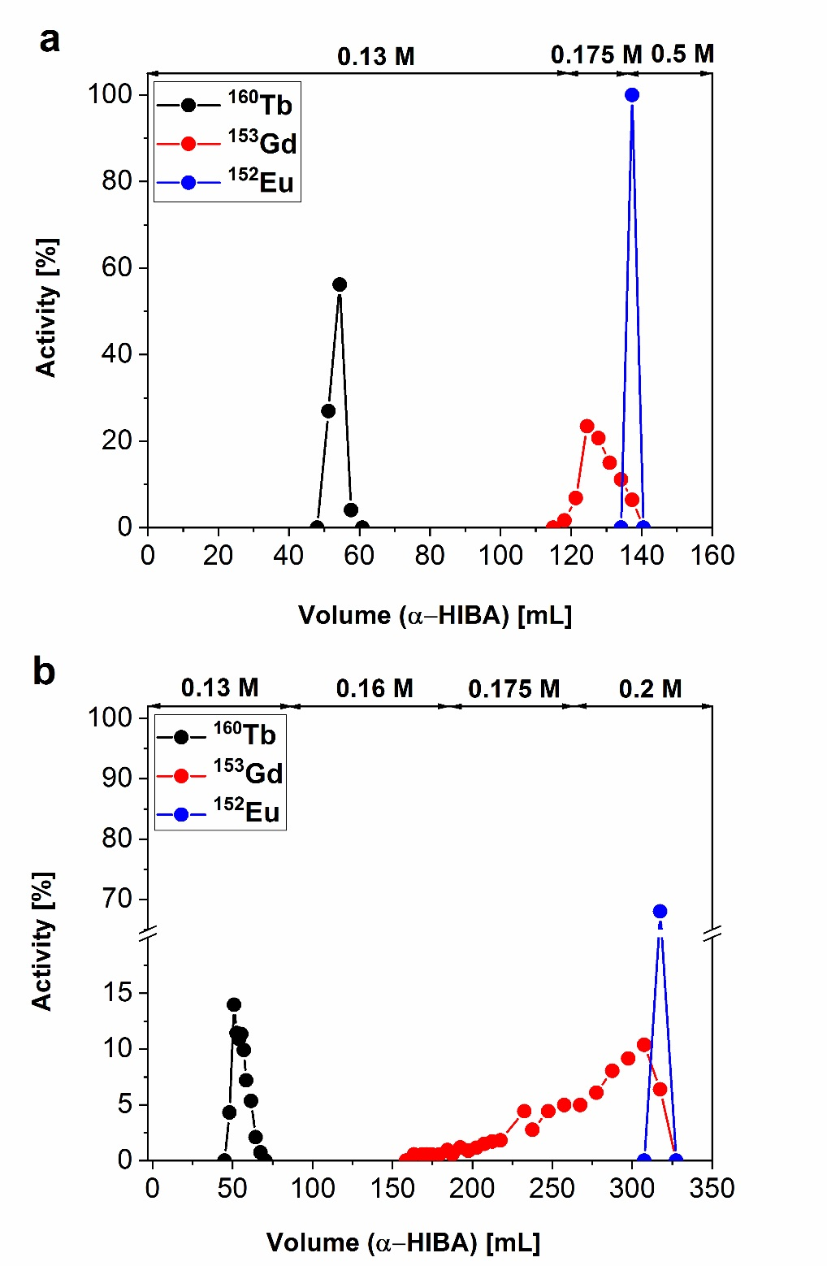
Fig. S1. Elution profile of Tb/Gd separation from the target material (10 mm x 170 mm Sykam resin column, 0.6 mL/min eluent flow rate). Experiment 1 (a) was run without addition of ^{nat}Gd₂O₃, while Experiment 2 (b) was performed with the addition of 140 mg ^{nat}Gd₂O₃.

Even in the presence of 140 mg of ^{nat}Gd₂O₃ in the system (Experiment 2), Tb was effectively separated from ^{nat/153}Gd (Fig. S1b). With the increase of the ^{nat}Gd mass, a significant fronting of the Gd peak was observed due to the expanded longitudinal occupation of the column volume. This zone broadening had no effect with regard to overlap of the Tb peak, however.
The next step was to study the behavior of various radioactive tracers in order to simulate the presence of potential impurities (Table S2) in the ¹⁶¹Tb chemical separation system (Fig. S2a, b). The purpose of Experiment 3, shown in Fig. S2a, was to understand the behavior of Zn and Na (or K) in simulated Tb production conditions, while the purpose of Experiment 4 (Fig. S2b) was to evaluate the behavior of Fe, Cr and Ni on the Sykam resin column – also simulating Tb production conditions.
In Experiment 4, the concentration of α-HIBA was increased from 0.13 M to 0.175 M before Tb was eluted from the Sykam column, such that one could speed up the elution of ⁶⁵Ni (its short 2.5 h half-life hinders γ-spectrometric ⁶⁵Ni detection in more time-consuming experiments). This resulted in the overlapping of Tb and Gd peaks.
Fig. S2. Elution profile of Tb separation from the target material (Gd) and the impurities of the target material (10 mm x 170 mm Sykam resin column, 0.6 mL/min eluent flow rate). Experiment 3 (a) ⁶⁵Zn and ²²Na were added to the system as impurities. Experiment 4 (b) ⁵⁹Fe, ⁵¹Cr and ⁶⁵Ni were added to the system as impurities.

The separation of Tb from the possible impurities of the target material on the Sykam resin column showed that Cr species were eluted at different concentrations of α-HIBA and resulted in the presence of Cr in Tb fraction (Experiment 4; Fig. S2b). Cr ions form oligomers (monomers to tetramers) in aqueous solution, which may interact individually with the eluent [1]. Unfortunately, the complexation mechanisms and complexation constants of such Cr species with α-HIBA are not known and it is difficult to explain why traces of Cr were eluted in every fraction throughout the separation process. Nevertheless, Cr was not retained on the LN3 resin column (Column 2 of the purification process, 6 mm x 5 mm), which allowed efficient Tb separation from Cr as an impurity in the ¹⁶¹Tb final product (Fig. S3).
Fig. S3. Elution profile of Tb separation from Cr as a possible radioactive impurity in the final ¹⁶¹Tb product (6 mm x 5 mm LN3 resin column, 0.6 mL/min eluent flow rate).

Conclusion: Experimental conditions for appropriate Tb separation from the Gd target material and potential impurities were established by performing bench experiments. These conditions were successfully translated for the purification of the reactor-produced ¹⁶¹Tb on the constructed purification module (discussed in the main manuscript).

¹⁶¹Tb radionuclidic purity
The only radionuclidic impurity, found in the decayed ¹⁶¹Tb product, was ¹⁶⁰Tb (T_{1/2} = 72.3 d) which was <0.007% of the total ¹⁶¹Tb activity at the end of separation (EOS) (Fig. S4). The absence of the long-lived ¹⁵³Gd (T_{1/2} = 239.5 d) in the decayed product, produced via the ¹⁵²Gd(n,γ)¹⁵³Gd nuclear reaction, emphasizes the efficient ¹⁶¹Tb separation from the Gd target material.

Fig. S4. Gamma spectrum of the decayed product (¹⁶¹TbCl₃), used for the determination of ¹⁶⁰Tb radionuclidic impurity in the total ¹⁶¹Tb fraction. No other radionuclides, other than ¹⁶⁰Tb, were found.

¹⁶¹Tb radiochemical purity
The radiochemical purity of ¹⁶¹Tb solution was determined by radio thin layer chromatography (radio TLC). Each batch of ¹⁶¹Tb had >99% radiochemical purity. The absence of the R_{f} 0 fraction (which would indicate Tb species not forming complexes with citrate, e.g. colloids) on the radio TLC chromatogram (Fig. S5) indicates the existence of only ¹⁶¹Tb³⁺ in the final product.
Fig. S5. Radio TLC chromatogram of ¹⁶¹TbCl₃ solution in 0.1 M sodium citrate (pH 5.5) for the determination of ¹⁶¹Tb radiochemical purity.
References
[1] Friese JI. Chromatographic separation and characterization of hydrolyzed Cr(III) species. Anal. Chem. 2002;74:2977-84.

