Radioimmunotherapy of PANC-1 Human Pancreatic Cancer Xenografts in NOD/SCID or NRG Mice with Panitumumab Labeled with Auger Electron Emitting, ¹¹¹In or β-Particle Emitting, ¹⁷⁷Lu

Sadaf Aghevlian¹, Zhongli Cai¹, David Hedley^{,3}, Mitchell A. Winnik²
and Raymond M. Reilly^{1,4,*}

¹ Department of Pharmaceutical Sciences, University of Toronto, Toronto, ON, Canada
² Department of Chemistry, University of Toronto, Toronto, ON, Canada
³ Department of Medical Oncology, Princess Margaret Cancer Centre, University Health Network, Toronto, ON, Canada
⁴ Department of Medical Imaging, University of Toronto, Toronto, ON, Canada

Supplementary Information

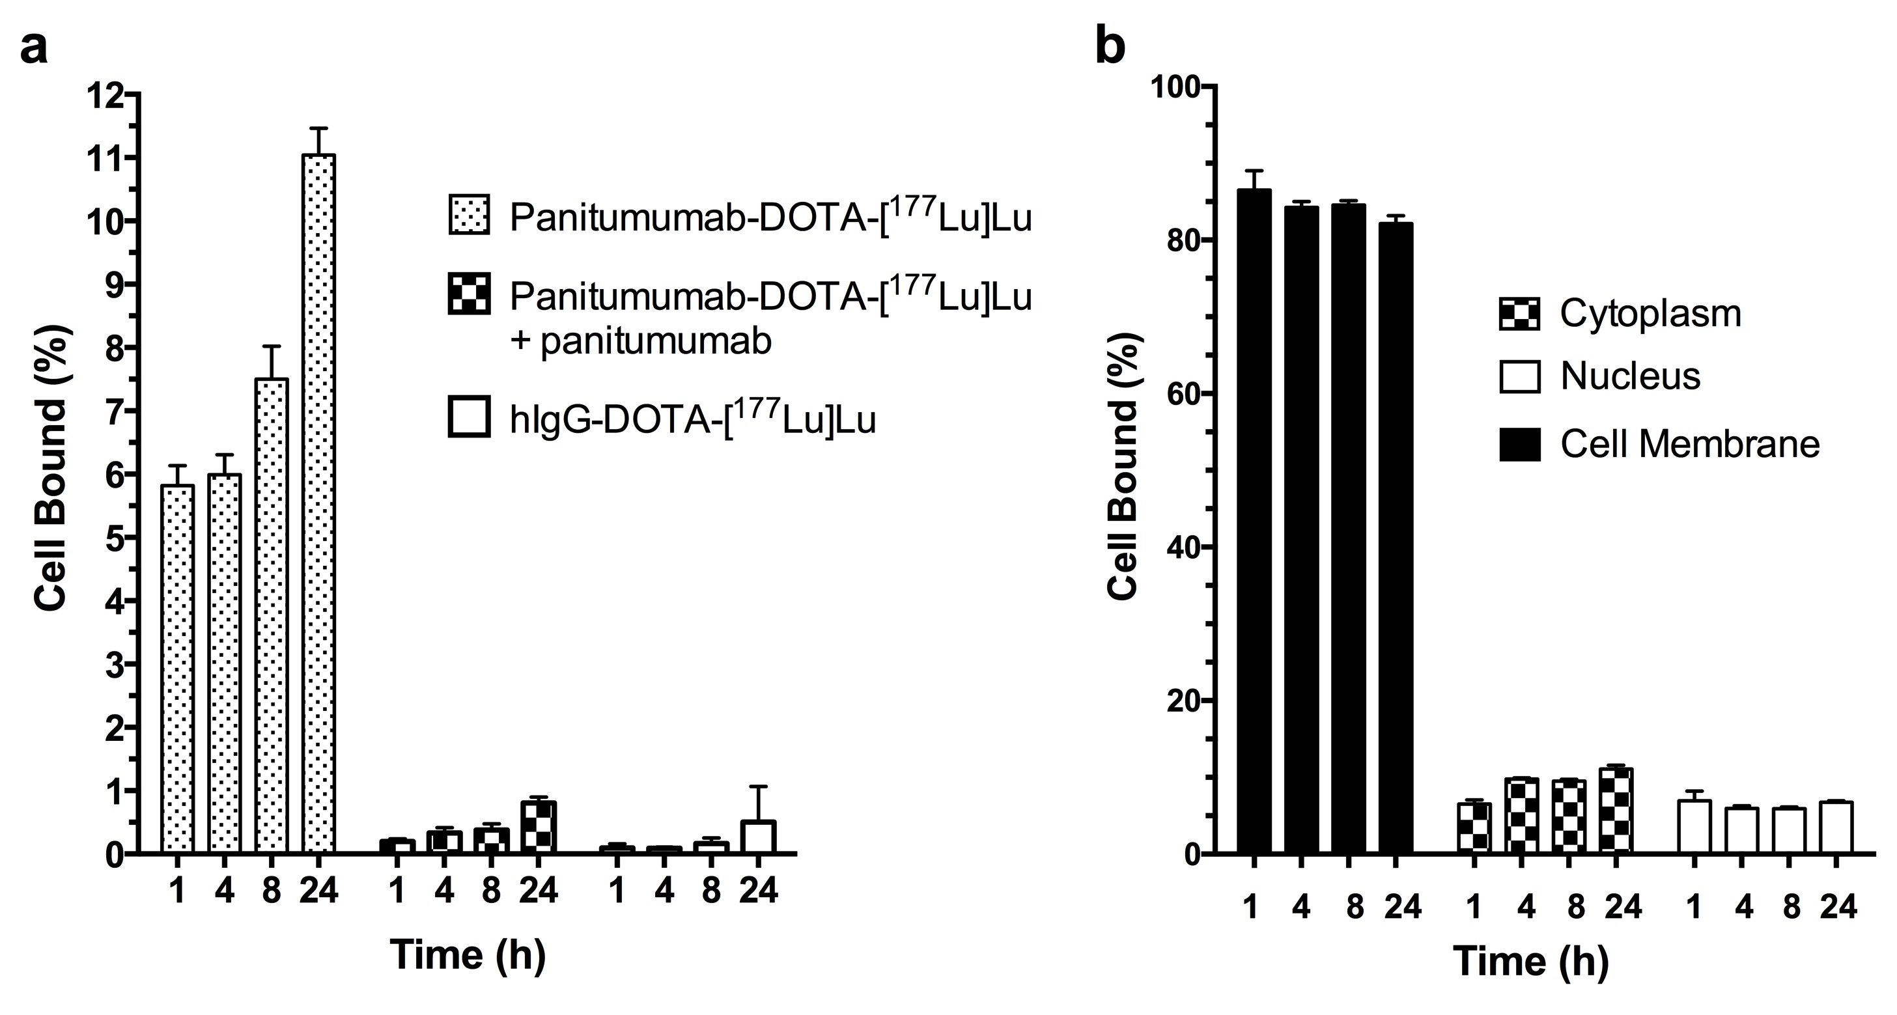

Fig. S1. (a) Percent cell bound radioactivity at selected times after incubation of 2 × 10⁵ PANC-1 cells with 1.2 MBq (2.5 nmoles/L) of panitumumab-DOTA-[¹⁷⁷Lu]Lu, panitumumab-DOTA-[¹⁷⁷Lu]Lu combined with an excess of unlabeled panitumumab, or non-specific hIgG-DOTA-[¹⁷⁷Lu]Lu. (b) Percent of cell bound radioactivity at selected times on the cell membrane, internalized into the cytoplasm or transported to the nucleus in PANC-1 cells incubated with panitumumab-DOTA-¹⁷⁷Lu. The time-integrated radioactivity (Bq × sec) in each subcellular compartment (${\tilde{A}}_{S}$) was calculated and used to estimate the absorbed doses in the nucleus as described in the Methods of the main article and shown in the Results (Table 1).

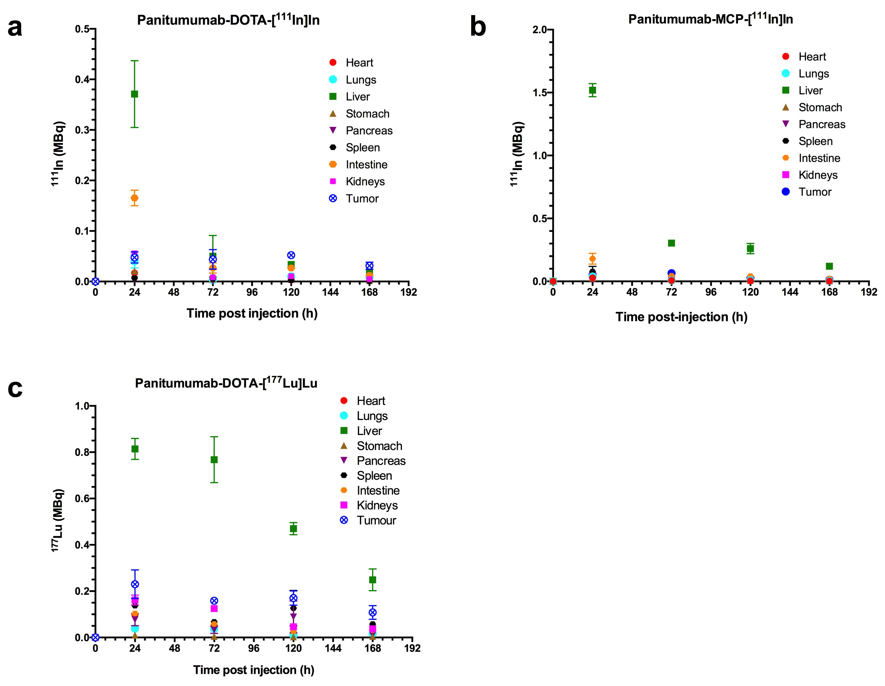

Fig. S2. Radioactivity vs. time in the tumor and normal organs in NOD/SCID mice with s.c. PANC-1 xenografts injected i.v. (tail vein) with (a) panitumumab-DOTA-[¹¹¹In]In or (b) panitumumab-MCP-[¹¹¹In]In, or (c) in NRG mice with s.c. PANC-1 xenografts injected with panitumumab-DOTA-[¹⁷⁷Lu]Lu. The time-integrated radioactivity (Bq × sec) in the tumor and source organs (${\tilde{A}}_{S}$) was obtained by integration and used to estimate the absorbed doses in the tumor and normal organs as described in the Methods of the main article and shown in the Results (Table 2).

