Supplemental Information

HPLC analysis of [¹⁸F]Ga-rhPSMA-7.3

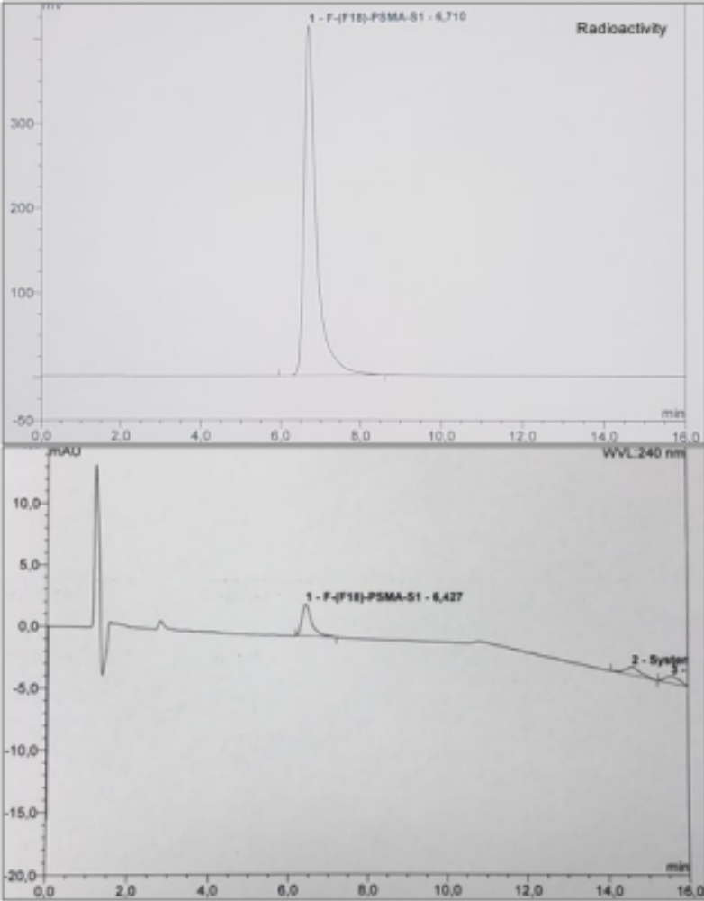

Supplemental Figure 1. Exemplary HPLC chromatogram (Radioactivity and UV) of the formulated product [¹⁸F]Ga-rhPSMA-7.3. The peak at retention time 6.7 min (radioactivity-channel) and 6.4 min (UV-channel) corresponds to [¹⁸F]Ga-rhPSMA-7.3. HPLC analysis was performed on a Prominence system, equipped with a variable wavelength detector (both Shimadzu) and a gamma-detector Gabi Star (Elysia-raytest). Water/0.1% TFA (solvent A) and MeCN (solvent B) served as mobile phases, a Nucleosil 100-5 C18 column of 125×4 mm was used as stationary phase. For sample analysis, 10 µL of product solution were injected and the following linear solvent gradient was applied: 30-38% B in 9 min, 38-95% B in 8 min, back to 30% B in 1 min and re-equilibration at 30% B for 1.5 min (flowrate = 1 mL/min, at 240 nm).

