Supporting Information
[¹¹C]CO₂: Before each synthesis, the CH₄ oven was conditioned with helium at 350 °C for 20 min and then cooled to <35 °C before end of bombardment (EOB). Cyclotron produced [¹¹C]CO₂ is trapped in a 4 Å MS at room temperature a released by heating the oven up to 380 °C. To achieve a complete activity transfer, a helium gradient was chosen. The total duration of this procedure was about 8 minutes.
Supplementary table 1 Description, time list and in-process control of [¹¹C]CO₂ trapping and release.
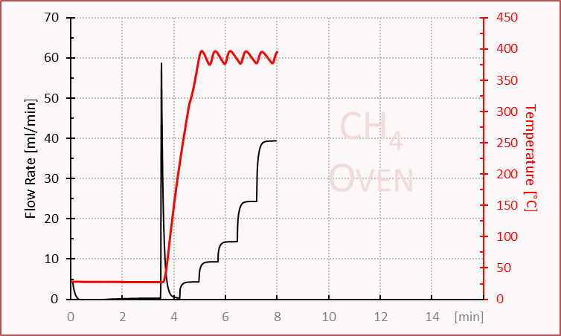

Time |  | Device |  | Value | Comment
0 | Set | Power | = | on | V.210416
2 | Set | Flow rate Set Point | = | 5
4 | Set | V28 | = | Open | Cooling on
6 | Set | V24 | = | a (down)
8 | Set | V25 | = | Open
10 | Set | V27 | = | Open
12 | Set | Process Control | = | Show Message and wait | System ready to receive activity
t1+2 | Set | V25 | = | Close
t1+3 | Set | V26 | = | Open | C11 activity release
t1+5 | Set | V27 | = | Open
t1+10 | Set | Select counter | = | 3B on, 3a Off
t1+11 | Get | Activity Product
t1+4’0 | Set | V25 | = | Open
t1+4’0 | Set | V26 | = | Close | C11 Activity stop
t1+4’1 | Set | V28 | = | Close | Cooling off
t1+4’2 | Set | V27 | = | Open
t1+4’3 | Set | Temp. Set Point CH4 | = | 300
t1+4’3 | Wait | Temp. Reg. Status CH4 | = | Temp OK
t2+0 | Set | VX | = | b (up)
t2+2 | Set | Temp. Set Point CH4 | = | 380
t2+3 | Wait | Temp. Reg. Status CH4 | = | Temp. OK
t3+1 | Set | Flow Rate Set point | = | 10
t3+45 | Set | Flow Rate Set Point | = | 15
t3+1’30 | Set | Flow Rate Set Point | = | 25
t3+2’15 | Set | Flow Rate Set Point | = | 40
t3+3’0 | Set | V27 | = | Close
t3+3’0 | Set | V28 | = | Open
t3+3’1 | Set | V25 | = | Reset
t3+3’1 | Set | V25 | = | Close

[¹¹C]CH₃I: The general synthesis process of labelling with [¹¹C]methyliodide is described as following (see service manual TRACERlab FX C Pro). Preparation: Before each synthesis, the CH₄ oven was conditioned with hydrogen at 350 °C for 20 min and then cooled to <45 °C before end of bombardment (EOB). Cyclotron produced [¹¹C]CO₂ was trapped on 4 Å molecular sieve and online converted by Ni-catalyst (Shimalite-Ni) support, under continuous addition of hydrogen at 360 °C. Both, formed H₂O and unconverted [¹¹C]CO₂ are held back by an ascarite-trap (immobilized NaOH). The produced [¹¹C]methane was trapped on a Carbosphere resin (60-80 mesh) under N₂ liq. cooling at -75 °C for further purification and concentration. Afterwards the purified [¹¹C]CH₄ was reacted with iodine at 720 °C to form [¹¹C]methyliodide in a gas circulating process system. Formed HI was removed by a separate ascarite trap. [¹¹C]Methyliodide was separated from this circulation process by a trap containing Porapak Q (50-80 mesh) as adsorbents at room temperature. Unconverted [¹¹C]CH₄ returns into the circulation process for reaction with iodine. The collected [¹¹C]methyliodide was released into a moderate helium flow off the adsorbents (190 °C) and used for further labelling. The total time of this procedure was about 15 minutes.
Supplementary table 2 Description, time list and in-process control of [¹¹C]CH₃I Production and release.
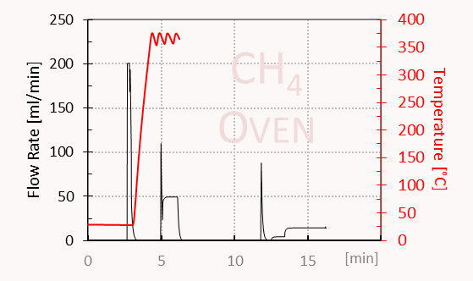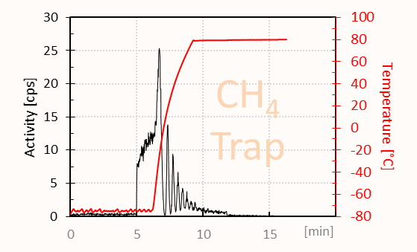
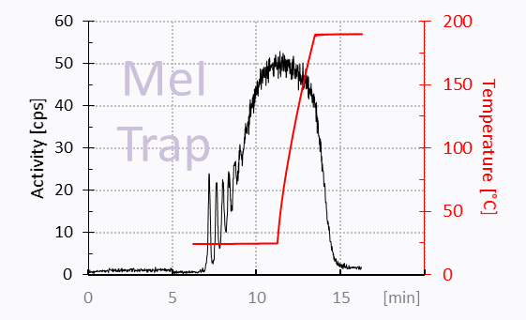
Time |  | Device |  | Value | Comment
0 | Set | Power | = | on | MeI for Choline Modified
0.4 | Set | Temp. Reg. Switch MeI | = | on
0.6 | Set | Flow Rate Set Point | = | 20
1 | Set | V25 | = | open
5 | Set | V28 | = | open
6 | Wait | Temp. CH4 | <= | 45
t1+0 | Set | Process Control | = | Show message and wait | Ready for CH4 trap cooling
t2+0 | Set | Temp. Set Point CH4 Trap | = | -75
t2+1 | Wait | Temp. Reg. Status CH4 Trap | = | Temp. OK
t3+0 | Set | Process Control | = | Show message and wait | System ready to receive activity
t4+0 | Set | Temp. Set Point I2 | = | 100
t4+1 | Get | Flow Rate Set Point | = | 0
t4+2 | Set | V25 | = | Close
t4+2.5 | Set | V26 | = | Open | C11 activity release
t4+3 | Set | V27 | = | Open
t4+4’9 | Set | V26 | = | Close | C11 activity stop
t4+4’10 | Set | V24 | = | B (up) | H2 flow
t4+4’11 | Wait | Flow Rate Set Point | = | 200
t4+4’12 | Set | V25 | = | Open
t4+4’13 | Set | Flow Rate | >= | 45
t5+5 | Set | V27 | = | Close
t5+10 | Set | V28 | = | Close
t5+15 | Set | V25 | = | Close
t5+16 | Set | V24 | = | A (down) | Switch to He
t5+17 | Set | Flow Rate Set Point | = | 50
t5+18 | Set | Temp. Set Point CH4 | = | 360
t5+19 | Wait | Temp. Reg. Status CH4 | = | Temp. OK
t6+40 | Set | V10 Exhaust | = | Open
t6+41 | Set | V15 CH4 Trap Input | = | B (left)
t6+42 | Set | V29 | = | Open
t6+43 | Set | V25 | = | Open | Purge and transport with He
t6+1’40 | Set | V09 | = | B(right)
t6+1’41 | Set | V16 Exhaust | = | B(up)
t6+1’5 | Set | V25 | = | Close
t6+1’51 | Set | V29 | = | Close
t6+1’53 | Set | V15 CH4 Trap Input | = | A (right)
t6+1’54 | Set | V16 Exhaust | = | A(down)
t6+1’55 | Set | Gas Pump | = | On
t6+1’56 | Set | V16 Exhaust | = | B (up)
t6+1’56 | Set | Temp. Set Point CH4 Trap | = | 80
t6+1’56 | Set | Temp. Reg. Switch CH4 | = | Off
t6+1'58 | Set | Select Heater | = | 3B on, 3 A off
t6+1'58 | Set | V16 Exhaust | = | A (down)
t6+4'20 | Set | Process Control | = | Show message and wait | Press o.k. when activity on MeI-Trap constant
t7+0 | Set | Temp. Set Point MeI Trap | = | 190
t7+30 | Set | Gas Pump | = | Off | Circulation
t7+31.9 | Set | V15 CH4 Trap Input | = | B (left)
t7+32.9 | Set | V29 | = | Open
t7+33.9 | Set | V25 | = | Open
t7+34.9 | Set | V16 Exhaust | = | B (up)
t7+36 | Set | Flow Rate Set Point | = | 5
t7+40 | Set | V17 | = | B (down)
t7+41 | Set | V16 Exhaust | = | A (down)
t7+42 | Set | V08 | = | Open
t7+43 | Wait | Temp. MeI Trap | >= | 185
t8+1 | Set | Flow Rate Set Point | = | 15
t8+1'10 | Set | Process Control | = | Show message and wait | Press Okay when MeI has been transferred

Supplementary table 3 Description, time list and in-process control of N-methyl-[¹¹C]choline Synthesis using a TRACERlab FX FE module.
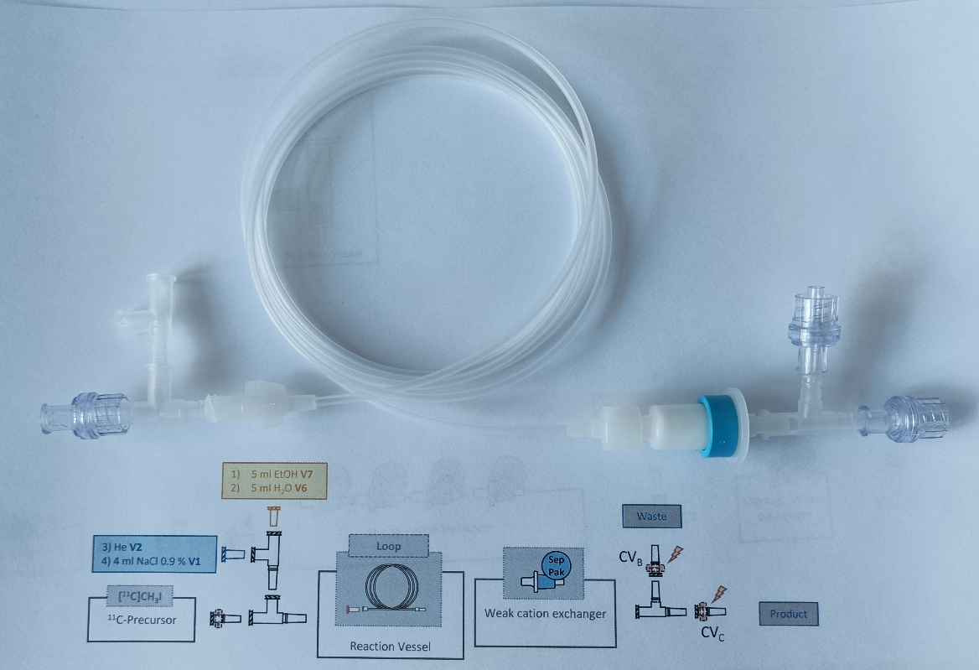
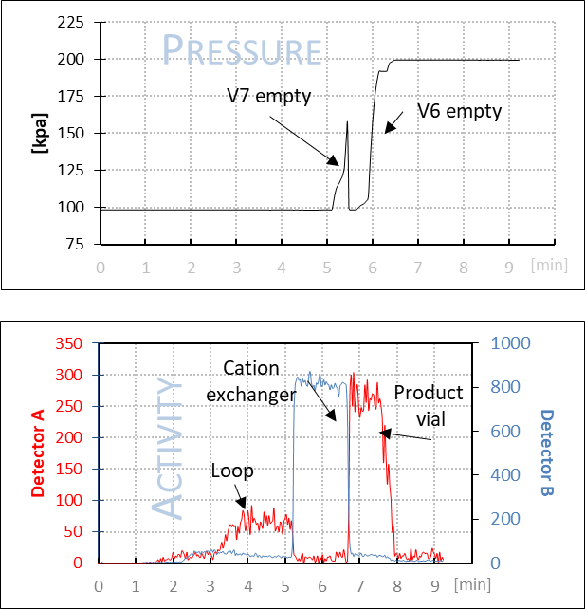

Step | Time | Device | Value | Comment
Radiolabelling | 0 | V11 | b (right) | Check valve B (CV_{B}) was open and CV_{C} was closed. After complete release of [¹¹C]CH₃I the operator started the workup.
Radiolabelling | 0 | V15 | b (left)
Radiolabelling | 0 | V16 | Open
Radiolabelling | 0 | V19 | Open
Radiolabelling | 5 | Activity Product
Radiolabelling | 5 | Activity Reactor
Radiolabelling | 10 | Process Control | Show message and wait
Ethanol Wash | t1+5 | V19 | Close | To remove unreacted starting material, the system was washed with ethanol. At the same time, an increase of activity on the cartridge was observed. A pressure increase in the waste container indicates that the washing step has been completed.
Ethanol Wash | t1+7 | V07 Vial7 | b (up)
Ethanol Wash | t1+20 | Process Control | Show message and wait
Ethanol Wash | t2+1 | V07 Vial7 | a (down)
Ethanol Wash | t2+1 | V19 | open
Ethanol Wash | t2+10 | V19 | close
Water Wash | t2+11 | V06 Vial6 | b (up) | To remove the ethanol residues from the cartridge, the system was then washed with water. The activity on the cartridge remains constant during this process. A pressure increase indicated the end of this step.
Water Wash | t2+35 | Process Control | Show message and wait
He Purge | t3+1 | V06 Vial6 | a (down) | Further purging with helium closes check valve B (CV_{B})
He Purge | t3+10 | V19 | Close | Further purging with helium closes check valve B (CV_{B})
He Purge | t3+11 | V02 Vial2 | Open | Further purging with helium closes check valve B (CV_{B})
He Purge | t3+20 | Process Control | Show message and wait | Further purging with helium closes check valve B (CV_{B})
Product Extraction | t4+1 | V02 Vial2 | Close | By releasing the pressure from the product vial, the check valve C was opened and the product was extracted from the cation exchanger with saline.
Product Extraction | t4+2 | V15 | a (right)
Product Extraction | t4+3 | V01 Vial1 | Open
Product Extraction | t4+1'0 | Process Control | Show message and wait
Filling | t5+1 | V15 | b (left) | Filling
Filling | t5+2 | V01 Vial1 | Close | Filling
Filling | t5+3 | V13 | Open | Filling
Filling | t5+1'0 | Process Control | Show message and wait | Filling
End | t6+1 | Process Control | Reset

Supplementary table 4 Description and time list of L-S-methyl-[¹¹C]methionine synthesis using the TRACERlab FX FE module.
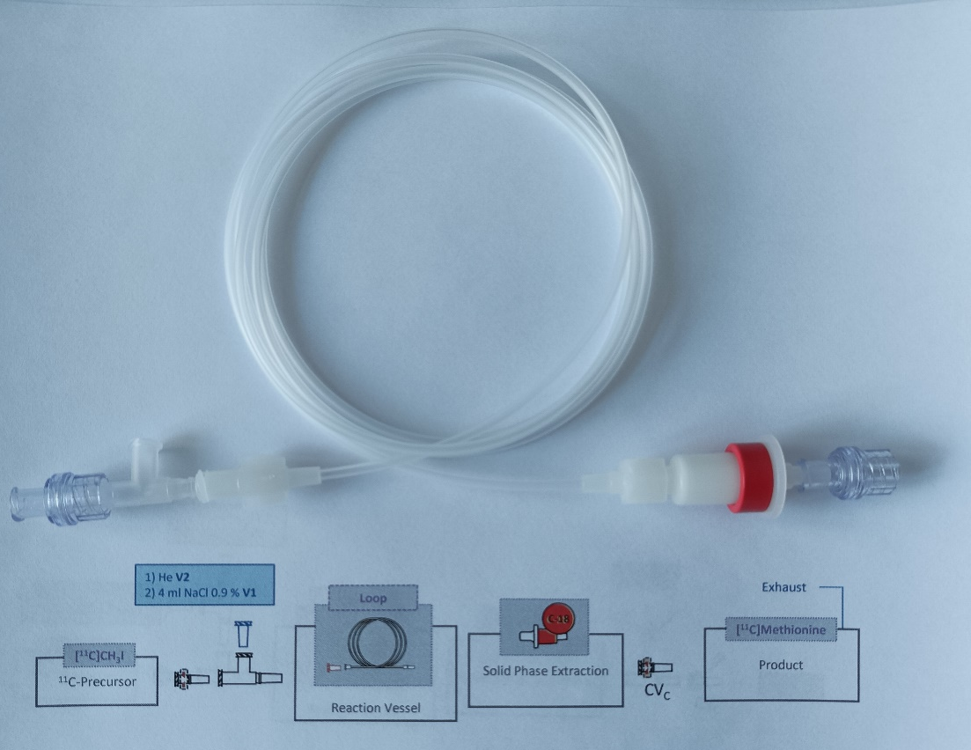
Step | Time | Device | Value | Comment
Radiolabelling | 15 | Process Control | Show message and wait | After complete release of [¹¹C]CH₃I the operator started the workup.
He Purge | t1+5 | V02 Vial2 | open | After the reaction was completed, the aperture was purged with helium to remove traces of unreacted methyliodide.
He Purge | t1+1’30 | V02 Vial2 | close
Product Extraction | t1+1’31 | V01 Vial1 | b (up) | Product extraction
Product Extraction | t1+2’30 | Process Control | Show message and wait
Filling | t2+1 | V15 | b (left) | Filling
Filling | t2+2 | V01 Vial1 | Close
Filling | t2+3 | V13 | Open
Filling | t2+1'0 | Process Control | Show message and wait
End | t3+1 | Process Control | Reset
Supplementary table 5 Description, time list and in process control of a representative [¹¹C]acetate synthesis using the TRACERlab FX FE module.
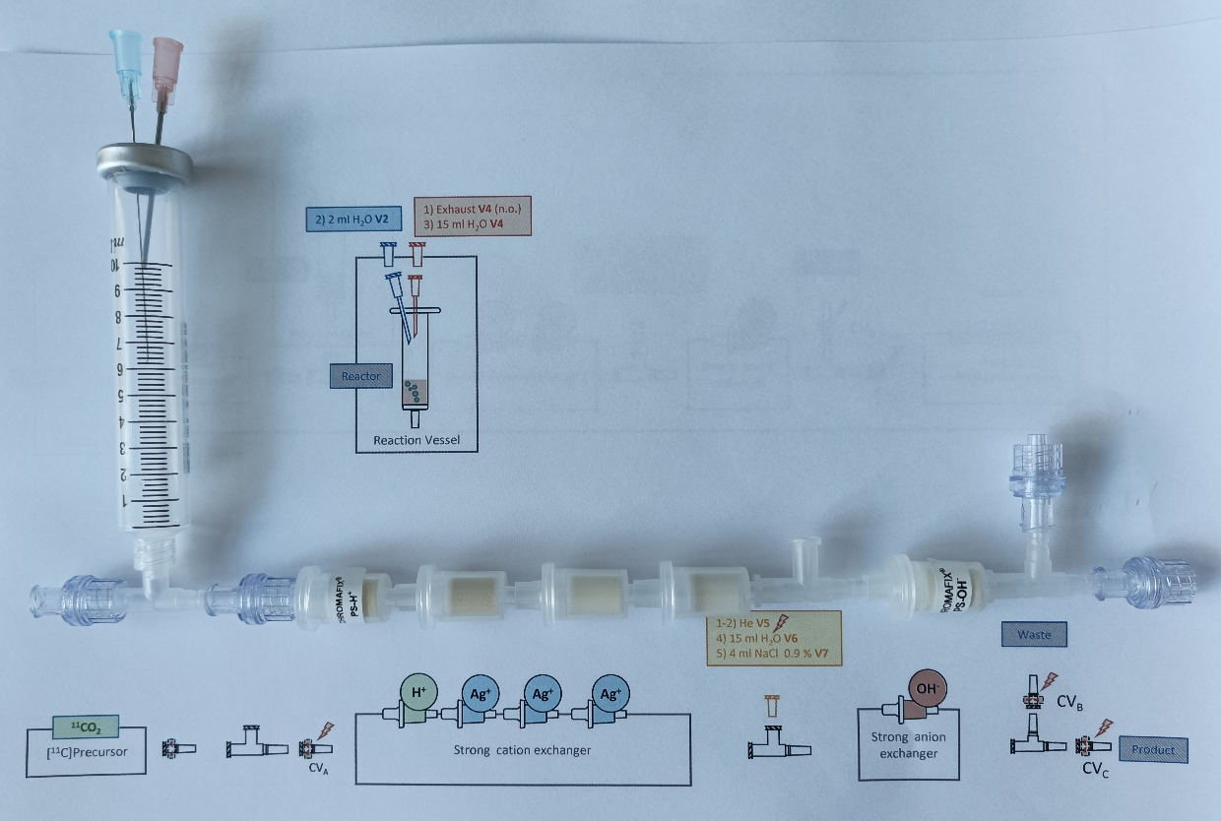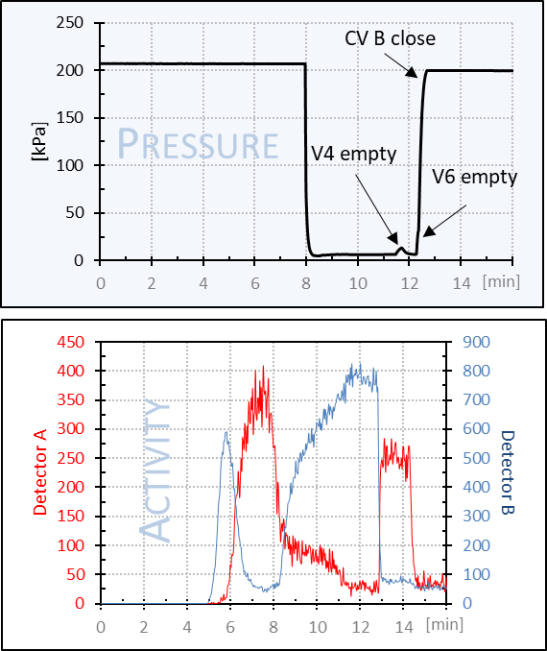
Step | Time | Device | Value | Comment
Pre-synthesis | 0 | V05 Vial5 | open | Check valve A (CV_{A}) was closed by helium overpressure from V5. The reactor was filled with Grignard reagent. The latter was purged with argon and the [¹¹C]CO₂ line was connected.
Pre-synthesis | 0 | V11 | b (right)
Pre-synthesis | 0 | V15 | b (left)
Pre-synthesis | 0 | V16 | Open
Pre-synthesis | 10 | Process Control | Show message and wait
Radiolabelling | t1+5 | Activity Product |  | The [¹¹C]CO₂ line was close to the product detector so temporary an increase in activity was observed. After the reaction, the highest activity was measured in the reaction vessel.
Radiolabelling | t1+6 | Activity Reactor
Radiolabelling | t1+10 | Process Control | Show message and wait
Quench and Wash | t2+10 | V02 Vial2 | Open | The reaction mixture was quenched and washed with water. The check valves A and B were opened by applying a vacuum. An increase in activity on the anion exchange cartridge was observed. A pressure increase in the waste vessel indicates that the washing step has been completed.
Quench and Wash | t2+20 | V02 Vial2 | Close
Quench and Wash | t2+20 | Power | On
Quench and Wash | t2+20.1 | V05 Vial5 | Close
Quench and Wash | t2+25 | V18 | Open
Quench and Wash | t2+25.1 | V04 Vial4 | Open
Quench and Wash | t2+30 | Process Control | Show message and wait
Wash wash anion exchanger | t3+5 | V04 Vial4 | Close | To ensure that all by-products were separated, the anion exchanger cartridge was washed again with water. A pressure increase in the waste vessel indicates that the washing step has been completed.
Wash wash anion exchanger | t3+10 | Vial06 Vial6 | b (up)
Wash wash anion exchanger | t3+20 | Process Control | Show message and wait
Helium Purge | t4+5 | V06 Vial6 | a(down) | Further purging with helium closes check valve B (CV_{B}).
Helium Purge | t4+5.1 | V05 Vial5 | Open | Further purging with helium closes check valve B (CV_{B}).
Helium Purge | t4+5.2 | V18 | Close | Further purging with helium closes check valve B (CV_{B}).
Helium Purge | t4+5.3 | Power | Off | Further purging with helium closes check valve B (CV_{B}).
Helium Purge | t4+10 | Process Control | Show message and wait | Further purging with helium closes check valve B (CV_{B}).
Product extraction and degassing | t5+1 | V05 Vial5 | Close | By releasing the pressure from the product vial, the check valve C (CV_{C}) was opened and the product was extracted by ion exchange with saline. The product is transferred into the citrate buffer solution and [¹¹C]carbonate was removed by helium bubbling.
Product extraction and degassing | t5+5 | V05 Vial5 | Close
Product extraction and degassing | t5+5.1 | V15 | a (right)
Product extraction and degassing | t5+5.2 | V07 Vial7 | b (up)
Product extraction and degassing | t5+1’30 | Process Control | Show message and wait
Filling | t6+5 | V07 Vial7 | a (down) | Filling
Filling | t6+10 | Process Control | Show message and wait | Filling
Filling | t7+5 | V15 | b (left) | Filling
Filling | t7+5.1 | V13 | Open | Filling
Filling | t7+30 | Process Control | Show message and wait | Filling
End | t8+1 | Process Control | Reset

