Table S1: γ-lines used for identification of antimony radioisotopes.
Isotope | γ-lines used for identification,  keV (abundance)
¹¹⁷Sb | 158.56 | (86%)
^{118m}Sb | 1229.68  253.68  1050.65 | (100%)  (99%)  (97%)
^{120m}Sb | 1171.3  1023.1  197.3  89.8 | (100%)  (99.4%)  (87%)  (79.5%)
¹²²Sb | 564.12  692.79 | (71%)  (3.85%)

Major γ-lines used for the identification and quantification of antimony radioisotopes used in this work [5].

Table S2: Irradiation of ^{nat}Sn targets, further production details.
Number of productions |  | 3
Beam current (µA) |  | 35-40
Total charge (µAh) |  | 69.1-79.6
Target thickness (mg⋅cm⁻²) |  | 12.2-18.8
Activity at EOB (MBq) | ¹¹⁷Sb | 186-374
Activity at EOB (MBq) | ^{118m}Sb | 12.9-35.9
Activity at EOB (MBq) | ^{120m}Sb | 0.8-2.2
Activity at EOB (MBq) | ¹²²Sb | 5.0-9.9

Production details following irradiation of ^{nat}Sn targets including produced activities of ¹¹⁷Sb, ^{118m}Sb, ^{120m}Sb and ¹²²Sb at EOB after irradiation with a 10.8 MeV proton beam.

Figure S1: Positive ion ESI mass spectrum of SbCl₂(TMe) in acetonitrile solution.
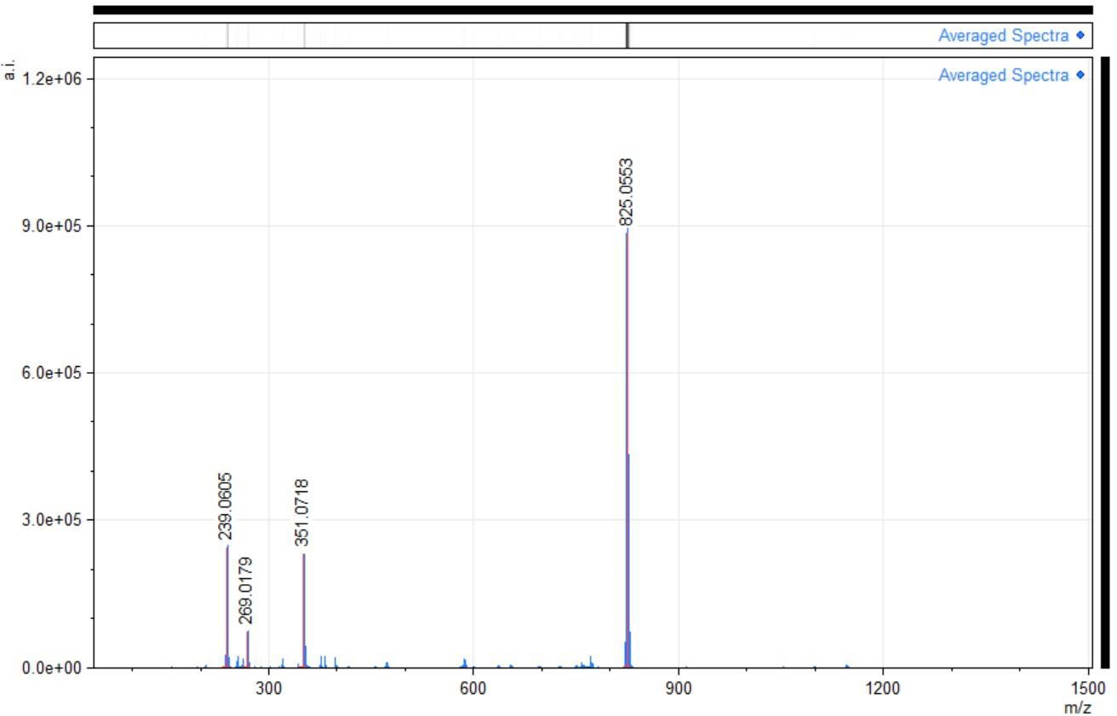

Figure S2: LC-MS spectra of Sb(TMe)Cl₂.
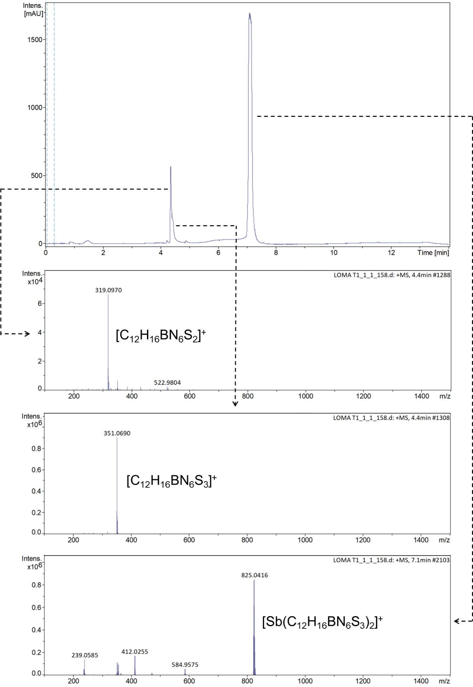
Figure S3: LC-MS spectra of [Sb(TMe)₂](TMe).
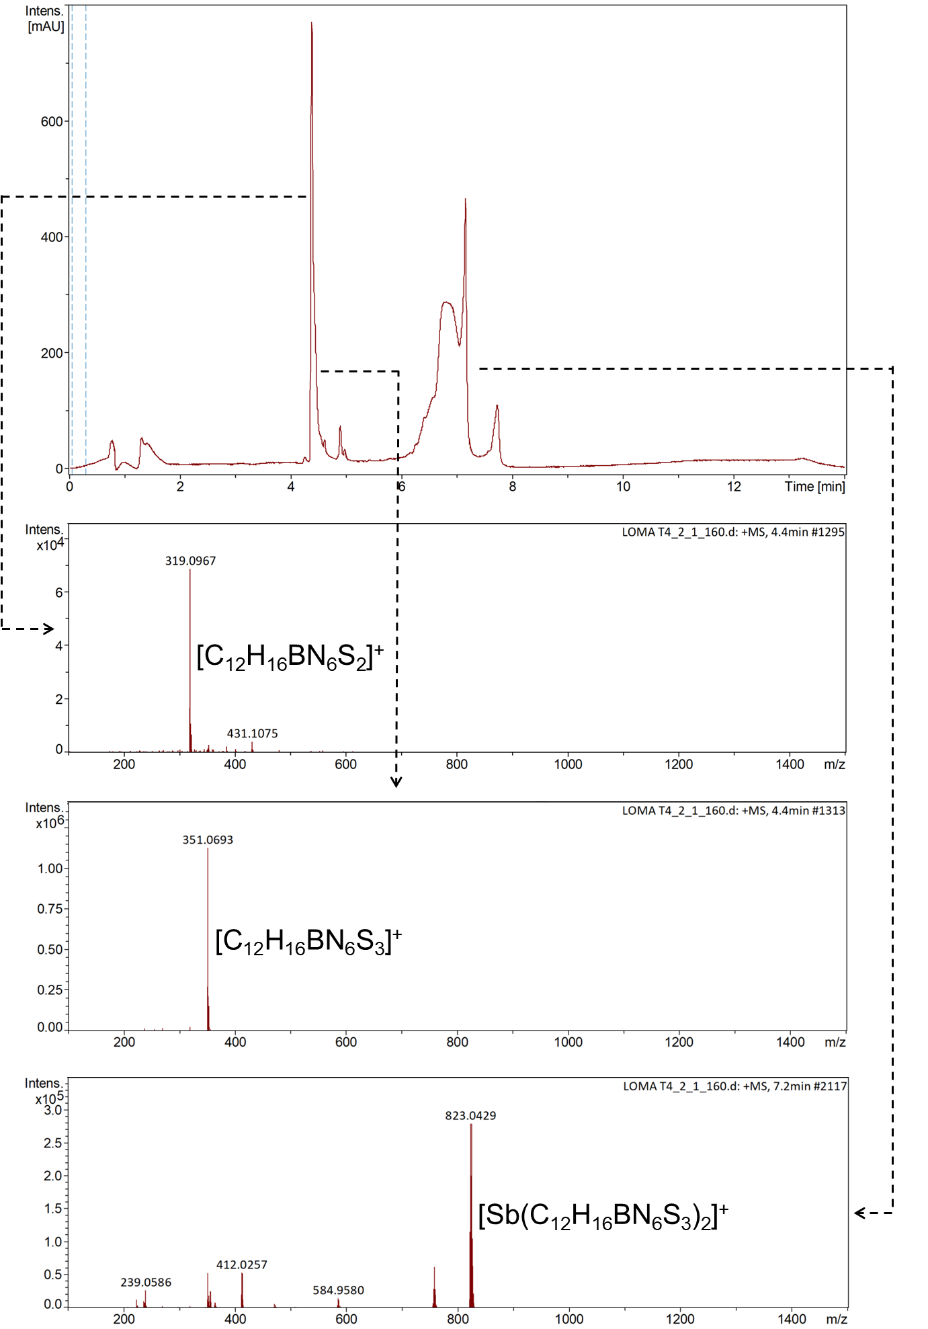
Figure S4: (A) radio chromatogram and (B) UV chromatogram obtained from analytical RP-HPLC of a sample of [^{1XX}Sb]Sb-TMe (5 MBq/µmol for ¹²²Sb) mixed 1:1 (V/V) with 0.9 mM non-radioactive SbCl₂(TMe) dissolved in MQ water.
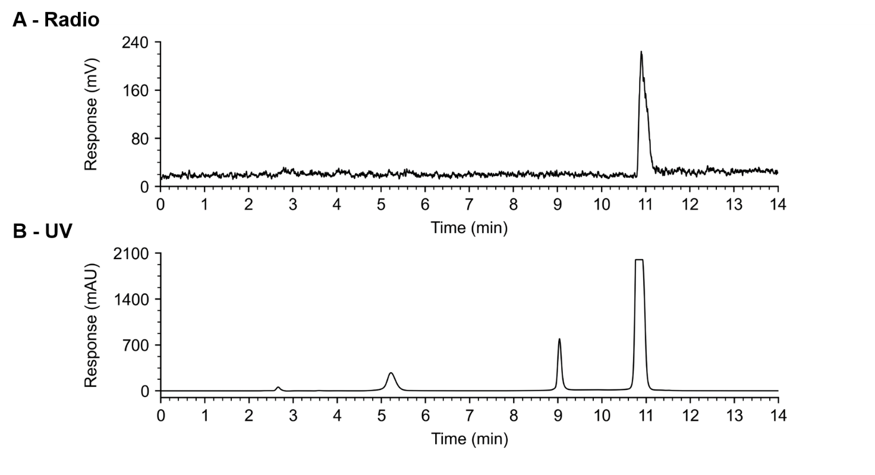

Figure S5: UV chromatogram of SbCl₂(TMe) dissolved in MQ water.
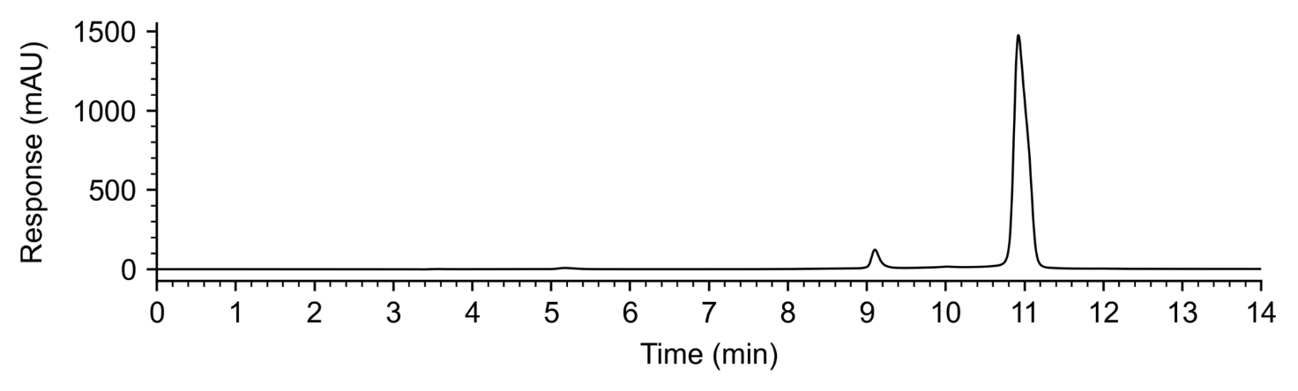

Figure S6: Radiochromatogram of a sample of ¹¹⁷Sb in HCl mixed 1:1 (V/V) with 0.9 mM non-radioactive Sb(TMe)Cl₂ dissolved in MQ water.

