Supplementary Material
Preclinical evaluation and automated synthesis of [⁸⁹Zr]ZrDFOSquaramide-girentuximab for diagnostic imaging of carbonic anhydrase IX positive tumours
Asif Noor,^{1*} Emily R. McGowan,¹ Jessica K. Van Zuylekom,² Carleen Cullinane,^{2,3†} Peter D. Roselt,^{3,6} Rodney J. Hicks^{2,3,4} Michael P. Wheatcroft,⁵ and Paul S. Donnelly¹*
¹School of Chemistry and Bio21 Molecular Science and Biotechnology Institute University of Melbourne, Parkville, Victoria 3010, Australia.
²Research Division, Peter MacCallum Cancer Centre, Melbourne, Victoria 3000, Australia.
³Sir Peter MacCallum Department of Oncology, The University of Melbourne, Parkville, VIC, Australia.
⁴Melbourne Theranostic Innovation Centre, Level 8/14-20 Blackwood St, North Melbourne VIC 3051, Australia
⁵Telix Pharmaceuticals Limited, Suite 401, 55 Flemington Road, North Melbourne, Victoria 3051, Australia.
⁶Department of Radiopharmaceutical Sciences, Cancer Imaging, Peter MacCallum Cancer Centre, Melbourne, Victoria 3000, Australia
† Deceased.

Correspondence: asif.noor@unimelb.edu.au; pauld@unimelb.edu.au

Table of Contents
Synthesis of DFOSq-Girentuximab 3
Selected SEC-HPLC Traces 3
MicroPET Imaging 4
Biodistribution Analysis 5
Automated synthesis 5
Stability of [⁸⁹Zr]ZrDFOSq-girentuximab in human serum 6

Synthesis of DFOSq-Girentuximab
Table S1 Bioconjugation of DFOSq with Girentuximab
DFO-Sq Equivalents | Reaction  Time (h) | Reaction Concentration (mg/ml) | No of Chelators attached | Average chelator to antibody ratio (chelator/antibody)
20 | 18 | 1 | 0-4 | 1.3
40 | 18 | 1 | 1-6 | 3.3
60 | 18 | 1 | 2-8 | 5.3
80 | 18 | 1 | 5-11 | 8.0
40* | 4 | 6 | 0-6 | 3.0
*Reaction performed at 37 °C

Selected SEC-HPLC Traces
Figure S1 size exclusion chromatogram (SEC) traces for the DFOsq-girentuximab sample incubated at different temperature of time over 7 days

MicroPET Imaging
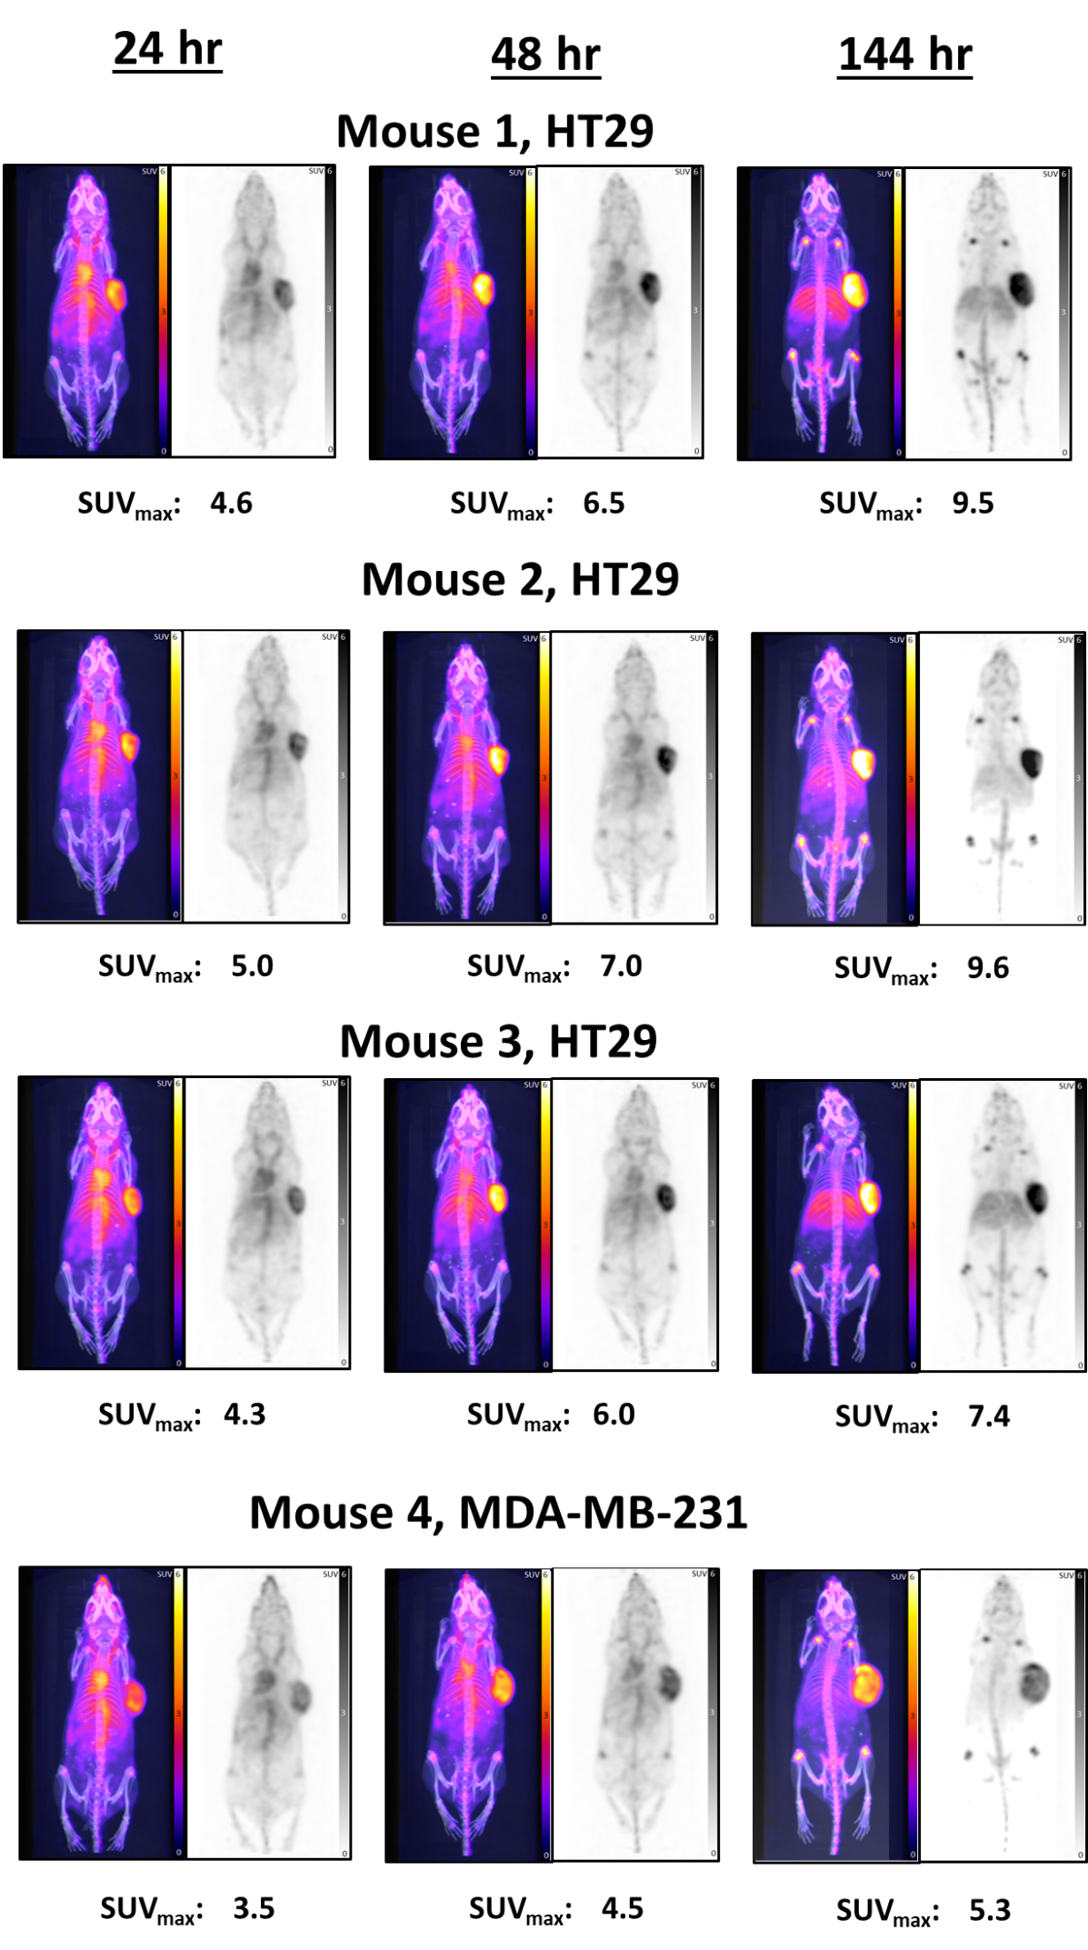
Figure S2 Whole-body microPET maximum intensity projection (MIP) and CT images of mice bearing xenograft HT29 and MDA-MB-231 tumors after 24, 48 and 144 h post injection of ⁸⁹ZrDFOSq-girentuximab

Biodistribution Analysis
Figure S3 Ex-vivo biodistribution analysis. Mice was euthanised at 24, 48 and 144 hr after injection with ⁸⁹ZrDFO-Sq-girentuximab in MDA-MB-231. Tissues were harvested, weighed and counted on a gamma counter. Tracer uptake is expressed as percent injected dose/gram tissue. Data represents n = 1

Automated synthesis
Figure S4. Representative example of Radio-SEC of [⁸⁹Zr]ZrDFOSq-girentuximab synthesized on automated process
Figure S5. Representative example of Radio-TLC [⁸⁹Zr]Zr-DFOSq-girentuximab (left) synthesized on automated process and buffered ⁸⁹Zr (right) in 0.1M citrate buffer.

Stability of [⁸⁹Zr]ZrDFOSq-girentuximab in human serum
[⁸⁹Zr]ZrDFOSq-girentuximab (30 MBq, 30 µg) was added to human serum (100 µL, Sigma Aldrich, human male AB plasma, USA origin, sterile-filtered). The sample was incubated at 37 °C and the mixture was analyzed after 1, 4, 24 and 48 hours by instant thin layer chromatography (mobile phase citrate 20 mM). [⁸⁹Zr]ZrDFOSq-girentuximab was stable for 48 hours (Figure S7).
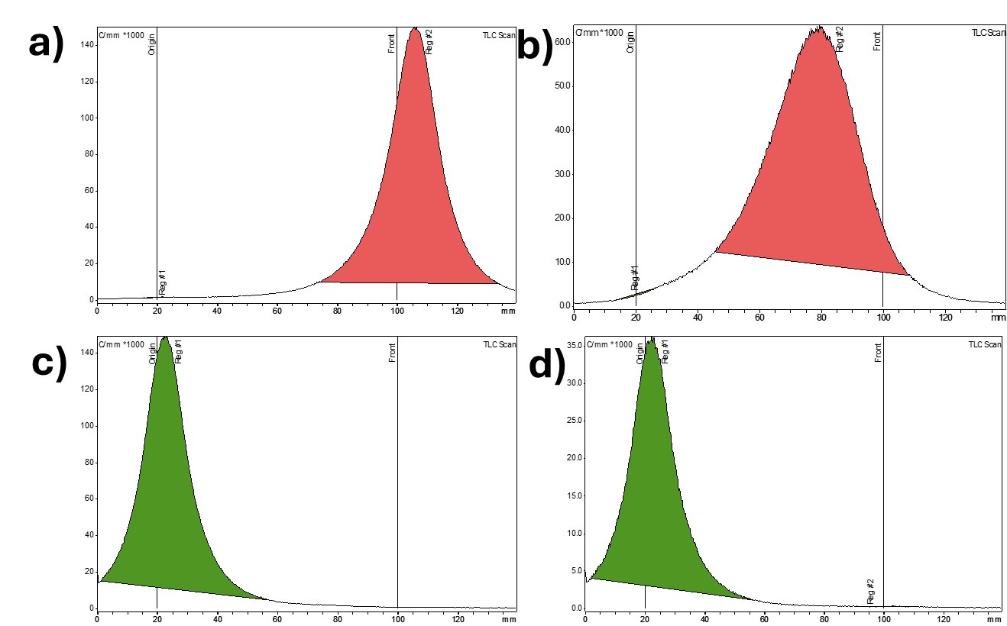

Figure S6. Radio-TLC chromatograms of: a) [⁸⁹Zr][Zr(ox)₄]⁴⁻; b) [⁸⁹Zr][Zr-DFOSq-OH]; c) [⁸⁹Zr]ZrDFOSq-girentuximab; d) [⁸⁹Zr]ZrDFOSq-girentuximab after 48 hours incubation in human serum at 37 °C.

Figure S7. Radio-TLC [⁸⁹Zr]ZrDFOSq-girentuximab (886 MBq) synthesized by automated process after 6 days post production, stored at RT.

