PET imaging of mitochondrial complex-I in the adenine-induced tubulointerstitial nephropathy mouse model using [¹⁸F]BCPP-BF
Kenneth Dahl^{1,2,}*, Peter Johnström^{1,2}, Miklós Toth², Vasco C. Sousa³, Charlotte Ericsson⁴, Maria Strömstedt⁴, Tord Inghardt⁵, Miguel Cortes Gonzalez², Anna Reznichenko⁶, Aurelija Jucaite^{1,2}, Zsolt Cselényi^{1,2}, Robert Unwin⁷, Hiroyuki Ohba⁸, Christer Halldin^{2,9}, Benjamin Challis⁵, Hideo Tsukada⁷, Magnus Schou^{1,2}
¹PET Science Centre, Precision Medicine and Biosamples, Oncology R&D, AstraZeneca, Karolinska Institutet, Stockholm, Sweden.
²Department of Clinical Neuroscience, Centre for Psychiatry Research, Karolinska Institutet and Stockholm County Council, Stockholm, Sweden
³Department of Clinical Neuroscience, Division of Imaging Core Facilities, Center for Imaging Research, Karolinska Institutet, Stockholm, Sweden.
⁴Bioscience, Early Cardiovascular, Renal and Metabolism, Biopharma R&D, AstraZeneca, Gothenburg, Sweden
⁵Chemistry, Early Cardiovascular, Renal and Metabolism, Biopharma R&D, AstraZeneca, Gothenburg, Sweden
⁶Translational Science and Experimental Medicine, Early Cardiovascular, Renal and Metabolism, Biopharma R&D, AstraZeneca, Gothenburg, Sweden
⁷Early Clinical Development, Early Cardiovascular, Renal and Metabolism, Biopharma R&D, AstraZeneca, Cambridge, United Kingdom
⁸Central Research Laboratory, Hamamatsu Photonics K. K., Hamamatsu, Japan
⁹HUN-REN TKI, Department of Biophysics and Radiation Biology, Semmelweis University, Budapest, Hungary

Supporting Information

Content
- [¹⁸F]BCPP-BF binding data in kidneys
- [¹⁸F]BCPP-BF binding data in heart, left ventricle, liver, and pancreas.
- In vitro autoradiography data with [¹⁸F]BCPP-BF
- [¹⁸F]BCPP-BF semipreparative and analytical chromatograms.

- [¹⁸F]BCPP-BF binding data in kidneys

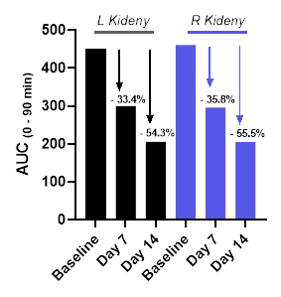
Fig S1. Radioactivity in kidney following the intravenous injection of [¹⁸F]BCPP-BF in a mice model of adenine-induced renal failure. Plot summarizing the area under the curve (AUC, 0 – 90 min) for the kidneys at baseline and relative change (%) after adenine diet.

- [¹⁸F]BCPP-BF binding data in heart, left ventricle, liver, and pancreas

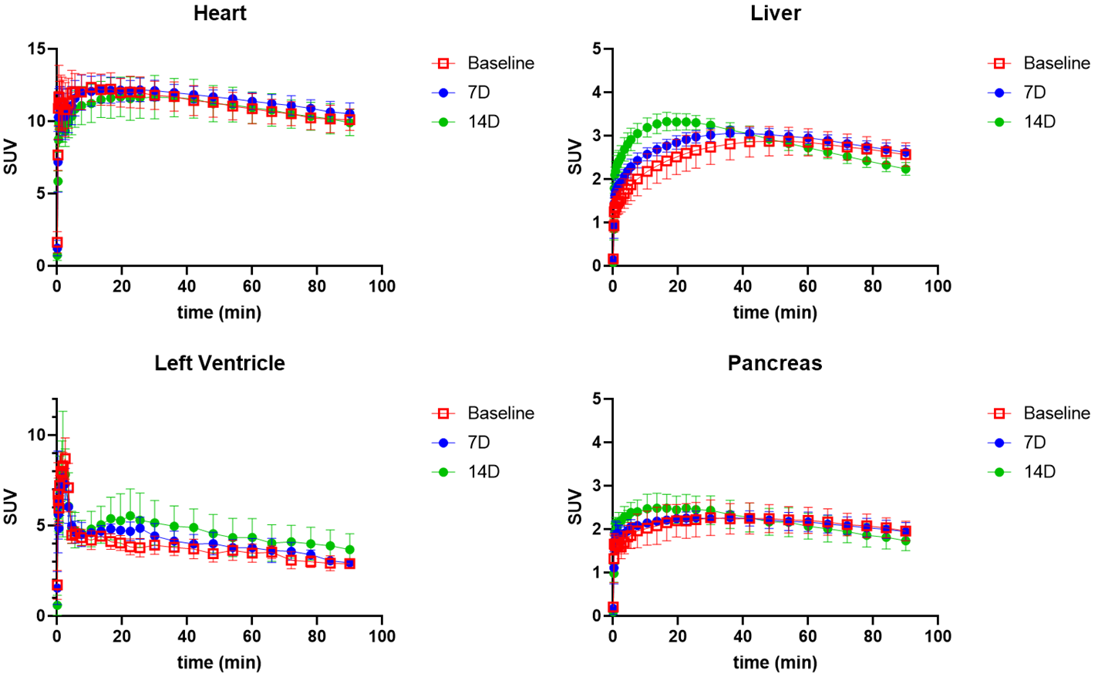
Fig S2. Radioactivity in the heart, left ventricle, liver, and pancreas following the intravenous injection of [¹⁸F]BCPP-BF in a mice model of renal failure.

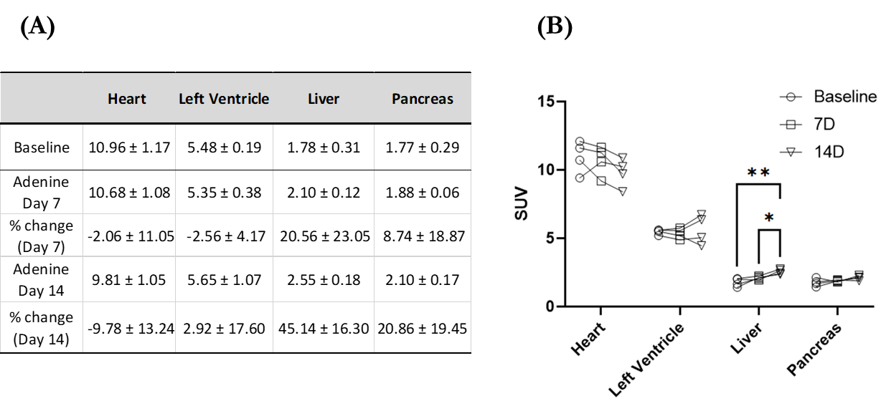
Table S1. Early (0 – 33 min) SUV values in the heart, left ventricle, liver, and pancreas following the intravenous injection of [¹⁸F]BCPP-BF. Average of early SUV values (n = 4) at baseline, Day 7, and Day 14. The data also include % change compared to baseline (A). Same SUV data as in (A) but displayed in a plot format (B). 2-way ANOVA, with Tukey's multiple comparison (*p=0.041; **p=0.0031).

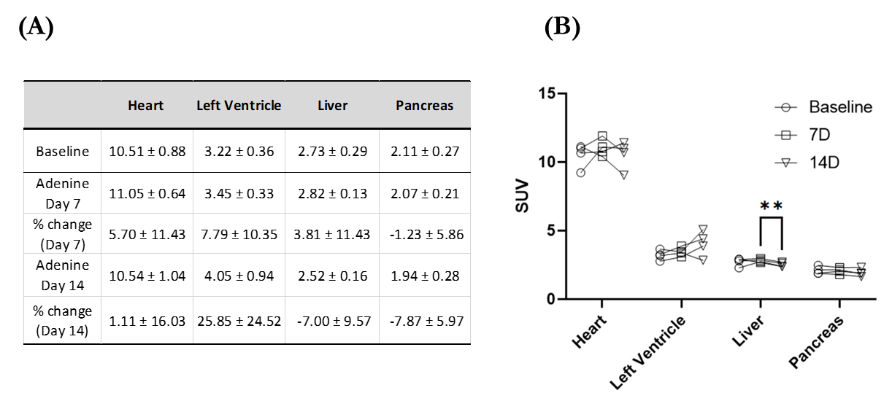
Table S2. Late (33 – 93 min) SUV values in the heart, left ventricle, liver, and pancreas following the intravenous injection of [¹⁸F]BCPP-BF. Average of late SUV values (n = 4) at baseline, Day 7, and Day 14. The data also include % change compared to baseline (A). Same SUV data as in (A) but displayed in a plot format (B). 2-way ANOVA, with Tukey's multiple comparison (**p=0.0013).

- In vitro autoradiography data with [¹⁸F]BCPP-BF

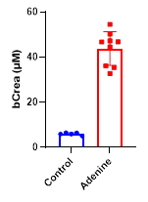
Fig S3. Measured creatine levels for mice used in the in vitro autoradiography study, n = 6 on normal (control) diet and n = 9 mice on adenine diet for two weeks.
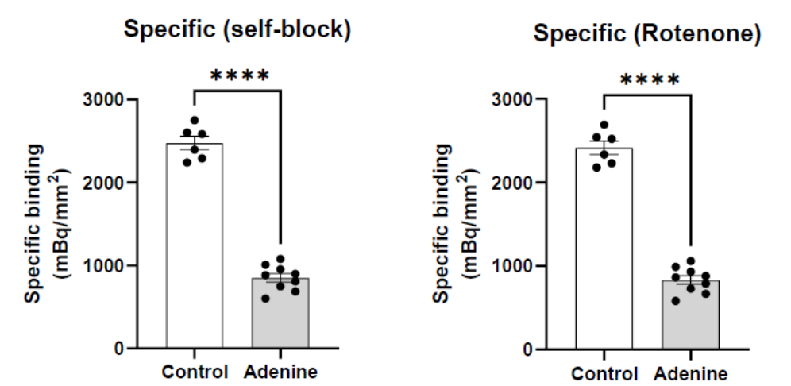
Fig S4. [¹⁸F]BCPP-BF binding autoradiography in kidney tissue sections from Control mice and mice fed with adenine in their diet for 14 days (Adenine). Specific [¹⁸F]BCPP-BF Binding (mBq/mm2), calculated by subtracting the signal obtained co-incubation of the [¹⁸F]BCPP-BF with 10 µM BCPP-BF (left) and 10 µM Rotenone (right) from the Total signal. **** p<0.0001, two-tailed unpaired t-test.

- [¹⁸F]BCPP-BF semipreparative and analytical chromatograms
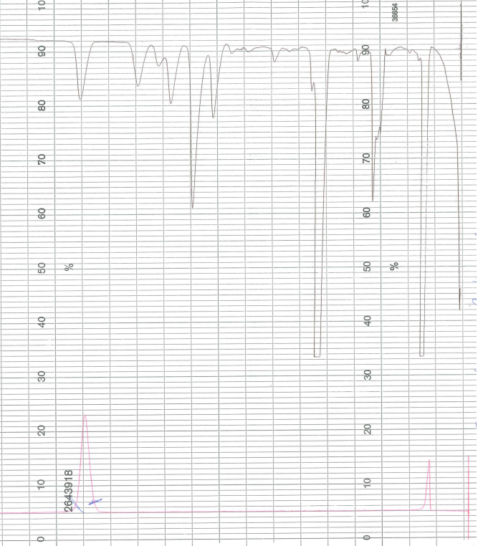

Fig. S5. Semipreparative HPLC chromatogram. Upper trace: Radioactivity trace. Lower trace: UV-trace. Each square corresponds to 1 minute.
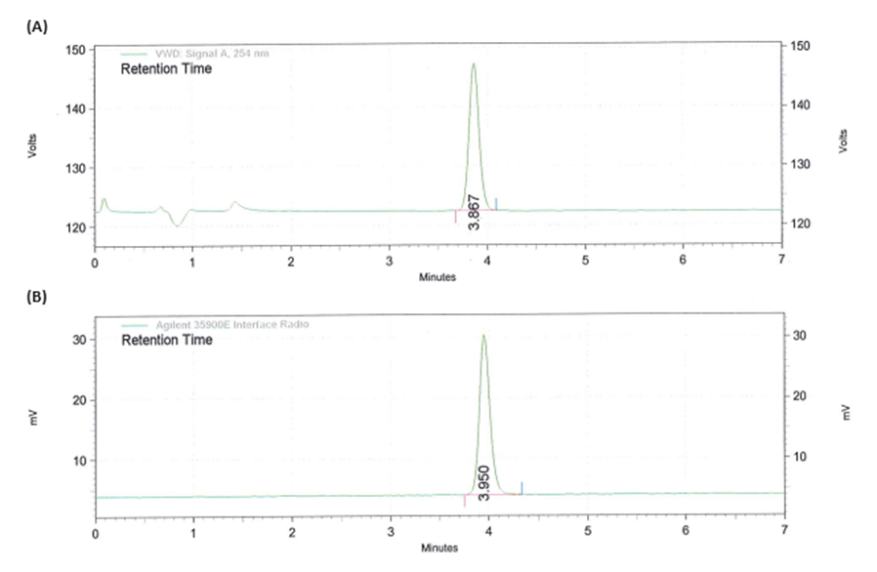
Fig. S6. HPLC chromatogram of [¹⁸F]BCPP-BF spiked with reference BCPP-BF. (A) UV-trace. (B) Radioactivity trace.

