Supplementary Information

Extending the shelf life of ⁶⁸Ge/⁶⁸Ga generators via preconcentration of [⁶⁸Ga]GaCl₃ for preclinical application

Hemantha Mallapura^{1*} and Olof Eriksson¹

¹ Science For Life Laboratory, Department of Medicinal Chemistry, Uppsala University, Uppsala, Sweden.

Hemantha Mallapura (H.M.)*
hemantha.mallapura@ilk.uu.se
Olof Eriksson (O.E.)
olof.eriksson@ilk.uu.se

*Corresponding author

Elution volume (µL) | 500 | 400 | 300
Elution Efficiency (%) | 96.7 | 92.4 | 94.8
Elution Efficiency (%) | 95.2 | 91.3 | 90.8
Elution Efficiency (%) | 94.7 | 96.8 | 90.8
Elution Efficiency (%) | 94.0 | 96.9 | 92.3
Elution Efficiency (%) | 93.8 |  | 91.5
Elution Efficiency (%) | 96.1 |  | 95.2
Elution Efficiency (%) | 94.5 |  | 91.1
Elution Efficiency (%) | 96.6
Average percentage (%) | 95.21±1.1 | 94.4±2.9 | 92.4±1.9

Table S1. Elution efficiency (EE) of [⁶⁸Ga]GaCl₃ from the SCX cartridge at different elution volumes.

Trapping efficiency (TE) % | Elution efficiency (EE) %
99.8±0.3% (n=19) | 500 µL | 95.2±1.1% (n=8)
99.8±0.3% (n=19) | 400 µL | 94.4±2.9% (n=4)
99.8±0.3% (n=19) | 300 µL | 92.4±1.9% (n=7)*

Table S2. Summary of trapping and elution efficiency of preconcentration method of [⁶⁸Ga]GaCl_{3.}
(* represents p < 0.05 compared to 500µL).

Month | Generator age (months) | Total [⁶⁸Ga]GaCl₃  (≈ MBq) | Direct elution (≈ MBq)ª | Pre-concentration  ( ≈ MBq)^{b}
24-Jan | 0 | 1400 | 280 | 806
24-Mar | 3 | 1111 | 222 | 640
24-Jun | 6 | 882 | 176 | 508
24-Sep | 9 | 700 | 140 | 403
24-Dec | 12 | 555 | 111 | 320
25-Mar | 15 | 441 | 88 | 254
25-Jun | 18 | 350 | 70 | 202
25-Sep | 21 | 277 | 55 | 160
25-Dec | 24 | 220 | 44 | 127

Table S3. Comparision direct and preconcentration of ⁶⁸Ge/⁶⁸Ga generator elution profile over 24 months.
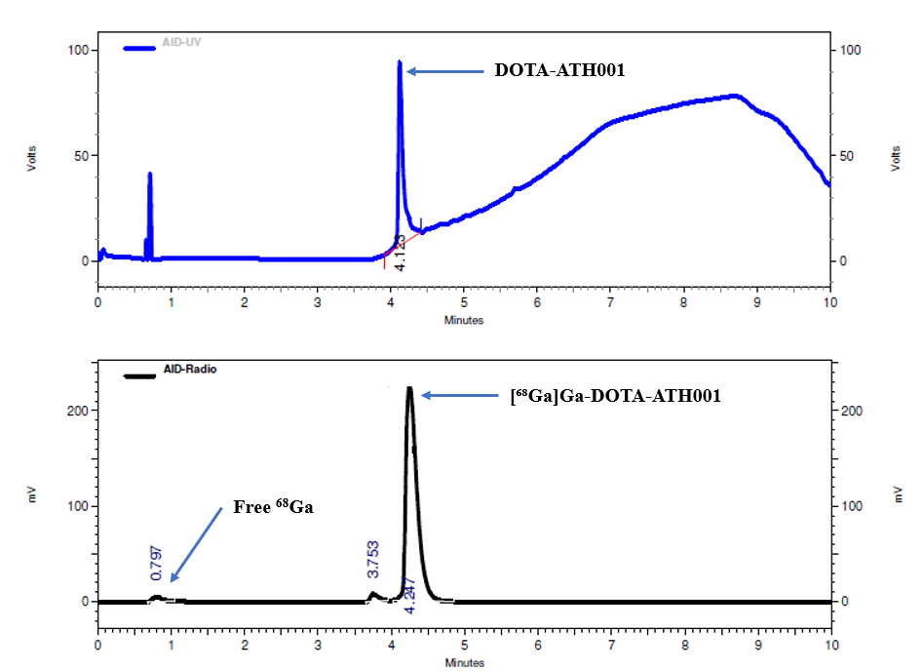
Figure S1: Representative HPLC chromatograms of DOTA-ATH001 and [⁶⁸Ga]Ga-DOTA-ATH001.
(Top) UV chromatogram showing the retention time of the unlabeled DOTA-ATH001 peptide.
(Bottom) Radiochromatogram of the radiolabeled product, [⁶⁸Ga]Ga-DOTA-ATH001, with a major peak at the same retention time as the peptide and a minor peak corresponding to free ⁶⁸Ga.

